**About This Course**





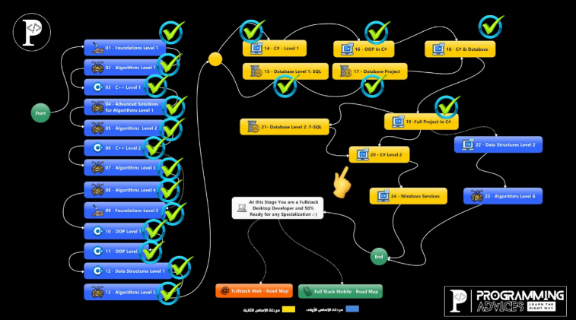

**Telegram Group for This Course**

رابط المجموعة على التلجرام

<https://t.me/+WbWn3Ghti_05ZWU0>

**Send Data To Form**

الأول لما بنكون عاملين فورم والفورم ده بيفتح فورم تاني وكنا عاوزين نبعتله داتا بنبعته عن طريق التعديل عال constructor

تعالي نشوف هوا عايز يقول ايه

تعالي نعمل تطبيق جديد ونعمل اتنين فورم

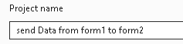

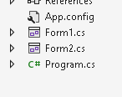

اول فورم هنحط فيه LABEL وtext box وزرار

تاني فورم هنحط فيه اتنين label

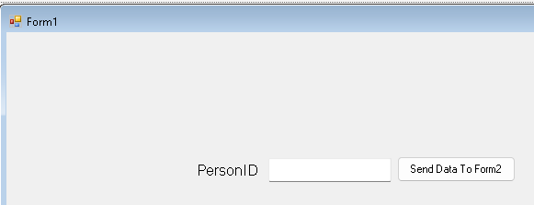

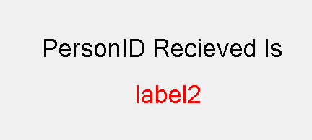

بعدين نروح عالكود بتاع form2 واعرف متغير واضيفه عال constructor بتاع الفورم

وبعدين في ال event بتاع الفورم اللي اسمه load بعدل ال label

|  |
| --- |
| using System;  using System.Collections.Generic;  using System.ComponentModel;  using System.Data;  using System.Drawing;  using System.Linq;  using System.Text;  using System.Threading.Tasks;  using System.Windows.Forms;  namespace send_Data_from_form1_to_form2  {  public partial class Form2 : Form  {  private int _ID = -1;  public Form2(int iD)  {  InitializeComponent();  _ID = iD;  }  private void Form2_Load(object sender, EventArgs e)  {  lblRecieved.Text = _ID.ToString();  }  }  } |

كده جهزنا form2 عشان يستقبل داتا

نروح للزرار اللي في form1 ونبعت منه الداتا

|  |
| --- |
| using System;  using System.Collections.Generic;  using System.ComponentModel;  using System.Data;  using System.Drawing;  using System.Linq;  using System.Text;  using System.Threading.Tasks;  using System.Windows.Forms;  namespace send_Data_from_form1_to_form2  {  public partial class Form1 : Form  {  public Form1()  {  InitializeComponent();  }  private void btnSend_Click(object sender, EventArgs e)  {  Form frm = new Form2(int.Parse(textBox1.Text));  frm.ShowDialog();  }  }  } |

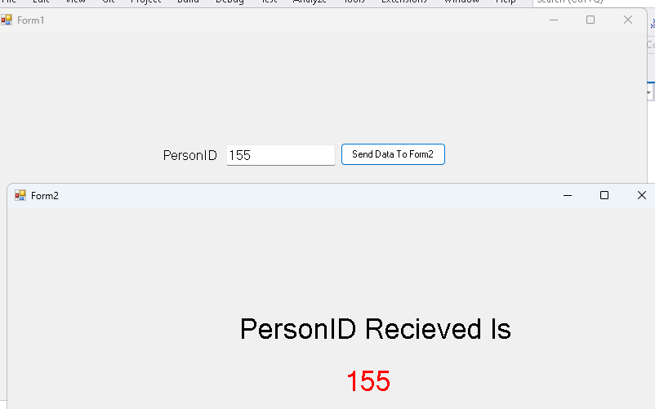

**Send Data Back To Form Using Delegate**

Delegate ومعناها انك بتخلي غيرك يعمل شغلك وفي البرمجه بيقولك ال delegation هيا عباره عن pointer علي method

تعرف الكوبري ؟

اه

طب ايه وظيفته ؟

انه بيكون اختصار بياخد الناس من مكان بيوديهم مكان تاني

بيتعمل امتي؟

لما بيكون فيه صعوبه في التنقل بين المكانين دول

طيب ليه بقولك الكلام ده؟

عشان ده هوا نفس المبدأ بتاع ال delegate

هشرحلك مثال في الاندرويد ستوديو بلغة الجافا وبعدين نيجي نطبق بال c#

في الاندرويد ستوديو كانت ظهرت عندي مشكلة شبيهه بدرس النهارده وهيا اني كان عندي كلاس فيه بيانات معينه وعندي شاشة

فكنت عايز وانا واقف في الكود بتاع الشاشه اكتب كود معين الكود ده بيستخدم داتا موجوده في الكلاس

الداتا دي مش هعرف اوصلها من بره

فكان حل المشكلة دي هوا ال delegation

طب كان ايه الحل برضه؟

الحل كان اني اعمل interface وال interface ده جواه method

ال method كانت بتاخد parameters من نفس أنواع ال parameters اللي هستعملها

طب اشمعنا interface ؟

لان ال interface هيجبرني اني اكتب implementation لل method لما اجي اخد منه object

وده كود ال interface

|  |
| --- |
| **package** com.example.database;  **public interface** on_recycler_view_item_click_listener {  **void** on_item_click(**int** car_id); } |

تاني خطوه واني اجي جوه الكلاس اللي فيه الداتا واخد object من ال interface

واجي في ال constructor بتاع الكلاس ده واحط parameter من نوع ال interface

|  |
| --- |
| **private** on_recycler_view_item_click_listener **listener**;   **public** car_adapter(on_recycler_view_item_click_listener listener) {  **this**.**listener**=listener;} |

كده يبقي أي شخص هييجي يستخدم الكلاس بتاعي لازم يديله object من ال interface وبالتالي مضطر يعمل ال implementation بتاع ال method وساعتها هيظهرله ال parameters اللي في ال method واللي انا أصلا عايز انقلهاله عشان يكتب الكود بتاعه

طب بالنسبه للكلاس؟

بالنسبة للكلاس فاانا خزنت فيه ال object بتاع ال interface وال implementation اصبح جاهز

وكل اللي محتاج اعمله اني اجي استدعي ال method اللي في ال object ده

خد مثال تاني وافهمه بالراحه

|  |  |
| --- | --- |
| ده interface اسمه printer وفيه function | public interface Printer {  public void print(String message);  } |
| وده كلاس بياخد فيه object من ال interface وبيعبيه عن طريق ال constructor  وبعدين بيستدعي ال function عشان ينفذها | public class PrinterDelegator {  private Printer printer;  public PrinterDelegator(Printer printer) {  this.printer = printer;  }  public void print(String message) {  printer.print(message);  }  } |
| هنا بقي في ال main بياخد object من الكلاس اللي اسمه printer delegator فبيطلب منه object من ال interface بال implementation بتاع ال method اللي في ال interface | public class Main {  public static void main(String[] args) {  PrinterDelegator printerDelegator = new PrinterDelegator(new Printer(){  @Override public void print(String message(){  //Write the implementation here  }  });  }  } |

ودي الخطوات اللي بيمشي فيها البرنامج

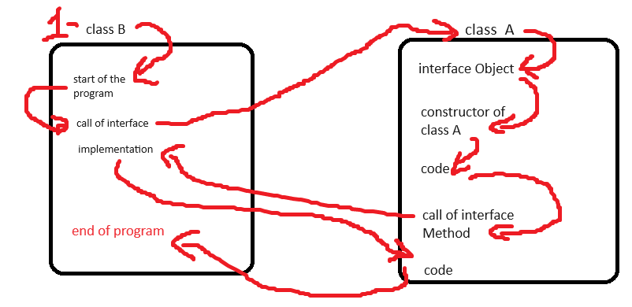

Call of class A

اظن كده فهمنا الشغل بيتم ازاي

الشغل بال c# بيتم بنفس المنطق بس بطريقه مختلفه

ازاي ؟

قالك انك بدل ماتقعد تعمل في interface وتعمل set وget وحوارات عملك حاجه ابسط اسمها delegate

ايه ال delegate دي؟

زي مااحنا عارفين ان ال pointer عباره عن مخزن لل address بتاع المتغير او ال object

قالك بقي ان ال delegate هيا عباره عن pointer عادي جدا بس بيشاور علي method بدل مايشاور علي object

يعني بدل ماتعمل interface لا اعمل pointer يشاور عال method نفسها

وطريقتها انك بتكتب function من غير implementation وتديها ال parameter اللي انت عايزه يتبعت بره الكلاس بس بتبعت معاه object بيكون عباره عن كلمة this واللي معناها انك بتبعت الكلاس اللي انت فيه عشان اللي هيستخدم ال delegate بتاعك يعرف هوا جاي منين

يعني بتعمل function من غير implementation وبتيجي قبل ال return type وبتكتب كلمة delegate

زي كده

|  |
| --- |
| [access modifier] delegate [return type] [delegate name]([parameters]) |

|  |
| --- |
| public delegate void DataBackEventHandler(Object sender,int PersonID); |

بالسطر ده انت كده عرفت pointer بيشاور علي method بس من غير implementation

(اعتبر نفسك عملت interface وال method بتاعته لو هتقارنه بالمثال بتاع الاندرويد اللي شرحتهولك فوق)

طب ليه؟

لأن ال implementation هيتكتب من بره الكلاس اصحي للكلام

بعدين هتاخد object من ال pointer ده

(برضه اعتبر نفسك عرفت object من ال interface في المثال بتاع الاندرويد)

|  |
| --- |
| public DataBackEventHandler DataBack; |

ناقص حاجتين

اول حاجه انك تستدعي ال method في المكان اللي انت عايزه في الكلاس بتاعك وده بيتم عن طريق انك تكتب السطر ده ومكان ال sender بتديلها الكلاس اللي انت فيه وبتبعت المتغير اللي انت عايز تبعته

|  |
| --- |
| DataBack?.Invoke(this,PersonID); |

طب يعني ايه invoke ؟

اصبر علي رزقك

تاني حاجه ال implementation بتاعت ال method في الكلاس التاني

هتعمل function عاديه هتحط فيها الكود اللي عايز تنفذه وال parameters اللي كنت محددها سمي ال method أي اسم المهم ان ال parameters تكون نفس ال parameters اللي حددتها فوق

|  |
| --- |
| private void Form2_DataBack(object sender, int PersonID)  {  textBox1.Text = PersonID.ToString();  } |

بس لما تيجي تشغل الفورم التاني هتكتب السطر ده واللي معناه انك بتستدعي ال object اللي عملته من ال pointer وبتقوله بالله عيك خد ال method دي شغلها معاك اهي تتعلم صنعه تنفعها

|  |
| --- |
| Form2 frm = new Form2();  frm.DataBack += Form2_DataBack;  frm.ShowDialog(); |

طيب لسه ماعرفناش ال invoke دي ايه وظيفتها

هنا بيقولك ان ال delegate دي معموله عشان يتم استدعائها من اكتر من مكان فلما بتكتب السطر ده

|  |
| --- |
| frm.DataBack += Form2_DataBack; |

ال delegate بيضم ال method والاكواد اللي فيها لقايمة ال methods اللي عايزه تتنفذ

شوف الصورة اللي جايه دي انا عملت debug عشان اظهرلك اللي متخزن في ال object هتلاقيه مخزن اسم ال method اللي هينفذها ولو ماكنتش زودت السطر اللي فوق قبل ماافتح الفورم ماكنتش ال method هتنضاف وبالتالي ال delegate مش هيلاقي حاجه ينفذها فياخد اجازه عشان يرتاح

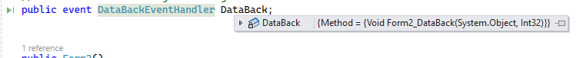

وبالتالي لما بستدعي ال invoke بيروح يدور علي كل ال methods اللي متخزنه في ال object وينفذها

تعالي نعمل تطبيق جديد باتنين فورم

اول فور هنحط فيه زرار و text box

وتاني فورم هنحط فيه label وtextbox وزرار

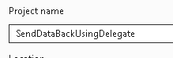

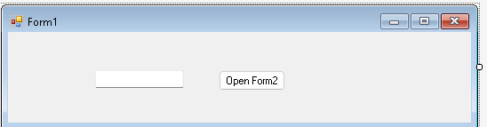

دي خصائص الزرار





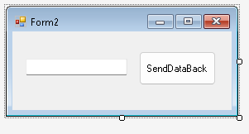

دي الخصائص بتاعت ال text box

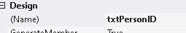

دي الخصائص بتاعت الزرار



وده الكود بتاع form2

|  |
| --- |
| using System;  using System.Collections.Generic;  using System.ComponentModel;  using System.Data;  using System.Drawing;  using System.Linq;  using System.Text;  using System.Threading.Tasks;  using System.Windows.Forms;  namespace SendDataBackUsingDelegate  {  public partial class Form2 : Form  {  public delegate void DataBackEventHandler(Object sender,int PersonID);  public DataBackEventHandler DataBack;  public Form2()  {  InitializeComponent();  }  private void button1_Click(object sender, EventArgs e)  {  int PersonID = int.Parse(txtPersonID.Text) ;  DataBack?.Invoke(this,PersonID);  this.Close();  }  }  } |

وده الكود بتاع form1

|  |
| --- |
| using System;  using System.Collections.Generic;  using System.ComponentModel;  using System.Data;  using System.Drawing;  using System.Linq;  using System.Text;  using System.Threading.Tasks;  using System.Windows.Forms;  namespace SendDataBackUsingDelegate  {  public partial class Form1 : Form  {  public Form1()  {  InitializeComponent();  }  private void btnOpenForm2_Click(object sender, EventArgs e)  {  Form2 frm = new Form2();  frm.DataBack += Form2_DataBack;  frm.ShowDialog();  }  private void Form2_DataBack(object sender, int PersonID)  {  textBox1.Text = PersonID.ToString();  }  }  } |

**User Controls**

انت دلوقتي عارف ال controls اللي في ال windows app زي ال text box وال combo box وغيره

هنا بقي بيقولك انك ممكن تعمل control جديد بيضم controls من اللي موجودين

يعني مثلا تعمل control بيكون فيه خمسه text box واربع ازرار وبياخد بيانات معينه بيعرضها

بيفيدك الموضوع ده لو عندك اكتر من شاشه بتعرض فيها نفس المعلومات بتحطها في control وبتستدعيها في كل الأماكن

زي كده

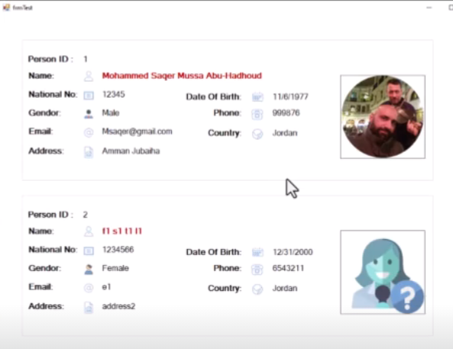

ال controls نوعين :

1. User Control وده بتستخدمه في برنامج واحد
2. Custom control وده بتستخدمه في اكتر من مشروع

تعالي نعمل فورم جديد

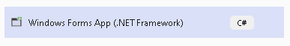

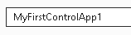

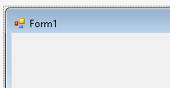

وبعدين هنضيف CONTROL جديد

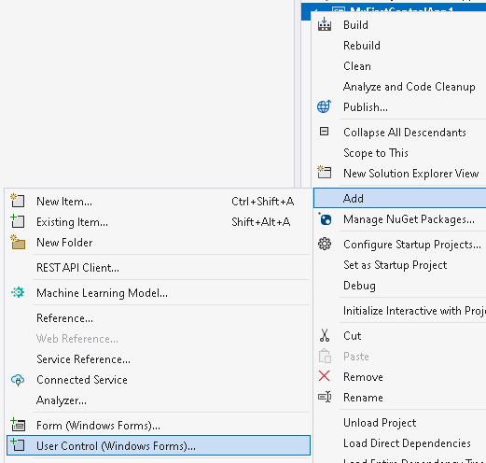

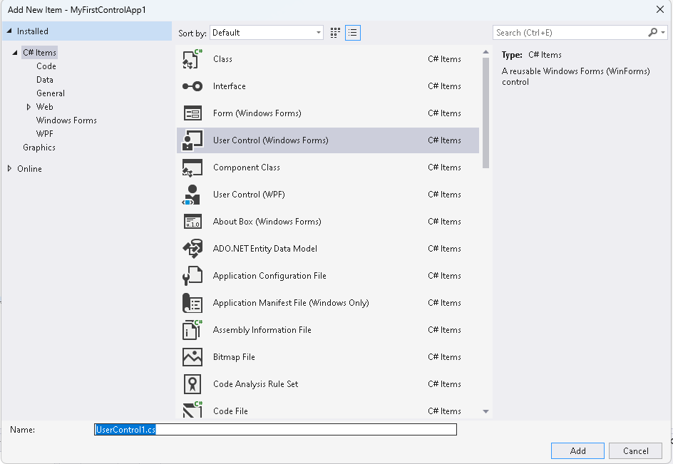

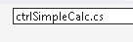



هتلاقيه ضافهولك وهتتعامل معاه كأنه فورم عادي وتضيف فيه controls زي ماانت عاوز

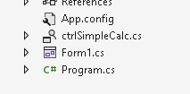

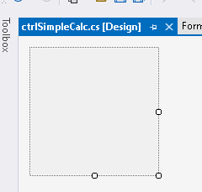

هنخلي حجم الخط 12

وبعدين هنضيف اتنين text box وزرار واتنين label

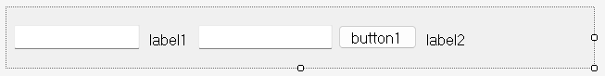

دي اعددات label1



دي اعدادات label2







ودي اعدادات الزرار



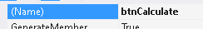



وده الكود بتاع ال CONTROL يدوب عملت EVENTعالزرار

|  |
| --- |
| using System;  using System.Collections.Generic;  using System.ComponentModel;  using System.Data;  using System.Drawing;  using System.Linq;  using System.Text;  using System.Threading.Tasks;  using System.Windows.Forms;  namespace MyFirstControlApp1  {  public partial class ctrlSimpleCalc : UserControl  {  public ctrlSimpleCalc()  {  InitializeComponent();  }  private void btnCalculate_Click(object sender, EventArgs e)  {  lblResult.Text=int.Parse(textBox1.Text)+int.Parse(textBox2.Text).ToString();  }  }  } |

هنروح عالفورم ونعمل build

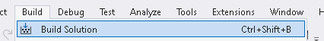

هتلاقيها في ال tool box

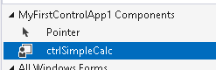

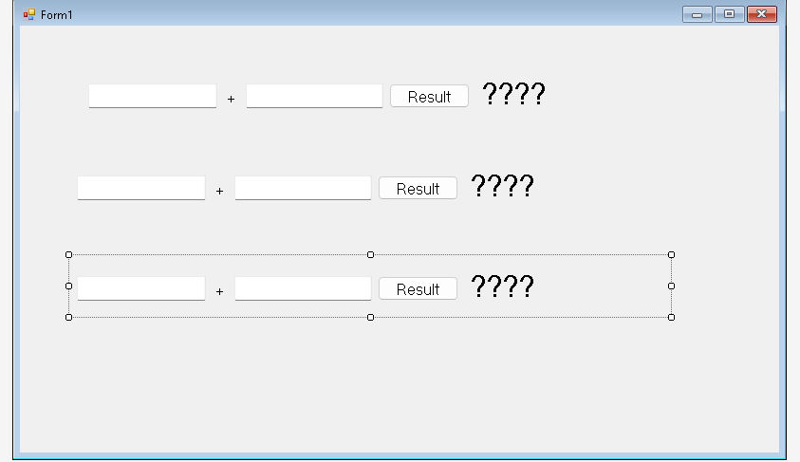

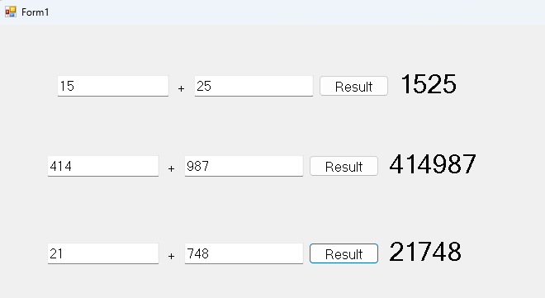

تعالي نعمل زرار يخفي ال control

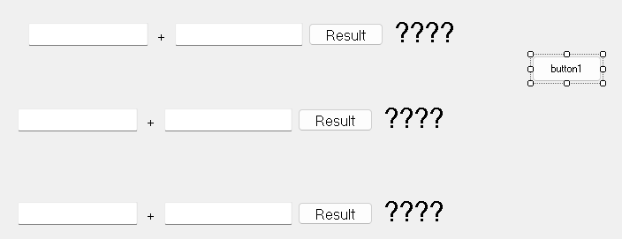

|  |
| --- |
| using System;  using System.Collections.Generic;  using System.ComponentModel;  using System.Data;  using System.Drawing;  using System.Linq;  using System.Text;  using System.Threading.Tasks;  using System.Windows.Forms;  namespace MyFirstControlApp1  {  public partial class Form1 : Form  {  public Form1()  {  InitializeComponent();  }  private void button1_Click(object sender, EventArgs e)  {  ctrlSimpleCalc1.Visible= false;  }  }  } |

**User Controls Expose Property**

هنا بيقولك لو عايز توصل لاي عنصر جوه ال control بتاعك بتستخدم ال get وال set

طيب انا دلوقتي في المشروع بتاع الدرس اللي فات عايز الزرار اللي بيخفي ال control عايزه يظهرلي message box فيها قيمة ال lblResult اللي جوه ال control

فهروح لل control واعمل متغير واعمله get وجوه ال get هجيب القيمه اللي انا عايزها

|  |
| --- |
| using System;  using System.Collections.Generic;  using System.ComponentModel;  using System.Data;  using System.Drawing;  using System.Linq;  using System.Text;  using System.Threading.Tasks;  using System.Windows.Forms;  namespace MyFirstControlApp1  {  public partial class ctrlSimpleCalc : UserControl  {  public ctrlSimpleCalc()  {  InitializeComponent();  }  public float Result { get { return (float)Convert.ToDouble(lblResult.Text); } }  private void btnCalculate_Click(object sender, EventArgs e)  {  lblResult.Text=int.Parse(textBox1.Text)+int.Parse(textBox2.Text).ToString();  }  }  } |

بعدين هروح للفورم واعمل اللي انا عايزه

|  |
| --- |
| using System;  using System.Collections.Generic;  using System.ComponentModel;  using System.Data;  using System.Drawing;  using System.Linq;  using System.Text;  using System.Threading.Tasks;  using System.Windows.Forms;  namespace MyFirstControlApp1  {  public partial class Form1 : Form  {  public Form1()  {  InitializeComponent();  }  private void button1_Click(object sender, EventArgs e)  {  MessageBox.Show(ctrlSimpleCalc1.Result.ToString());  }  }  } |

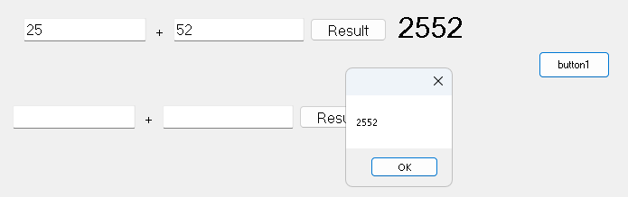

**Simple Event With Parameter**

**How to make a simple event in user control and send parameter with it?**

الدرس اللي فات اتعلمنا فيه ازاي نستقبل داتا من فورم بعد مانفتحه

دلوقتي احنا عاوزين نعمل EVENT زي اللي موجودين في الفورم زي ال on click وال on load

تعالي الأول نعمل تطبيق جديد

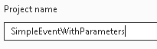

وبعدين هنعمل control جديد

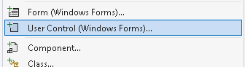

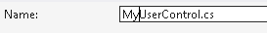

هنضيف اتنين text box و أربعة label وزرار

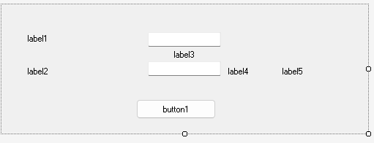

دي خصائص ال control

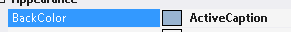



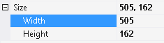

ودي الخصائص بتاعت label 1



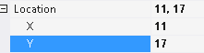



ودي خصائص label2



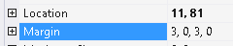

ودي خصائص label3





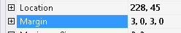

ودي خصائص label 4



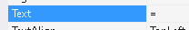

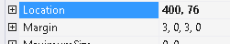

ودي خصائص label5

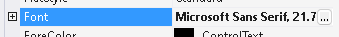



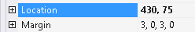

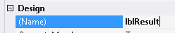

ودي خصائص ال textBox1



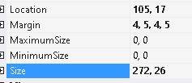

ودي خصائص textbox2



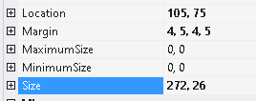

ودي خصائص الزرار

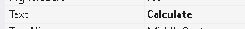



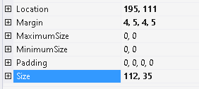

بعدين هنعمل build

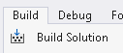

ونروح للفورم نضيف فيه ال control ده

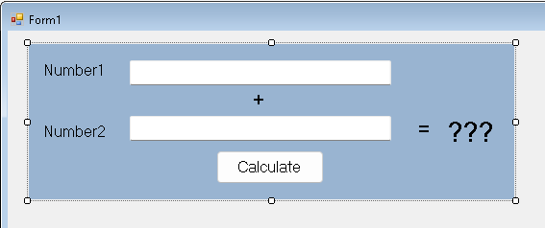

دلوقتي احنا عاوزين نعمل event بحيث انه لما يخلص العملية الحسابيه بتاعته اكتب كود معين زي اني اطلع رساله

بس الكود ده هكتبه في الفورم

يعني عايز ال control اللي عملته يكون ليه event خاص بيه زي ما ال button ليه events كده

الموضوع هنا زيه زي موضوع ال delegate مجرد pointer بيشاور علي method معينه ال method دي ال implementation بتاعها المسؤول عنه هوا اللي هيستخدم ال control مش اللي عمل ال control

اللي هتعرف تعمله في ال event هتعرف تعمله في ال delegate لان الاتنين واحد الفرق بس انهم جابوا ال delegate وقعدول يضيفوا ويعدلوا عليه بحيث ان استخدامه يكون اسهل واأمن وعشان ماحدش ييجي يلعب في ال delegate يبوظها

ال event بتشتغل زي قنوات الراديو لو حابب تسمع قناه معينه بتظبط التردد عليها

فال event هوا عباره عن notification بيتم ارساله لكل الناس اللي مشتركين فيه والكلاس اللي بيبعت ال notification دي اسمه publisher يبعتلهم داتا معينه في وقت معين وكل الناس المشتركين فيه واللي اسمهم subscribers لو حد فيهم عايز يعمل حاجه بيعملها

طيب عشان اعرف event لازم اعرف delegate الأول لانه مبني عليه

في ال c# هما عاملين حاجه اسمها built in delegates ودي عباره عن مجموعه من ال delegates هما عرفوها مسبقا عشان يسهلوا عليك الموضوع

اللي يهمنا منهم واحد اسمه action وبياخد منك data type عشان يحدد ال data type اللي في ال parameters بتاعه

فكل اللي عمله اني هكتب public event action وبعدين هحدد datatype من نفس نوع الداتا اللي عايز انقلها بره للي هيستخدم الcontrol يعني هعرف event من النوع action

وهكتب اسم لل event ده

|  |  |
| --- | --- |
| ده تعريف ال event | public event Action<int> onCalculationComplete; |

من التسهيلات اللي بيسهلها عليك ال event انه بيخليك بدل ماتستدعي ال invoke لا انت بتستدعي اسم ال event نفسه وتديله ال parameter اللي انت عايزها

|  |  |
| --- | --- |
| وهنا بستدعيه واديله القيمه لو مش ب null | if (onCalculationComplete != null) {  onCalculationComplete(Result);  } |

بس كده ده كل الحوار

وده كود ال control

|  |
| --- |
| using System;  using System.Collections.Generic;  using System.ComponentModel;  using System.Data;  using System.Drawing;  using System.Linq;  using System.Text;  using System.Threading.Tasks;  using System.Windows.Forms;  namespace SimpleEventWithParameters  {  public partial class MyUserControl : UserControl  {  public MyUserControl()  {  InitializeComponent();  }  public event Action<int> onCalculationComplete;  private void btnCalculate_Click(object sender, EventArgs e)  {  int Result = Convert.ToInt32(textNumber1.Text)+Convert.ToInt32(textNumber2.Text);  lblResult.Text = Result.ToString();  if (onCalculationComplete != null) {  onCalculationComplete(Result);  }  }  }  } |

وده كود ال form

|  |
| --- |
| using System;  using System.Collections.Generic;  using System.ComponentModel;  using System.Data;  using System.Drawing;  using System.Linq;  using System.Text;  using System.Threading.Tasks;  using System.Windows.Forms;  namespace SimpleEventWithParameters  {  public partial class Form1 : Form  {  public Form1()  {  InitializeComponent();  }  private void myUserControl1_onCalculationComplete(int obj)  {  int Results = obj;  MessageBox.Show("Results =" + obj);  }  }  } |

هنا الأستاذ عمل تعديل بسيط وهوا انه بدل مايستدعي ال event علي طول في ال control لا هوا عمل method استدعاه جواه بحيث انه مايشغلش ال event عمال علي بطال

|  |
| --- |
| using System;  using System.Collections.Generic;  using System.ComponentModel;  using System.Data;  using System.Drawing;  using System.Linq;  using System.Text;  using System.Threading.Tasks;  using System.Windows.Forms;  namespace SimpleEventWithPrameters  {  public partial class MyUserControl : UserControl  {  // Define a custom event handler delegate with parameters  public event Action<int> OnCalculationComplete;  // Create a protected method to raise the event with a parameter  protected virtual void CalculationComplete(int PersonID)  {  Action<int> handler = OnCalculationComplete;  if (handler != null)  {  handler(PersonID); // Raise the event with the parameter  }  }  public MyUserControl()  {  InitializeComponent();  }  private void btnCalculate_Click(object sender, EventArgs e)  {  int Result = Convert.ToInt32 ( txtNumber1.Text) + Convert.ToInt32(txtNumber2.Text);  lblResult.Text = Result.ToString();  if (OnCalculationComplete != null)  // Raise the event with a parameter  CalculationComplete(Result);  }  }  } |

لاحظ انك لو فتحت ال properties بتاعت ال control لما ضيفته للفورم هتلاقي ال event بتاعك

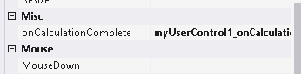

**Simple Event With Parameters Using Arguments**

دلوقتي احنا عاوزين نعمل standard event يعني event زي اللي بنلاقيه في أي control ال method بتاعته بيكون فيها source واللي بيقوك ال event ده جاي منين وال e اللي هيا ال event arguement واللي بيكون فيها شوية متغيرات بتقدر تستخدمها في الكود بتاعك

في نفس المشروع اللي فات انا مش عايز ابعت ال result بس لا انا عايز ابعت الرقم الأول والرقم الثاني والنتيجه وكمان عايز ابعت وأقول ال event ده مين اللي استدعاه او جاي منين

تعالي ناخد الموضوع واحده واحده

احنا دلوقتي عاوزين نبعت اكتر من متغير الحل اننا نجمعم كلهم في كلاس واحد

فهنعمل كلاس عادي جدا جوه الكلاس بتاعنا وهنعمل constructor و get لكل متغير من المتغيرات اللي فيه

الكلاس ده لازم نخليه يورث من كلاس تاني اسمه event args

|  |
| --- |
| public class CalculationCompleteEventArgs : EventArgs {  public int Result { get; }  public int Val1 { get; }  public int Val2 { get; }  public CalculationCompleteEventArgs(int Results,int Val1,int Val2) {  this.Result = Results;  this.Val1 = Val1;  this.Val2 = Val2;  }  } |

بعدين هنعمل event عادي جدا بس ال delegate بتاعه مش هيكون action هيكون

event handler وال event handler هيطلب مننا data type هنديله اسم الكلاس اللي عملناه

|  |
| --- |
| public event EventHandler<CalculationCompleteEventArgs> OnCalculationComplete; |

وبعدين ؟

وبعدين بتكمل الكود بتاعك عادي بس فيه ملاحظه صغيره

وهيا انك هتحتاج تستعدي ال method من خلال ال invoke زي ماكنت بتعمل مع ال delegate العاديه

فااحنا حطينا الخطوه دي في method لوحدها

|  |
| --- |
| protected virtual void RaiseOnCalculationComplete(CalculationCompleteEventArgs e)  {  OnCalculationComplete?.Invoke(this, e);  }  public void RaiseOnCalculationComplete(int Results, int Val1, int Val2) {  RaiseOnCalculationComplete(new CalculationCompleteEventArgs( Results, Val1, Val2));  }  private void btnCalculate_Click(object sender, EventArgs e)  {  int Val1, Val2;  Val1= Convert.ToInt32(textNumber1.Text);  Val2= Convert.ToInt32(textNumber2.Text);  int Result = Val1 + Val2;  lblResult.Text = Result.ToString();  if (OnCalculationComplete!=null) {  RaiseOnCalculationComplete(Result, Val1, Val2);  }  } |

بس بعد كده هنروح للفورم نستدعي ال event زي ماكنا بنعمل مع ال button

|  |
| --- |
| using System.Windows.Forms;  namespace SimpleEventWithParameters  {  public partial class Form1 : Form  {  public Form1()  {  InitializeComponent();  }  private void myUserControl1_OnCalculationComplete(object sender, MyUserControl.CalculationCompleteEventArgs e)  {  MessageBox.Show($"Results={e.Result},val1= {e.Val1},val2= {e.Val2}");  }  }  } |

وده كود ال control كله

|  |
| --- |
| using System;  using System.Windows.Forms;  namespace SimpleEventWithParameters  {  public partial class MyUserControl : UserControl  {  public MyUserControl()  {  InitializeComponent();  }  public class CalculationCompleteEventArgs : EventArgs {  public int Result { get; }  public int Val1 { get; }  public int Val2 { get; }  public CalculationCompleteEventArgs(int Results,int Val1,int Val2) {  this.Result = Results;  this.Val1 = Val1;  this.Val2 = Val2;  }  }  public event EventHandler<CalculationCompleteEventArgs> OnCalculationComplete;  protected virtual void RaiseOnCalculationComplete(CalculationCompleteEventArgs e)  {  OnCalculationComplete?.Invoke(this, e);  }  public void RaiseOnCalculationComplete(int Results, int Val1, int Val2) {  RaiseOnCalculationComplete(new CalculationCompleteEventArgs( Results, Val1, Val2));  }  private void btnCalculate_Click(object sender, EventArgs e)  {  int Val1, Val2;  Val1= Convert.ToInt32(textNumber1.Text);  Val2= Convert.ToInt32(textNumber2.Text);  int Result = Val1 + Val2;  lblResult.Text = Result.ToString();  if (OnCalculationComplete!=null) {  RaiseOnCalculationComplete(Result, Val1, Val2);  }  }  }  } |

**Temperature Change Event Example**

هنعمل تطبيق بسيط عال event بال console application

تعالي نعمل واحد فاضي

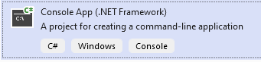

بص كده عالكلاس ده

|  |
| --- |
| public class Thermostat {  private double OldTemperature;  private double CurrentTemperature;  public void SetTemperature(double NewTemperature) {  if (NewTemperature != CurrentTemperature) {  OldTemperature = CurrentTemperature;  CurrentTemperature = NewTemperature;  }    }  } |

احنا هنا عملنا كلاس اسمه thermostat الكلاس ده فيه درجة الحراة القديمه ودرجة الحراره الجديده

وفيه property set بتخليني اقدر اعدل علي درجات الحراره بحيث لما استدعي ال set واديها درجه حراره اخلي ال current degree تتخزن في ال old degree والدرجة اللي انا اديتهاله يخزنها في ال current

ايوه عايز ايه يعني؟

انا دلوقتي عايز لما اغير في درجة الحراره اعرض رسالة عالشاشه تقولي درجة الحرارة قبل التعديل وبعد التعديل والفرق بين الدرجتين

بس عايز الرسالة دي تظهر لو درجة الحرارة فعلا اتغيرت يعني لو كانت ال new لاتساوي ال current بس يعني لو درجة الحرارة الحاليه كانت 10 وانا قولتله يغيرها يخليها 10 مايظهرش الرسالة وعايز اعمل الرسالة دي بره الكلاس بتاع ال thermostat

اقدر اعمل ده بال if statement عادي بس افرض انه في البرنامج بتاعنا فيه اكتر من مكان واكتر من كود بيعتمدوا علي تغير درجة الحرارة هقعد اعمل if statement كل شوية؟

امال اعمل ايه؟

اعمل event امال هما اخترعوها ليه

طب يلا بينا نشوف هنعملها ازاي

اول حاجه احنا عشان نعرض الرسالة بتاعت الدرجه القديمه والجديده احنا عاوزين نوصل للقيم بتاعهم

عشان كده هنعمل كلاس يجمعهم كلهم والكلاس ده هنخليه يورث من event args

|  |
| --- |
| public class TemperatureChangedEventArgs:EventArgs {  public double OldTemperature { get; }  public double NewTemperature { get; }  public double Difference { get; }  public TemperatureChangedEventArgs(double OldTemperature, double NewTemperature) {  this.OldTemperature = OldTemperature;  this.NewTemperature = NewTemperature;  this.Difference = NewTemperature - OldTemperature;  }  } |

كده أي حد هياخد object من الكلاس هيحتاج يدخل درجات الحرارة وهوا هيحسب لوحده الفرق

بعدين هنعرف event في كلاس ال thermostat وال event ده هيشتغل محطة راديو بتبث موجات الاذاعه

|  |
| --- |
| public event EventHandler<TemperatureChangedEventArgs> TemperatureChanged; |

وبعدين هنعمل method وظيفتها انها تشغل ال event من خلال ال invoke ال invoke هتطلب مننا parameter من نوع الكلاس هنقوم نخلي ال method تطلبه ك parameter

|  |
| --- |
| private void OnTemperatureChanged(TemperatureChangedEventArgs e) {  TemperatureChanged?.Invoke( this,e);  } |

احنا عملناها private عشان مش عايزين حد يوصلها بالطريقة دي

امال هنوصلها ازاي ؟

هنعمل method تانيه بتطلب درجات الحراره وتستدعيها زي كده

|  |
| --- |
| protected virtual void OnTemperatureChanged(double OldTemperature, double CurrentTemperature) {  OnTemperatureChanged(new TemperatureChangedEventArgs(OldTemperature,CurrentTemperature));  } |

بعدين هنشغل ال event في ال property set

|  |
| --- |
| public void SetTemperature(double NewTemperature) {  if (NewTemperature != CurrentTemperature) {  OldTemperature = CurrentTemperature;  CurrentTemperature = NewTemperature;  OnTemperatureChanged(OldTemperature, CurrentTemperature);  } |

كده أي حد هييجي يعدل علي درجة الحرارة الحاليه هيشوف هل الدرجه اللي جت مختلفه عن الدرجة الحاليه ولال لا لو مختلفه هيعمل تعديل عالمتغيرات ويعمل بث مباشر

ازاي هيعمل بث مباشر ؟

امال احنا كنا بنشرح فيه أي؟

مااحنا قولنا ان ال pointer هيبدأ يلف علي كل address بيشاور عليه ويشغله

طب ازاي هنخلي ال pointer يشاور علي ال address ؟

ده اللي جاي بقي

دلوقتي احنا عايزين نعمل كلاس كل وظيفته انه يعرض رسالة معينه لما يحصل التغيير في درجة الحرارة

فكل اللي احنا محتاجينه اننا نعمل method خاصه بعرض الرساله وعاوزين نخلي ال pointer اللي في الكلاس بتاع ال thermostat يشاور علي ال method دي

ده كود ال method وخلي بالك انها لازم تاخد نفس ال parameters اللي بياخدها ال event

وحط في بالك انك هنا بتعمل implementation مش بتشغل ال method لان التشغيل جاي منين؟

ايوه التشغيل جاي من كلاس ال thermostat يعني زرار ال power في ال thermostat

|  |
| --- |
| public void HandleTemperatureChange(object sender,TemperatureChangedEventArgs e) {  Console.WriteLine("\n\nTemperature changed:");  Console.WriteLine($"Temperature changed from {e.OldTemperature}°C");  Console.WriteLine($"Temperature changed to {e.NewTemperature}°C");  Console.WriteLine($"Temperature Difference is {e.Difference}°C");  } |

وهنا احنا بنخلي الpointer يشاور علي ال method

|  |
| --- |
| public void Subscribe(Thermostat thermostat) {  thermostat.TemperatureChanged += HandleTemperatureChange;  } |

هنيجي في ال main ناخد object من كلاس ال thermostat وobject من كلاس ال display وبعدين هنستدعي ال subscribe عشان يخلي ال pointer يشاور عال method

وبعدين من كلاس ال thermostat هنقعد نغير في الحراره براحتنا ولو كانت درجات الحراره مختلفه فعلا هيعرض الرسالة

|  |
| --- |
| public class Program  {  static void Main(string[] args)  {  Thermostat thermostat = new Thermostat();  Display display = new Display();  display.Subscribe(thermostat);  thermostat.SetTemperature(5);  thermostat.SetTemperature(10);  thermostat.SetTemperature(10);  thermostat.SetTemperature(10);  thermostat.SetTemperature(50);  Console.ReadLine();  }  } |

وده الكود كله

|  |
| --- |
| using System;  namespace TemperatureChangeEventExample  {  public class TemperatureChangedEventArgs:EventArgs {  public double OldTemperature { get; }  public double NewTemperature { get; }  public double Difference { get; }  public TemperatureChangedEventArgs(double OldTemperature, double NewTemperature) {  this.OldTemperature = OldTemperature;  this.NewTemperature = NewTemperature;  this.Difference = NewTemperature - OldTemperature;  }  }  public class Thermostat {  public event EventHandler<TemperatureChangedEventArgs> TemperatureChanged;  private double OldTemperature;  private double CurrentTemperature;  private void OnTemperatureChanged(TemperatureChangedEventArgs e) {  TemperatureChanged?.Invoke( this,e);  }  protected virtual void OnTemperatureChanged(double OldTemperature, double CurrentTemperature) {  OnTemperatureChanged(new TemperatureChangedEventArgs(OldTemperature,CurrentTemperature));  }  public void SetTemperature(double NewTemperature) {  if (NewTemperature != CurrentTemperature) {  OldTemperature = CurrentTemperature;  CurrentTemperature = NewTemperature;  OnTemperatureChanged(OldTemperature, CurrentTemperature);  }    }  }  public class Display {  public void Subscribe(Thermostat thermostat) {  thermostat.TemperatureChanged += HandleTemperatureChange;  }  public void HandleTemperatureChange(object sender,TemperatureChangedEventArgs e) {  Console.WriteLine("\n\nTemperature changed:");  Console.WriteLine($"Temperature changed from {e.OldTemperature}°C");  Console.WriteLine($"Temperature changed to {e.NewTemperature}°C");  Console.WriteLine($"Temperature Difference is {e.Difference}°C");  }  }  public class Program  {  static void Main(string[] args)  {  Thermostat thermostat = new Thermostat();  Display display = new Display();  display.Subscribe(thermostat);  thermostat.SetTemperature(5);  thermostat.SetTemperature(10);  thermostat.SetTemperature(10);  thermostat.SetTemperature(10);  thermostat.SetTemperature(50);  Console.ReadLine();  }  }  } |

احنا كان ممكن نعمل تعديل بحيث ان ال object بتاع ال thermostat يكون جوه كلاس ال display زي كده بس الطريقه اللي فوق dynamic اكتر هتلاحظ ده في الدرس الجاي وطبعا انت بتحدد الطريقه حسب احتياجك

|  |
| --- |
| public class Display {  public Display() {  thermostat.TemperatureChanged += HandleTemperatureChange;  }  Thermostat thermostat = new Thermostat();  public void SetTemperature(double NewTemperature) {    thermostat.SetTemperature(NewTemperature);  }  public void HandleTemperatureChange(object sender,TemperatureChangedEventArgs e) {  Console.WriteLine("\n\nTemperature changed:");  Console.WriteLine($"Temperature changed from {e.OldTemperature}°C");  Console.WriteLine($"Temperature changed to {e.NewTemperature}°C");  Console.WriteLine($"Temperature Difference is {e.Difference}°C");  }  }  public class Program  {  static void Main(string[] args)  {  Display display = new Display();  display.SetTemperature(5);  display.SetTemperature(10);  display.SetTemperature(10);  display.SetTemperature(10);  display.SetTemperature(50);  Console.ReadLine();  }  } |

بص كده علي مكان السطر ده في الكود اللي فوق

|  |
| --- |
| thermostat.TemperatureChanged += HandleTemperatureChange; |

لو لاحظت هتلاقيني حاطه في ال constructor بتاع الكلاس

طيب ليه ماسيبتهوش في الشارع في الكلاس

عشان قالك انه لازم يتحط في method عشان يضمن ان الكود هيتنفذ ال method دي تكون constructor او تكون setter او تكون method لوحدها كده تكون زي ماتكون المهم انها تتحط في مكان يضمن تنفيذها

طيب ليه ماحطيناهاش مع ال set temperature ؟

لانه في كل مره هستدعي ال set temperature هيتم اضافه الmethod لل pointer وبالتالي هيتم تنفيذ الكود بتاعي اكتر من مره زي كده

شوف التعديل ده

|  |
| --- |
| public class Display {  public Display() {  //thermostat.TemperatureChanged += HandleTemperatureChange;  }  Thermostat thermostat = new Thermostat();  public void SetTemperature(double NewTemperature) {  thermostat.TemperatureChanged += HandleTemperatureChange;  thermostat.SetTemperature(NewTemperature);  }  public void HandleTemperatureChange(object sender,TemperatureChangedEventArgs e) {  Console.WriteLine("\n\nTemperature changed:");  Console.WriteLine($"Temperature changed from {e.OldTemperature}°C");  Console.WriteLine($"Temperature changed to {e.NewTemperature}°C");  Console.WriteLine($"Temperature Difference is {e.Difference}°C");  }  } |

وشوف نتيجته

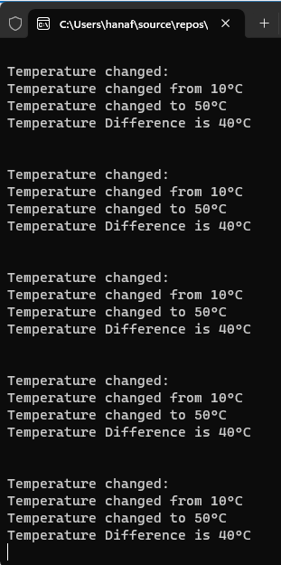

عشان كده حطيناه مع ال constructor بحيث انه يتنفذ مره واحدة اثناء انشاء ال object

الموضوع ده مافكركش بحاجه؟

افكرك انا

في الشرح بتاع الكورس اللي فات انا كنت قولتلك ان الفورم اللي بنعموله مقسوم نصين نص بنكتب فيه الكود بتاعنا والنص التاني خاص بالديزاين وتعريف ال controls والخواص بتاعتها

من ضمن الخواص كان السطر بتاع ال event

اللي لما كنا بنحذف الكود بتاع ال event يطلعلنا الخطأ ده

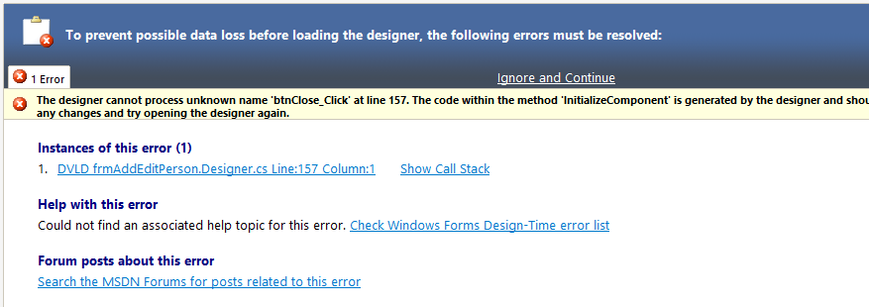

وكنا بندوس علي الخطأ عشان يفتحلنا كود نحذف منه السطر ده

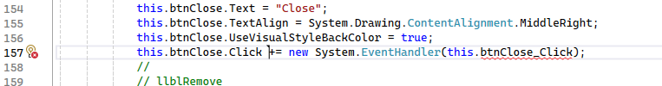

طب فاكر اني قولتلك ان المكان ده هو ال impelemtation بتاع ال method اللي اسمها initialize components اللي هيا دي؟

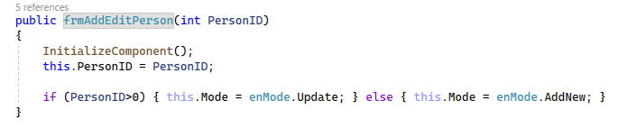

يعني عايز تقول ايه قرفتني؟

عايز اقولك انه ال events بتاعت ال controls بيتم اضافتها في ال constructor بتاع الفورم عشان يسهل عليك الاستخدام وعشان ده المكان اللي هيضمن فيه ان ال events كلها هيتم اضافتها وهيتم اضافتها مره واحده بس

شوف ملف الشرح بتاعي بتاع الكورس اللي فات عشان تفهم اكتر هتلاقيه في درس ال main form

**News Publisher Subscriber Example**

دلوقتي عاوزين نعمل خدمه إخبارية مكونه من publisher و subscriper واي حد حابب يفعل الاشعارات بيفعها واي حد عايز يلغي الاشتراك من ناشر معين يلغيه

اول حاجه هيا اننا نعمل كلاس خاص بالخبر نفسه بس المرادي مش هنخليه يورث من event args عشان عاوزين نبعت الكلاس كله علي بعضه

|  |
| --- |
| public class NewsArticle  {  public string Title { get; }  public string Content { get; }  public NewsArticle(string Title, string Contenet)  {  this.Title = Title;  this.Content = Contenet;  }  } |

بعدين هنعمل كلاس ال publisher عباره عن method و event عادي جدا

|  |
| --- |
| public class NewsPublisher  {  public event EventHandler<NewsArticle> NewNewsPublished;  protected virtual void OnNewsPublished(NewsArticle News)  {  NewNewsPublished?.Invoke(this, News);  }  public void PublishNews(string Title, string Content)  {  NewsArticle article = new NewsArticle(Title, Content);  OnNewsPublished(article);  }  } |

بعدين هنعرف subscriber هنخزن فيه اسم لل subscriber وهنزود method لالغاء الاشتراك مع الناشر

|  |
| --- |
| public class NewsSubscriber  {  public string Name { get; }  public NewsSubscriber(string Name)  {  this.Name = Name;  }  public void Subscribe(NewsPublisher Publisher)  {  Publisher.NewNewsPublished += HandleNewNews;  }  public void Unsubscribe(NewsPublisher Publisher)  {  Publisher.NewNewsPublished -= HandleNewNews;  }  public void HandleNewNews(object sender, NewsArticle article)  {  Console.WriteLine($"{Name} Recieved a new news article:");  Console.WriteLine($"Ttile: {article.Title}");  Console.WriteLine($"Content: {article.Content}");  Console.WriteLine();  }  } |

وفي ال main اقدر اعمل اكتر من ناشر واكتر من مشترك وكل مشترك يقدر يتحكم في الاشعارات اللي بتوصله من كل ناشر

انت بقيممكن تعمل كلاس تاني تسميه archive هيكون هوا هوا كلاس ال subscriber بس الفرق انه بدل مايعرض رساله لا ده ياخدها يخزنها في الداتابيزباسم الناشر والوقت والتاريخ

|  |
| --- |
| using System;  using System.Security.Policy;  namespace TemperatureChangeEventExample  {  public class NewsArticle  {  public string Title { get; }  public string Content { get; }  public NewsArticle(string Title, string Contenet)  {  this.Title = Title;  this.Content = Contenet;  }  }  public class NewsPublisher  {  public event EventHandler<NewsArticle> NewNewsPublished;  protected virtual void OnNewsPublished(NewsArticle News)  {  NewNewsPublished?.Invoke(this, News);  }  public void PublishNews(string Title, string Content)  {  NewsArticle article = new NewsArticle(Title, Content);  OnNewsPublished(article);  }  }  public class NewsSubscriber  {  public string Name { get; }  public NewsSubscriber(string Name)  {  this.Name = Name;  }  public void Subscribe(NewsPublisher Publisher)  {  Publisher.NewNewsPublished += HandleNewNews;  }  public void Unsubscribe(NewsPublisher Publisher)  {  Publisher.NewNewsPublished -= HandleNewNews;  }  public void HandleNewNews(object sender, NewsArticle article)  {  Console.WriteLine($"{Name} Recieved a new news article:");  Console.WriteLine($"Ttile: {article.Title}");  Console.WriteLine($"Content: {article.Content}");  Console.WriteLine();  }  }  public class Program  {  static void Main(string[] args)  {  NewsPublisher publisher = new NewsPublisher();  NewsSubscriber subscriber1 = new NewsSubscriber("Subscriper 1");  subscriber1.Subscribe(publisher);  NewsSubscriber subscriber2 = new NewsSubscriber("Subscriper 2");  subscriber2.Subscribe(publisher);  publisher.PublishNews("Breaking News", "A significant event just happened!");  publisher.PublishNews("Tech Update", "New Gadgets are htting the market.");  subscriber1.Unsubscribe(publisher);  publisher.PublishNews("Weather Forcast", "Expected sunny weather for the weekend.");  subscriber2.Unsubscribe(publisher);  publisher.PublishNews("Final Edition", "Last news update for today.");  Console.ReadLine();  }  }  } |

**New Order Event Example**

دلوقتي احنا عايزين نعمل كلاس لل order ولما العميل يطلب order معين يبعت notification بالايميل وال sms ويبلغ شركة الشحن

الكود مافيهوش حاجه جديه هوا الفكره انك بدل ماتعمل subscriber واحد لا بتعمل اكتر من واحد وبنفس الطريقه

هنا بيقولك انك كان ممكن تعمل ال object بتاع ال order داخل ال subscriber نفسه زي ماشرحتلك فوق بس ممكن تعمل تعديل معين او انك مثلا عندك اكتر من object لنفس الاوردر تلاقي نفسك عشان تعدل عالاوردر انت هتدخل جوه ال subscriber نفسه وتعدل

فالطريقه دي بيقولك انها بتخلي الكود loosely coupled يعني مش معتمد علي بعضه وكل جزء بيكون قائم بذاته

|  |
| --- |
| using System;  using System.Security.Policy;  namespace TemperatureChangeEventExample  {  public class OrderEventArgs : EventArgs {  public int OrderID { get; }  public int OrderTotalPrice { get; }  public string ClientEmail { get; }  public OrderEventArgs(int orderID, int OrderTotalPrice, string clientEmail)  {  this.OrderID = orderID;  this.OrderTotalPrice = OrderTotalPrice;  this.ClientEmail = clientEmail;  }  }  public class Order {  public event EventHandler<OrderEventArgs> OnOrderCreated;  public void Create(int orderID, int OrderTotalPrice, string ClientEmail) {  Console.WriteLine("New order created; now will notify everyone by raising the event.\n");  if(OnOrderCreated!=null){  OnOrderCreated(this,new OrderEventArgs(orderID,OrderTotalPrice,ClientEmail));  }  }  }  public class EmailService {  public void Subscribe(Order order) {  order.OnOrderCreated += HandleNewOrder;  }  public void UnSubscribe(Order order)  {  order.OnOrderCreated -= HandleNewOrder;  }  public void HandleNewOrder(object sender,OrderEventArgs e) {  Console.WriteLine($"----------------Email Service------------------");  Console.WriteLine($"Email Service Object Recieved a new order event");  Console.WriteLine($"Order ID: {e.OrderID}");  Console.WriteLine($"Order Price: {e.OrderTotalPrice}");  Console.WriteLine($"Email: {e.ClientEmail}");  Console.WriteLine($"\nSend an Email");  Console.WriteLine($"-----------------------------------------------");  // write the code to send email  Console.WriteLine();  }  }  public class SMSService {  public void Subscribe(Order order)  {  order.OnOrderCreated += HandleNewOrder;  }  public void UnSubscribe(Order order)  {  order.OnOrderCreated -= HandleNewOrder;  }  public void HandleNewOrder(object sender, OrderEventArgs e)  {  Console.WriteLine($"----------------SMS Service------------------");  Console.WriteLine($"SMS Service Object Recieved a new order event");  Console.WriteLine($"Order ID: {e.OrderID}");  Console.WriteLine($"Order Price: {e.OrderTotalPrice}");  Console.WriteLine($"Email: {e.ClientEmail}");  Console.WriteLine($"\nSend an SMS");  Console.WriteLine($"-----------------------------------------------");  // write the code to send SMS  Console.WriteLine();  }  }  public class ShippingService {  public void Subscribe(Order order)  {  order.OnOrderCreated += HandleNewOrder;  }  public void UnSubscribe(Order order)  {  order.OnOrderCreated -= HandleNewOrder;  }  public void HandleNewOrder(object sender, OrderEventArgs e)  {  Console.WriteLine($"----------------Shipping Service------------------");  Console.WriteLine($"Shipping Service Object Recieved a new order event");  Console.WriteLine($"Order ID: {e.OrderID}");  Console.WriteLine($"Order Price: {e.OrderTotalPrice}");  Console.WriteLine($"Email: {e.ClientEmail}");  Console.WriteLine($"\nSend an Shipping");  Console.WriteLine($"-----------------------------------------------");  // write the code to send Shipping  Console.WriteLine();  }  }  public class Program  {  static void Main(string[] args)  {  Order order = new Order();  EmailService emailService = new EmailService();  SMSService smsService = new SMSService();  ShippingService shipping Service = new ShippingService();  emailService.Subscribe(order);  smsService.Subscribe(order);  shippingService.Subscribe(order);  order.Create(10,540,"Ahmed@gmail.com");  order.Create(10,540,"Ali@gmail.com");  Console.ReadLine();  }  }  } |

الشغله دي اسمها publisher subscriber design pattern



**Delegation Concept**

الفكره فيه انك بتفصل المهام عن بعض وبيزيل التعقيد في الكود

**Logger Example**

ال log معناها انك عايز تسجل معلومه معينه تسجلها عالشاشه او علي ملف او في أي مكان

مثال عليها هوا ال error اللي بيطلع ممكن تظهره باي طريقه او تخزنه

فاكر لما كنا بنعمل enum وكنا بعد كده بنعمل عليها switch هنا بقي انت مش هتعمل switch كل اللي هتعمله انك هتبعت ال address بتاع ال function اللي عايز تنفذها

تعالي كده واحده واحده ومن البدايه خالص

احنا اتكلمنا عن ال event وعرفنا انه أصلا مبني عال delegete

ايه هوا ال delegate ؟

هوا pointer بس بدل مايشاور علي object او متغير لا هيشاور علي method

بيشتغل ازاي؟

بيشتغل كوبري انك دلوقتي موجود في كلاس اسمه محمد وعايز تنفذ كود معين الكود ده بيعتمد علي داتا معينه وفي وقت معين

الداتا دي موجوده في كلاس اسمه احمد والوقت المعين ده بيكون في مرحله معينه من تشغيل الكلاس اللي اسمه احمد برضه

فبنيجي لاحمد ونعرف فيه delegate (ال pointer اللي هيشاور عال method)

ولما تيجي اللحظه المناسبه بنقول لاحمد شغلي ال method اللي ال delegate بتاعك بيشاور عليه

أيا كان بقي هوا مين او موجود فين اهم حاجه ان ال parameters وال return type بتوع ال delegate يكونوا نفسهم بتوع ال method

طيب ازاي بنعرف ال delegate

كأنك بتعرف method بالظبط بس بتزود كلمة delegate

طيب ازاي بشغل الmethods اللي بيشاور عليها؟

لو هنشاور علي method واحده بس

بناخد object من ال delegate وبنخزن فيه ال method

تعالي ناخد مثال

هنعمل logger

هنعمل كلاس عادي كل وظيفته انه بيعرف delegate وبيشغله

ادي الكلاس

|  |
| --- |
| public class Logger {} |

وبعدين هنعرف delegate ونسميه logAction وهنخليه ياخد رساله

الرساله دي احنا ملناش دعوه فيها ايه ولا عايزين نعمل بيها ايه

دي بس وظيفتها انها بتحددلنا ال parameters بتاعت ال method اللي هنشاور عليها وفيما بعد لما تشغل ال method هتطلب مننا داتا عشان تمررها لل method

|  |
| --- |
| public delegate void LogAction(string Message); |

وبعدين هناخد object من ال delegate اللي عملناه ده

|  |
| --- |
| private LogAction _logAction; |

طيب هنيجي في ال constructor بتاع الكلاس ونطلب فيه object من نفس نوع ال delegate اللي عملناه ونخزنه في ال object اللي عندنا

|  |
| --- |
| public Logger(LogAction action) {  this._logAction = action;  } |

بعد كده هنشغل ال logger هيطلب مننا الداتا هنقوله ياخدها من الشخص اللي هيستخدم ال logger بعدين

|  |
| --- |
| public void Log(string message) {  this._logAction(message); } |

طيب تعالي بقي نعمل method ونشغلها

هنعمل اتنين واحده بتطبع عالشاشه والتانيه بتكتب في ملف text (methods عاديه جدا بس بتاخد نفس ال parameters )

|  |
| --- |
| public static void LogToScreen(string Message) {  Console.WriteLine(Message);  }  public static void LogToFile(string Message) {  string FileName = "log.txt";  using (StreamWriter writer = new StreamWriter(FileName, true)) {  writer.WriteLine(Message);  }  } |

نيجي في ال main

هناخد فيه object من ال logger فال constructor يطلب مننا action هنيدله اسم ال method

|  |
| --- |
| static void Main(string[] args)  {  Logger ScreenLogger = new Logger(LogToScreen);  Logger FileLogger = new Logger(LogToFile); |

هل كده اشتغل؟

لا انت كده يدوب خليته يشاور عال method

طب عايزين نشغلها

خد شغلها براحتك

|  |
| --- |
| ScreenLogger.Log("The message will be displayed on the screen.");  FileLogger.Log("The message will be logged to a File."); |

طبعا انت ممكن تعمل method جوه ال logger عان تقدر تغير ال method اللي عاوز تشاور عليها

زي كده

|  |
| --- |
| public void ChangeMethod(LogAction action)  {  this._logAction = action;  } |

|  |
| --- |
| FileLogger.ChangeMethod(LogToScreen);  FileLogger.Log("The message will be displayed on the screen."); |

بس كده وده الكود كله

|  |
| --- |
| using System;  using System.IO;  namespace TemperatureChangeEventExample  {  public class Logger {  public delegate void LogAction(string Message);  private LogAction _logAction;  public Logger(LogAction action) {  this._logAction = action;  }  public void ChangeMethod(LogAction action)  {  this._logAction = action;  }  public void Log(string message) { this._logAction(message); }  }  public class Program  {  public static void LogToScreen(string Message) {  Console.WriteLine(Message);  }  public static void LogToFile(string Message) {  string FileName = "log.txt";  using (StreamWriter writer = new StreamWriter(FileName, true)) {  writer.WriteLine(Message);  }  }  static void Main(string[] args)  {  Logger ScreenLogger = new Logger(LogToScreen);  Logger FileLogger = new Logger(LogToFile);  ScreenLogger.Log("The message will be displayed on the screen.");  FileLogger.Log("The message will be logged to a File.");  FileLogger.ChangeMethod(LogToScreen);  FileLogger.Log("The message will be displayed on the screen.");  Console.ReadLine();  }  }  } |

**What is Multicast Delegate?**

هناخد الكود اللي فات عشان هنعمل عليه تعديل بسيط تقدر من خلاله تخلي ال pointer او ال delegate الواحد يشاور علي اكتر من method

ده التعديل في ال logger هشيل ال constructor وهعدل عال method اللي بتغير ال method اللي بنشاور عليها وهنخليها تضيف بدل ماتغير

|  |
| --- |
| public class Logger {  public delegate void LogAction(string Message);  private LogAction _logAction;  public void AddMethod(LogAction action)  {  this._logAction += action;  }  public void Log(string message) { this._logAction(message); }  } |

وهاجي في ال main هاخد object من الكلاس logger وهضيف علي نفس ال object اتنين methods

بحيث انك تشغل كل ال method باستدعاء ال logger.log مرة واحده

|  |
| --- |
| static void Main(string[] args)  {  Logger Logger = new Logger();  Logger.AddMethod(LogToScreen);  Logger.AddMethod(LogToFile);  Logger.Log("The message will be displayed on the screen.{115}");  Console.ReadLine();  } |

You already know it :-) , many methods can subscribe to a delegate, and when delegate is called it will call all subscribers, this is called **multicast delegate**.

### **Multicast Delegate:**

In C#, a multicast delegate is a special type of delegate that can **reference multiple methods** **and invoke them in a single call**.

Delegates are used to encapsulate and reference methods, and a multicast delegate extends this concept by allowing you to combine multiple method references into a single delegate object.

You can create a multicast delegate by using the += and -= operators to add or remove method references to the delegate. When you invoke a multicast delegate, it will call all the referenced methods in the order they were added.

Here's a simple example:

using System;

public delegate void MyDelegate(string message);

class Program

{

    static void Main()

    {

        MyDelegate myDelegate = Method1;

        myDelegate += Method2;

        myDelegate("Hello, world!");

        myDelegate -= Method1;

        myDelegate("Another message.");

    }

    static void Method1(string message)

    {

        Console.WriteLine("Method1: " + message);

    }

    static void Method2(string message)

    {

        Console.WriteLine("Method2: " + message);

    }

}

In this example, the MyDelegate delegate is a multicast delegate that references both Method1 and Method2. When you invoke the delegate with myDelegate("Hello, world!");, both Method1 and Method2 are called, and their output is displayed.

You can also use multicast delegates for scenarios like event handling, where multiple event handlers need to be called when an event is raised. Multicast delegates are commonly used in C# for implementing the observer pattern and event-driven programming.

**Func Delegate**

ال func ممكن ماتستخدمهاش عادي بس زيادة معرفة وهيا عباره عن انها بتخليك تعرف delegate بيرجع داتا مش بيرجع void زي ماكنا بنعمل

ده كود بسيط لل delegate الجديد فيه اني بدل كلمة void حطيت int عشان اعرفه اني أي function هيشاور عليها هترجع int

|  |
| --- |
| using System;  using System.IO;  namespace TemperatureChangeEventExample  {  public class Program  {  delegate int SquareDelegate(int x);  static int SquareMethod(int x) {  return x * x;  }  static void Main(string[] args)  {  SquareDelegate square = new SquareDelegate(SquareMethod);  int result = square(5);  Console.WriteLine("The Square of 5 is: "+result);  Console.ReadLine();  }  }  } |

هنا بقي قالك بدل ماتكتب السطر ده لا عملك اختصار وهوا ببساطه انك بتكتب func وبتكتب بعديه اكتر من data type بتقدر تضيف لحد 16 data type واخر واحد فيهم لازم يعبر عن ال data type اللي ال method هترجعها

شوف الفرق في الكود اللي جاي

|  |
| --- |
| using System;  using System.IO;  namespace TemperatureChangeEventExample  {  public class Program  {  // delegate int SquareDelegate(int x);  static Func<int,int> square = SquareMethod;  static int SquareMethod(int x) {  return x * x;  }  static void Main(string[] args)  {  // SquareDelegate square = new SquareDelegate(SquareMethod);  int result = square(5);  Console.WriteLine("The Square of 5 is: "+result);  Console.ReadLine();  }  }  } |

### **What is Func Delegates?**

In simple words: it's a shortcut for normal delegate..

The Func delegate is a predefined delegate type in C# that represents a method that takes zero or more input parameters and returns a value. It's part of the System namespace and is often used to define and pass around functions or methods that return a value.

The Func delegate is defined in various forms, depending on the number of input parameters and the return value:

- Func<TResult>: Represents a method that takes no parameters and returns a result of type TResult.

- Func<T, TResult>: Represents a method that takes one parameter of type T and returns a result of type TResult.

- Func<T1, T2, TResult>: Represents a method that takes two parameters of types T1 and T2 and returns a result of type TResult.

- So on, Func<T1, T2, ..., Tn, TResult> for methods with n parameters.

Here are a few examples of how to use the Func delegate:

1. Func<int, int>: Represents a method that takes an int as input and returns an int.

2. Func<string, int, bool>: Represents a method that takes a string and an int as input and returns a bool.

3. Func<double, double, double, double>: Represents a method that takes three double parameters and returns a double.

**Action Delegate**

زي ماقولنا قبل كده ال action هوا delegate جاهز محتاج منك بس تدخل ال data types بتاعت ال parameters

وممكن تضيف لحد 16 parameter

ال action هوا delegate بيرجع void يبقي لازم ال methods اللي بيشاور عليها ترجع void

|  |
| --- |
| using System;  using System.IO;  namespace TemperatureChangeEventExample  {  public class Program  {  static void Main(string[] args)  {  Action ParameterLessAction = ParamameterLessMethod;  Action<int> ActionWith_int_Parameter = MethodWith_int_Parameter;  Action<string ,int> ActionWithMultipleParameters = MethodWithMultipleParameters;  ParameterLessAction();  ActionWith_int_Parameter(42);  ActionWithMultipleParameters("Hi",100);  Console.ReadLine();  }  static void ParamameterLessMethod() {  Console.WriteLine("ParameterLessAction");  }  static void MethodWith_int_Parameter(int num)  {  Console.WriteLine($"ParamameterLessMethod {num}");  }  static void MethodWithMultipleParameters(string z, int x)  {  Console.WriteLine($"{z} {x}");  }  }  } |

### **Action Delegate:**

In simple words: it's a shortcut for normal delegate like the Func Delegate but without returning value.

In C#, a delegate is a type that represents a reference to a method, allowing you to treat methods as first-class objects. Delegates are often used for implementing callback functions, event handling, and other scenarios where you want to pass a method as a parameter to another method.

An Action delegate is a predefined delegate type in C# that represents a method that takes zero or more parameters and does not return a value (i.e., it has a void return type). It is part of the System namespace. Actions are typically used when you need to perform some action or operation without needing to return a value.

**Predicate Delegate**

ال predicate delegate هوا delegate عادي بياخد parameter واحد بس وبيرجع bool

|  |
| --- |
| using System;  using System.IO;  namespace TemperatureChangeEventExample  {  public class Program  {  static Predicate<int> isEvenPredicate = isEven;  static bool isEven(int x) {  return x % 2 == 0;  }  static void Main(string[] args)  {  bool result = isEvenPredicate(5);  Console.WriteLine(result);    Console.ReadLine();  }    }  } |

In simple words: it's a shortcut for a delegate function that takes one parameter and return boolean.

In C#, a predicate is a delegate that represents a method that takes one or more parameters and returns a Boolean value. Specifically, the Predicate<T> delegate is a built-in generic delegate in the System namespace, and it's commonly used for defining conditions or filters.

The Predicate<T> delegate is defined as follows:

public delegate bool Predicate<in T>(T obj);

Here, T is the type of the parameter that the method takes, and the delegate returns a Boolean value.

**Lambda Expression**

ال methods اللي كنا بنعملها اسمها name functions فيه نوع تانيه اسمه

lambda expression وده يعتبر اختصار مش اكتر لكن مش هيأثر عالسرعه

ومعموله عشان يخلوا ال oop تدعم ال functional programming وهيا عادة بتستخدم مع ال delegates

بص ال method بتاعت ال square في الكود اللي جاي ده

|  |
| --- |
| using System;  using System.IO;  namespace TemperatureChangeEventExample  {  public class Program  {  // delegate int SquareDelegate(int x);  static Func<int, int> square = SquareMethod;  static int SquareMethod(int x)  {  return x * x;  }  static void Main(string[] args)  {  // SquareDelegate square = new SquareDelegate(SquareMethod);  int result = square(5);  Console.WriteLine("The Square of 5 is: " + result);  Console.ReadLine();  }  }  } |

تقدر تستغني عن الجزء ده

|  |
| --- |
| static int SquareMethod(int x)  {  return x * x;  } |

بالجزء ده

|  |
| --- |
| static Func<int, int> square = x=>x*x; |

الجزء ده x=>x*x اسمه lambda expression وعلامة ال lambda هيا العلامه دي =>

وال lambda expression بيسموها anonymous function يعني لو عايز تعمل حاجه عالسريع وال scope بتاعها محدود استخدمها بدل ماتكتب في سطور كتير عشان تعمل حاجه بسيطه

ال lambda بتتكتب ازاي؟

اول حاجه هتسأل نفسك هل ال method اللي عايزتعملها دي بتاخد parameters ؟

لو بتاخد بتحطهم بين قوسين ولو مش بتاخد بتحط القوسين فاضيين

|  |
| --- |
| (input-parameters) |

بعدين بتحط علامة يساوي وبعدها اكبر من

|  |
| --- |
| => |

تالت حاجه هيا ال implementation بتاع ال function هل هوا مجرد expression يعني مثلا عباره عن عملية جمع او طرح او مقاره او الحاجات دي؟

لو اه بتكتبها علي طول

فيصبح عندك ال expression بالشكل ده

|  |
| --- |
| (input-parameters) => expression |

طيب لو كان ال implementation عباره عن سطر كود معين خفيف لطيف ؟

هتحطه بين قوسين فيصبح ال expression بالمنظر ده

|  |
| --- |
| (input-parameters) => { Your Code } |

شوف المثال اللي جاي ده

|  |
| --- |
| using System;  using System.IO;  namespace TemperatureChangeEventExample  {  public class Program  {  // delegate int SquareDelegate(int x);  static Func<int, int> square = x=>x*x;  static void Main(string[] args)  {  // SquareDelegate square = new SquareDelegate(SquareMethod);  int result = square(5);  Console.WriteLine("The Square of 5 is: " + result);  Console.ReadLine();  }  }  } |

ده الكود اللي كنا عاملينه بتاع ال action delegate

|  |
| --- |
| using System;  using System.IO;  namespace TemperatureChangeEventExample  {  public class Program  {  static void Main(string[] args)  {  Action ParameterLessAction = ParamameterLessMethod;  Action<int> ActionWith_int_Parameter = MethodWith_int_Parameter;  Action<string, int> ActionWithMultipleParameters = MethodWithMultipleParameters;  ParameterLessAction();  ActionWith_int_Parameter(42);  ActionWithMultipleParameters("Hi", 100);  Console.ReadLine();  }  static void ParamameterLessMethod()  {  Console.WriteLine("ParameterLessAction");  }  static void MethodWith_int_Parameter(int num)  {  Console.WriteLine($"ParamameterLessMethod {num}");  }  static void MethodWithMultipleParameters(string z, int x)  {  Console.WriteLine($"{z} {x}");  }  }  } |

لو عملناه بال lambda هيكون كده

|  |
| --- |
| using System;  using System.IO;  namespace TemperatureChangeEventExample  {  public class Program  {  static void Main(string[] args)  {  Action ParameterLessAction = ()=> {  Console.WriteLine("ParameterLessAction"); };  Action<int> ActionWith_int_Parameter = (num) => {  Console.WriteLine($"ParamameterLessMethod {num}"); };  Action<string, int> ActionWithMultipleParameters = (z,x) => {  Console.WriteLine($"{z} {x}");  };  ParameterLessAction();  ActionWith_int_Parameter(42);  ActionWithMultipleParameters("Hi", 100);  Console.ReadLine();  }  }  } |

بص الكود ده

|  |
| --- |
| using System;  using System.IO;  namespace TemperatureChangeEventExample  {  public class Program  {  delegate int Operation(int x,int y);  static void ExcuteOperation(int x, int y,Operation operation) {  int Result = operation(x , y);  Console.WriteLine("Result: "+Result);  }  static int Add(int x, int y) { return x + y; }  static int Sub(int x, int y) { return x - y; }  static void Main(string[] args)  {  Operation AddOp = Add;  Operation SubOp = Sub;  ExcuteOperation(5,10,AddOp);  ExcuteOperation(5,10,SubOp);  Console.ReadLine();  }  }  } |

ممكن نعمله كده

|  |
| --- |
| using System;  using System.IO;  namespace TemperatureChangeEventExample  {  public class Program  {  delegate int Operation(int x,int y);  static void ExcuteOperation(int x, int y,Operation operation) {  int Result = operation(x , y);  Console.WriteLine("Result: "+Result);  }  static void Main(string[] args)  {  Operation AddOp = (x,y)=>x+y;  Operation SubOp = (x, y) =>x-y;  ExcuteOperation(5,10,AddOp);  ExcuteOperation(5,10,SubOp);  Console.ReadLine();  }  }  } |

وممكن نخلي ال excute operation تاخد func ك parameter بحيث انك تكتب كل function لوحدها

|  |
| --- |
| using System;  using System.IO;  namespace TemperatureChangeEventExample  {  public class Program  {  static void ExcuteOperation(int x, int y,Func<int,int,int>Operation) {  int Result = Operation(x , y);  Console.WriteLine("Result: "+Result);  }  static void Main(string[] args)  {  Func<int,int,int> Add = (x,y)=>x+y;  Func<int, int, int> Sub = (x, y) =>x-y;  ExcuteOperation(5,10,Add);  ExcuteOperation(5,10,Sub);  Console.ReadLine();  }  }  } |

Lambda expressions are often preferred over normal (named) functions in specific scenarios because they offer some advantages, such as **conciseness, inline definition, and the ability to create anonymous functions.** Here are a few reasons why you might choose to use lambda expressions over normal functions:

1. **Conciseness:**Lambda expressions are typically more concise than defining a separate function, especially for small, simple operations. This leads to more readable and less verbose code.
2. **Anonymous Functions:** Lambda expressions allow you to create anonymous functions on the fly without needing to declare a separate named function. This is particularly useful when you need a function for a one-time or specific purpose.
3. **Inline Definitions:** Lambda expressions can be defined inline within a statement or method call, making it easy to pass functions as arguments to methods or use them in LINQ queries without defining separate functions.
4. **Readability:** In some cases, a lambda expression's compact and in-place definition can improve code readability, as it keeps the code closer to the point where the function is used.
5. **Functional Programming:** Lambda expressions align with functional programming principles, which can lead to more expressive and declarative code in certain contexts, such as LINQ queries and event handling.
6. **Flexibility:** Lambda expressions can capture variables from their surrounding scope (known as closures), allowing you to create more flexible and context-aware functions.

While lambda expressions offer these advantages, it's important to note that there are cases where defining a separate named function is more appropriate. You would typically use named functions when you need to reuse the same logic in multiple places, promote code organization, or when the function is more complex and requires detailed documentation.

In summary, lambda expressions are a valuable tool in C# for creating concise, **inline, and anonymous functions**, which can improve code readability and maintainability in specific scenarios, such as LINQ queries, event handlers, and small, one-off operations.

**Named Functions vs. Lambda Expressions when to use and which is faster?**

### **Named Functions vs. Lambda Expressions**

#### Let's talk about when to use named functions and when to use lambda expressions, and also touch on the performance aspect.

#### ****Named Functions:****

1.Readability and Reusability:

* Use named functions when the logic is complex or when the operation needs to be reused in multiple places. Named functions can enhance code readability and maintainability.

int Square(int num)

{

    return num * num;

}

// Usage

int result = Square(5);

Console.WriteLine("Square of number: " + result);

2 .Clear Intent:

* If the function's purpose is clear from its name, using a named function is often a good choice. It makes your code self-documenting.

#### Lambda Expressions:

* Conciseness:
  + Use lambda expressions for short, simple operations, especially when the logic is straightforward and doesn't need a separate named function. They shine in scenarios where brevity is essential.

// Lambda expression for squaring a number

Func<int, int> square = (int num) => num * num;

// Usage

int result = square(5);

Console.WriteLine("Square of number: " + result);

* Inline Usage: If the function is used inline, for example, in LINQ queries or event handling, lambda expressions can be more convenient.

// Using lambda in LINQ

var evenNumbers = numbers.Where(n => n % 2 == 0);

// Using lambda in event handling

button.Click += (sender, e) => Console.WriteLine("Button clicked!");

### **Performance Considerations:**

In terms of performance, the difference between named functions and lambda expressions is usually negligible. Both can be optimized by the compiler. The choice between them should primarily be based on readability, maintainability, and code organization.

In terms of performance, the difference between using a lambda expression and a declared function (method) is usually negligible. Both approaches can be optimized by the compiler, and the generated IL (Intermediate Language) code may end up being quite similar.

The choice between a lambda expression and a declared function often depends on factors like readability, code organization, and whether the function is used in a single location or needs to be reused in multiple places.

In simple cases, using a lambda expression with the Func<int, int> type is concise and suitable for a simple operation like squaring a number. If your logic becomes more complex or you need to reuse the operation in multiple places, declaring a separate method might make your code more modular and maintainable.

Ultimately, for performance considerations, the difference between these two approaches is likely to be minimal. Choose the one that fits best with your coding style and the overall structure of your program.

### **Conclusion:**

* Named functions: Ideal for complex logic, reuse, and when code readability is crucial.
* Lambda expressions: Great for concise, one-off operations, and when brevity is a priority.

Remember, the performance difference is often minimal, and your choice should be driven by the specific needs of your code and the principles of clean and maintainable coding.

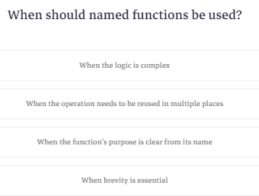

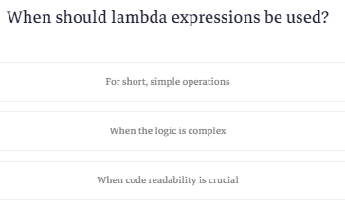

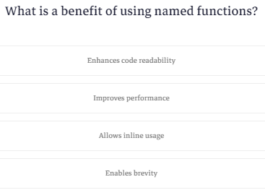

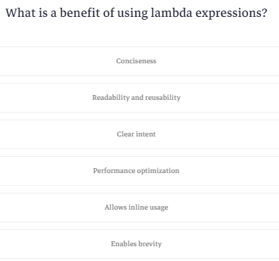

**C# using - To Import Library**

كلمة using ليها اربع استخدامات اول حاجه وهيا اننا نعمل import للمكتبات

# **C# using - To Import Library**

In C#, we use the using keyword to import external resources (namespaces, classes, etc) inside a program. For example,

// using System namespace

using System;

namespace Program {

class Program1 {

static void Main(string[] args) {

Console.WriteLine("Hello World!");

}

}

}

**Output**

Hello World!

In the above example, notice the line

using System;

Here, we are importing the System namespace inside our program. This helps us to directly use the classes present in the System namespace.

Also, because of this, we don't have to write the fully qualified name of the print statement.

// full print statement

System.Console.WriteLine("Hello World!");

// print statement with using System;

Console.WriteLine("Hello World!");

**C# using to create an alias**

تاني استخدام لكلمة using هوا لما يكون عندك كود طويل ممكن تعمله اختصار بكلمة using

يعني بدل ماكنت بتكتب مثلا a.b.c.getname لا انت ممكن تكتب في الكلاس من فوق a.b بحيث انك تيجي في الكود تكتب c.getname علي طول

زي في ال c++ لما كنا بنستخدم ال using عشان مانفضلش كل شوية نكتب std

في المثال اللي جاي بدل مانفضل كل شوية نكتب system.Console.Writeline لا احنا حطيناهم في كلمة كوكو وبقينا نستخدم كلمة كوكو لدلاله علي system.console

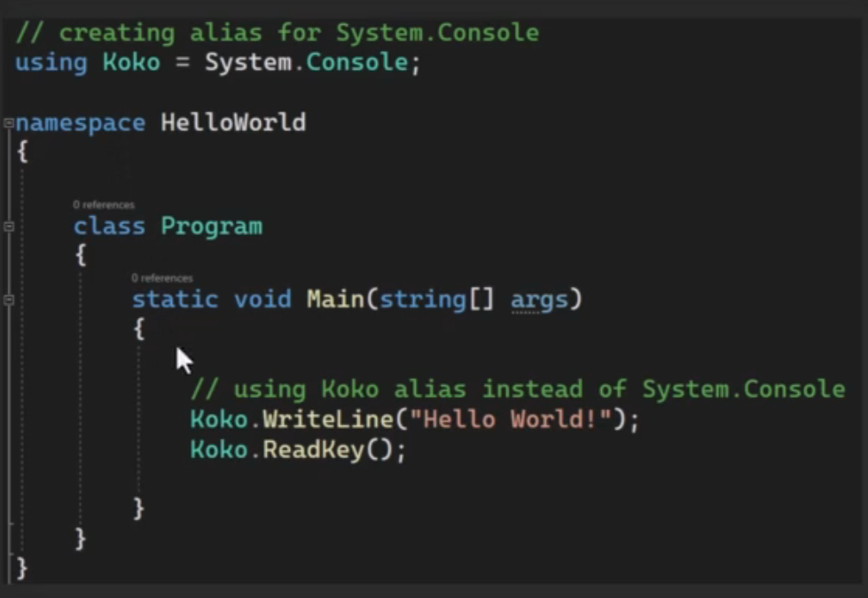

## C# using to create an alias

We can also create aliases with the help of using in C#. For example,

// creating alias for System.Console

using Koko = System.Console;

namespace HelloWorld {

class Program {

static void Main(string[] args) {

// using Koko alias instead of System.Console

Koko.WriteLine("Hello World!");

Koko.ReadKey();

}

}

}

**Output**

Hello World!

In the above program, we have created an alias for System.Console.

using Koko = System.Console;

This allows us to use the alias Koko instead of System.Console.

Koko.WriteLine("Hello World!");

Here, Koko will work just like System.Console.

**C# using static directive**

لما كنا بنكتب كلمة using وبعدها اسم namespace معين بنقدر بعد كده نستخدم أي عنصر جوه الnamespace بدون مانذكر اسمه

طيب انا هستخدمه عشان اشاور علي عناصر معينه جوه كلاس معين جوه ال namespace والعناصر دي من النوع static بس

خلاص اكتب كلمة static بعد كلمة using

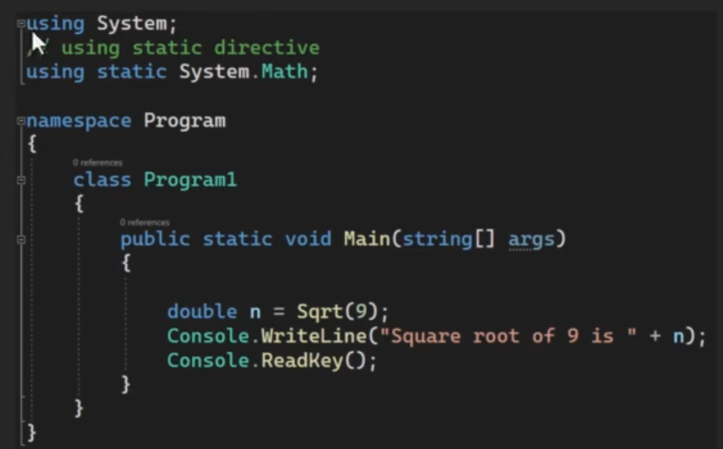

## C# using static directive

In C#, we can also import classes in our program. Once we import these classes, we can use the static members (fields, methods) of the class.

We use the using static directive to import classes in our program.

### **Example: C# using static with System.Math**

using System;

// using static directive

using static System.Math;

namespace Program {

class Program1 {

public static void Main(string[] args) {

double n = Sqrt(9);

Console.WriteLine("Square root of 9 is " + n);

}

}

}

**Output**

Square root of 9 is 3

In the above example, notice the line,

using static System.Math;

Here, this line helps us to directly access the methods of the Math class.

double n = Sqrt(9);

We have used the Sqrt() method directly without specifying the Math class.

If we don't use the using static System.Math in our program, we have to include the class name Math while using Sqrt(). For example,

using System;

namespace Program {

class Program1 {

public static void Main(string[] args) {

// using the class name Math

double n = Math.Sqrt(9);

Console.WriteLine("Square root of 9 is " + n);

}

}

}

**Output**

Square root of 9 is 3

In the above example, notice the line,

double n = Math.Sqrt(9);

Here, we are using Math.Sqrt() to compute the square root of **9**. This is because we haven't imported the System.Math in this program.

**C# using for Resource Management**

فيه حاجه اسمها managed code و unmanaged code

ال managed code بيبقي ليه مميزات انه بيكون فيه garbage collection وغيرها من المميزات اللي مش موجوده في ال c++

طيب احنا عارفين انه ال c# مبنيه علي c++ بالتالي فيه اكواد معموله بال c# وبالتالي بتكون managed code وفيه مكتبات بتعتمد علي ال c++ وبالتالي بتكون unmanaged

حاجه زي لما كنا بنفتح اتصال ب file او قاعدة بيانات كنا لازم نخلي بالنا اننا نقفل ال connection عشان مايعملش مشاكل

هنا بقي بيقولك انه ال using بتخلي ال connection يتقفل من غير ماانت تقول يعني بتخلي الكود بتاعك managed



هنا لما بنيجي نفتح ملف بتحط ال connection اللي عايز تفتحه بين قوسين بس يكون الكلاس اللي هتستخدمه يكون بيستخدم interface اسمه I disposible interfaceزي ال stream reader وبتكتب الكود بتاعك من غير ماتحتاج انك تقفله لانه بمجرد ما ال compiler يخرج من الجزء ده هيقفل الاتصال مع نفسه

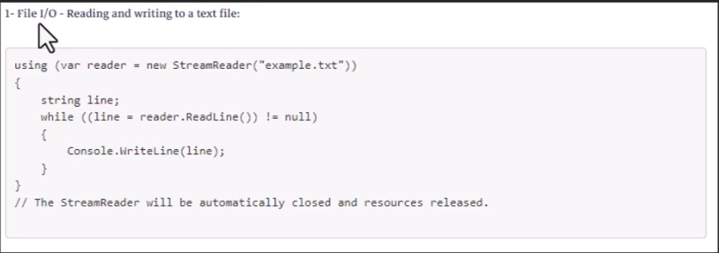

وده مثال تاني عالداتا بيز

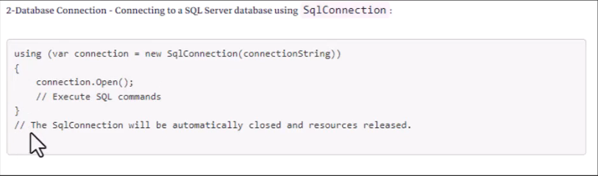

وده مثال عال network

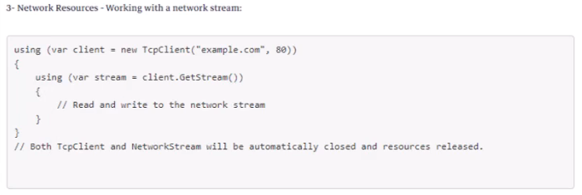

لو انت عملت كلاس بيعمل implementation لل I disposable interface بتقدر تستخدم ال using

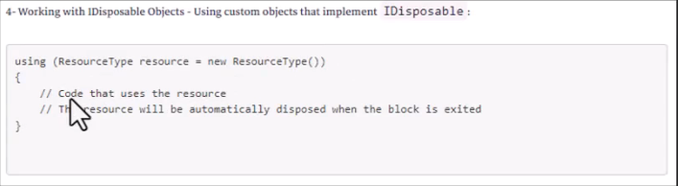

بالنسبالنا في الداتا بيز بنستخدم ال using مع ال command وال connection وال

data reader من غير ماتقوله افتح واقفل

|  |
| --- |
| using System;  using System.Data.SqlClient;  class Program  {  static void Main()  {  string connectionString = "Server=your_server;Database=your_database;User Id=your_username;Password=your_password;";  try  {  using (SqlConnection connection = new SqlConnection(connectionString))  {  connection.Open();  string query = "SELECT FirstName, LastName FROM Employee";  using (SqlCommand command = new SqlCommand(query, connection))  {  using (SqlDataReader reader = command.ExecuteReader())  {  if (reader.HasRows)  {  while (reader.Read())  {  string firstName = reader["FirstName"].ToString();  string lastName = reader["LastName"].ToString();  Console.WriteLine($"Name: {firstName} {lastName}");  }  }  else  {  Console.WriteLine("No rows found.");  }  }  }  }  }  catch (SqlException ex)  {  Console.WriteLine("Database connection error: " + ex.Message);  }  }  } |

In C#, the using statement is also used for **Resource Management**: The using statement is commonly used for resource management, such as working with objects that implement the IDisposable interface. The IDisposable interface provides a method called Dispose that allows you to release unmanaged resources or perform cleanup operations. By using the using statement, you can ensure that the Dispose method is called automatically when the block of code is exited, even if an exception is thrown.

Here's an example of how the using statement is used for resource management:

using (var resource = new DisposableResource())

{

    // Use the resource

    // The Dispose method will be automatically called when this block is exited.

}

**Examples of using the Using statement:**

1- File I/O - Reading and writing to a text file:

using (var reader = new StreamReader("example.txt"))

{

    string line;

    while ((line = reader.ReadLine()) != null)

    {

        Console.WriteLine(line);

    }

}

// The StreamReader will be automatically closed and resources released.

2-Database Connection - Connecting to a SQL Server database using SqlConnection:

using (var connection = new SqlConnection(connectionString))

{

    connection.Open();

    // Execute SQL commands

}

// The SqlConnection will be automatically closed and resources released.

3- Network Resources - Working with a network stream:

using (var client = new TcpClient("example.com", 80))

{

    using (var stream = client.GetStream())

    {

        // Read and write to the network stream

    }

}

// Both TcpClient and NetworkStream will be automatically closed and resources released.

4- Working with IDisposable Objects - Using custom objects that implement IDisposable:

using (ResourceType resource = new ResourceType())

{

    // Code that uses the resource

    // The resource will be automatically disposed when the block is exited

}

If you have a custom class that needs to be used with the using statement, make sure it implements IDisposable and properly handles resource cleanup in its Dispose method, as demonstrated in the previous response.

In all these examples, the using statement ensures that the resources are properly released and disposed of when they go out of scope, making the code cleaner and more reliable.

Here are a few reasons why using using is recommended for database connections:

1. Resource Cleanup: Database connections often involve unmanaged resources, such as network connections or file handles. The Dispose method is where you release these resources. If you don't properly release these resources, it can lead to issues like connection leaks, where the database server runs out of available connections.
2. Timely Release of Resources: By using the using statement, you guarantee that the Dispose method is called when the code block is exited. This ensures that resources are released in a timely manner, even if an exception occurs within the block.
3. Easier Code Maintenance: Using using makes the code cleaner and more readable. It clearly indicates the scope in which the resource is used, making it easier for developers to understand when the resource is acquired and when it is released.

**Nullable Data Types**

في الكروس اللي فات كنا بنتجنب الأخطاء الناتجه عن ان ال object تكون قيمته null عن طريق ال

if statement دلوقتي بقي بيقولك انك ممكن تعرف object او متغير معين انه nullable يعني ممكن يكون null بدل ماتقعد تكتب if كل شوية

طريقه تعريف المتغير انه null ليه طريقتين

اول طريقه انك تكتب nullable وتحدد ال data type

|  |
| --- |
| Nullable<int> nullableInt1 = null; |

وتاني طريقه واسمها short hand notation يدوب بتحط علامة استفهام

|  |
| --- |
| int? nullableInt2 = null; |

وبتقدر تشيك ان كان فيها قيمه ولا لا

|  |
| --- |
| nullableInt1.HasValue |

وبتقدر تعين قيمه بحيث انه المتغير بتاعك مايظهرش ب null ابدأ تجنبا للاخطاء وده بيتم بعلامتين استفهام

|  |
| --- |
| nullableInt2= nullableInt2 ?? 0; |

|  |
| --- |
| int result = nullableInt2 ?? 0; |

وتقدر تحوله ل string بالطريقه دي انك تحط علامة استفهام وبعدها tostring

|  |
| --- |
| string stringValue = nullableInt2?.ToString(); |

In C#, a nullable data type is a value type that can also be assigned a value of null. This is achieved by using the Nullable<T> structure or its shorthand notation T?, where T is the underlying value type. This is particularly useful when dealing with database values or scenarios where a variable may legitimately have no value.

Here's an example using Nullable<T> with an int:

using System;

class NullableExample

{

    static void Main()

    {

        // Declare a nullable int using Nullable<T>

        Nullable<int> nullableInt1 = null;

        // Shorthand notation using int?

        int? nullableInt2 = null;

        // Check if the nullable ints have values

        if (nullableInt1.HasValue)

        {

            Console.WriteLine("nullableInt1 has a value: " + nullableInt1.Value);

        }

        else

        {

            Console.WriteLine("nullableInt1 is null.");

        }

        if (nullableInt2.HasValue)

        {

            Console.WriteLine("nullableInt2 has a value: " + nullableInt2.Value);

        }

        else

        {

            Console.WriteLine("nullableInt2 is null.");

        }

        // Using the null-coalescing operator

        int result = nullableInt2 ?? 0;

        Console.WriteLine("Using null-coalescing operator: " + result);

        // Using the null-conditional operator

        string stringValue = nullableInt2?.ToString();

        Console.WriteLine("String representation: " + (stringValue ?? "null"));

        Console.ReadKey();

    }

}

In this example:

* Nullable<int> and int? are both used to declare nullable integers.
* HasValue property is used to check if the nullable value has a value.
* The null-coalescing operator (??) is used to provide a default value if the nullable value is null.
* The null-conditional operator (?.) is used to access a property or method only if the nullable value is not null.

Using int? is more common and convenient for declaring nullable integers in C#. You can apply the concept of nullable types to other value types as well, such as DateTime?, float?, etc., depending on your requirements.

**Nullable Datatypes Example 2**

|  |
| --- |
| using System;  class NullableExample  {  static void Procedure1(string name,Nullable<int> Age) {    Console.WriteLine(name);  if (Age.HasValue) {  Console.WriteLine(Age.ToString());  } else { Console.WriteLine("Age is null"); }  }  static void Procedure2(string name, int? Age) {  Console.WriteLine(name);  if (Age.HasValue)  {  Console.WriteLine(Age.ToString());  }  else { Console.WriteLine("Age is null"); }  }  static void Main()  {  Procedure1("Mohamed",null);  Procedure1("Aly",35);  Procedure2("Mohamed",null);  Procedure2("Ali",35);    Console.ReadKey();  }  } |

**Serialization / Deserialization**

ال serialization هيا عباره عن انك بتاخد object موجود في ال memory وتحوله لصيغه معينه من خلال الصيغة دي تقدر تبعته لاي برنامج تاني او ملف تاني يقدر يتعامل معاه ويرجعه object تاني

وهيا طريقه من خلالها بتقدر تبعت object كله علي بعضه من برنامج لبرنامج تاني يعني من الاخر بدل ماكنا مثلا واحنا بنتعامل مع الداتابيز كنا بنفك ال object ونطلع المتغيرات اللي فيه ونبعتها ولما نيجي نستلمها بنستلمها متفرطه ونرجع نجمعها تاني في object هنا لا قالك حول ال object لصيغه معينه وبعدين ابعته كله علي بعضه

انك تحول ال object لصيغه معينه ده اسمه serialization لكن لو عايز تعمل العكس ده اسمه deserialization يعني تحول الصيغه ل object زي ماكان

فيه أنواع من الصيغ اللي تقدر تحول ليها ال object بتاعك :-

* 1. Binary serialization :- وهيا انك تحول ال object ل binary ودي اسرع طريقه لو هتستعمل الserialization في نفس البرنامج وعشان تستخدمها بتستدعي مكتبه اسمها كده بس عيبه انك ماتقدر تفتحه وتقراه



* 1. Xml serialization :- انك بتحط ال object بصيغة xml وده بيكون مقروء يعني تقدر تقراه وكمان كل ال operating systems بتقدر تقراه ويفضل انك تتعامل بيها لو هتبعت ال object من نظام تشغيل لنظام تشغيل تاني زي من ويندوز ل os مثلا

دي المكتبه بتاعته



* 1. JSON serialization :- وده زيه زي ال xml بس اخف منه وده استخدامه شائع مع ال web APIs وال AJAX

دي المكتبه بتاعته



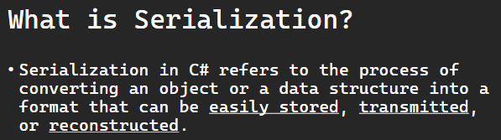

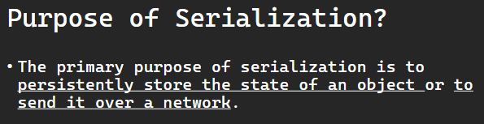

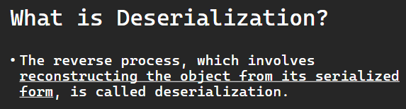

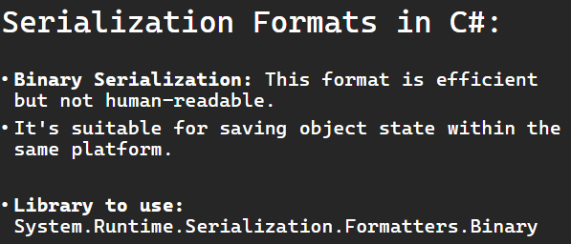

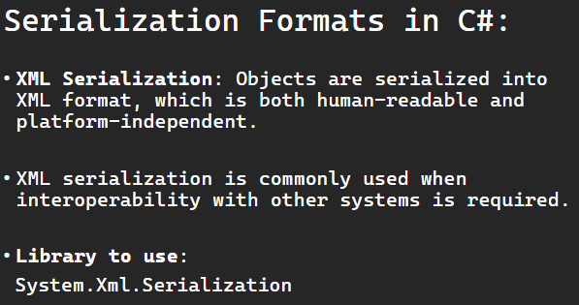

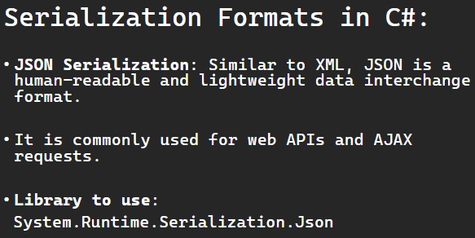

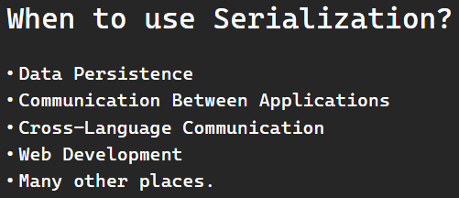

Serialization in C# refers to the process of converting an object or a data structure into a format that can be easily stored, transmitted, or reconstructed. The primary purpose of serialization is to persistently store the state of an object or to send it over a network. The reverse process, which involves reconstructing the object from its serialized form, is called deserialization.

### **Key Points about Serialization in C#:**

* Format:
  + Serialization typically involves converting an object into a format such as XML, JSON, binary, or other custom formats.
* Object State:
  + During serialization, the entire state of an object, including its data members and their values, is saved. This allows the object to be reconstructed later with the same state.
* Interfaces:
  + Objects that need to be serialized often implement the Serializable interface. In C#, this is achieved by marking a class with the [Serializable] attribute.

[Serializable]

public class MyClass

{

    // Class members and methods

}

* Serialization Formats in C#:
  + Binary Serialization: This format is efficient but not human-readable. It's suitable for saving object state within the same platform.
  + XML Serialization: Objects are serialized into XML format, which is both human-readable and platform-independent. XML serialization is commonly used when interoperability with other systems is required.
  + JSON Serialization: Similar to XML, JSON is a human-readable and lightweight data interchange format. It is commonly used for web APIs and AJAX requests.
* Serialization Libraries:
  + In C#, the System.Runtime.Serialization namespace provides classes for binary and XML serialization. The DataContractJsonSerializer class is commonly used for JSON serialization.

// Binary Serialization

using System.Runtime.Serialization.Formatters.Binary;

// XML Serialization

using System.Xml.Serialization;

// JSON Serialization

using System.Runtime.Serialization.Json;

Serialization is a crucial aspect of many applications, especially when working with distributed systems, databases, or any scenario where object state needs to be persisted or transmitted between different parts of a system.

**When to use Serialization?**

Serialization is used in various scenarios to persistently store object state, transmit data over a network, or share data between different parts of an application. Here are common situations where serialization is beneficial:

* Data Persistence:
  + Use Case: Storing and retrieving object state from storage, such as databases or files.
  + Example: Saving application settings, user preferences, or any data that needs to persist between program executions.
* Communication Between Applications:
  + Use Case: Transmitting data between different applications or services over a network.
  + Example: Web API communication, inter-process communication (IPC), or sending data between a client and server.
* Object Copying:
  + Use Case: Creating deep copies of objects.
  + Example: Cloning an object to preserve its state at a specific point in time or duplicating complex data structures.
* Cross-Language Communication:
  + Use Case: Communicating between programs written in different languages.
  + Example: Exchanging data between a C# application and a Python application or any other combination of languages.
* Caching and Memorization:
  + Use Case: Storing the result of expensive computations to avoid redundant calculations.
  + Example: Caching the results of database queries or complex algorithmic computations.
* Web Development:
  + Use Case: Sending data between the client and server in web applications.
  + Example: Serializing data to JSON for transmission between the browser and the server in AJAX requests or web API interactions.
* Message Queues:
  + Use Case: Placing messages in a queue for asynchronous communication between components.
  + Example: Serializing messages before placing them in a message queue for processing by other parts of the system.
* State Management in Distributed Systems:
  + Use Case: Managing state in distributed systems or microservices.
  + Example: Serializing and deserializing messages or data when passing information between different components in a distributed architecture.
* Remoting and RPC (Remote Procedure Call):
  + Use Case: Invoking methods on objects located on a remote machine.
  + Example: Remoting in .NET or using technologies like gRPC for remote procedure calls.
* Versioning and Migration:
  + Use Case: Updating applications while preserving compatibility with previously stored data.
  + Example: Serializing data in a way that allows for versioning and handling changes in the object structure over time.
* Testing:
  + Use Case: Creating consistent test data for unit testing or mocking.
  + Example: Serializing and deserializing objects to ensure that the test data is representative of real-world scenarios.

While serialization provides many benefits, it's essential to consider factors such as performance, security, and interoperability when choosing a serialization method. Additionally, be aware of potential issues, such as versioning challenges when updating object structures.

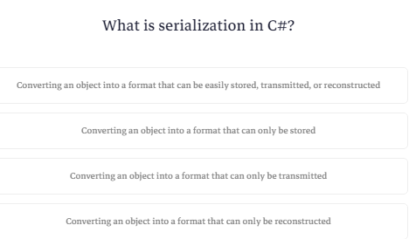

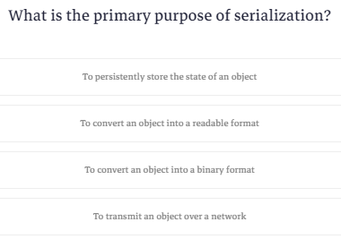

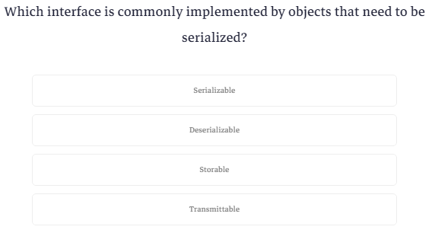

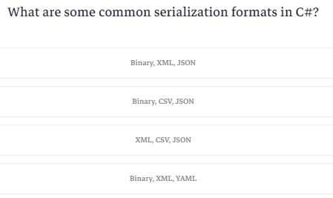

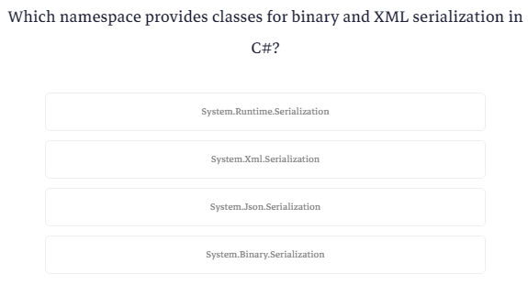

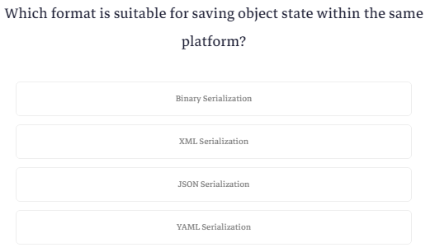

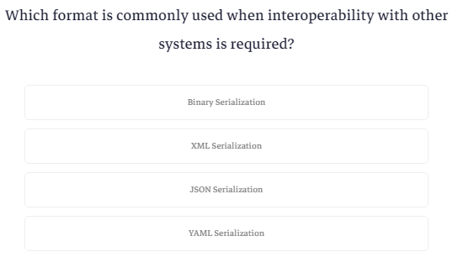

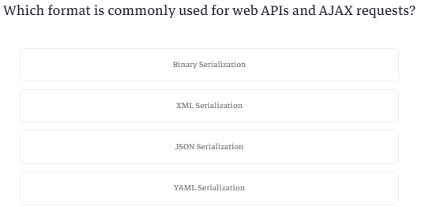

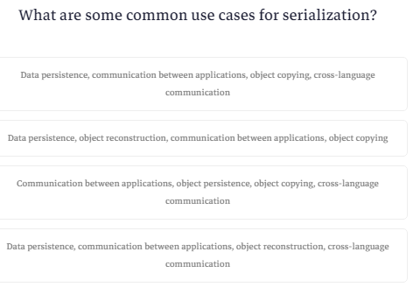

**XML Serialization Example**

هنعمل الأول كلاس person بسيط

|  |
| --- |
| public class clsPerson {  public string Name { get; set; }  public int Age { get; set; }  } |

تعالي ناخد منه object

|  |
| --- |
| clsPerson person = new clsPerson {Name="Mohammed",Age=40 }; |

عاوزين نخزن ال object ده في ملف صيغته xml ونحط الملف ده عالجهاز بتاعتنا وبعدين نرجع نقرا الملف ونحول اللي فيه ل object تاني

طيب فيه حاجتين لازم تعملهم قبل ماتبدأ التحويل

اول حاجه انك تستدعي المكتبه بتاعت التحويل

|  |
| --- |
| using System.Xml.Serialization; |

تاني حاجه انك تعرف الكلاس انه هيتحول عشان يجهز نفسه طب ازاي؟

قالك فيه حاجه اسمها attribute عباره عن كلمه بين قوسين بتحطها عشان تحدد خاصيه معينه لسه هنيجي لشرح بتاعها بعدين

المهم انك بتلطع الكلمه دي فوق الكلاس

|  |
| --- |
| [Serializable]  public class clsPerson { |

كده انت جاهز للتحويل

عشان نكتب في ملف معين كنا بنستخدم stream writer وعشان نقرأ في ملف بنستخدم stream reader تعالي نعملهم

|  |
| --- |
| using (TextWriter writer = new StreamWriter("person.xml")) {}  using (TextReader reader=new StreamReader("person.xml")) {} |

طيب عشان نعمل عمليه التحويل بناخد object من كلاس اسمه XmlSerializer وال constructor بتاعه بيطلب مننا ال datatype

|  |
| --- |
| XmlSerializer Serializer = new XmlSerializer(typeof(clsPerson)); |

عشان نحول ل xml بنستعدي method اسمها serialize وعشان نحول من xml بنستدعي deserialize

بس كده خلصنا

|  |
| --- |
| Serializer.Serialize(writer,person); |

|  |
| --- |
| clsPerson DeserializedPerson=(clsPerson)Serializer.Deserialize(reader); |

|  |
| --- |
| using System;  using System.IO;  using System.Xml.Serialization;  [Serializable]  public class clsPerson {  public string Name { get; set; }  public int Age { get; set; }  }  class NullableExample  {    static void Main()  {  clsPerson person = new clsPerson {Name="Mohammed",Age=40 };  XmlSerializer Serializer = new XmlSerializer(typeof(clsPerson));  using (TextWriter writer = new StreamWriter("person.xml")) {  Serializer.Serialize(writer,person);  }  using (TextReader reader=new StreamReader("person.xml")) {  clsPerson DeserializedPerson=(clsPerson)Serializer.Deserialize(reader);  Console.WriteLine($"Name: {DeserializedPerson.Name}, Age: {DeserializedPerson.Age}");  }  Console.ReadLine();  }  } |

XML Serialization is another common way to serialize objects in C#. Here's the same example using XML Serialization:

using System;

using System.IO;

using System.Xml.Serialization;

[Serializable]

public class Person

{

    public string Name { get; set; }

    public int Age { get; set; }

}

class Program

{

    static void Main()

    {

        // Create an instance of the Person class

        Person person = new Person { Name = "Mohammed Abu-Hadhoud", Age = 46 };

        // XML serialization

        XmlSerializer serializer = new XmlSerializer(typeof(Person));

        using (TextWriter writer = new StreamWriter("person.xml"))

        {

            serializer.Serialize(writer, person);

        }

        // Deserialize the object back

        using (TextReader reader = new StreamReader("person.xml"))

        {

            Person deserializedPerson = (Person)serializer.Deserialize(reader);

            Console.WriteLine($"Name: {deserializedPerson.Name}, Age: {deserializedPerson.Age}");

        }

    }

}

In this example, the XmlSerializer class from the System.Xml.Serialization namespace is used to serialize and deserialize the Person object. The XmlSerializer automatically generates XML tags based on the properties of the object.

Remember that for XML Serialization to work, the class must have a parameterless constructor (either explicitly defined or provided by default) and all properties to be serialized must be public. Additionally, the class or its members can be annotated with attributes to control the serialization process.

**Json Serialization Example**

عشان تستخدم المكتبه بتاعت ال JSON بتروح تعملها reference الأول

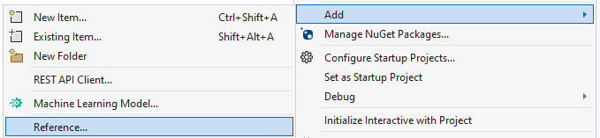

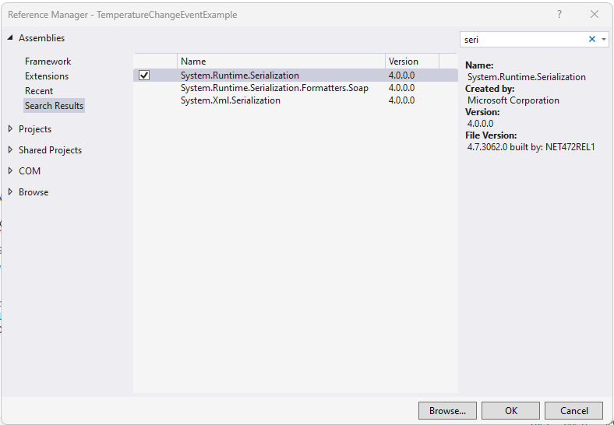

دي المكتبه

|  |
| --- |
| using System.Runtime.Serialization.Json; |

وده نفس السطر بس تغيير اسم الكلاس

|  |
| --- |
| DataContractJsonSerializer Serializer = new DataContractJsonSerializer(typeof(clsPerson)); |

وهنا لما بيحول ال object بيحوله في ال memory الأول قبل مايحطه في ملف

|  |
| --- |
| using (MemoryStream stream = new MemoryStream()) {  Serializer.WriteObject(stream, person);  string jsonString = System.Text.Encoding.UTF8.GetString(stream.ToArray());  File.WriteAllText("person.json", jsonString);  } |

والقراية عادي مافيهاش حاجه

|  |
| --- |
| using (FileStream stream=new FileStream("person.json",FileMode.Open)) {  clsPerson DeserializedPerson=(clsPerson)Serializer.ReadObject(stream);  Console.WriteLine($"Name: {DeserializedPerson.Name}, Age: {DeserializedPerson.Age}");  } |

JSON Serialization is commonly used in web development and APIs. Here's the same example using JSON Serialization in C#:

using System;

using System.IO;

using System.Runtime.Serialization.Json;

[Serializable]

public class Person

{

    public string Name { get; set; }

    public int Age { get; set; }

}

class Program

{

    static void Main()

    {

        // Create an instance of the Person class

        Person person = new Person { Name = "Mohammed Abu-Hadhoud", Age = 30 };

        // JSON serialization

        DataContractJsonSerializer serializer = new DataContractJsonSerializer(typeof(Person));

        using (MemoryStream stream = new MemoryStream())

        {

            serializer.WriteObject(stream, person);

            string jsonString = System.Text.Encoding.UTF8.GetString(stream.ToArray());

            // Save the JSON string to a file (optional)

            File.WriteAllText("person.json", jsonString);

        }

        // Deserialize the object back

        using (FileStream stream = new FileStream("person.json", FileMode.Open))

        {

            Person deserializedPerson = (Person)serializer.ReadObject(stream);

            Console.WriteLine($"Name: {deserializedPerson.Name}, Age: {deserializedPerson.Age}");

        }

    }

}

In this example, the DataContractJsonSerializer class from the System.Runtime.Serialization.Json namespace is used to serialize and deserialize the Person object. The resulting JSON string is UTF-8 encoded, and you can save it to a file or send it over the network.

Just like with XML Serialization, ensure that the class is marked with the [Serializable] attribute, and the properties to be serialized are public. If needed, you can customize the serialization process using attributes like [DataMember] for properties. Also, consider using third-party libraries like Newtonsoft.Json (Json.NET) for more advanced JSON serialization scenarios.

**Binary Serialization Example**

عشان تحول ل binary بتستخدم formatter.serialize و deserialize مفيهاش حاجه صعبه

|  |
| --- |
| using System;  using System.IO;  using System.Runtime.Serialization.Formatters.Binary;  using System.Runtime.Serialization.Json;  [Serializable]  public class clsPerson {  public string Name { get; set; }  public int Age { get; set; }  }  class NullableExample  {    static void Main()  {  clsPerson Person = new clsPerson {Name="Mohammed",Age=40 };  BinaryFormatter formatter = new BinaryFormatter();  using (FileStream stream = new FileStream("person.bin", FileMode.Create))  {  formatter.Serialize(stream, Person);  }  // Deserialize the object back  using (FileStream stream = new FileStream("person.bin", FileMode.Open))  {  clsPerson deserializedPerson = (clsPerson)formatter.Deserialize(stream);  Console.WriteLine($"Name: {deserializedPerson.Name}, Age: {deserializedPerson.Age}");  Console.ReadKey();  }  Console.ReadLine();  }  } |

Here's the example using Binary Serialization in C#:

using System;

using System.IO;

using System.Runtime.Serialization.Formatters.Binary;

[Serializable]

public class Person

{

    public string Name { get; set; }

    public int Age { get; set; }

}

class Program

{

    static void Main()

    {

        // Create an instance of the Person class

        Person person = new Person { Name = "Mohammed Abu-Hadhoud", Age = 46 };

        // Binary serialization

        BinaryFormatter formatter = new BinaryFormatter();

        using (FileStream stream = new FileStream("person.bin", FileMode.Create))

        {

            formatter.Serialize(stream, person);

        }

        // Deserialize the object back

        using (FileStream stream = new FileStream("person.bin", FileMode.Open))

        {

            Person deserializedPerson = (Person)formatter.Deserialize(stream);

            Console.WriteLine($"Name: {deserializedPerson.Name}, Age: {deserializedPerson.Age}");

Console.ReadKey();

        }

    }

}

In this example, the BinaryFormatter class from the System.Runtime.Serialization.Formatters.Binary namespace is used for both serialization and deserialization. The resulting binary file (person.bin) contains the serialized data of the Person object.

Remember that binary serialization is more efficient in terms of size and speed compared to XML or JSON serialization, but the resulting file is not human-readable. Additionally, be cautious when using binary serialization in scenarios where the serialized data might need to be shared across different platforms or languages, as binary formats are less interoperable in such cases.

**Attributes In C#**

ال attributes هيا طريقه بتمكنك انك تضيف معلومات زياده عالكلاس او ال method او المتغيرات المعلومات الزياده دي اسمها meta data

طريقتها انك بتحط القوسين دول [] فوق الككلاس او ال method او أيا كان وفيها منها نوعين

built in و custom

ال built in زي ال serializable اللي كنا بنستعملها في تحويل صيغة ال object

فيه برضه obsolete وفيه conditional

التلاته attributes دول بيستفيد منهم ال compiler

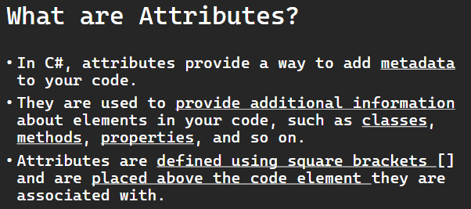

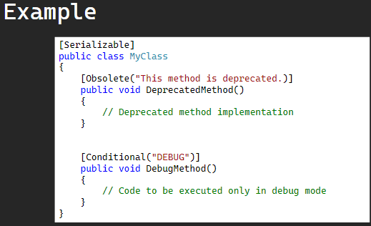

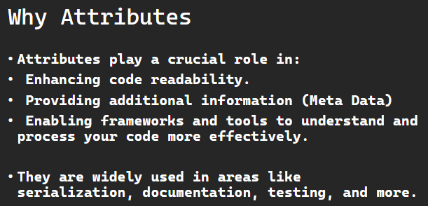

In C#, attributes provide a way to add metadata to your code. They are used to provide additional information about elements in your code, such as classes, methods, properties, and so on. Attributes are defined using square brackets [] and are placed above the code element they are associated with.

Here's a basic example of using attributes in C#:

[Serializable]

public class MyClass

{

    [Obsolete("This method is deprecated. Use NewMethod instead.")]

    public void DeprecatedMethod()

    {

        // Deprecated method implementation

    }

    [Conditional("DEBUG")]

    public void DebugMethod()

    {

        // Code to be executed only in debug mode

    }

}

In this example:

* The Serializable attribute is applied to the MyClass class, indicating that instances of this class can be serialized.
* The Obsolete attribute is applied to the DeprecatedMethod method, marking it as deprecated and providing a message that suggests using the NewMethod instead.
* The Conditional attribute is applied to the DebugMethod method, indicating that the method should only be called if the symbol DEBUG is defined during compilation.

Attributes play a crucial role in enhancing code readability, providing additional information, and enabling frameworks and tools to understand and process your code more effectively. They are widely used in areas like serialization, documentation, testing, and more.

**Serialization Attributes**

اتكلمنا قبل كده عن ال serialize وانه بيسمحلك انك تحول صيغة ال object

لو انت عامل serialization لكلاس معين وفيه attribute جوه الكلاس ده مش عايزه يدخل في ال serialization بتكتب فوقيه non serialized

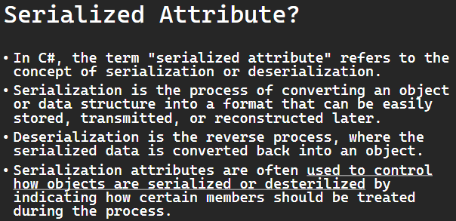

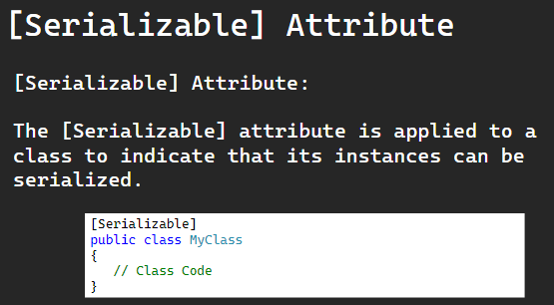

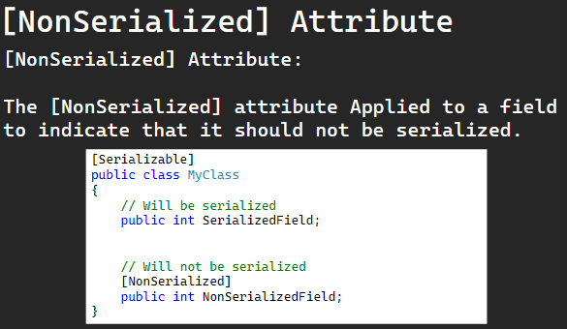

In C#, the term "serialized attribute" refers to the concept of serialization attributes used with classes and objects when performing serialization or deserialization.

Serialization is the process of converting an object or data structure into a format that can be easily stored, transmitted, or reconstructed later. Deserialization is the reverse process, where the serialized data is converted back into an object.

Attributes in C# are used to provide metadata about the code elements like classes, methods, or properties. Serialization attributes are often used to control how objects are serialized or desterilized by indicating how certain members should be treated during the process.

Here are some commonly used serialization attributes in C#:

### **[Serializable] Attribute:**

* + The [Serializable] attribute is applied to a class to indicate that its instances can be serialized.
* Example:

[Serializable]

public class MyClass

{

    // Class members

}

### **[NonSerialized] Attribute:**

* + Applied to a field to indicate that it should not be serialized.
* Example:

[Serializable]

public class MyClass

{

    // Will be serialized

    public int SerializedField;

    // Will not be serialized

    [NonSerialized]

    public int NonSerializedField;

}

These attributes help customize the serialization and deserialization process to meet specific requirements, such as excluding certain fields, renaming elements, or controlling the order of serialization. Depending on the serialization framework or library used (e.g., XML serialization, JSON serialization, binary serialization), different attributes might be employed.

Note: there are more advance attributes for serialization, at your level now you dont need to know them.

**Conditional Attribute Examples**

ال conditional attribute لو انت فيه method معينه مش عايزها تشتغل غير في ال

debug time لكن في ال release مش هتشتغل

شايف السطر ده؟

|  |
| --- |
| [Conditional("DEBUG")] |

لو كتبته فوق method وال mode بتاعك كان debug mode هيشتغل لو كان release مش هيشتغل

ال mode بتعرفه من هنا

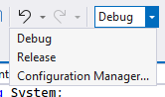

لو غيرت ال MODE وعملته RELEASE مش هتشتغل غير ال METHOD العاديه

لو جيت اخترت RELEASE وطلعتلك الرسالة دي

اختار اللي علمتلك عليه

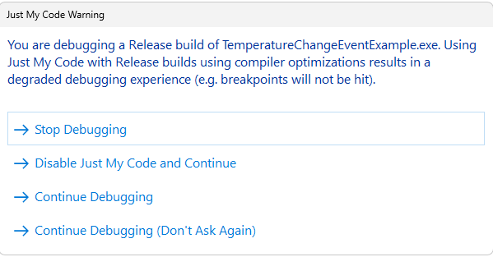

|  |
| --- |
| using System;  using System.Diagnostics;  using System.IO;  public class MyClass  {  [Conditional("DEBUG")]  public void DebugMethod()  {  Console.WriteLine("Debug method excuted.");  }  public void NormalMethod()  {  Console.WriteLine("Normal Method excuted.");  }  }  class NullableExample  {  static void Main()  {  MyClass cls = new MyClass();  cls.NormalMethod();  cls.DebugMethod();  Console.ReadLine();  }  } |

فاكر محمد هنيدي في فول الصين العظيم (يوم ورا يوم حبيبي ماجالي نوم)؟

اهو هوا ده ال conditional

بتحط كلمة سر ومش هيتم تنفيذ ال method غير لما تقول كلمة السر دي

بص ال method دي حطينا عليها كلمة السر

|  |
| --- |
| [Conditional("YOM_WARA_YOM")]  public static void LogTrace(string Message)  {  Console.WriteLine($"[TRACE] {Message}");  } |

لو عملت قرد الكود ده مش هيتنفذ غير لما تعرف كلمة السر او تشيل ال CONDITIONAL دي

طيب هعرف ال conditional ازاي؟

قالك فيه طريقتين

اول طريقه انك تيجي في اول الكود وتكتب define وبعدها كلمة السر

|  |
| --- |
| #define YOM_WARA_YOM  using System; |

تاني طريقه انك تعرفها في ال properties بتاعت ال project

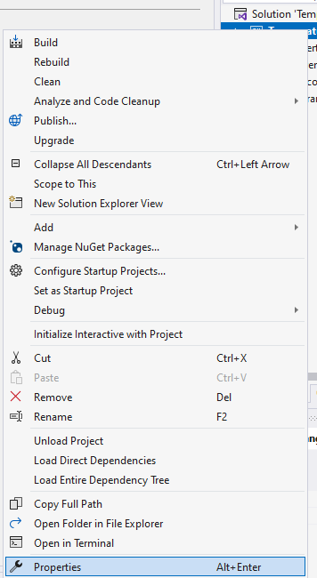

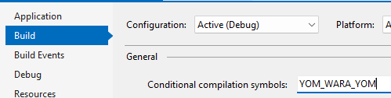

|  |
| --- |
| #define YOM_WARA_YOM  using System;  using System.Diagnostics;  using System.IO;  public class TraceExample  {    }  class NullableExample  {  [Conditional("YOM_WARA_YOM")]  public static void LogTrace(string Message)  {  Console.WriteLine($"[TRACE] {Message}");  }  static void Main()  {  LogTrace("this trace message will be included only if YOM_WARA_YOM is defined");  Console.WriteLine("Rest of the program");  Console.ReadLine();  }  } |

### **Conditional Attributes?**

﻿In C#, the term "conditional attribute" is commonly associated with the [Conditional] attribute. The [Conditional] attribute is used in C# to conditionally include or exclude methods from compilation based on the specified compilation symbols. It doesn't affect the runtime behavior of the code but rather influences whether or not a particular method is included in the compiled output.

Below is a simple C# program that demonstrates the use of the Conditional attribute. In this example, the DebugMethod will only be compiled and executed if the DEBUG compilation symbol is defined.

using System;

using System.Diagnostics;

public class MyClass

{

    [Conditional("DEBUG")]

    public void DebugMethod()

    {

        Console.WriteLine("Debug method executed.");

    }

    public void NormalMethod()

    {

        Console.WriteLine("Normal method executed.");

    }

}

class Program

{

    static void Main()

    {

        MyClass myClass = new MyClass();

        // Call the methods

        myClass.DebugMethod();  // This will only be executed in DEBUG builds

        myClass.NormalMethod(); // This will always be executed

        Console.ReadLine();

    }

}

Here's how you can compile and run this program:

* In a development environment like Visual Studio, you can set the build configuration to "Debug" or "Release" to see the difference. The DebugMethod will be included only in the "Debug" build.
* Alternatively, you can use the #define directive to manually define the DEBUG symbol in your code, like this:

#define DEBUG

Place the #define DEBUG line at the beginning of your code file, and then both DebugMethod and NormalMethod will be included in the compilation.

Remember that the Conditional attribute affects the inclusion of the method at compile-time, not runtime. So, if the DEBUG symbol is not defined during compilation, the DebugMethod calls will not be present in the compiled code.

**Custom Symbol Example:**

Example of using the Conditional attribute in combination with trace statements, you might be interested in incorporating conditional compilation of trace statements based on the presence of a compilation symbol. Here's a simple example:

#define TRACE_ENABLED

using System;

using System.Diagnostics;

public class TraceExample

{

    [Conditional("TRACE_ENABLED")]

    public static void LogTrace(string message)

    {

        Console.WriteLine($"[TRACE] {message}");

    }

    public static void Main()

    {

        LogTrace("This trace message will only be included if TRACE_ENABLED is defined.");

        Console.WriteLine("Rest of the program.");

        Console.ReadLine();

    }

}

In this example:

* The TRACE_ENABLED compilation symbol is defined at the beginning of the file using #define.
* The LogTrace method is marked with the Conditional("TRACE_ENABLED") attribute. This means that the method calls will only be included in the compiled code if the TRACE_ENABLED symbol is defined during compilation.
* In the Main method, a trace message is logged using LogTrace, and it will only be included if TRACE_ENABLED is defined.

You can experiment with this example by commenting out or removing the #define TRACE_ENABLED line. When the symbol is not defined, the trace messages will be excluded during compilation.

Remember, the Conditional attribute is a compile-time directive, so it affects what gets compiled into the executable based on the presence or absence of the specified compilation symbols.

**Obsolete Attribute**

ال obsolete attribute دي خاصه بالمبرمجين انه لو فيه حد بيستخدم method معينه في الكلاس بتاعي وبعدين عملت تحديثات وعايز اشيل ال method دي وابدلها بواحده تانيه مش بشيلها علي طول لا بعمل زي hint او تحذير ان ال method دي هلغيها في التحديثات الجايه واحسنلك تستخدم التانيه

حصلت معاي كتير في الاندرويد لما كنت بذاكر من كورس قديم وكان فيه methods معينه جوجل لغت الدعم عنها لانها عملت حاجات افضل فكان بيحط عليها خط كأنها مشطوبه

ال methods القديمه دي بنقول عليها deprecated يعني

تعالي نشوف بتتعمل ازاي هنا

|  |
| --- |
| using System;  public class MyClass  {  [Obsolete("this Method will be deprecated")]  public void Method1() { }  public void Method2() { }  }  class NullableExample  {  static void Main()  {  MyClass myobject=new MyClass();  myobject.Method1();  myobject.Method2();  Console.ReadLine();  }  } |

هنا بيظهرلك خط اخضر

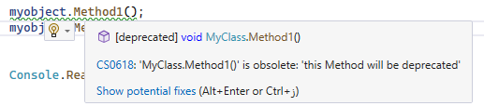

The Obsolete attribute in C# is used to mark program entities (such as classes, methods, properties, etc.) that are considered obsolete or deprecated. This attribute informs developers that the marked entity should not be used because it is outdated or will be removed in future versions of the code. It also allows you to provide a custom message to suggest an alternative or explain the reason for deprecation.

Here's an example of using the Obsolete attribute in a C# program:

using System;

public class MyClass

{

    [Obsolete("This method is marked as obsolete, and will be deprecated in the future.")]

    public void Method1()

    {

        Console.WriteLine("This method is marked as obsolete, and will be deprecated in the future.");

    }

    public void Method2()

    {

        Console.WriteLine("This is the recommended method to use.");

    }

}

class Program

{

    static void Main()

    {

        MyClass myObject = new MyClass();

        // Deprecated method usage

        myObject.Method1(); // Generates a compiler warning

        // New method usage

        myObject.Method2();

        Console.ReadLine();

    }

}

In this example:

* The Method1 in the MyClass class is marked with the Obsolete attribute. The attribute includes a custom message indicating that the method is obsolete and suggesting the use of Method2 instead.
* When you compile the program, calling Method1 will generate a compiler warning. This warning serves as a notification to developers that the method is deprecated, and they should consider using the recommended alternative.
* The Method2 is introduced as a replacement for the deprecated method, and it can be used without generating any warnings.

Keep in mind that while the Obsolete attribute helps communicate to developers that certain code is deprecated, it's ultimately up to the development team to manage the deprecation process and migrate to newer alternatives. It's a good practice to provide clear and informative messages when marking code as obsolete to guide developers on how to proceed.

**Quiz**

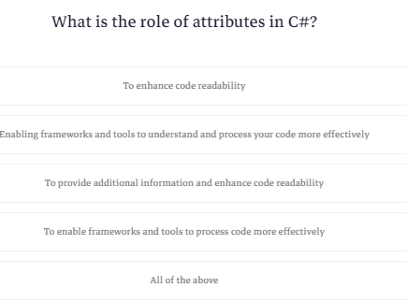

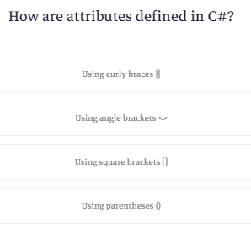

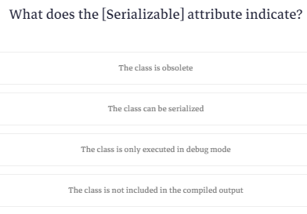

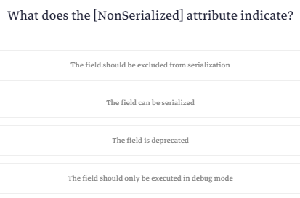

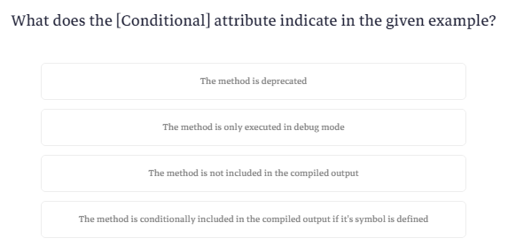

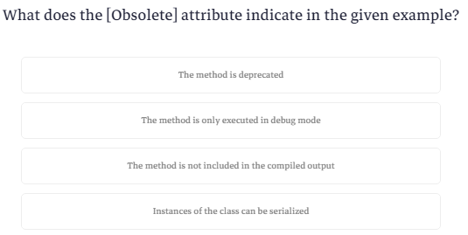

**Custom Attribute**

خلصنا من ال built in attributes نيجي لل cutom attribute

هنا بيقولك تقدر تعمل ال attribute الخاص بيك عشان تستخدمه في أي وقت او أي مكان انت عايزه

عشان تعمل ال attribute بتعمل كلاس بيورث من System.Attribute

تعالي نعمل كلاس خفيف

|  |
| --- |
| public class MyCustomAttribute : Attribute  {  public string Description { get; }  public MyCustomAttribute(string description)  {  Description = description;  }  } |

كلاس اهو مافيهوش حاجه

ناقص بس حاجه واحده وهيا انك تحدد الاستخدام بتاعه

فبتيجي فوق الكلاس وبتحدد هل هتستخدمه لل classes ولا لل methods ولاايه بالظبط عن طريق انك تكتب AttributeTargets وبعدها نقطه وتختار اللي انت عايزه

وبعدين لو هتستخدمه مره واحده ولا اكتر من مره علي نفس العنصر

|  |
| --- |
| [AttributeUsage(AttributeTargets.Class | AttributeTargets.Method , AllowMultiple = true)] |

ود الكود كله

|  |
| --- |
| using System;  [AttributeUsage(AttributeTargets.Class | AttributeTargets.Method , AllowMultiple = true)]  public class MyCustomAttribute : Attribute  {  public string Description { get; }  public MyCustomAttribute(string description)  {  Description = description;  }  }  [MyCustom("This is a class attribute")]  class MyClass  {  [MyCustom("This is a method attribute")]  public void MyMethod()  {  // Method implementation  }  }  class NullableExample  {  static void Main()  {  Console.ReadLine();  }  } |

In C#, a custom attribute is a user-defined metadata that you can apply to elements in your code, such as classes, methods, properties, or parameters. Attributes provide a way to add declarative information to your code, which can be used by the runtime, tools, or other code to perform specific actions or make decisions.

To define a custom attribute, you create a class that inherits from the System.Attribute class or one of its derived classes. The attribute class can then be applied to various elements in your code using square brackets.

Here's a simple example of a custom attribute:

[AttributeUsage(AttributeTargets.Class | AttributeTargets.Method, AllowMultiple = true)]

public class MyCustomAttribute : Attribute

{

    public string Description { get; }

    public MyCustomAttribute(string description)

    {

        Description = description;

    }

}

[MyCustom("This is a class attribute")]

class MyClass

{

    [MyCustom("This is a method attribute")]

    public void MyMethod()

    {

        // Method implementation

    }

}

In this example, MyCustomAttribute is a custom attribute that takes a description as a parameter. The attribute can be applied to classes and methods. The AttributeUsage attribute is used to specify where the custom attribute can be applied (AttributeTargets.Class and AttributeTargets.Method in this case) and whether it can be applied multiple times to the same element (AllowMultiple = true).

You can then use reflection or other mechanisms to access and utilize the information provided by these custom attributes at runtime. Custom attributes are often used for various purposes such as code generation, documentation, or influencing the behavior of frameworks and libraries.

**Note When we study reflection we will explain it.**

**What is Reflection?**

ال reflection هيا مكتبات بتمكنك انك تدخل علي كود أي حد وتشوف كل حاجه فيه تقدر تشوف ال methods وال parameters وال datatypes بتاعت كل حاجه وكمان تستدعي أي حاجه منهم في ال run time

اعتبره هاكر بيكشفلك الكود بتاع الشخص

زي مثلا في ال serialization لما كنا بنستدعي ال object.serialize كان بيلف علي كل العناصر اللي جوه ال object ويتعامل

الكود اللي بتكشفه ده انت مش عارف عنه حاجه في ال compile time بتعرف في ال runtime

لو انت مثلا بتعمل reference لملف dll بتلاقيه كشفلك كل اللي فيه ده بيتم عن طريق ال reflection هتلاقي التطبيقات بتاعته تحت

هنا بيقولك انك لازم تخلي بالك وانت بتستخدم ال reflection لانه بيأثر عالسرعه وممكن في ال runtime يضرب بسبب datatype



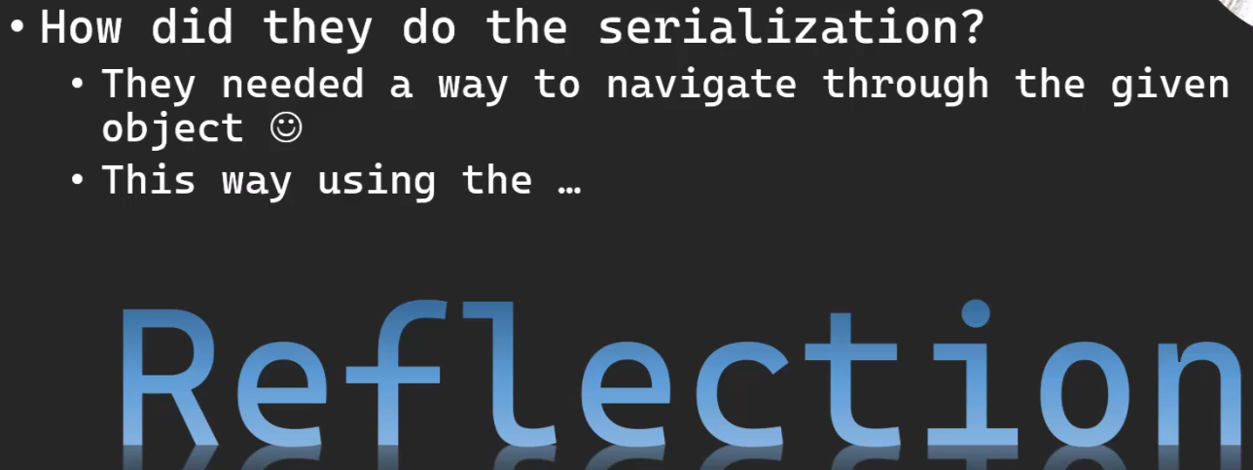

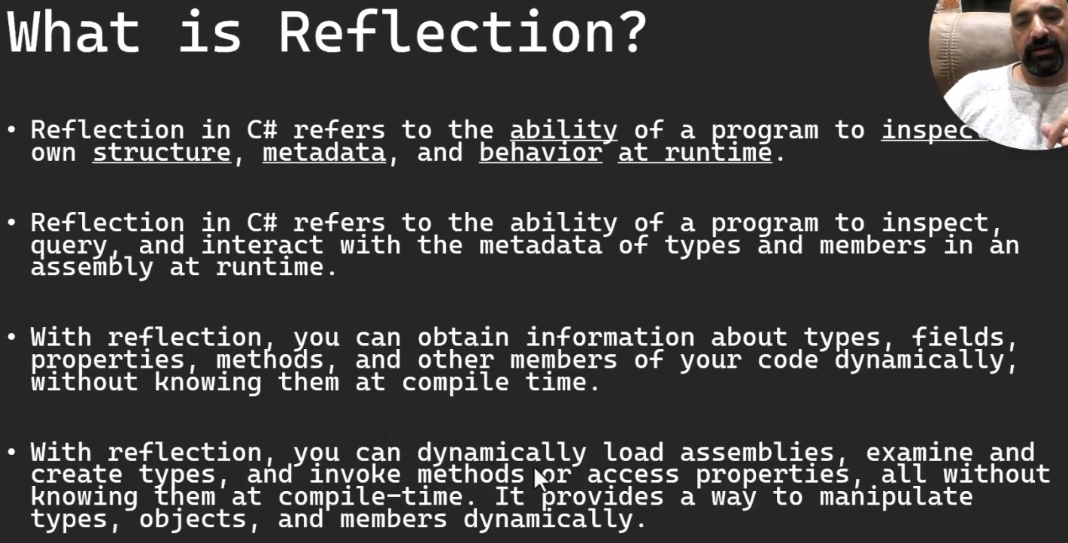

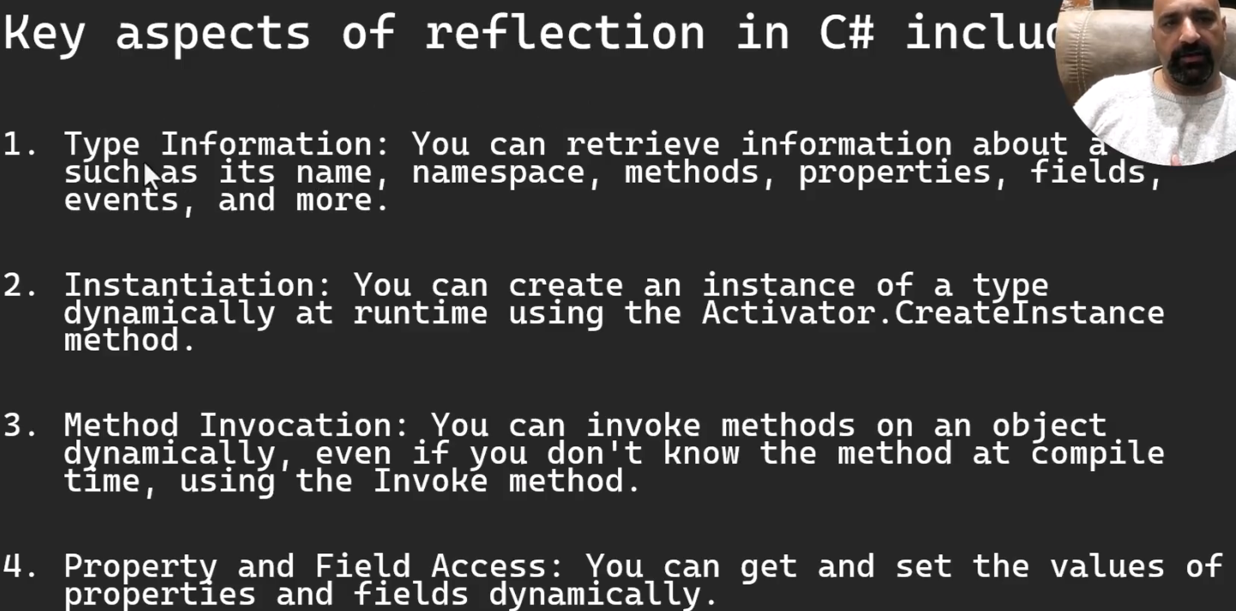

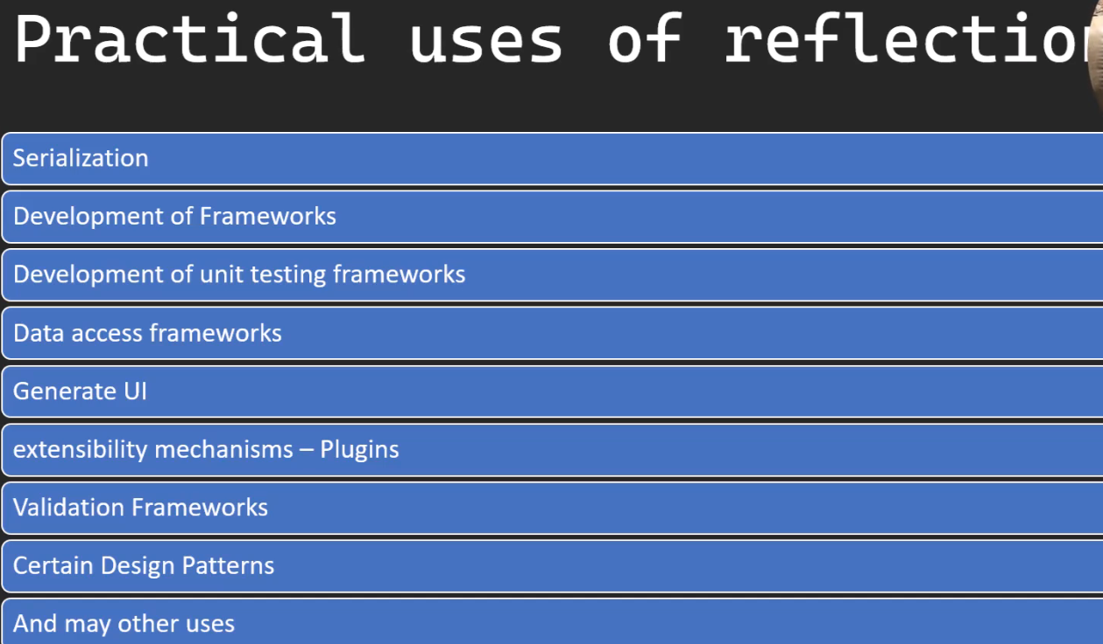

Reflection in C# refers to the ability of a program to inspect its own structure, metadata, and behavior at runtime.

Reflection in C# refers to the ability of a program to inspect, query, and interact with the metadata of types and members in an assembly at runtime. With reflection, you can obtain information about types, fields, properties, methods, and other members of your code dynamically, without knowing them at compile time.

With reflection, you can dynamically load assemblies, examine and create types, and invoke methods or access properties, all without knowing them at compile-time. It provides a way to manipulate types, objects, and members dynamically.

Key aspects of reflection in C# include:

1. Type Information: You can retrieve information about a type, such as its name, namespace, methods, properties, fields, events, and more.
2. Instantiation: You can create an instance of a type dynamically at runtime using the Activator.CreateInstance method.
3. Method Invocation: You can invoke methods on an object dynamically, even if you don't know the method at compile time, using the Invoke method.
4. Property and Field Access: You can get and set the values of properties and fields dynamically.

Reflection is powerful but comes with some trade-offs:

* Performance: Reflection can have a performance overhead compared to statically typed code because it bypasses some of the optimizations performed by the compiler.
* Type Safety: Since reflection allows dynamic interaction with types, there's a risk of runtime errors if the code is not carefully designed.

**Practical uses of reflection:**

* One practical use of reflection in C# is in the development of frameworks and tools where the structure of types is not known at compile time. Reflection enables these frameworks to dynamically discover and interact with types provided by user code. One such example is in the development of dependency injection containers.
* Another practical use of reflection in C# is in the development of serialization and deserialization frameworks. These frameworks convert objects into a format that can be easily stored, transmitted, or reconstructed, and reflection is often used to dynamically inspect and manipulate the structure of objects.
* Another practical use of reflection in C# is in the development of unit testing frameworks. Unit testing frameworks often utilize reflection to dynamically discover and execute test methods within test classes.
* Another practical use of reflection in C# is in the development of data access frameworks or Object-Relational Mapping (ORM) tools. Reflection can be employed to dynamically map object properties to database fields, allowing for flexible and generic data access without explicit knowledge of the underlying database schema.
* Another practical use of reflection in C# is in the development of user interface frameworks or libraries that need to dynamically generate or bind UI elements based on the properties of data objects.
* Another practical use of reflection in C# is in the implementation of extensibility mechanisms, where the application can dynamically discover and load extensions or plugins at runtime without having to know about them at compile time.
* Another practical use of reflection in C# is in the development of attribute-based validation frameworks. By utilizing custom attributes and reflection, you can create a system where validation rules are associated with class properties, making it easier to define and enforce data validation rules.
* Another practical use of reflection in C# is in the development of code generation tools or frameworks. Reflection allows you to inspect and analyze the structure of types at runtime, and this capability is often leveraged in code generation scenarios.
* Another practical use of reflection in C# is in certain design patterns.
* Reflection can also be utilized in the context of documentation generation, where you dynamically extract information about types, methods, properties, and other elements in your codebase to generate documentation automatically.
* and may other uses :-)

**Quiz**

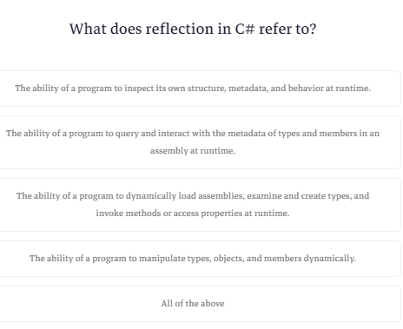

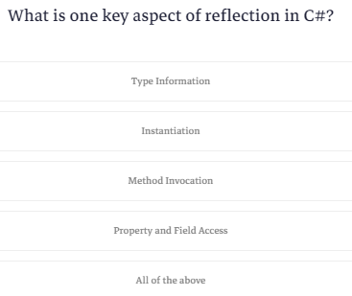

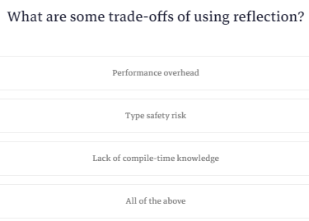

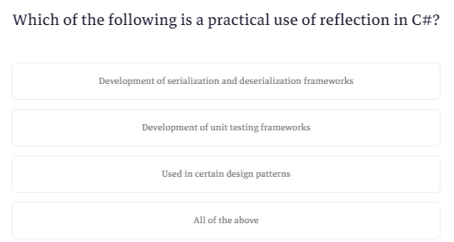

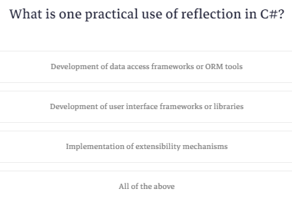

**'Type' Class**

ال reflection بتتكون من مكتبات

فيه كلاس أساسي اسمه type الكلاس ده بيخليك توصل لمعلومات ال type نفسه يعني مثلا عندك كلاس اسمه person تقدر توصل للمعلومات اللي فيه عن طريق انك تخزنه في ال object من الكلاس type

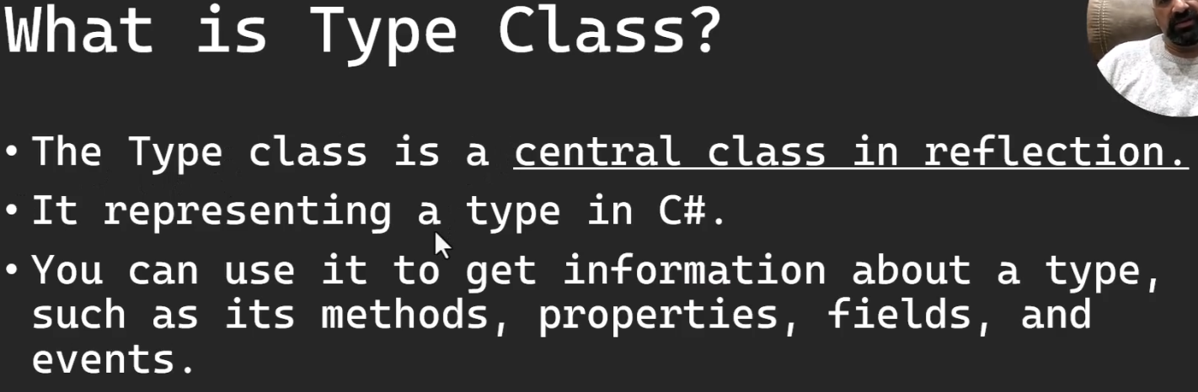

|  |
| --- |
| Type type = typeof(string);  Console.WriteLine("Type Information:");  Console.WriteLine($"Name: {type.Name}");  Console.WriteLine($"Full Name: {type.FullName}");  Console.WriteLine($"Is Class: {type.IsClass}"); |

### **Type Class:**

The Type class is a central class in reflection, representing a type in C#. You can use it to get information about a type, such as its methods, properties, fields, and events.

#### Example 1: Getting Type Information

using System;

class Program

{

    static void Main()

    {

        Type myType = typeof(string);

        Console.WriteLine("Type Information:");

        Console.WriteLine($"Name: {myType.Name}");

        Console.WriteLine($"Full Name: {myType.FullName}");

        Console.WriteLine($"Is Class: {myType.IsClass}");

        Console.ReadLine();

    }

}

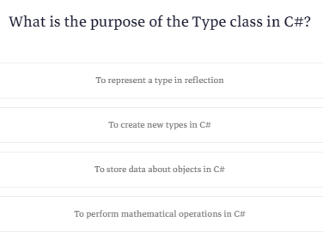

**Navigate String Library Using Reflection Example**

هناخد ال string libarary نخزنها في assemply ونطبعها عالشاشه

اول حاجه هناخد object من النوع assemply وده اللي بيتحط فيه المكتبات

وبحدد فيه ال data type اللي عايز استكشفها

|  |
| --- |
| Assembly assembly = typeof(string).Assembly; |

بعدين هناخد object من type ونخزن فيه ال datatype اللي في ال assemply اللي عاوزين نستكشفه

|  |
| --- |
| Type type = assembly.GetType("System.String"); |

هستدعي المكتبه linq عشان تسهل عليا عمليات ال sorting

|  |
| --- |
| using System.Linq; |

بعدين لو كان الtype مش فاضي هاتلي كل ال public methods وكل ال methods اللي بتظهرلي لما باخد object وتقدر تحدد أي حاجه تانيه عن طريق ال binding.flag وبعدين برتبهم بالاسم

|  |
| --- |
| var Methods=type.GetMethods(BindingFlags.Public|BindingFlags.Instance)  .OrderBy( method => method.Name ); |

بعدين هلف عليهم واطبعهم

|  |
| --- |
| foreach (var method in Methods)  {  Console.WriteLine($"\t{method.ReturnType} {method.Name}({GetParameterList(method.GetParameters())})");  }  } else { Console.WriteLine("System.String type not found."); } |

ودي function عشان تظبط بيانات ال methods في سطر واحد

|  |
| --- |
| static string GetParameterList(ParameterInfo[] parameters)  {  return string.Join(", ", parameters.Select(parameter => $"{parameter.ParameterType} {parameter.Name}"));  } |

|  |
| --- |
| using System;  using System.Reflection;  using System.Linq;  class NullableExample  {  public class Person {  public string Name { get; set; }  public void Method() { }  }  static void Main()  {  Assembly assembly = typeof(string).Assembly;  Type type = assembly.GetType("System.String");  if (type!=null) {    var Methods=type.GetMethods(BindingFlags.Public|BindingFlags.Instance)  .OrderBy( method => method.Name );  foreach (var method in Methods)  {  Console.WriteLine($"\t{method.ReturnType} {method.Name}({GetParameterList(method.GetParameters())})");  }  } else { Console.WriteLine("System.String type not found."); }  Console.ReadLine();  }  static string GetParameterList(ParameterInfo[] parameters)  {  return string.Join(", ", parameters.Select(parameter => $"{parameter.ParameterType} {parameter.Name}"));  }  } |

انا جيت عمل السطر ده بدون ال assembly واشتغل عادي

|  |
| --- |
| Type type = typeof(string); |

Navigating the entire .NET string library using reflection is not a straightforward task, as it involves exploring the assemblies, types, methods, and properties related to strings. However, I can provide you with a simple example that uses reflection to list all methods of the System.String class in the mscorlib assembly.

using System;

using System.Linq;

using System.Reflection;

class Program

{

    static void Main()

    {

        // Get the assembly containing the System.String type

        Assembly mscorlib = typeof(string).Assembly;

        // Get the System.String type

        Type stringType = mscorlib.GetType("System.String");

        if (stringType != null)

        {

            Console.WriteLine($"Methods of the System.String class:\n");

            // Get all public methods of the System.String class

            var stringMethods = stringType.GetMethods(BindingFlags.Public  | BindingFlags.Instance)

                .OrderBy(method => method.Name);

            foreach (var method in stringMethods)

            {

                Console.WriteLine($"\t{method.ReturnType} {method.Name}({GetParameterList(method.GetParameters())})");

            }

        }

        else

        {

            Console.WriteLine("System.String type not found.");

        }

        Console.ReadKey();

    }

    static string GetParameterList(ParameterInfo[] parameters)

    {

        return string.Join(", ", parameters.Select(parameter => $"{parameter.ParameterType} {parameter.Name}"));

    }

}

This example does the following:

1. Retrieves the mscorlib assembly, which contains fundamental types like System.String.
2. Obtains the System.String type.
3. Lists and prints the names and signatures of all public methods of the System.String class.

Keep in mind that this example only scratches the surface, and the .NET Framework has a comprehensive string library with many methods, properties, and functionalities. The methods obtained by reflection include not only commonly used methods but also internal methods and methods that are less commonly used. Additionally, newer versions of .NET may introduce new members to the System.String class.

**Reflection Example 2 - Dynamically Create Objects and Invoke Methods.**

مثال تاني

|  |
| --- |
| using System;  using System.Reflection;  using System.Linq;  using MyNaneSpace;  namespace MyNaneSpace {  public class MyClass {  public int Property1 { get; set; }  public void Method1() {  Console.WriteLine("\tMethod1 is Excuted");  }  public void Method2(int Value1,string Value2)  {  Console.WriteLine($"\tMethod2 is Excuted with parameters: {Value1 },{Value2 }");  }  }  }  class NullableExample  {  static string GetParameterList(ParameterInfo[] parameters)  {  return string.Join(", ", parameters.Select(parameter => $"{parameter.ParameterType} {parameter.Name}"));  }  static void Main()  {  Type type = typeof(MyClass);  Console.WriteLine($"Type Name: {type.Name}");  Console.WriteLine($"Type Full Name: {type.FullName}");  Console.WriteLine("\nProperties:");  foreach (var property in type.GetProperties()) {  Console.WriteLine($"\tProperty name: {property.Name},type: {property.PropertyType}");  }  foreach (var method in type.GetMethods())  {  Console.WriteLine($"\t {method.ReturnType}, {method.Name}({GetParameterList(method.GetParameters())})");  }  object myClassInstance=Activator.CreateInstance(type);  type.GetProperty("Property1").SetValue(myClassInstance,42);  Console.WriteLine($"\nSet Property1 to 42 using reflection:");  Console.WriteLine($"\nGetting Property1 value using reflection: ");  int Property1Value=(int)type.GetProperty("Property1").GetValue(myClassInstance,null);  Console.WriteLine($"\tProperty1 Value: {Property1Value}");  Console.WriteLine("\nExcuting Methods using reflection:\n");  type.GetMethod("Method1").Invoke(myClassInstance, null);  object[] Prameters = { 100, "Mohamed" };  type.GetMethod("Method2").Invoke(myClassInstance, Prameters);  Console.ReadLine();  }    } |

**Reflection with Custom Attributes**

عرفنا attribute عادي كلاس وزودنا فوقيه سطر

|  |
| --- |
| [AttributeUsage(AttributeTargets.Class | AttributeTargets.Method, AllowMultiple = true)]  public class MyCustomAttribute : Attribute  {  public string Description { get; }  public MyCustomAttribute(string description)  {  Description = description;  }  } |

دلوقتي ال constructor بتاع ال attribute ده هيطلب قيمه من النوع string فاي كلاس او method هتيجي تضيفله ال attribute ده لازم يكتب فيه أي حاجه

احنا عاملينه عشان تقدر تحط فيه description للكود اللي بتكتبه سواء كان كلاس او method بحيث لو هتعمل documentation مثلا تقدر تستخدم ال reflection في انك تستدعي بيانات الكلاس بما فيهم ال description وتحطهم في ملف word او text حتي

هنا هنعمل بقي كلاس ونضيفله ال attribute

|  |
| --- |
| [MyCustom("This is a class attribute")]  class MyClass  {  [MyCustom("This is a method attribute")]  public void MyMethod()  {  // Method implementation  }  } |

في ال main بلف عال attributes وبطبعها

|  |
| --- |
| Type type = typeof(MyClass);  // Get class-level attributes  object[] classAttributes = type.GetCustomAttributes(typeof(MyCustomAttribute), false);  foreach (MyCustomAttribute attribute in classAttributes)  {  Console.WriteLine($"Class Attribute: {attribute.Description}");  } |

وهنا بجيب ال attributes بتاعت ال method وبطبعها ممكن بقي لو عندك اكتر من method تلف عليهم وتنادي ال attributes بتاعهم

|  |
| --- |
| // Get method-level attributes  MethodInfo methodInfo = type.GetMethod("MyMethod");  object[] methodAttributes = methodInfo.GetCustomAttributes(typeof(MyCustomAttribute), false);  foreach (MyCustomAttribute attribute in methodAttributes)  {  Console.WriteLine($"Method Attribute: {attribute.Description}");  } |

In C#, a custom attribute is a user-defined metadata that you can apply to elements in your code, such as classes, methods, properties, or parameters. Attributes provide a way to add declarative information to your code, which can be used by the runtime, tools, or other code to perform specific actions or make decisions.

Using custom attributes in C# involves applying them to elements in your code and then retrieving or utilizing that metadata at runtime. Here's a step-by-step guide on how to use custom attributes:

### **Step 1: Define the Custom Attribute**

Create a class that inherits from System.Attribute or one of its derived classes. Add any properties or fields that you need to store metadata. Here's an example:

[AttributeUsage(AttributeTargets.Class | AttributeTargets.Method, AllowMultiple = true)]

public class MyCustomAttribute : Attribute

{

    public string Description { get; }

    public MyCustomAttribute(string description)

    {

        Description = description;

    }

}

In this example, MyCustomAttribute is a custom attribute that takes a description as a parameter. The attribute can be applied to classes and methods. The AttributeUsage attribute is used to specify where the custom attribute can be applied (AttributeTargets.Class and AttributeTargets.Method in this case) and whether it can be applied multiple times to the same element (AllowMultiple = true).

### **Step 2: Apply the Custom Attribute**

Apply the custom attribute to the desired elements in your code using square brackets:

[MyCustom("This is a class attribute")]

class MyClass

{

    [MyCustom("This is a method attribute")]

    public void MyMethod()

    {

        // Method implementation

    }

}

In this example, the MyCustomAttribute is applied to both the MyClass class and the MyMethod method.

### **Step 3: Retrieve Attribute Information at Runtime**

You can use reflection to retrieve information about the custom attribute at runtime. Here's an example:

using System;

using System.Reflection;

class Program

{

    static void Main()

    {

        // Get the type of MyClass

        Type type = typeof(MyClass);

        // Get class-level attributes

        object[] classAttributes = type.GetCustomAttributes(typeof(MyCustomAttribute), false);

        foreach (MyCustomAttribute attribute in classAttributes)

        {

            Console.WriteLine($"Class Attribute: {attribute.Description}");

        }

        // Get method-level attributes

        MethodInfo methodInfo = type.GetMethod("MyMethod");

        object[] methodAttributes = methodInfo.GetCustomAttributes(typeof(MyCustomAttribute), false);

        foreach (MyCustomAttribute attribute in methodAttributes)

        {

            Console.WriteLine($"Method Attribute: {attribute.Description}");

        }

    }

}

In this example, we use reflection to get information about the MyClass type and its MyMethod method. We then retrieve and print the custom attribute information.

### **Step 4: Compile and Run**

Compile your code and run it. The output should display the descriptions provided in the custom attributes.

This is a basic example, and in real-world scenarios, custom attributes can be more complex and used for various purposes, such as configuration, validation, or documentation. The key is to apply them to the appropriate elements in your code and use reflection to access the attribute information at runtime.

**Custom Attributes for Validation Example**

هنستخدم ال custom attribute عشان نعمل ال validation

دلوقتي عملنا attribute بياخد منك رقمين وبتقدر تعمل فيه error message بحيث انك تقدر بعد كده تعمل متغير وتضيفله معلومات زي اقل رقم واكتر رقم يقدر يوصله ورسالة الخطأ الخاصه بيه

كانك بتعمل كلاس مرتبط بمتغير

|  |
| --- |
| [AttributeUsage(AttributeTargets.Property, AllowMultiple = false)]  public class RangeAttribute : Attribute {  public int Min { get; set; }  public int Max { get; set; }  public string ErrorMessage { get; set; }  public RangeAttribute(int min, int max) { Min = min; Max = max; }  } |

وهنا عملنا كلاس person وعملنا attribute للعمر واديناله القيم

|  |
| --- |
| public class Person {  [Range(18,99,ErrorMessage ="Age must be between 18 and 99.")]  public int Age { get; set; }  public string Name { get; set; }  } |

طيب نيجي لل validation

الفكره هنا انك بتلف علي كل المتغيرات اللي في الكلاس تشوف هل فيها متغير معين تمت إضافة ال attribute اللي انا عامله ليه ولا لا؟

لو تمت اضافه ال attribute ليه بمسك ال attribute اخزنه

وبعدين بمسك القيمه بتاعت المتغير واخزنها برضه

بعدين اقارنهم ببعض واطلع بنتيجه

هنا الفكره انك بتقدرتضيف نفس attribute لاي متغير في الكلاس وتغير حاجات صغير فيه وتعمل method واحده تشيك بيها علي كل المتغيرات وال method دي كبيره شوية بس احسن ماتقعد تكتب اكتر من method او حتي تعمل switch statement علي 100 متغير مثلا

|  |
| --- |
| static bool ValidatePerson(Person person)  {  Type type = typeof(Person);  foreach (var property in type.GetProperties()) {  if (Attribute.IsDefined(property,typeof(RangeAttribute))) {    var rangeAttribute=(RangeAttribute)Attribute.GetCustomAttribute(property,typeof(RangeAttribute));  int value=(int)property.GetValue(person);  if (value<rangeAttribute.Min||value>rangeAttribute.Max) {  Console.WriteLine($"Validation failed for property '{property.Name}': {rangeAttribute.ErrorMessage}");  return false;  }  }  }  return true;  } |

في ال main بقي احنا مش حاسين بحاجه

|  |
| --- |
| static void Main()  {  Person person = new Person{Age=25,Name="Mohamed" };  if (ValidatePerson(person)) {  Console.WriteLine("Valid");  } else { Console.WriteLine("not Valid"); }  Console.ReadKey();  } |

وده الكود كله

|  |
| --- |
| using System;  using System.Reflection;  using System.Linq;  using System.Net.Cache;  [AttributeUsage(AttributeTargets.Property, AllowMultiple = false)]  public class RangeAttribute : Attribute {  public int Min { get; set; }  public int Max { get; set; }  public string ErrorMessage { get; set; }  public RangeAttribute(int min, int max) { Min = min; Max = max; }  }  public class Person {  [Range(18,99,ErrorMessage ="Age must be between 18 and 99.")]  public int Age { get; set; }  public string Name { get; set; }  }  class NullableExample  {  static bool ValidatePerson(Person person)  {  Type type = typeof(Person);  foreach (var property in type.GetProperties()) {  if (Attribute.IsDefined(property,typeof(RangeAttribute))) {    var rangeAttribute=(RangeAttribute)Attribute.GetCustomAttribute(property,typeof(RangeAttribute));  int value=(int)property.GetValue(person);  if (value<rangeAttribute.Min||value>rangeAttribute.Max) {  Console.WriteLine($"Validation failed for property '{property.Name}': {rangeAttribute.ErrorMessage}");  return false;  }  }  }  return true;  }  static void Main()  {  Person person = new Person{Age=25,Name="Mohamed" };  if (ValidatePerson(person)) {  Console.WriteLine("Valid");  } else { Console.WriteLine("not Valid"); }  Console.ReadKey();  }  } |

**Special Comments In C#**

ال special comments لما بتيجي تقف علي built in method مثلا بتطلعلك الرساله دي

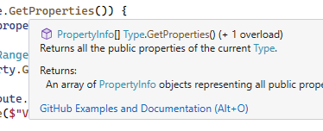

دي بيقولك بتتعمل ب comment بس بيتكتب بطريقة ال xml انك تفتح tag وتكتب جواه اللي انت عايزه

ده كلاس اهو عاوزين نعمل فيه الحوار ده

|  |
| --- |
| public class Calculator {  public int Add(int a,int b) { return a + b; }  public int Sub(int a, int b) { return a - b; }  } |

ال comment العادي كنا بنعمله ب // ده هنعمله ب ///

انت اول ماتحط ال3 شرطات هيطلعلك المنظر ده بتكتب اللي انت عايزه في النص

|  |
| --- |
| /// <summary>  ///  /// </summary> |

|  |
| --- |
| /// <summary>  /// this class represent simple Calculator  /// </summary> |

لو جيت وقفت عالكلاس بالماوس هتطلعلك دي

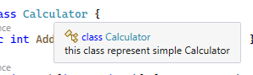

في ال method برضه اول ماكتبت ال 3 شرطات ظهرت دي

|  |
| --- |
| /// <summary>  ///  /// </summary>  /// <param name="a"></param>  /// <param name="b"></param>  /// <returns></returns>  public int Add(int a,int b) { return a + b; } |

تقدر تكتب اللي انت عايزه كده

|  |
| --- |
| /// <summary>  /// Adds two numbers  /// </summary>  /// <param name="a">the first member to be added</param>  /// <param name="b">the second member to be added</param>  /// <returns>the sum of two numbers</returns> |

|  |
| --- |
| using System;  using System.Reflection;  using System.Linq;  using System.Net.Cache;  /// <summary>  /// this class represent simple Calculator  /// </summary>  public class Calculator {  /// <summary>  /// Adds two numbers  /// </summary>  /// <param name="a">the first member to be added</param>  /// <param name="b">the second member to be added</param>  /// <returns>the sum of two numbers</returns>  public int Add(int a,int b) { return a + b; }  /// <summary>  /// Subtracts two numbers  /// </summary>  /// <param name="a">the number from which to subtract</param>  /// <param name="b">the number to be subtracted</param>  /// <returns>the result</returns>  public int Sub(int a, int b) { return a - b; }  }  class NullableExample  {    static void Main()  {  Calculator myCalculator = new Calculator();  int sum = myCalculator.Add(5, 3);  Console.WriteLine("Sum: " + sum);  int difference = myCalculator.Sub(8, 3);  Console.WriteLine("Difference: " + difference);  Console.ReadKey();  }  } |

In C#, method descriptions are typically added using XML comments, which are special comments that provide information about the code and can be used to generate documentation. Here's an example of how you can add descriptions to methods in C# using XML comments:

using System;

/// <summary>

/// This class represents a simple calculator.

/// </summary>

public class Calculator

{

    /// <summary>

    /// Adds two numbers and returns the result.

    /// </summary>

    /// <param name="a">The first number to be added.</param>

    /// <param name="b">The second number to be added.</param>

    /// <returns>The sum of the two numbers.</returns>

    public int Add(int a, int b)

    {

        return a + b;

    }

    /// <summary>

    /// Subtracts the second number from the first number and returns the result.

    /// </summary>

    /// <param name="a">The number from which to subtract.</param>

    /// <param name="b">The number to subtract.</param>

    /// <returns>The result of subtracting the second number from the first number.</returns>

    public int Subtract(int a, int b)

    {

        return a - b;

    }

}

class Program

{

    static void Main()

    {

        // Create an instance of the Calculator class

        Calculator myCalculator = new Calculator();

        // Example usage of the Add method

        int sum = myCalculator.Add(5, 3);

        Console.WriteLine("Sum: " + sum);

        // Example usage of the Subtract method

        int difference = myCalculator.Subtract(8, 3);

        Console.WriteLine("Difference: " + difference);

        Console.ReadKey();

    }

}

In the example above, the <summary> tags provide a brief description of the class and each method. The <param> tags are used to describe the parameters of the methods, and the <returns> tag is used to describe the return value.

* These comments can be processed by tools like Visual Studio to generate documentation for your code. To view the documentation, you can hover over a method or class, or use the IntelliSense feature in Visual Studio. Additionally, you can use tools like Sandcastle or DocFX to generate more formal documentation from these XML comments.

When you use an Integrated Development Environment (IDE) like Visual Studio, these XML comments are often displayed as tooltips or in the IntelliSense suggestions, providing developers with information about the method while they are writing code.

To generate documentation from these XML comments, you can use tools like Sandcastle or Visual Studio's built-in features. This documentation can be valuable for anyone using your code, as it provides clear and concise information about the purpose and usage of your methods.

**Mutable and Immutable Types**

Mutable يعني قابل للتغيير و immutable يعني غير قابل للتغيير

ال objects او المتغيرات هل تقدر تعدل فيهم في ال runtime ولا لا

فيه حاجات زي ال string دي مابتتغيرش لو جيت غيرتها في ال runtime هوا بيعمل نسخه منه بالقيمه الجديده لكن القيمة الاصليه مابتتغيرش

ال mutable بيكون اوفر لل memory لانك بتغير عالقيمه الاصليه

من عيوبها انك ممكن لو فيه threads بتستعمل نفس المتغير وتغير علي قيمته الاصليه وتبدأ تحصل مشاكل وده من مميزات ال immutable انه اامن

من عيوب ال immutable انك بتعمل اكتر من نسخه لنفس المتغير فبتاكل من المساحه

بيقولك الأفضل انك تستخدم ال immutable types عشان دي بتقلل ال bugs بس مش في كل الأوقات بتقدر تستخدمها فعادي يعني

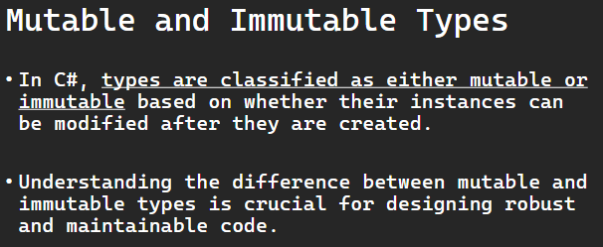

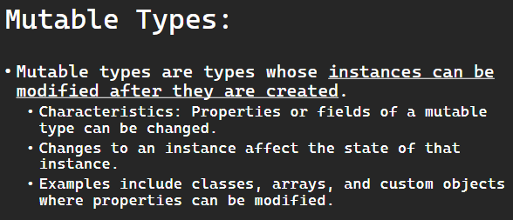

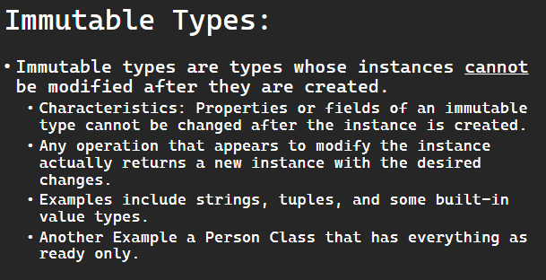

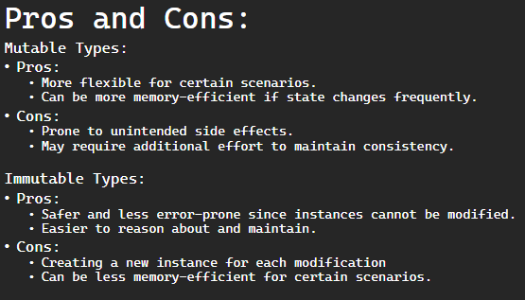

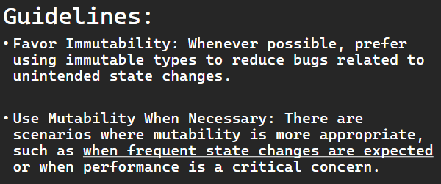

In C#, types are classified as either mutable or immutable based on whether their instances can be modified after they are created. Understanding the difference between mutable and immutable types is crucial for designing robust and maintainable code.

### **Mutable Types:**

* Definition: Mutable types are types whose instances can be modified after they are created.
  + Characteristics: Properties or fields of a mutable type can be changed.
  + Changes to an instance affect the state of that instance.
  + Examples include classes, arrays, and custom objects where properties can be modified.

Example of a mutable class in C#:

public class MutablePerson

{

    public string Name { get; set; }

    public int Age { get; set; }

}

### **Immutable Types:**

* Definition: Immutable types are types whose instances cannot be modified after they are created.
  + Characteristics:Properties or fields of an immutable type cannot be changed after the instance is created.
  + Any operation that appears to modify the instance actually returns a new instance with the desired changes.
  + Examples include strings, tuples, and some built-in value types.

Example of an immutable class in C#:

public class ImmutablePerson

{

    public string Name { get; }

    public int Age { get; }

    public ImmutablePerson(string name, int age)

    {

        Name = name;

        Age = age;

    }

}

### **Pros and Cons:**

Mutable Types:

* + Pros: More flexible for certain scenarios.
  + Can be more memory-efficient if state changes frequently.
  + Cons: Prone to unintended side effects.
  + May require additional effort to maintain consistency.

Immutable Types:

* + Pros: Safer and less error-prone since instances cannot be modified.
  + Easier to reason about and maintain.
  + Cons: Creating a new instance for each modification can be less memory-efficient for certain scenarios.

### **Guidelines:**

* + Favor Immutability: Whenever possible, prefer using immutable types to reduce bugs related to unintended state changes.
  + Use Mutability When Necessary: There are scenarios where mutability is more appropriate, such as when frequent state changes are expected or when performance is a critical concern.

### **Example Usage:**

// Mutable example

MutablePerson person1 = new MutablePerson { Name = "Alice", Age = 30 };

person1.Age = 31; // Mutable state change

// Immutable example

ImmutablePerson person2 = new ImmutablePerson("Bob", 25);

// person2.Age = 26; // Compiler error - immutable type

ImmutablePerson newPerson = new ImmutablePerson(person2.Name, 26); // Creating a new instance with the desired change

In practice, the choice between mutable and immutable types depends on the specific requirements and constraints of your application and the use case at hand. Immutable types are often preferred in scenarios where predictability and avoiding unintended side effects are crucial.

**Quiz**

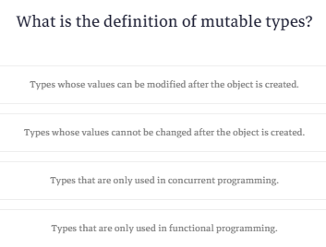

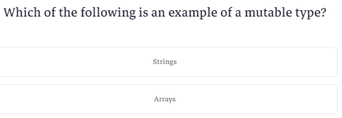

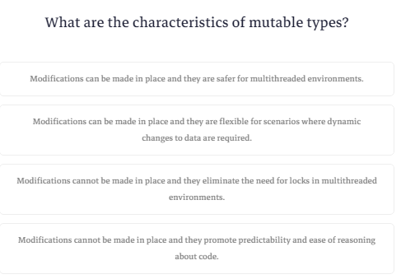

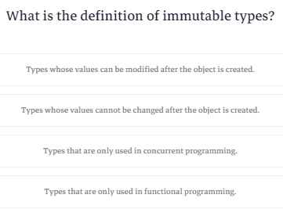

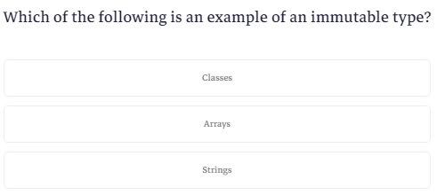

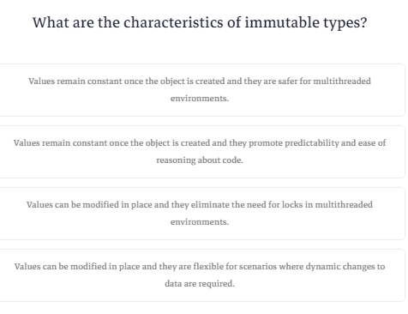

**What are Generics?**

ال generic هوا نفسه ال template في الc++ انك تقدر تقدر تخلي اللي هيستخدم الكلاس بتاعك هوا اللي يحدد ال data type

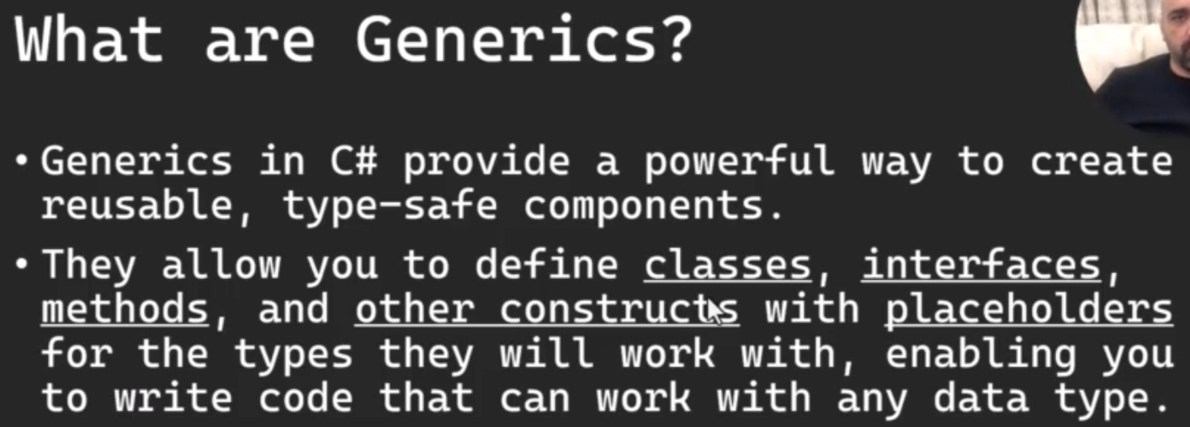

Generics in C# provide a powerful way to create reusable, type-safe components.

﻿They allow you to define classes, interfaces, methods, and other constructs with placeholders for the types they will work with, enabling you to write code that can work with any data type.

Generics provide a flexible and efficient way to create reusable code that works with a variety of data types while maintaining type safety. They are widely used in the .NET Framework and in C# programming.

**Generic Methods**

عشان تخلي ال method تقبل متغير من النوع generic بتيجي قبل اسم ال method وبتكتب T وبعد الاسم بتكتب <T> وبعدين بتستخدم ال T ك data type وبتتعامل

|  |
| --- |
| using System;  public class Utility  {  public static T Swap<T>(ref T first, ref T second)  {  T temp = first;  first = second;  second = temp;  return temp;  }  }  class NullableExample  {    static void Main()  {  int a = 5, b = 10;  Console.WriteLine($"Before swap: a = {a}, b = {b}");  Utility.Swap(ref a, ref b);  Console.WriteLine($"After swap: a = {a}, b = {b}");  Console.WriteLine();  string x = "Hello", y = "World";  Console.WriteLine($"Before swap: x = {x}, y = {y}");  Utility.Swap(ref x, ref y);  Console.WriteLine($"After swap: x = {x}, y = {y}");  Console.ReadKey();  }  } |

Here's a complete C# program that includes the Utility class with the generic Swap method and demonstrates its usage:

using System;

public class Utility

{

    public static T Swap<T>(ref T first, ref T second)

    {

        T temp = first;

        first = second;

        second = temp;

        return temp;

    }

}

class Program

{

    static void Main()

    {

        // Usage with integers

        int a = 5, b = 10;

        Console.WriteLine($"Before swap: a = {a}, b = {b}");

        Utility.Swap(ref a, ref b);

        Console.WriteLine($"After swap: a = {a}, b = {b}");

        Console.WriteLine();

        // Usage with strings

        string x = "Hello", y = "World";

        Console.WriteLine($"Before swap: x = {x}, y = {y}");

        Utility.Swap(ref x, ref y);

        Console.WriteLine($"After swap: x = {x}, y = {y}");

    }

}

In the Utility class, the Swap method is declared as a static method that takes two parameters (first and second) by reference using the ref keyword. The method uses a temporary variable (temp) to perform the swap operation.

In the usage section, you demonstrate how this generic Swap method can be used with both integers (int) and strings (string). The method is called with the ref parameters, and after the call, the values of the variables are swapped.

This is a great illustration of the flexibility and type safety provided by generics in C#. The same Swap method can be used for different types without the need for code duplication.

In this program:

1. The Utility class is defined with the generic Swap method.
2. The Program class contains the Main method, which demonstrates the usage of the Swap method with both integers and strings.
3. The program prints the values before and after the swap to illustrate the effect of the Swap method.

When you run this program, you should see output similar to the following:

Before swap: a = 5, b = 10

After swap: a = 10, b = 5

Before swap: x = Hello, y = World

After swap: x = World, y = Hello

This confirms that the Swap method is working as expected, swapping the values of the variables for both integers and strings.

**Generic Classes**

عشان تعمل generic class بتحط <T> بعد اسمه

|  |
| --- |
| using System;  public class GenericBox<T> {  private T content;  public GenericBox(T value) {  this.content = value; }  public T GetContent() {  return content;  }  }  class NullableExample  {    static void Main()  {  GenericBox<int> intBox = new GenericBox<int>(42);  Console.WriteLine("Content of intBox: "+intBox.GetContent());  GenericBox<string> srtingBox = new GenericBox<string>("hello");  Console.WriteLine("Content of stringBox: "+ srtingBox.GetContent());  Console.ReadKey();  }  } |

A generic class is a class that has one or more type parameters. Type parameters are placeholders for the actual types that the class will work with.

Here's a complete C# program that includes the GenericBox<T> class and demonstrates its usage:

using System;

public class GenericBox<T>

{

    private T content;

    public GenericBox(T value)

    {

        content = value;

    }

    public T GetContent()

    {

        return content;

    }

}

class Program

{

    static void Main()

    {

        // Usage:

        GenericBox<int> intBox = new GenericBox<int>(42);

        Console.WriteLine("Content of intBox: " + intBox.GetContent()); // Outputs: 42

        GenericBox<string> stringBox = new GenericBox<string>("Hello, World!");

        Console.WriteLine("Content of stringBox: " + stringBox.GetContent()); // Outputs: Hello, World!

    }

}

In this complete program:

1. The GenericBox<T> class is defined with a generic parameter T.
2. The Program class contains the Main method, which demonstrates the usage of the GenericBox<T> class with both int and string types.
3. Instances of GenericBox<int> and GenericBox<string> are created, and the content is printed using the GetContent method.

When you run this program, you should see output similar to the following:

Content of intBox: 42

Content of stringBox: Hello, World!

This demonstrates how the generic class GenericBox<T> can be instantiated with different types, providing flexibility and reusability.

**Quiz**

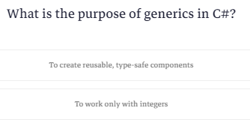

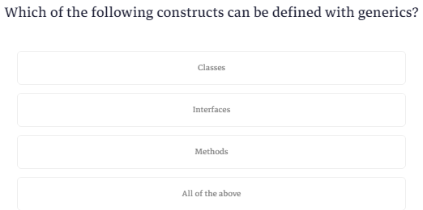

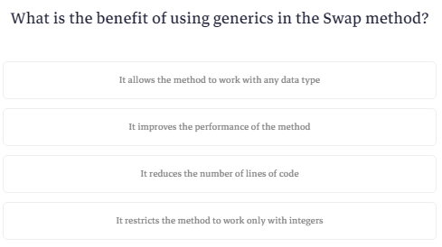

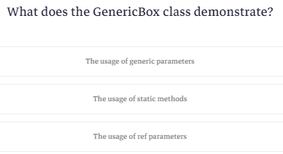

**What is Windows Registry and Why?**

قبل مانبدا عايز اقولك ان الدواء فيه سم قاتل

ماتلعبش كتير في اللي جاي ده عشان ماتبوظش برامج عندك

لما تدوس علي زرار الويندوز مع حرف ال r هتطلعلك شاشة ال run اكتب reg edit هتطلعلك شاشة ال registry

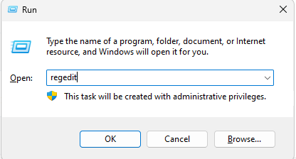

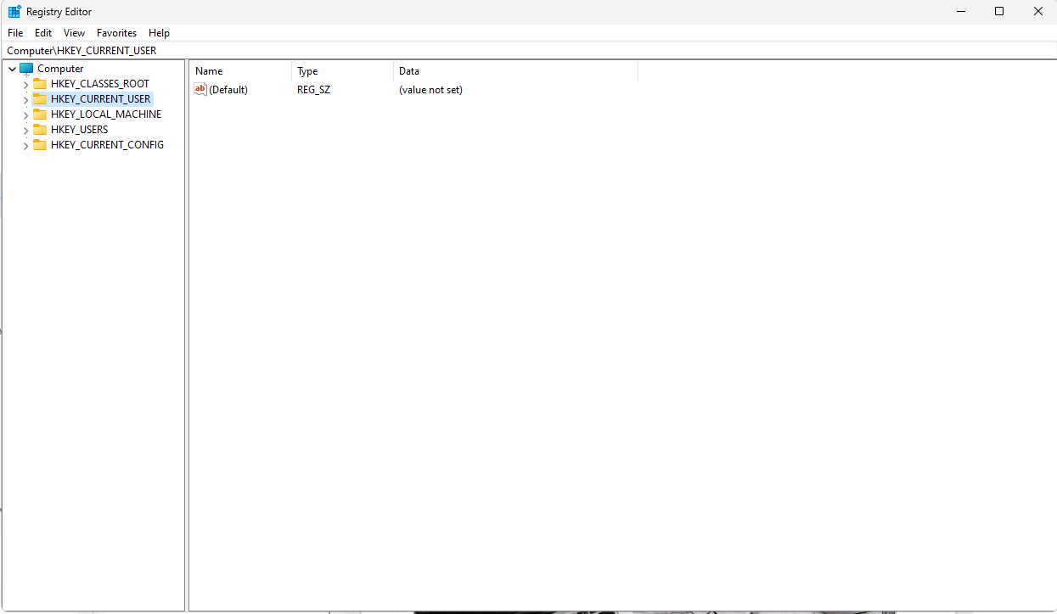

طيب ايه هوا ال registry ؟

قالك هوا عبارة عن داتابيز فيها keys و sub keys

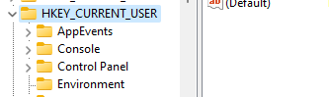

**subkeys**

**keys**

ولما بتبص في الجنب بتلاقي حاجات ملونه دي اسمها values عباره عن اسم ال value والنوع والقيمه

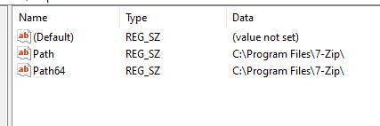

فال windows registry هوا مكان بتقدر التطبيقات انها تخزن فيه معلومات خاصه بيها زي مثلا ال product key

تقدر كمان تيجي في التطبيق بتاع الكورس اللي فات وتحفظ اسم المستخدم وكلمة المرور هنا بدل ال text file

دول اهم keys

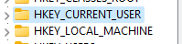

ال local machine القيم اللي فيه هيا مشتركه بين كل المستخدمين بتوع الجهاز

ال current user بيتحط فيه القيم الخاصه بالمستخدم الحالي فقط يعني كل مستخدم ليه

current user

لو روحت فتحت المسار ده

Computer\HKEY_CURRENT_USER\Software\Microsoft\Windows\CurrentVersion\Run

تقدر تحط مسار لبرنامج معين وتشغله اول ماتشغل الويندوز



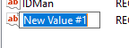

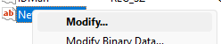

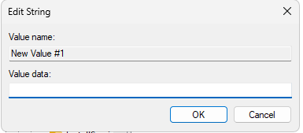

وتحط المسار بتاع البرنامج وتحفظه

تقدر تعمل أي حاجه في البرنامج بتاعك عن طريق ال registry بس عشان تضيف key في ال local machine بتحتاج permission

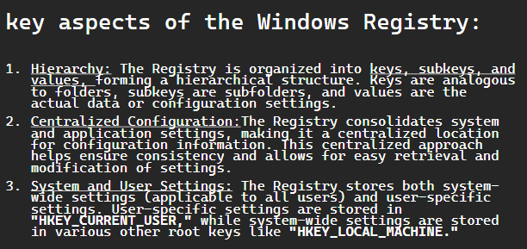

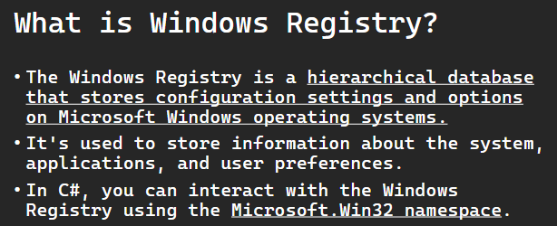

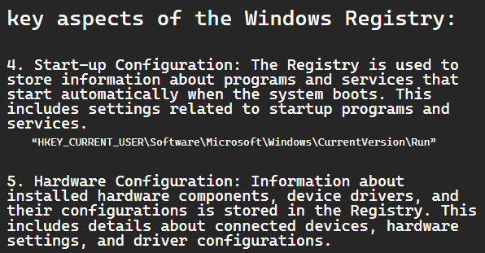

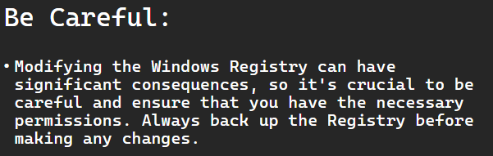

The Windows Registry is a hierarchical database that stores configuration settings and options on Microsoft Windows operating systems. It's used to store information about the system, applications, and user preferences. In C#, you can interact with the Windows Registry using the Microsoft.Win32 namespace.

Here are some key aspects of the Windows Registry:

1. Hierarchy: The Registry is organized into keys, subkeys, and values, forming a hierarchical structure. Keys are analogous to folders, subkeys are subfolders, and values are the actual data or configuration settings.
2. Centralized Configuration: The Registry consolidates system and application settings, making it a centralized location for configuration information. This centralized approach helps ensure consistency and allows for easy retrieval and modification of settings.
3. System and User Settings: The Registry stores both system-wide settings (applicable to all users) and user-specific settings. User-specific settings are stored in "HKEY_CURRENT_USER," while system-wide settings are stored in various other root keys like "HKEY_LOCAL_MACHINE."
4. Start-up Configuration: The Registry is used to store information about programs and services that start automatically when the system boots. This includes settings related to startup programs and services.

“HKEY_CURRENT_USER\Software\Microsoft\Windows\CurrentVersion\Run”

1. Hardware Configuration: Information about installed hardware components, device drivers, and their configurations is stored in the Registry. This includes details about connected devices, hardware settings, and driver configurations.

Note: Modifying the Windows Registry can have significant consequences, so it's crucial to be careful and ensure that you have the necessary permissions. Always back up the Registry before making any changes.

**Writing to Registry**

عشان تكتب في ال registry بتستخدم المكتبه دي

|  |
| --- |
| using Microsoft.Win32; |

وبعدين بتستدعي method اسمها set value وتديها المسار والاسم وال value وال datatype والقيمه نفسها

|  |
| --- |
| using System;  using Microsoft.Win32;  class NullableExample  {  static void Main()  {  string KeyPath = @"HKEY_LOCAL_MACHINE\SOFTWARE\YourSoftware";  string valueName = "YourValueName";  string valueData = "YourvalueData";  try {  Registry.SetValue(KeyPath, valueName, valueData,RegistryValueKind.String);  Console.WriteLine($"Value {valueName} successfully written to the registery.");  } catch(Exception e) {  Console.WriteLine($"An error occurred:{e.Message}");  }  Console.ReadKey();  }  } |

### **Writing to the Registry:**

To write values to the Registry, you can use the Registry class as well. Here's an example of how to write a string value to the Registry:

using Microsoft.Win32;

using System;

class Program

{

    static void Main()

    {

        // Specify the Registry key and path

        string keyPath = @"HKEY_LOCAL_MACHINE\SOFTWARE\YourSoftware";

        string valueName = "YourValueName";

        string valueData = "YourValueData";

        try

        {

            // Write the value to the Registry

            Registry.SetValue(keyPath, valueName, valueData, RegistryValueKind.String);

            Console.WriteLine($"Value {valueName} successfully written to the Registry.");

        }

        catch (Exception ex)

        {

            Console.WriteLine($"An error occurred: {ex.Message}");

        }

    }

}

Remember to handle exceptions appropriately, as working with the Registry can result in exceptions if there are permission issues or if the specified key doesn't exist.

Note: Modifying the Windows Registry can have significant consequences, so it's crucial to be careful and ensure that you have the necessary permissions. Always back up the Registry before making any changes.

**Reading from Registry**

عشان تقرأ قيمه بتستخدم GET VALUE ولو القيمه مش موجوده بيحط القيمه NULL

|  |
| --- |
| using System;  using Microsoft.Win32;  class NullableExample  {  static void Main()  {  string keyPath = @"HKEY_LOCAL_MACHINE\SOFTWARE\YourSoftware";  string valueName = "YourValueName";  try  {  string value = Registry.GetValue(keyPath, valueName, null) as string;  if (value != null)  {  Console.WriteLine($"The value of {valueName} is: {value}");  }  else  {  Console.WriteLine($"Value {valueName} not found in the Registry.");  }  }  catch (Exception ex)  {  Console.WriteLine($"An error occurred: {ex.Message}");  }  Console.ReadKey();  }  } |

### **Reading from the Registry:**

To read values from the Registry, you can use the Registry class. Here's an example of how to read a string value from the Registry:

using Microsoft.Win32;

using System;

class Program

{

    static void Main()

    {

        // Specify the Registry key and path

        string keyPath = @"HKEY_LOCAL_MACHINE\SOFTWARE\YourSoftware";

        string valueName = "YourValueName";

        try

        {

            // Read the value from the Registry

            string value = Registry.GetValue(keyPath, valueName, null) as string;

            if (value != null)

            {

                Console.WriteLine($"The value of {valueName} is: {value}");

            }

            else

            {

                Console.WriteLine($"Value {valueName} not found in the Registry.");

            }

        }

        catch (Exception ex)

        {

            Console.WriteLine($"An error occurred: {ex.Message}");

        }

    }

}

Remember to handle exceptions appropriately, as working with the Registry can result in exceptions if there are permission issues or if the specified key doesn't exist.

Note: Modifying the Windows Registry can have significant consequences, so it's crucial to be careful and ensure that you have the necessary permissions. Always back up the Registry before making any changes.

**Permission to Write to Registry**

عشان تاخد ال permission عشان تكتب علي ال registry وخصوصا ال local machine عندك طريقتين

اول واحدة وهيا انك تشغل البرنامج run as administrator (في حالتنا هنا هنشغل ال

visual studio علي ال run as adiministrator)

قبل مانشوف الطريقه التانيه خلينا نعرف حاجه وهيا اني لما كتبت ال registry استخدمت مكتبة اسمها win32 بس انا النظام عندي win 64

فهتلاقي ال key بتاعك موجود في ملف wow6432Node وال wow ده معناه

windows on windows

ال win 64 بيقدر يشغل البرامج اللي مبنيه علي ويندوز 32 فبيحط ملفات ال registry بتاعتها في الملف ده وده المسار بتاعه

 HKEY_LOCAL_MACHINE\SOFTWARE\**WOW6432Node**

الطريقه التانيه هيا انك تخلي البرنامج بتاعك يطلب من الويندوز الصلاحيات عن طريق انك تضيف ملف manifest وده ملف بيتحط فيه meta data خاصه بالرنامج



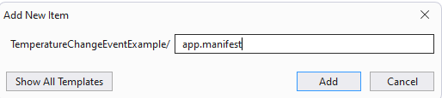

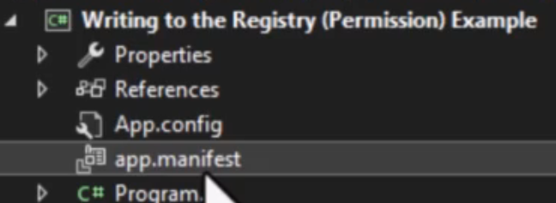

الملف ده عباره عن ملف xml بتكتب فيه الكود ده

|  |
| --- |
| <?xml version="1.0" encoding="utf-8"?>  <assembly manifestVersion="1.0" xmlns="urn:schemas-microsoft-com:asm.v1">    <assemblyIdentity version="1.0.0.0" processorArchitecture="X86" name="YourAppName" type="win32" />    <trustInfo xmlns="urn:schemas-microsoft-com:asm.v2">      <security>        <requestedPrivileges>          <requestedExecutionLevel level="requireAdministrator" uiAccess="false" />        </requestedPrivileges>      </security>    </trustInfo>  </assembly> |

بعدين بتروح عال properties

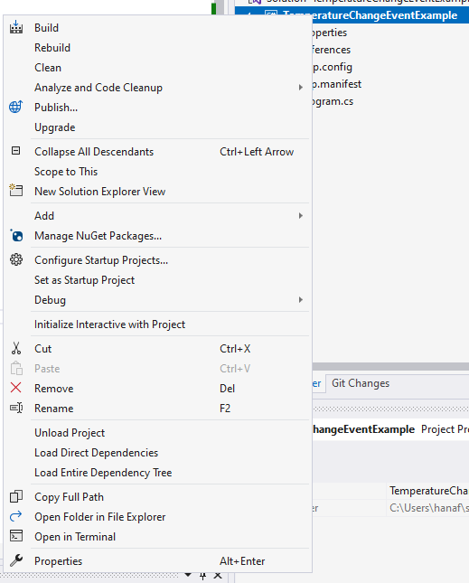

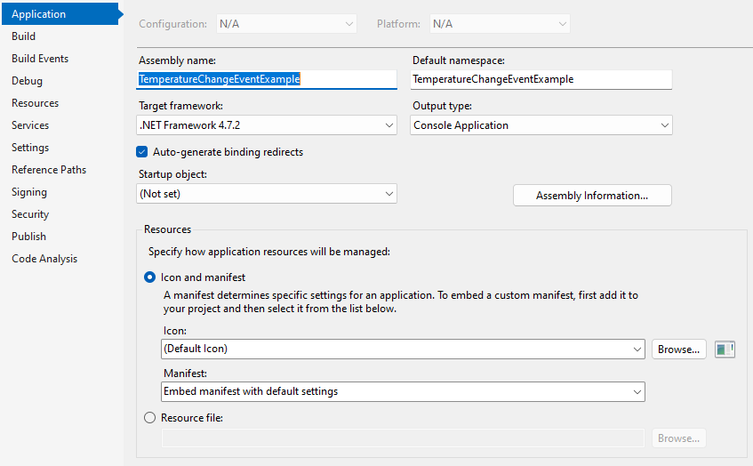

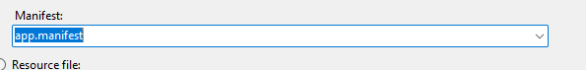

بعدين هتعمل run هيطلب منك restart وبعدين هتشتغل البرنامج عادي وهتقدر تستخدم أي ملف من ال registry

Why writing to registry under software on win64 writes to HKEY_LOCAL_MACHINE\SOFTWARE\**WOW6432Node ?**

When a 32-bit application runs on a 64-bit version of Windows, the operating system uses a feature called Windows-on-Windows 64-bit (WOW64) to provide compatibility. This allows 32-bit applications to run on a 64-bit system without modification.

One aspect of this compatibility is related to the Windows Registry. The registry on a 64-bit Windows system is divided into two parts:

1. HKEY_LOCAL_MACHINE\SOFTWARE: This is where 64-bit applications store their registry entries.
2. HKEY_LOCAL_MACHINE\SOFTWARE\WOW6432Node: This is a special node created by the WOW64 subsystem to redirect 32-bit applications when they try to access the registry under the HKEY_LOCAL_MACHINE\SOFTWARE path. This redirection ensures that 32-bit applications access the correct part of the registry without causing conflicts with 64-bit applications.

So, when a 32-bit application writes to HKEY_LOCAL_MACHINE\SOFTWARE on a 64-bit system, it is redirected to HKEY_LOCAL_MACHINE\SOFTWARE\WOW6432Node by the operating system. This redirection helps maintain separation between the registry entries for 32-bit and 64-bit applications and ensures compatibility in a mixed environment.

Why it is not using the same concept when writing on HKEY_CURRENT_USER?

The redirection concept for the registry is specific to the HKEY_LOCAL_MACHINE hive on 64-bit Windows systems. This redirection is implemented to avoid conflicts between 32-bit and 64-bit applications by directing 32-bit applications to a separate registry path (HKEY_LOCAL_MACHINE\SOFTWARE\WOW6432Node).

However, when it comes to user-specific settings in the registry (e.g., settings stored under HKEY_CURRENT_USER), the redirection is not necessary. This is because each user has their own registry hive under HKEY_USERS, and 32-bit and 64-bit applications do not share the same registry space in the user-specific context.

For example:

* 32-bit applications on a 64-bit system would write to HKEY_CURRENT_USER\Software without redirection.
* 64-bit applications on the same system would also write to HKEY_CURRENT_USER\Software without redirection.

The user-specific registry settings are isolated to each user's profile, and there is no need for the redirection mechanism in this context. The redirection is mainly implemented at the machine level (HKEY_LOCAL_MACHINE) to avoid conflicts in a shared space between 32-bit and 64-bit applications.

Modifying the Windows Registry requires administrative privileges. Here's how you can run your C# application with elevated permissions to write to the local machine registry:

1. Run Visual Studio as Administrator:
   * Right-click on the Visual Studio icon.
   * Select "Run as administrator."
   * This will ensure that any application you run from Visual Studio inherits administrative privileges.
2. Require Administrative Privileges in Your Application:
   * In your C# application, you can include a manifest file that requests administrative privileges.
   * Create a file named app.manifest in your project (if it doesn't already exist).

* Add the following contents to the manifest file:

<?xml version="1.0" encoding="utf-8"?>

<assembly manifestVersion="1.0" xmlns="urn:schemas-microsoft-com:asm.v1">

  <assemblyIdentity version="1.0.0.0" processorArchitecture="X86" name="YourAppName" type="win32" />

  <trustInfo xmlns="urn:schemas-microsoft-com:asm.v2">

    <security>

      <requestedPrivileges>

        <requestedExecutionLevel level="requireAdministrator" uiAccess="false" />

      </requestedPrivileges>

    </security>

  </trustInfo>

</assembly>

* + Replace "YourAppName" with the actual name of your application.

1. Embed Manifest in Your Application:
   * Open your project properties in Visual Studio.
   * Go to the "Application" tab.
   * Set "Manifest" to the path of your app.manifest file.

Now, when you run your application, it will prompt for administrative privileges. This ensures that your application has the necessary permissions to write to the local machine registry.

Keep in mind that modifying the registry requires caution, as incorrect changes can impact the system's stability. Always make sure you have a backup of the registry before making any changes, especially if your application involves writing to critical areas of the registry.

**Homework**

### **Now , go to your Project in Course 19, and save the username and password to registry instead of file.**

الحل بتاعي

|  |
| --- |
| using System;  using System.IO;  using System.Windows.Forms;  using DVLD_Buisness;  using Microsoft.Win32;  namespace DVLD.Classes  {  internal static class clsGlobal  {  public static clsUser CurrentUser;  public static bool RememberUsernameAndPassword(string Username, string Password)  {  try  {  string KeyName = @"HKEY_LOCAL_MACHINE\SOFTWARE\DVLD";  string ValueName ="LastLogIn";  string ValueData = Registry.GetValue(KeyName,ValueName,null)as string;  if (Username=="" && !string.IsNullOrEmpty( ValueData ))  {  ValueData = "";  Registry.SetValue(KeyName, ValueName, ValueData, RegistryValueKind.String);  return true;  }  ValueData = Username + "#//#" + Password;  Registry.SetValue(KeyName,ValueName,ValueData,RegistryValueKind.String);  return true;  }  catch (Exception ex)  {  MessageBox.Show ($"An error occurred: {ex.Message}");  return false;  }  }  public static bool GetStoredCredential(ref string Username, ref string Password)  {  //this will get the stored username and password and will return true if found and false if not found.  try  {  string KeyName = @"HKEY_LOCAL_MACHINE\SOFTWARE\WOW6432Node\DVLD";  string ValueName = "LastLogIn";  string Value= Registry.GetValue(KeyName,ValueName, null) as string;  if (!string.IsNullOrEmpty( Value )) {    string[] result = Value.Split(new string[] { "#//#" }, StringSplitOptions.None);  Username = result[0];  Password = result[1];  return true;  } else {  return false;  }  }  catch (Exception ex)  {  MessageBox.Show ($"An error occurred: {ex.Message}");  return false;  }  }  }  } |

**Quiz 1**

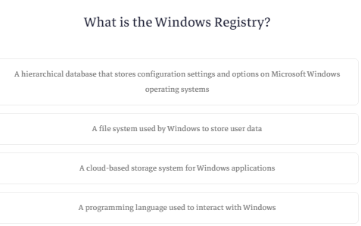

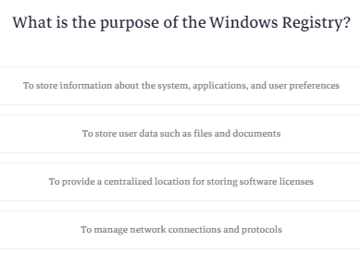

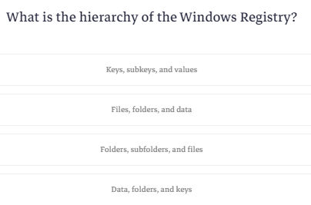

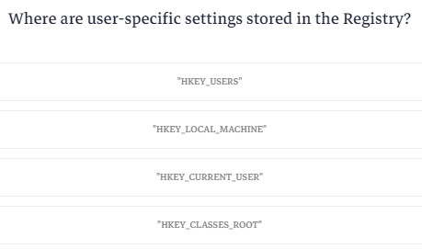

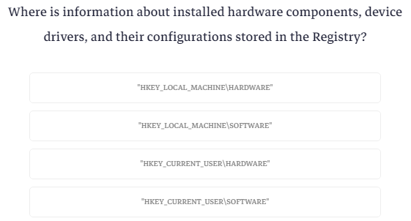

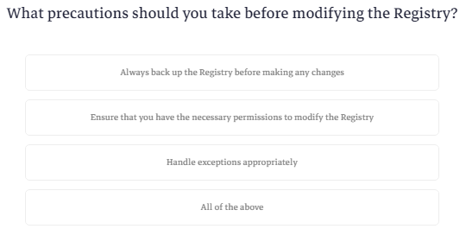

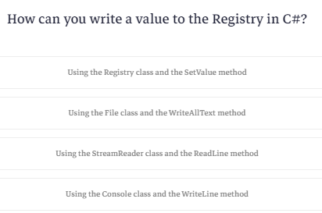

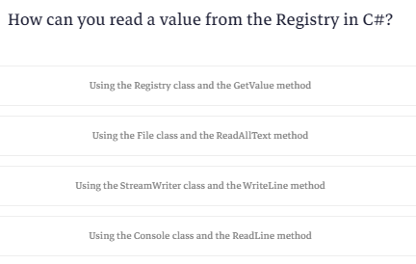

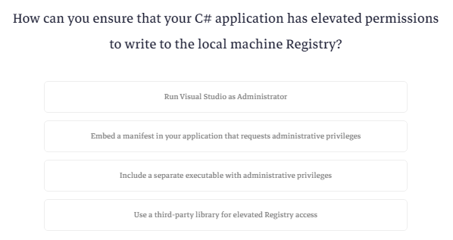

**Quiz 2**

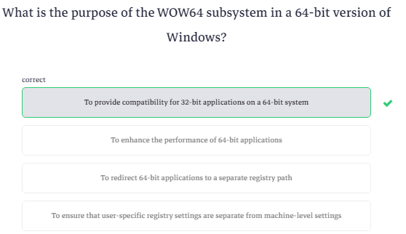

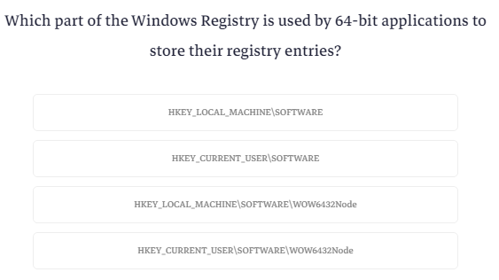

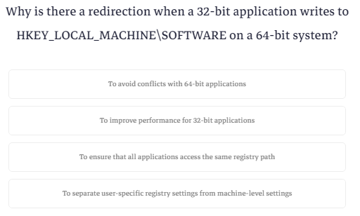

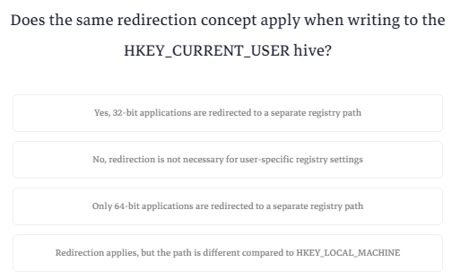

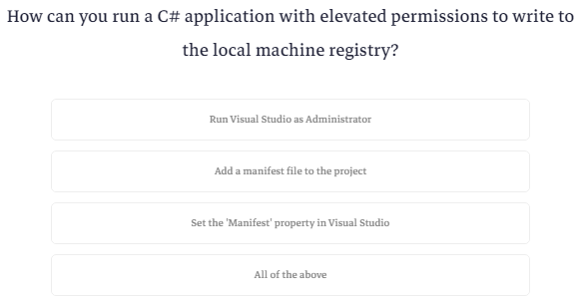

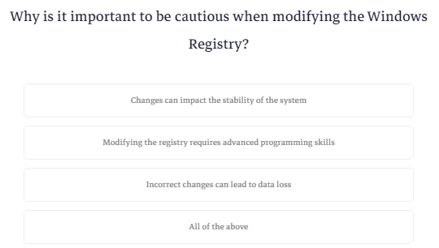

**Delete value from Registry - Example**

عشان نحذف registry هنحتاج اسم الkey والملف اللي قبليه علي طول زي كده

|  |
| --- |
| string keyPath = @"SOFTWARE\YourSoftware"; |

كمان هنحتاج اسم ال value

|  |
| --- |
| string valueName = "YourValueName"; |

الطريقه اللي هنستخدمها هتبقي اننا هنعمل اتنين objects واحد لل base key والتاني لل key بتاعنا

هنعمل دلوقتي ال base key تمام؟

هناخد object من كلاس اسمه registry key وهنستدعي method اسمها open base key

ال method دي بتاخد اتنين parameters

اول واحد المسار الأساسي سواء كان current user او local machine حسب انت حاطط ال registry بتاعك فين

تاني واحد هوا انت شغال علي سيستم 32 ولا 64 ؟

وهنحط ال using

|  |
| --- |
| using (RegistryKey baseKey = RegistryKey.OpenBaseKey(RegistryHive.CurrentUser, RegistryView.Registry64)) |

بعدين هنعمل ال sub key

هناخد object من registry key بس المرادي هنستدعي method موجوده في ال base key اسمها open sub key ودي بتاخد المسار المختصر وtrue عشان تبقي في ال write mode وتقدر تعدل عليه

|  |
| --- |
| using (RegistryKey key = baseKey.OpenSubKey(keyPath, true)) |

بعدين هتقوله لو ال key موجود احذفه

|  |
| --- |
| if (key != null)  {  // Delete the specified value  key.DeleteValue(valueName); |

بس كده

اهم حاجه ركز في ال parameters بتاعت ال base key عشان ماتقعدش تلف حوالين نفسك عالفاضي

|  |
| --- |
| using Microsoft.Win32;  using System;  class Program  {  static void Main()  {  // Specify the registry key path and value name  string keyPath = @"SOFTWARE\YourSoftware";  string valueName = "YourValueName";  try  {  // Open the registry key in read/write mode with explicit registry view  using (RegistryKey baseKey = RegistryKey.OpenBaseKey(RegistryHive.CurrentUser, RegistryView.Registry64))  {  using (RegistryKey key = baseKey.OpenSubKey(keyPath, true))  {  if (key != null)  {  // Delete the specified value  key.DeleteValue(valueName);  Console.WriteLine($"Successfully deleted value '{valueName}' from registry key '{keyPath}'");  }  else  {  Console.WriteLine($"Registry key '{keyPath}' not found");  }  }  }  }  catch (UnauthorizedAccessException)  {  Console.WriteLine("UnauthorizedAccessException: Run the program with administrative privileges.");  }  catch (Exception ex)  {  Console.WriteLine($"An error occurred: {ex.Message}");  }  Console.ReadKey();  }  } |

**What is Event Log?**

ال event logهيا داتا بيز موجوده في الويندوز بيكون فيه كل رسايل ال log اللي بيكون فيها معلومات او أخطاء

بتفتحها عن طريق زرار الويندوز وتبحث عن event viewer

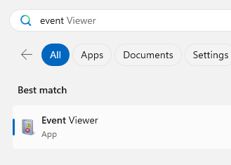

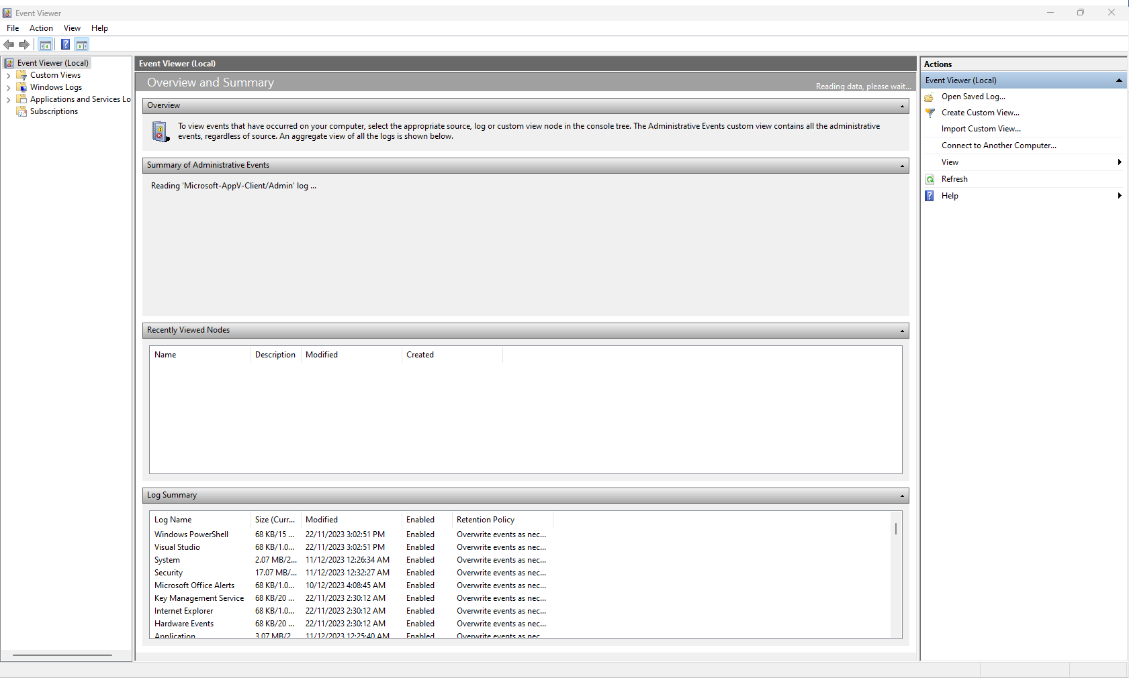

عندك مثلا ال logs بتاعت الويندوز بيكون فيها كل ال logs بتاعت التطبيقات

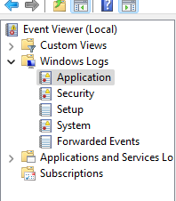

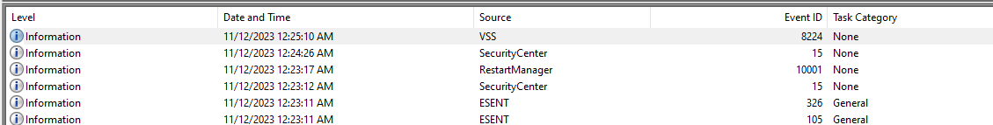

لما بتدوس علي كل log بتطلع بيانته تحت

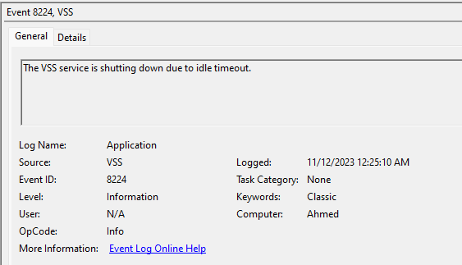

تقدر تعمل tracing بكل خطوة بيقوم بيها البرنامج بحيث لما العميل يقولك فيه مشكله في البرنامج تقوله يدخل عال logs ويفلتر علي التطبيق بتاعك

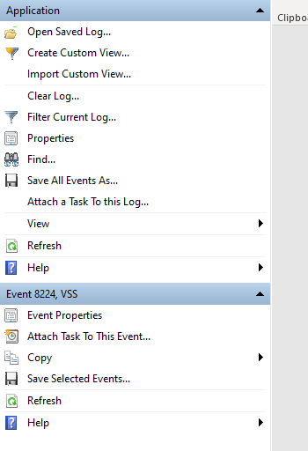

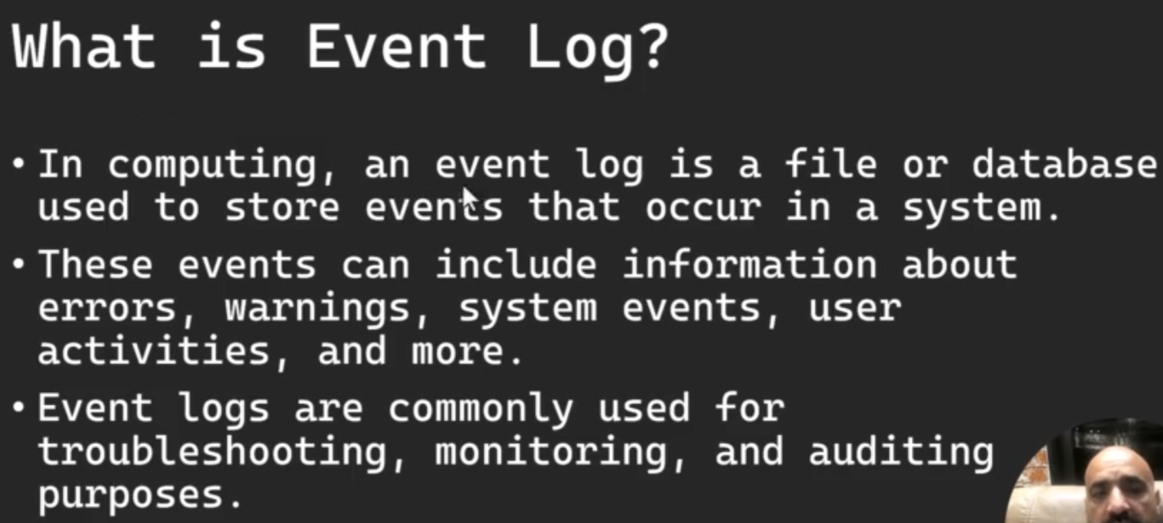

In computing, an event log is a file or database used to store events that occur in a system. These events can include information about errors, warnings, system events, user activities, and more. Event logs are commonly used for troubleshooting, monitoring, and auditing purposes.

To run the Windows Event Viewer, you can follow these steps:

1. Open the Start Menu:
   * In Windows 10, you can click on the Windows icon in the bottom left corner of your screen.
2. Search for "Event Viewer":
   * Type "Event Viewer" into the search bar.
3. Open Event Viewer:
   * Click on the "Event Viewer" app that appears in the search results.
4. Navigate to Event Logs:
   * In the Event Viewer window, you'll see a left-hand navigation pane. Click on "Windows Logs" to expand it.
5. Choose a Log:
   * Under "Windows Logs," you'll find several logs like "Application," "Security," "Setup," "System," and more. Choose the log you're interested in viewing. For the example provided earlier, you would likely find the log entry in the "Application" log.
6. View Log Entries:
   * Click on the log you selected, and you'll see a list of log entries in the center pane. Look for the entry created by your C# program.

The logs in the Event Viewer contain information about various events on your system, including system errors, warnings, information events, and more. You can filter, sort, and search for specific events within the Event Viewer interface to help you locate the information you need.

After running this program, you can check the Windows Event Viewer to see the log entry. Open the Event Viewer, navigate to "Windows Logs," and select "Application" to view the log entries.

**Logging Example**

بيقولك قبل ماتعمل log لازم تحدد انت عايز تعمله فين

فااحنا هنعمله في ال application

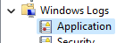

طيب عشان نعمل log جديد لازم نستدعي المكتبه دي

|  |
| --- |
| using System.Diagnostics; |

تاني حاجه بنحدد ال source اللي هوا اسم البرنامج

|  |
| --- |
| string Source = "KokoApp"; |

بعدين بنقول لو ال source ده مش موجود

|  |
| --- |
| if (!EventLog.SourceExists(Source)) {} |

اعمل واحد جديد واديله ال source وال category اللي هيتعمل فيه

|  |
| --- |
| if (!EventLog.SourceExists(Source)) {  EventLog.CreateEventSource(Source, "Application");  Console.WriteLine("Event Source created");  } |

احنا كده كأننا عملنا ملف هنحط جواه كل المعلومات بتاعتنا وكل اللي هنعمله بعد كده عشان نضيف معلومه هوا اننا نستدعي method اسمها write entry وبتاخد اسم ال source والمعلومه ونوع ال log

كانك بتعمل message box

|  |
| --- |
| EventLog.WriteEntry(Source,"this is information",EventLogEntryType.Information);  EventLog.WriteEntry(Source,"this is warning",EventLogEntryType.Warning);  EventLog.WriteEntry(Source,"this is Error",EventLogEntryType.Error); |

بس هتحتاج صلاحيات ودي شرحناها قبل كده

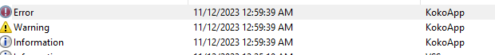

In computing, an event log is a file or database used to store events that occur in a system. These events can include information about errors, warnings, system events, user activities, and more. Event logs are commonly used for troubleshooting, monitoring, and auditing purposes.

In C#, you can work with the event log using the EventLog class, which is part of the System.Diagnostics namespace. Here's a simple example of how to write an entry to the Windows event log in C#:

using System;

using System.Diagnostics;

class Program

{

    static void Main()

    {

        // Specify the source name for the event log

        string sourceName = "MyApp";

        // Create the event source if it does not exist

        if (!EventLog.SourceExists(sourceName))

        {

            EventLog.CreateEventSource(sourceName, "Application");

            Console.WriteLine("Event source created.");

        }

        // Log an information event

        EventLog.WriteEntry(sourceName, "This is an information event.", EventLogEntryType.Information);

        Console.WriteLine("Event written to the log.");

    }

}

In this example:

1. We define a sourceName variable, which represents the source of the event log entries. This is typically the name of your application.
2. We check if the event source exists, and if not, we create it using EventLog.CreateEventSource.
3. We use EventLog.WriteEntry to write an entry to the event log. In this case, it's an information event, but you can choose from different entry types such as Information, Warning, or Error.

Make sure to run this program with sufficient permissions, as creating an event source may require administrative privileges.

After running this program, you can check the Windows Event Viewer to see the log entry. Open the Event Viewer, navigate to "Windows Logs," and select "Application" to view the log entries. You should see the entry created by your C# program.

**Quiz**

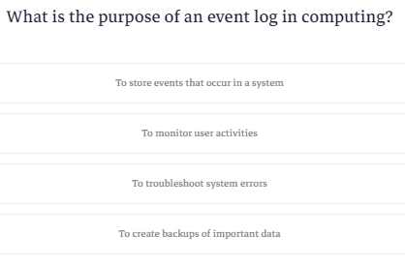

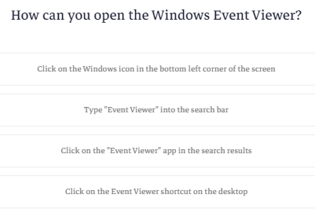

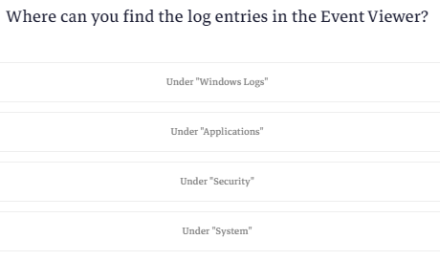

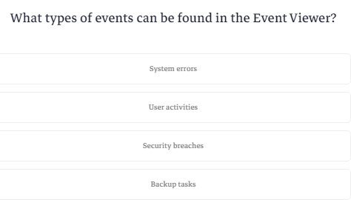

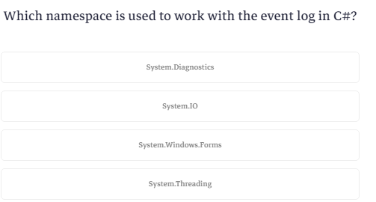

**Homework**

### **Go to the DVLD project in course 19 and log all exceptions in the event log :-)**

### **Wherever there is try catch, use event log to log the exception.**

|  |
| --- |
| using System.Diagnostics;  namespace DVLD_DataAccess  {  public class clsDataAccessLogs  {  public static void CreateExceptionLog(string Message) {  string SourceName = "DVLD";  if (!EventLog.SourceExists(SourceName)) {  EventLog.WriteEntry(SourceName, Message,EventLogEntryType.Error);  }  }  }  } |

**What is App.Config?**

في الكورس اللي فات كنا بنخزن ال connection string جوه البرنامج نفسه

بس لو جيت تحط الكود عند العميل هتحتاج تعدله وخصوصا لو عندك اكتر من عميل او مثلا هتيجي تغير السيرفر

فقالك انه فيه ملف اسمه app.config ولما بتعمل build بيشيل كلمة app ويحط مكانها اسم المشروع بتاعك الملف ده ده بتخزن الحاجات اللي زي كده وده بيكون ملف xml وده بيكون عباره عن أجزاء كل جزء بيمثل settings معينه جوه البرنامج وفيه مكتبه بتقدر تخليك توصله وتعدل فيه

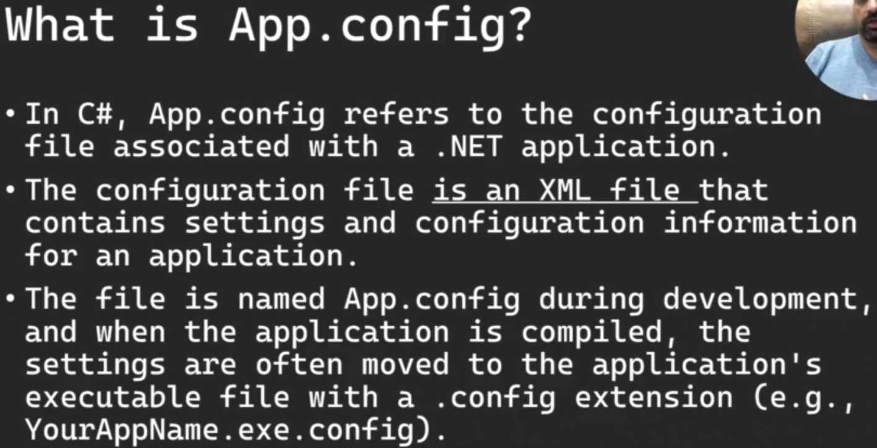

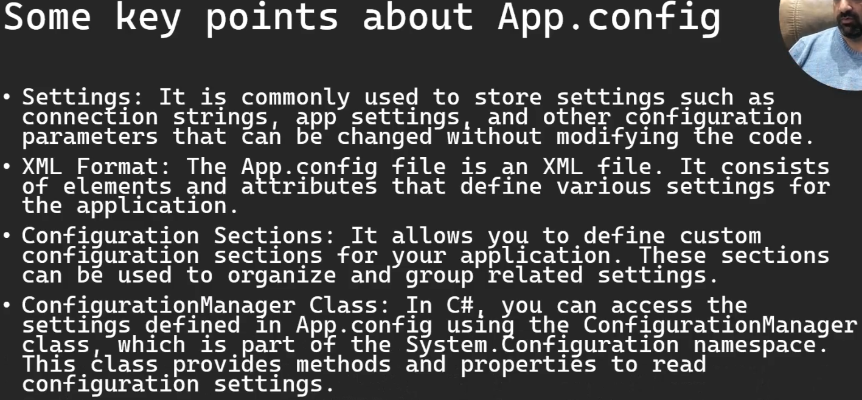

In C#, App.config refers to the configuration file associated with a .NET application. The configuration file is an XML file that contains settings and configuration information for an application. The file is named App.config during development, and when the application is compiled, the settings are often moved to the application's executable file with a .config extension (e.g., YourAppName.exe.config).

Here are some key points about App.config:

1. Settings: It is commonly used to store settings such as connection strings, app settings, and other configuration parameters that can be changed without modifying the code.
2. XML Format: The App.config file is an XML file. It consists of elements and attributes that define various settings for the application.
3. Configuration Sections: It allows you to define custom configuration sections for your application. These sections can be used to organize and group related settings.
4. ConfigurationManager Class: In C#, you can access the settings defined in App.config using the ConfigurationManager class, which is part of the System.Configuration namespace. This class provides methods and properties to read configuration settings.

If you are using the .NET Framework and still facing issues with ConfigurationManager, there are a few more steps you can take to troubleshoot the problem:

* Check System.Configuration Reference:
  + Right-click on your project in Visual Studio.
  + Choose "Add" -> "Reference..."
  + In the Reference Manager, make sure that System.Configuration is checked.
* Verify Namespace and Using Directive:
* Ensure that your code file has the following using directive:

using System.Configuration;

* Framework Version:
  + Confirm that your project is targeting a version of the .NET Framework that supports ConfigurationManager. Open your project properties and check the "Target framework" setting. It should be set to a version of the .NET Framework (e.g., .NET Framework 4.x).
* Clean and Rebuild:
  + Try cleaning and rebuilding your solution. Right-click on your solution in Solution Explorer and choose "Clean," then right-click again and choose "Rebuild."
* Restart Visual Studio:
  + Sometimes, issues can be resolved by restarting Visual Studio.

Remember that the App.config is primarily used during development. In production, the settings are often moved to the application's actual configuration file.

**How to use App.config Examlpe**

عشان تستخدم المكتبه بتاعت ال system.configurations لازم تعملها reference الأول

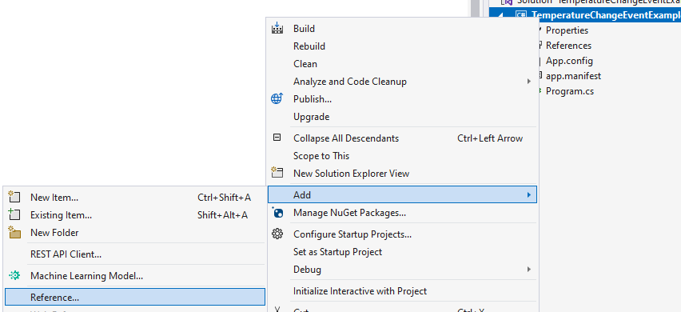

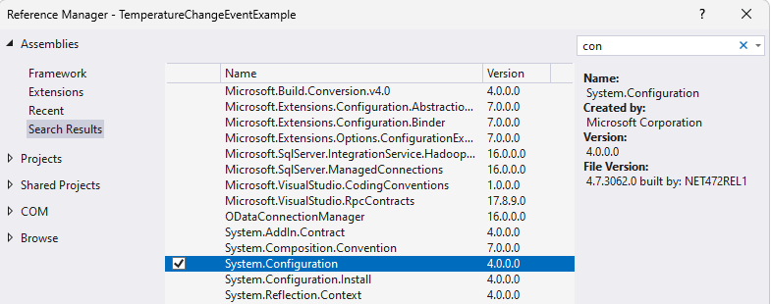

بالنسبالي لقيت الملف بتاع ال config موجود بس لو مالقيتهوش هنضيفه من خلال add>>Item ونسميه

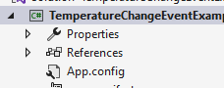

ده الكود اللي لقيته جوه

|  |
| --- |
| <?xml version="1.0" encoding="utf-8" ?>  <configuration>  <startup>  <supportedRuntime version="v4.0" sku=".NETFramework,Version=v4.7.2" />  </startup>  </configuration> |

انت بتكتب الكود بتاعك كله جوه ال configuration يعني مابين ال tag ده

|  |
| --- |
| <configuration>  </configuration> |

اللي فوق ده اسمه tag عباره عن كلمة بين علامة اكبر من واصغر من وال compiler بيفهم ان الكود اللي جوه ال tag ده انتهي لما بتقفل ال tag عن طريق انك تكتب اسمه بين علامتين اكبر واصغر بس بتحط قبل الاسم شرطه مايله

وتحط تعمل اكتر من tag جوه ال tag الواحد

ال tag عامتأ بيمثل object او داتا معينه ولو هتحط جواه داتا يبقي بتحطها بالمنظر ده

|  |
| --- |
| <Tag>  --Your code here--  </Tag> |

طيب لو ال tag ده ليه خصائص معينه زي انه مثلا بيمثل button ال button ده ليه خصائص زي ال name وال text وهكذا

بتحط الخصائص دي قبل علامة اكبر من بالمنظر ده

|  |
| --- |
| <Tag  property1= ProppertyValue  Property2=propertyvalue  >  --Your code here--  </Tag> |

فيه حاجه كمان وهيا انك لو مش هتكتب حاجه جوه ال tag وهتكتب الخصائص بتاعته بس او حتي مفيش خصائص تقدر تعمله بالمنظر ده

|  |
| --- |
| <Tag  property1= ProppertyValue  Property2=propertyvalue  /> |
| <Tag / > |

طيب تعالي نعمل الكود بتاع ال connection string

هنا قالك فيه طريقتين

اول طريقه انك تعمل tag واحد تحط فيه اعدادات البرنامج كلهاويكون من ضمنها ال

connection string

وده عن طريق انك بتعمل tag تكتب فيه add key وتكتب اسم لل key والقيمه بتاعته زي كده

ال key ده الاسم اللي هتستدعي القيمه من خلاله يعني كأنك بتعرف متغير

|  |
| --- |
| <add key="ConnectionString" value="Data Source=ServerName;Initial Catalog=DatabaseName;Integrated Security=True" />  <add key="LogLevel" value="Debug" />  <add key="koko" value="Koko Value" /> |

في الكود اللي فات احنا كأننا عرفنا متغير واديناه القيمه بتاعته

تاني طريقه وهيا انك تعمله في section لوحده كأنك بتخزن object

|  |
| --- |
| <connectionStrings>  <add name="MyDbConnection" connectionString="Data Source=ServerName;Initial Catalog=DatabaseName;Integrated Security=True" providerName="System.Data.SqlClient" />  </connectionStrings> |

وده الكود كله

|  |
| --- |
| <?xml version="1.0" encoding="utf-8" ?>  <configuration>  <appSettings>  <add key="ConnectionString" value="Data Source=ServerName;Initial Catalog=DatabaseName;Integrated Security=True" />  <add key="LogLevel" value="Debug" />  <add key="koko" value="Koko Value" />    </appSettings>  <connectionStrings>  <add name="MyDbConnection" connectionString="Data Source=ServerName;Initial Catalog=DatabaseName;Integrated Security=True" providerName="System.Data.SqlClient" />  </connectionStrings>  </configuration> |

بالنسبالي انا هاخد الكود واضيفه عالملف اللي عندي

|  |
| --- |
| <?xml version="1.0" encoding="utf-8" ?>  <configuration>  <startup>  <supportedRuntime version="v4.0" sku=".NETFramework,Version=v4.7.2" />  </startup>    <appSettings>  <add key="ConnectionString" value="Data Source=ServerName;Initial Catalog=DatabaseName;Integrated Security=True" />  <add key="LogLevel" value="Debug" />  <add key="koko" value="Koko Value" />  </appSettings>  <connectionStrings>  <add name="MyDbConnection" connectionString="Data Source=ServerName;Initial Catalog=DatabaseName;Integrated Security=True" providerName="System.Data.SqlClient" />  </connectionStrings>  </configuration> |

طيب نيجي للكود

اول حاجه هنضيف المكتبه

|  |
| --- |
| using System.Configuration; |

طيب عشان تستدعي القيم اللي خزنتها هتعمل ايه؟

اول حاجه هتستدعي ال configuration manager وبعدين نقطه وبعدين اسم ال tag اللي مخزن تحتيه القيمه اللي انت عايزها وبعدين بتكتب الname او ال key

لو كنت مخزن key فاانت هتكتب اسم ال key وخلصنا

انما لو كنت مخزن object فهتكتب ال name وبعدها نقطه وبعدها تشوف انت عايز تستدعي ايه من جواه

|  |
| --- |
| using System;  using System.Configuration;  class NullableExample  {  static void Main()  {  string ConnectionString = ConfigurationManager.AppSettings["ConnectionString"];  string logLevel = ConfigurationManager.AppSettings["LogLevel"];  string koko = ConfigurationManager.AppSettings["koko"];  string MyDbConnection = ConfigurationManager.ConnectionStrings["MyDbConnection"].ConnectionString;  Console.WriteLine($"\nConnectionString:{ConnectionString}");  Console.WriteLine($"\nlogLevel: {logLevel}");  Console.WriteLine($"\nkoko: {koko}");  Console.WriteLine($"\nMyDbConnection: {MyDbConnection}");  Console.ReadKey();  }  } |

خلي بالك لو هتشغل البرنامج عند العميل مش هتعدل عال app config لا الملف هيكون واخد اسم البرنامج .config

**Quiz**

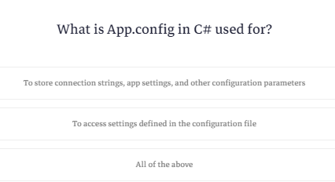

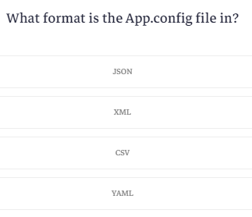

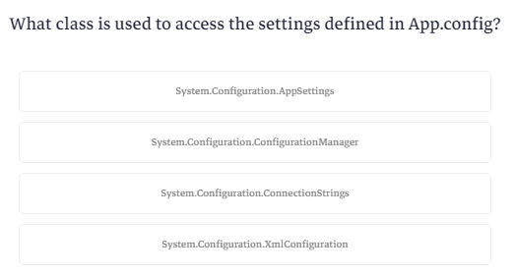

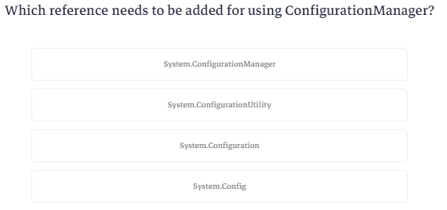

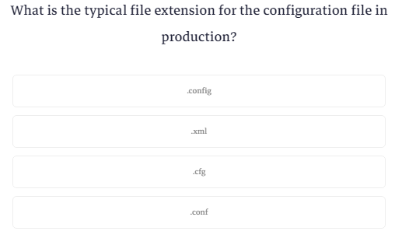

**What is String Builder and Why?**

دلوقتي كلنا عرفنا انه ال string هوا عباره عن immutable data type يعني قيمته لايمكن ان تتغير فكل مره انت بتعدل عالقيمه اللي فيه بيروح يعمل نسخه منه بالقيمه الجديده

عشان كده عملوا حاجه تانيه اسمها string builder وده mutable datatype

فكرته انه بيعمل buffer بحيث انك تقدر تعدل عال string ولو ال buffer ده اتملي بيعمل copy ويضيف عليه

فعدد ال copies هنا اقل بكتير من ال string

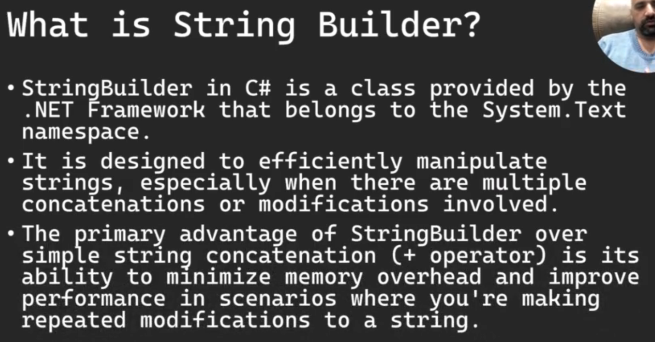

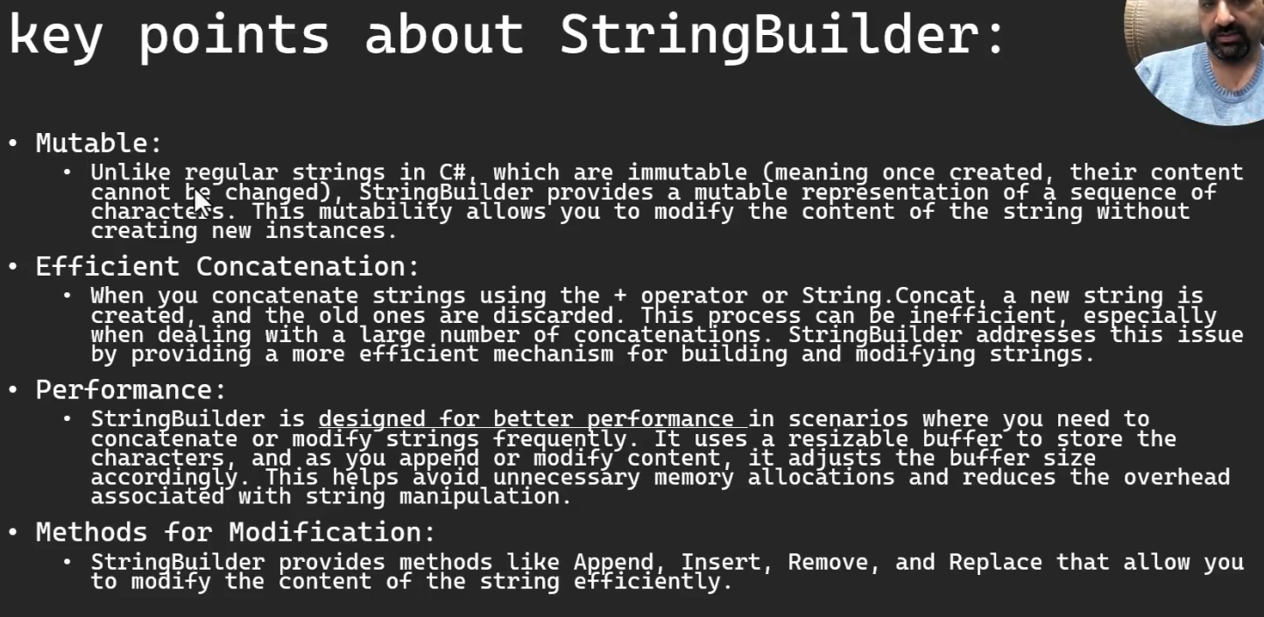

|  |
| --- |
| using System;  using System.Diagnostics;  using System.Text;  class NullableExample  {  static void ConcatenateStrings(int iterations) {  string result = "";  for (int i=0;i< iterations;i++) {  result += "a";  }  }  static void ConcatenateStringBuilder(int iterations) {  StringBuilder sb = new StringBuilder();  for (int i = 0; i < iterations; i++)  {  sb.Append("a");  }  string result=sb.ToString();  }  static void Main()  {  int Iterations = 200000;  Stopwatch stopwatch1 = Stopwatch.StartNew();  ConcatenateStrings(Iterations);  stopwatch1.Stop();  Console.WriteLine($"ConcatenateStrings took : {stopwatch1.ElapsedMilliseconds}");  Stopwatch stopwatch2 = Stopwatch.StartNew();  ConcatenateStringBuilder(Iterations);  stopwatch2.Stop();  Console.WriteLine($"ConcatenateStrings took : {stopwatch2.ElapsedMilliseconds}");  Console.ReadKey();  }  } |

StringBuilder in C# is a class provided by the .NET Framework that belongs to the System.Text namespace. It is designed to efficiently manipulate strings, especially when there are multiple concatenations or modifications involved. The primary advantage of StringBuilder over simple string concatenation (+ operator) is its ability to minimize memory overhead and improve performance in scenarios where you're making repeated modifications to a string.

Here are some key points about StringBuilder:

* Mutable:
  + Unlike regular strings in C#, which are immutable (meaning once created, their content cannot be changed), StringBuilder provides a mutable representation of a sequence of characters. This mutability allows you to modify the content of the string without creating new instances.
* Efficient Concatenation:
  + When you concatenate strings using the + operator or String.Concat, a new string is created, and the old ones are discarded. This process can be inefficient, especially when dealing with a large number of concatenations. StringBuilder addresses this issue by providing a more efficient mechanism for building and modifying strings.
* Performance:
  + StringBuilder is designed for better performance in scenarios where you need to concatenate or modify strings frequently. It uses a resizable buffer to store the characters, and as you append or modify content, it adjusts the buffer size accordingly. This helps avoid unnecessary memory allocations and reduces the overhead associated with string manipulation.
* Methods for Modification:
  + StringBuilder provides methods like Append, Insert, Remove, and Replace that allow you to modify the content of the string efficiently.
* Capacity Management:
  + You can explicitly set the initial capacity of the StringBuilder to reduce the number of reallocations if you have an estimate of the final string size.

**What is Cryptography?**

ال cryptographyمعناها التشفيروفايدته انك حتي لواتهكرت الهاكر هيوصل للمعلومه مشفرة ومش هيعرف يستفيد منها

وبيتم تشفير البيانات عن طريق algorithms معقدة

دي المكتبه اللي هنستخدمها في التشفير

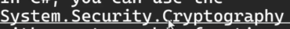

وبيقولك فيه 3 أنواع من التشفير هما

(hashing-symetric encryption – asymmetric encryption)

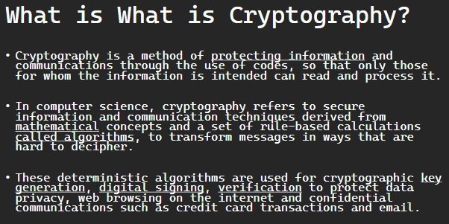

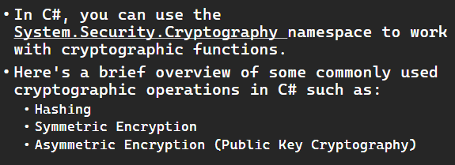

**Cryptography**is a method of protecting information and communications through the use of codes, so that only those for whom the information is intended can read and process it.

In computer science, **cryptography**refers to secure information and communication techniques derived from mathematical concepts and a set of rule-based calculations called algorithms, to transform messages in ways that are hard to decipher. These deterministic algorithms are used for cryptographic key generation, digital signing, verification to protect data privacy, web browsing on the internet and confidential communications such as credit card transactions and email.

**Cryptography**is the practice and study of techniques for secure communication in the presence of third parties. In C#, you can use the System.Security.Cryptography namespace to work with cryptographic functions. Here's a brief overview of some commonly used cryptographic operations in C# such as:

* Hashing
* Symmetric Encryption
* Asymmetric Encryption (Public Key Cryptography)

**Cryptography Quiz**

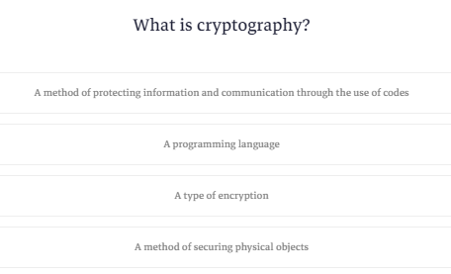

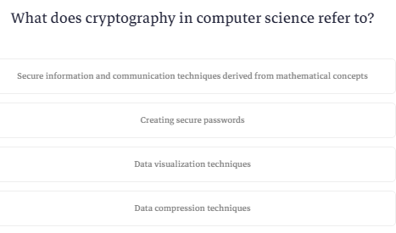

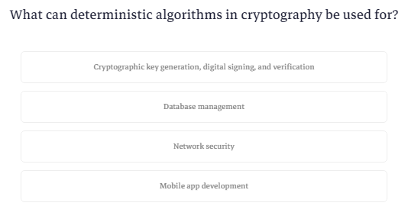

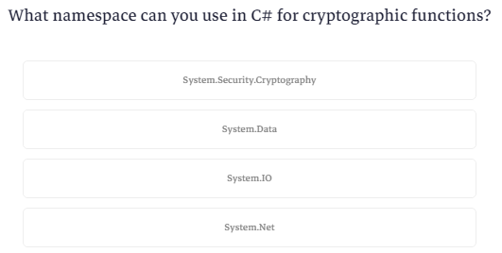

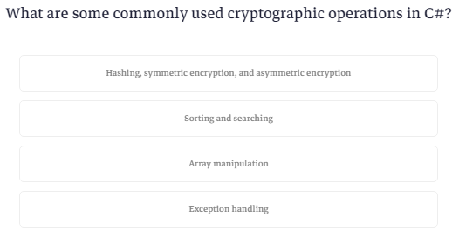

**What is Hashing?**

ال hashing هيا طريقة لتشفير المعلومات وده بيكون one way يعني لما بيشفرلك الداتا بيطلعلك text ماتفهمش منه حاجه وماتقدرش ترجعه لاصله

امال هنعرف القيمه الاصليه منين؟

قالك لو عندك مثلا باسوورد بتعمله hashing هيطلعلك text تخزنه في الداتابيز وبعدين لما ييجي اليوزر يكتب الباسورد بتاعه هتاخد الباسورد اللي اتكتب ده وبعدين تعمله تشفير هوا كمان وبعدها تقارن المتشفر بالمتشفر

يعني الحل الوحيد لو نسيت الباسورد هوا انك تقعد تجرب تدخله او تعمله reset

عشان كده لازم تستعمل نفس ال algorithm في التشفير عشان تطلع نفس النتيجه

عشان تستعمل ال hashing بتستعمل حاجه اسمها SHA-265 وده اختصار ل

Secure hash algorithm خاصه بمجموعتين من hash functions ال 265 معناها 265 بت

الكود او الtext الناتج عن عملية التشفير دي بيكون 64 حرف ممثلين بال hexa decimal فلو ضربتهم في 4 يطلعلك ال 265 bit

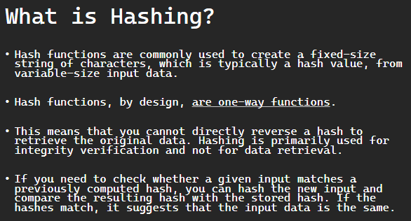

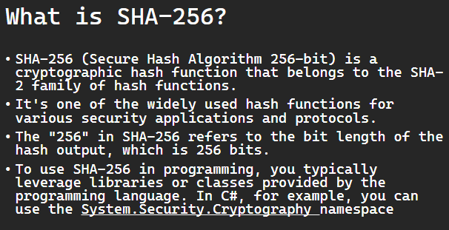

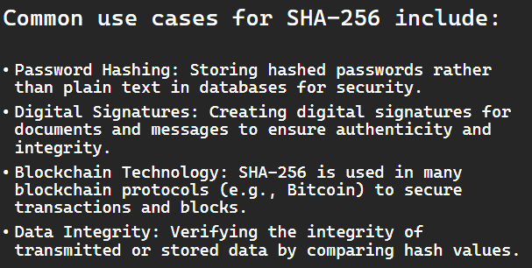

### **Hashing:**

Hash functions are commonly used to create a fixed-size string of characters, which is typically a hash value, from variable-size input data.

Hash functions, by design, are one-way functions. This means that you cannot directly reverse a hash to retrieve the original data. Hashing is primarily used for integrity verification and not for data retrieval.

If you need to check whether a given input matches a previously computed hash, you can hash the new input and compare the resulting hash with the stored hash. If the hashes match, it suggests that the input data is the same.

**SHA-256** (Secure Hash Algorithm 256-bit) is a cryptographic hash function that belongs to the SHA-2 family of hash functions. It's one of the widely used hash functions for various security applications and protocols. The "256" in SHA-256 refers to the bit length of the hash output, which is 256 bits.

Common use cases for SHA-256 include:

* Password Hashing: Storing hashed passwords rather than plain text in databases for security.
* Digital Signatures: Creating digital signatures for documents and messages to ensure authenticity and integrity.
* Blockchain Technology: SHA-256 is used in many blockchain protocols (e.g., Bitcoin) to secure transactions and blocks.
* Data Integrity: Verifying the integrity of transmitted or stored data by comparing hash values.

To use SHA-256 in programming, you typically leverage libraries or classes provided by the programming language. In C#, for example, you can use the System.Security.Cryptography namespace, as demonstrated in the code examples provided in previous responses.

**Hashing Example**

عشان تستخدم الhashing بتستدعي المكتبه دي

|  |
| --- |
| using System.Security.Cryptography; |

عشان تعمل hash بتستخدم ال using وتعمل object من SHA265 عن طريق METHOD اسمها CREATE

|  |
| --- |
| using (SHA256 sHA256=SHA256.Create()) { |

وبعدين بتعمل array من النوع byte عشان تضيف فيه الكود اللي هيطلع

وهتستدعي method اسمها compute hash وتديها النص اللي عايز تشفره بس عن طريق ال encoding

|  |
| --- |
| Byte[] hashBytes = sHA256.ComputeHash(Encoding.UTF8.GetBytes(input)); |

ولما يخلص هتحول ال bytes ل string

|  |
| --- |
| return BitConverter.ToString( hashBytes ).Replace("-","").ToLower(); |

بس كده وده الكود كله

|  |
| --- |
| using System;  using System.Security.Cryptography;  using System.Text;  class NullableExample  {  static void Main()  {  string data = "Mohammed";  string hashData = ComputeHash(data);  Console.WriteLine($"Original:{data}");  Console.WriteLine($"hashed:{hashData}");  Console.WriteLine($"Hashed Data LENGTH: {hashData.Length}");  Console.ReadKey();  }  static string ComputeHash(string input) {  using (SHA256 sHA256=SHA256.Create()) {  Byte[] hashBytes = sHA256.ComputeHash(Encoding.UTF8.GetBytes(input));  return BitConverter.ToString( hashBytes ).Replace("-","").ToLower();  }  }  } |

To use SHA-256 in programming, you typically leverage libraries or classes provided by the programming language. In C#, for example, you can use the System.Security.Cryptography namespace, as demonstrated in the code examples provided in previous responses.

The following C# program is a simple example of computing the SHA-256 hash of a string using the System.Security.Cryptography namespace. Here's a breakdown of your code:

using System;

using System.Security.Cryptography;

using System.Text;

class Program

{

    static void Main()

    {

        // Input data

        string data = "Mohammed Abu-Hadhoud";

        // Compute the SHA-256 hash of the input data

        string hashedData = ComputeHash(data);

        // Display the original data and its hash

        Console.WriteLine($"Original Data: {data}");

        Console.WriteLine($"Hashed Data: {hashedData}");

        // Pause to keep the console window open for viewing the results

        Console.ReadKey();

    }

    static string ComputeHash(string input)

    {

        //SHA is Secutred Hash Algorithm.

        // Create an instance of the SHA-256 algorithm

        using (SHA256 sha256 = SHA256.Create())

        {

            // Compute the hash value from the UTF-8 encoded input string

            byte[] hashBytes = sha256.ComputeHash(Encoding.UTF8.GetBytes(input));

            // Convert the byte array to a lowercase hexadecimal string

            return BitConverter.ToString(hashBytes).Replace("-", "").ToLower();

        }

    }

}

Explanation:

1. Input Data: You have a string data containing the text "Mohammed Abu-Hadhoud".
2. Hashing: The ComputeHash method takes a string as input, converts it to a byte array using UTF-8 encoding, and then computes the SHA-256 hash using the SHA256 class. The resulting hash is a byte array.
3. Formatting the Hash: The byte array is converted to a lowercase hexadecimal string using BitConverter.ToString() and then removing the hyphens with Replace("-", ""). This creates a string representation of the hash.
4. Displaying Results: The original data and its computed hash are then displayed in the console.
5. Console.ReadKey(): This line is used to pause the console window so that you can view the output. Pressing a key will close the console window.

The code demonstrates the basics of computing a SHA-256 hash in C#. It's a common practice to use hash functions for various purposes, such as data integrity verification and storing passwords securely. Keep in mind that for password storage, you should use additional techniques like salting to enhance security.

**Hashing Homework**

### **Go to the project in course 19 , and use hashing to hash the password and save it to database , then update your project accordingly ( update the login, change password forms ).**

تم تكبير خانة الباسورد في الداتابيز بحيث تسع 64 حرف وتم استخدام نفس ال method في المثال السابق تم وضعها في كلاس ال util وتم استخدامها اثناء حفظ الباسورد في

=========================

RememberUsernameAndPassword

===========================

frmChangePassword>>>>>btnSave_Click _User.Password =clsUtil.ComputeHash(txtNewPassword.Text);

==================================

frmAddUpdateUser>>>>>btnSave_Click _User.Password = clsUtil.ComputeHash( txtPassword.Text.Trim());

=====================================

frmLogin>>>>>>>>btnLogin_Click clsUser user= clsUser.FindByUsernameAndPassword(txtUserName.Text.Trim(),clsUtil.ComputeHash(txtPassword.Text.Trim()));

============================

**Hashing Quiz**

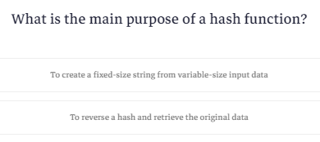

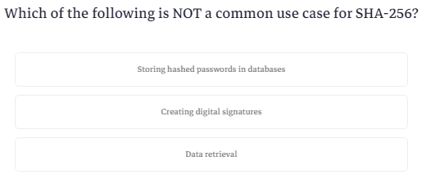

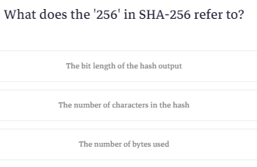

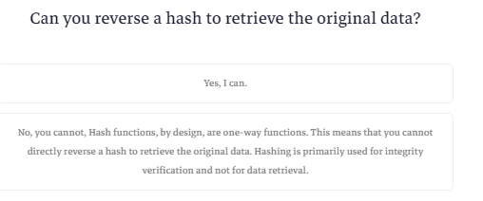

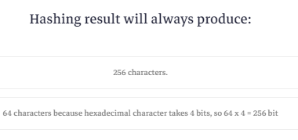

**What is Symmetric Encryption?**

ال symmetric encryption ودي بيتم تشفير الداتا وبتقدر تفك التشفير تاني

الحوار ده بيعتمد علي key انت بتيديهوله عشان يعمل تشفير وبتحتاج نفس ال key عشان تفك التشفير

زي ماكنا بنعمل في ال c++ لما كنا بنزود حرفين وننقص حرفين فبيطلع كلام مش مفهوم

بيقولك انه فيه اكتر من algorithm للتشفير منها DES وهيا اختصار ل

Data encryption standard

و 3DS وهيا اختصار ل triple des و AES وهيا اختصار ل

Advanced encryption standard وكمان ال RC4

احنا هنستخدم ال AES

هنا بيقولك انه ال key اللي ال AES بيكون حجمه 128 بت ليه؟

عشان مثلا لو انت عامل الباسورد بتاعك من رقم واحد او حرف واحد ده بيكون من السهل تخمينه لان اللي عايز يهكرك يدوب هيجرب يدخل الرقم 10 مرات ولو حرف فهيكون بعدد الحروف هيجرب

لكن لو ال key بتاعك طويل زي في حالة ال aes هنا 128 bit هيكون صعب تخمينه

طيب ال 128 bit دول كام حرف ؟

هما 16 حرف لان الحرف الواحد بياخد مساحه byte واحد اللي هيا 8 bits فلو ضربت 16*8=128

بيقولك كمان انه ال AES بتستخدم 3 احجام من ال key (128bit-192-bit-256bit)

طيب ال 128bit عشان يقدر حد يخمنه هيحتاج يعمل محاولات عددها 2 اس 128 وده الشائع استخدامه

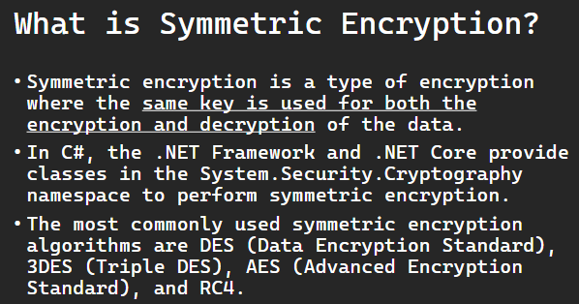

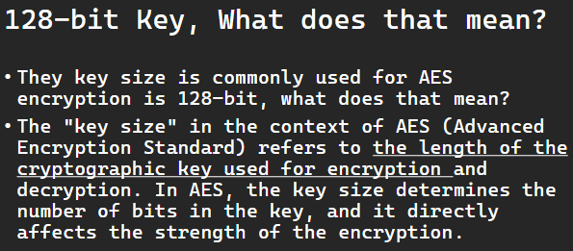

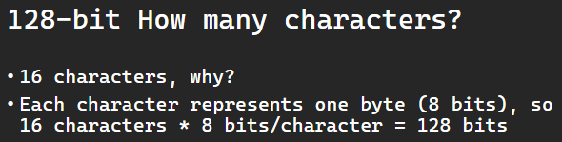

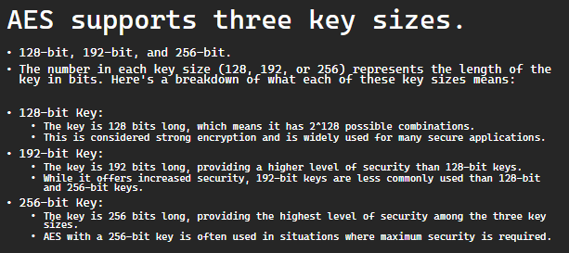

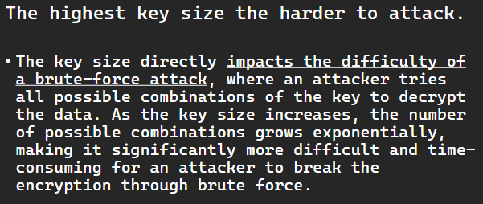

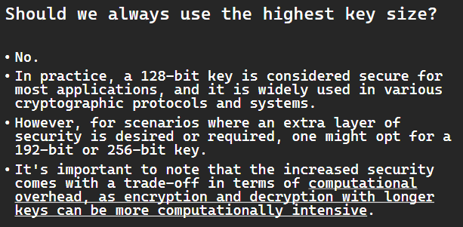

**Symmetric encryption** is a type of encryption where the same key is used for both the encryption and decryption of the data. In C#, the .NET Framework and .NET Core provide classes in the System.Security.Cryptography namespace to perform symmetric encryption. The most commonly used symmetric encryption algorithms are DES (Data Encryption Standard), 3DES (Triple DES), AES (Advanced Encryption Standard), and RC4.

#### ****They key size is commonly used for AES encryption is 128-bit, what does that mean?****

The "key size" in the context of **AES (Advanced Encryption Standard)** refers to the length of the cryptographic key used for encryption and decryption. In AES, the key size determines the number of bits in the key, and it directly affects the strength of the encryption.

AES supports three key sizes: 128-bit, 192-bit, and 256-bit. The number in each key size (128, 192, or 256) represents the length of the key in bits. Here's a breakdown of what each of these key sizes means:

* 128-bit Key:
  + The key is 128 bits long, which means it has 2^128 possible combinations.
  + This is considered strong encryption and is widely used for many secure applications.
* 192-bit Key:
  + The key is 192 bits long, providing a higher level of security than 128-bit keys.
  + While it offers increased security, 192-bit keys are less commonly used than 128-bit and 256-bit keys.
* 256-bit Key:
  + The key is 256 bits long, providing the highest level of security among the three key sizes.
  + AES with a 256-bit key is often used in situations where maximum security is required.

The key size directly impacts the difficulty of a brute-force attack, where an attacker tries all possible combinations of the key to decrypt the data. As the key size increases, the number of possible combinations grows exponentially, making it significantly more difficult and time-consuming for an attacker to break the encryption through brute force.

In practice, a 128-bit key is considered secure for most applications, and it is widely used in various cryptographic protocols and systems. However, for scenarios where an extra layer of security is desired or required, one might opt for a 192-bit or 256-bit key. It's important to note that the increased security comes with a trade-off in terms of computational overhead, as encryption and decryption with longer keys can be more computationally intensive.

**You should not lose the key!**

Remember that in real-world scenarios, you would typically use a more secure method for key management, and for sensitive information, it's important to handle encryption keys securely. Additionally, consider using authenticated encryption modes for added security.

**Symmetric Encryption Example**

قبل مانبدأ تشفير لازم نحدد ال key وال key ده ليه طرق في تخزينه ولازم مايضيعش لكن حاليا هنحطه في string ولازم يكون 16 حرف

|  |
| --- |
| string Key = "1234567890123456"; |

عشان نشفر الداتا هناخد object من aes ونعمله جوه using

|  |
| --- |
| using (Aes aes=Aes.Create()) { |

ال object ده فيه parameters صح؟

صح

من ال parameters دي حاجه اسمها key وفيه بخزن ال key اللي انا عملته بس في شكل bytes

|  |
| --- |
| aes.Key=Encoding.UTF8.GetBytes(Key); |

بعدين لازم اعمل vector عشان يخزن فيه الداتا هنقوله ناخد حجم ال key بال bits ونقسمه علي 8 عشان يدينا عدد الخلايا اللي في ال vector

|  |
| --- |
| aes.IV = new byte[aes.BlockSize / 8]; |

بعدين هنعمل encryptor ونديله ال key وال vector اللي موجودين في ال aes

|  |
| --- |
| ICryptoTransform encryptor=aes.CreateEncryptor(aes.Key,aes.IV); |

بعدين نفتح اتصال مع ال memory

|  |
| --- |
| using (var msEncrypt=new System.IO.MemoryStream()) { |

بعدين هناخد object من حاجه اسمها crypto stream

|  |
| --- |
| using (var csEncrypt=new CryptoStream(msEncrypt,encryptor,CryptoStreamMode.Write)) { |

بعدين هنعمل stream writer ونقوله يكتب اللي طلعه ونرجع الداتا بعد التشفير

|  |
| --- |
| using (var swEncrypt=new System.IO.StreamWriter(csEncrypt)) {    swEncrypt.Write(plainText);  }  return Convert.ToBase64String(msEncrypt.ToArray()); |

طيب في فك التشفير ؟

نفس الخطوات بس هتشيل كلمه encrypt وتحط decrypt وتشيل write وتحط read وهكذا

وده الكود كله

|  |
| --- |
| using System;  using System.Security.Cryptography;  using System.Text;  class NullableExample  {  static void Main()  {  string OriginalData = "Sensitive information";  string Key = "1234567890123456";  string encryptedData = Encrypt(OriginalData,Key);  string decryptedData = Decrypt(encryptedData, Key);  Console.WriteLine($"OriginalData: {OriginalData}");  Console.WriteLine($"encryptedData: {encryptedData}");  Console.WriteLine($"decryptedData: {decryptedData}");  Console.ReadKey();  }  static string Encrypt(string plainText,string Key) {  using (Aes aes=Aes.Create()) {  aes.Key=Encoding.UTF8.GetBytes(Key);  aes.IV = new byte[aes.BlockSize / 8];  ICryptoTransform encryptor=aes.CreateEncryptor(aes.Key,aes.IV);  using (var msEncrypt=new System.IO.MemoryStream()) {  using (var csEncrypt=new CryptoStream(msEncrypt,encryptor,CryptoStreamMode.Write)) {  using (var swEncrypt=new System.IO.StreamWriter(csEncrypt)) {    swEncrypt.Write(plainText);  }  return Convert.ToBase64String(msEncrypt.ToArray());  }  }  }  }  static string Decrypt(string cipherText,string Key) {  using (Aes aes = Aes.Create())  {  aes.Key = Encoding.UTF8.GetBytes(Key);  aes.IV = new byte[aes.BlockSize / 8];  ICryptoTransform decryptor = aes.CreateDecryptor(aes.Key, aes.IV);  using (var msdecrypt = new System.IO.MemoryStream(Convert.FromBase64String(cipherText)))  {  using (var csdecrypt = new CryptoStream(msdecrypt, decryptor, CryptoStreamMode.Read))  {  using (var srdecrypt = new System.IO.StreamReader(csdecrypt))  {  return srdecrypt.ReadToEnd();  }  }  }  }  }  } |

The Following C# program demonstrates basic symmetric encryption and decryption using the AES (Advanced Encryption Standard) algorithm. Here's a breakdown of your code:

using System;

using System.Security.Cryptography;

using System.Text;

class Program

{

    static void Main()

    {

        // Original data

        string originalData = "Sensitive information";

        // Key for AES encryption (128-bit key)

        string key = "1234567890123456";

        // Encrypt the original data

        string encryptedData = Encrypt(originalData, key);

        // Decrypt the encrypted data

        string decryptedData = Decrypt(encryptedData, key);

        // Display results

        Console.WriteLine($"Original Data: {originalData}");

        Console.WriteLine($"Encrypted Data: {encryptedData}");

        Console.WriteLine($"Decrypted Data: {decryptedData}");

    }

    static string Encrypt(string plainText, string key)

    {

        using (Aes aesAlg = Aes.Create())

        {

            // Set the key and IV for AES encryption

            aesAlg.Key = Encoding.UTF8.GetBytes(key);

            aesAlg.IV = new byte[aesAlg.BlockSize / 8];

            // Create an encryptor

            ICryptoTransform encryptor = aesAlg.CreateEncryptor(aesAlg.Key, aesAlg.IV);

            // Encrypt the data

            using (var msEncrypt = new System.IO.MemoryStream())

            {

                using (var csEncrypt = new CryptoStream(msEncrypt, encryptor, CryptoStreamMode.Write))

                using (var swEncrypt = new System.IO.StreamWriter(csEncrypt))

                {

                    swEncrypt.Write(plainText);

                }

                // Return the encrypted data as a Base64-encoded string

                return Convert.ToBase64String(msEncrypt.ToArray());

            }

        }

    }

    static string Decrypt(string cipherText, string key)

    {

        using (Aes aesAlg = Aes.Create())

        {

            // Set the key and IV for AES decryption

            aesAlg.Key = Encoding.UTF8.GetBytes(key);

            aesAlg.IV = new byte[aesAlg.BlockSize / 8];

            // Create a decryptor

            ICryptoTransform decryptor = aesAlg.CreateDecryptor(aesAlg.Key, aesAlg.IV);

            // Decrypt the data

            using (var msDecrypt = new System.IO.MemoryStream(Convert.FromBase64String(cipherText)))

            using (var csDecrypt = new CryptoStream(msDecrypt, decryptor, CryptoStreamMode.Read))

            using (var srDecrypt = new System.IO.StreamReader(csDecrypt))

            {

                // Read the decrypted data from the StreamReader

                return srDecrypt.ReadToEnd();

            }

        }

    }

}

Explanation:

1. Original Data: You have a string originalData containing sensitive information.
2. Encryption: The Encrypt method takes the original data and a key as input, encrypts the data using AES encryption, and returns the result as a Base64-encoded string.
3. Decryption: The Decrypt method takes the encrypted data and the same key, decrypts the data using AES decryption, and returns the original data.
4. Displaying Results: The original data, encrypted data, and decrypted data are then displayed in the console.

**Symmetric Encryption Quiz**

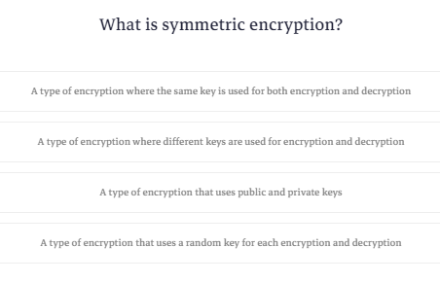

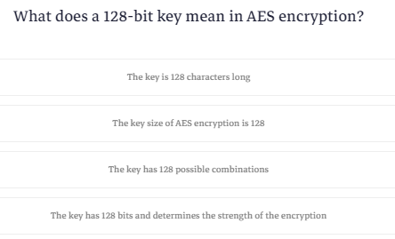

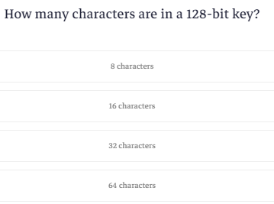

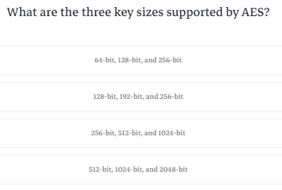

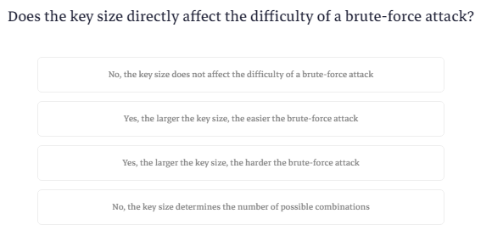

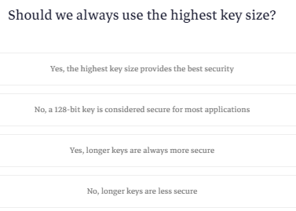

**What is Asymmetric Encryption?**

ال asymmetric encryption زيها زي ال symmetric بس دي بتستخدم اتنين keys واحد public وده عشان ال encryption والتاني private عشان ال decryption

هنا بيقولك انك تقدر تستخدم ال public key عشان تتاكد انك هتبعت الداتا للشخص الصح زي لما تيجي تبعت لحد عن طريق ال share it او لو نسيت الباسورد بيبعتلك رمز ودلوقتي لو فتحت ال gmail علي جهاز جديد بيبعت لجهازك القديم رقم

فيه مكتبات بنستخدمها عشان التشفير ده منها ال RSA و ECC و DSA

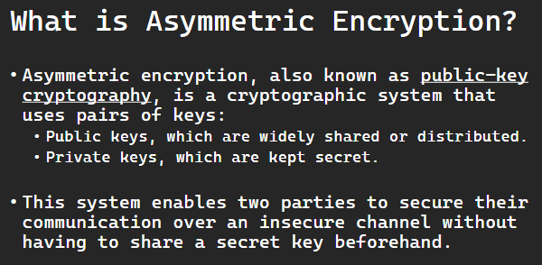

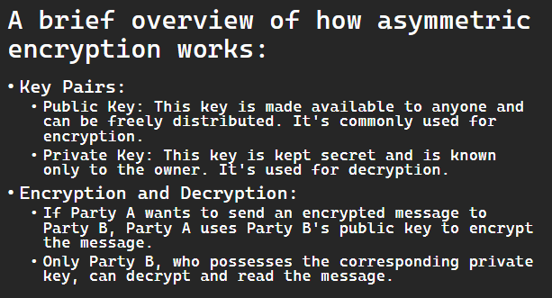

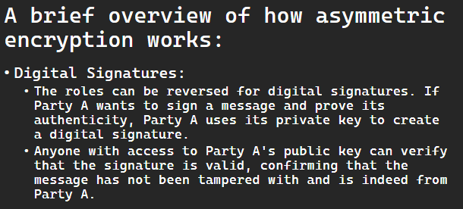

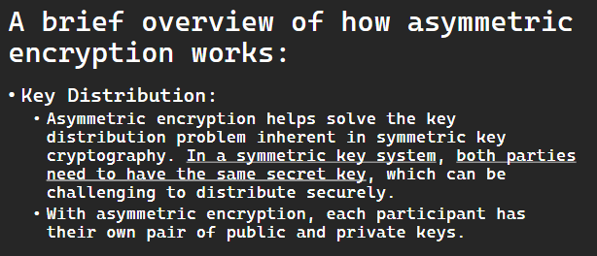

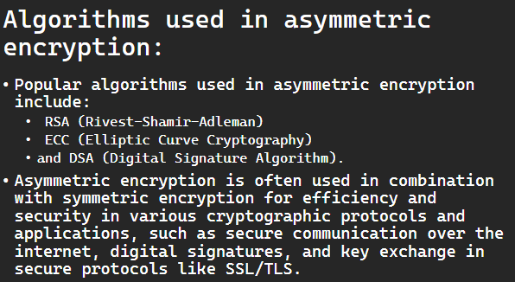

Asymmetric encryption, also known as public-key cryptography, is a cryptographic system that uses pairs of keys: public keys, which are widely shared or distributed, and private keys, which are kept secret. This system enables two parties to secure their communication over an insecure channel without having to share a secret key beforehand.

Here's a brief overview of how asymmetric encryption works:

* Key Pairs:
  + Public Key: This key is made available to anyone and can be freely distributed. It's commonly used for encryption.
  + Private Key: This key is kept secret and is known only to the owner. It's used for decryption.
* Encryption and Decryption:
  + If Party A wants to send an encrypted message to Party B, Party A uses Party B's public key to encrypt the message.
  + Only Party B, who possesses the corresponding private key, can decrypt and read the message.
* Digital Signatures:
  + The roles can be reversed for digital signatures. If Party A wants to sign a message and prove its authenticity, Party A uses its private key to create a digital signature.
  + Anyone with access to Party A's public key can verify that the signature is valid, confirming that the message has not been tampered with and is indeed from Party A.
* Key Distribution:
  + Asymmetric encryption helps solve the key distribution problem inherent in symmetric key cryptography. In a symmetric key system, both parties need to have the same secret key, which can be challenging to distribute securely.
  + With asymmetric encryption, each participant has their own pair of public and private keys.

Popular algorithms used in asymmetric encryption include RSA (Rivest-Shamir-Adleman), ECC (Elliptic Curve Cryptography), and DSA (Digital Signature Algorithm). Asymmetric encryption is often used in combination with symmetric encryption for efficiency and security in various cryptographic protocols and applications, such as secure communication over the internet, digital signatures, and key exchange in secure protocols like SSL/TLS.

Why two Keys?

The use of two keys (public and private keys) in asymmetric encryption serves several important purposes:

1. Encryption and Decryption:
   * Public Key: Used for encryption. Anyone can use the public key to encrypt a message.
   * Private Key: Used for decryption. Only the owner of the private key can decrypt messages encrypted with the corresponding public key.

* This separation of roles allows for secure communication between parties without the need for them to share a secret key for encryption and decryption.

1. Digital Signatures:
   * Private Key: Used to create a digital signature, providing a way for the owner of the private key to authenticate messages.
   * Public Key: Used to verify the digital signature. Anyone with access to the public key can verify that the message was signed by the corresponding private key.
2. Digital signatures help ensure the integrity and authenticity of messages, allowing the recipient to verify that a message has not been tampered with and that it indeed comes from the claimed sender.
3. Key Distribution:
   * Public Keys: Can be freely distributed and shared. For example, in secure communication, users can publish their public keys on a public key server or share them directly with others.
   * Private Keys: Kept secret by the key owner. They do not need to be shared with others.
4. This separation simplifies the key distribution problem that exists in symmetric key cryptography, where both parties need to have the same secret key. With asymmetric encryption, each user has their own pair of keys, and they only need to share their public keys.

The combination of public and private keys in asymmetric encryption provides a flexible and secure framework for various cryptographic applications, including secure communication, digital signatures, and key exchange.

**Asymmetric Encryption Example**

هنستخدم ال RSA في التشفير

الفكره هنا انك بتعمل ملف xml بتحط فيه داتا

ايه هيا الداتا ملناش دعوه المهم انه ملف فيه داتا وخلاص

الملف ده بيكون هوا ال private key

وبعدين بتنسخ جزء من الداتا دي في ملف تاني وبيكون ده هوا ال public key

طيب قبل التشفير بنجهز الداتا الأول

فبناخد object من كلاس rsa service

|  |
| --- |
| using (RSACryptoServiceProvider rsa = new RSACryptoServiceProvider()) |

وبعدين بناخد ال parameters اللي من النوع public بس وبنحولها لملف xml ونحولها تاني ل string

|  |
| --- |
| string publicKey = rsa.ToXmlString(false); |

وناخد كل الملف نحوله ل private key

|  |
| --- |
| string privateKey = rsa.ToXmlString(true); |

وبعدين بنقوله encrypt و decrypt

طيب ال encrypt بتشتغل ازاي؟

هناخد object من rsa برضه ونحط فيه ال public key بعد مانرجعه تاني لملف xml وبعدين بنقوله encrypt

|  |
| --- |
| rsa.FromXmlString(publicKey);  byte[] encryptedData = rsa.Encrypt(Encoding.UTF8.GetBytes(plainText), false);  return Convert.ToBase64String(encryptedData); |

طيب بنفك التشفير ازاي؟

بناخد ال private key نحوله ل xml ونخزنه في ال rsa وبعدين بنقوله decrypt

|  |
| --- |
| using (RSACryptoServiceProvider rsa = new RSACryptoServiceProvider())  {  rsa.FromXmlString(privateKey);  byte[] encryptedData = Convert.FromBase64String(cipherText);  byte[] decryptedData = rsa.Decrypt(encryptedData, false); |

بس كده

وده الكود كله

|  |
| --- |
| using System;  using System.Security.Cryptography;  using System.Text;  class NullableExample  {  static void Main()  {  try  {  using (RSACryptoServiceProvider rsa = new RSACryptoServiceProvider())  {  string publicKey = rsa.ToXmlString(false);  string privateKey = rsa.ToXmlString(true);  string originalMessage = "Hello, this is a secret message!";  string encryptedMessage = Encrypt(originalMessage, publicKey);  string decryptedMessage = Decrypt(encryptedMessage, privateKey);  Console.WriteLine($"\n\nPublic Key:\n {publicKey}");  Console.WriteLine($"\n\nPrivate Key:\n {privateKey}");  Console.WriteLine($"\nOriginal Message:\n {originalMessage}");  Console.WriteLine($"\nEncrypted Message:\n {encryptedMessage}");  Console.WriteLine($"\nDecrypted Message:\n {decryptedMessage}");  Console.WriteLine("\nPress any key to exit...");  Console.ReadKey();  }  }  catch (CryptographicException ex)  {  Console.WriteLine($"Encryption/Decryption error: {ex.Message}");  Console.ReadKey();  }  catch (Exception ex)  {  Console.WriteLine($"An unexpected error occurred: {ex.Message}");  Console.ReadKey();  }  }  static string Encrypt(string plainText, string publicKey)  {  try  {  using (RSACryptoServiceProvider rsa = new RSACryptoServiceProvider())  {  rsa.FromXmlString(publicKey);  byte[] encryptedData = rsa.Encrypt(Encoding.UTF8.GetBytes(plainText), false);  return Convert.ToBase64String(encryptedData);  }  }  catch (CryptographicException ex)  {  Console.WriteLine($"Encryption error: {ex.Message}");  throw;  }  }  static string Decrypt(string cipherText, string privateKey)  {  try  {  using (RSACryptoServiceProvider rsa = new RSACryptoServiceProvider())  {  rsa.FromXmlString(privateKey);  byte[] encryptedData = Convert.FromBase64String(cipherText);  byte[] decryptedData = rsa.Decrypt(encryptedData, false);  return Encoding.UTF8.GetString(decryptedData);  }  }  catch (CryptographicException ex)  {  Console.WriteLine($"Decryption error: {ex.Message}");  throw;  }  }  } |

### **Asymmetric Encryption (Public Key Cryptography):**

Asymmetric encryption involves a pair of public and private keys. Data encrypted with the public key can only be decrypted with the corresponding private key.

using System;

using System.Security.Cryptography;

using System.Text;

class AsymmetricEncryptionExample

{

    static void Main()

    {

        try

        {

            // Generate public and private key pair

            using (RSACryptoServiceProvider rsa = new RSACryptoServiceProvider())

            {

                // Get the public key

                /*

                 When exporting the public key, ToXmlString(false) is used with the argument set

                 to false to indicate that only the public parameters should be included in the XML string.

                 */

                string publicKey = rsa.ToXmlString(false);

                // Get the private key

                string privateKey = rsa.ToXmlString(true);

                // Original message

                string originalMessage = "Hello, this is a secret message!";

                // Encrypt using the public key

                string encryptedMessage = Encrypt(originalMessage, publicKey);

                // Decrypt using the private key

                string decryptedMessage = Decrypt(encryptedMessage, privateKey);

                // Display the results

                Console.WriteLine($"\n\nPublic Key:\n {publicKey}");

                Console.WriteLine($"\n\nPrivate Key:\n {privateKey}");

                Console.WriteLine($"\nOriginal Message:\n {originalMessage}");

                Console.WriteLine($"\nEncrypted Message:\n {encryptedMessage}");

                Console.WriteLine($"\nDecrypted Message:\n {decryptedMessage}");

                // Wait for user input before closing the console window

                Console.WriteLine("\nPress any key to exit...");

                Console.ReadKey();

            }

        }

        catch (CryptographicException ex)

        {

            Console.WriteLine($"Encryption/Decryption error: {ex.Message}");

            Console.ReadKey();

        }

        catch (Exception ex)

        {

            Console.WriteLine($"An unexpected error occurred: {ex.Message}");

            Console.ReadKey();

        }

    }

    static string Encrypt(string plainText, string publicKey)

    {

        try

        {

            using (RSACryptoServiceProvider rsa = new RSACryptoServiceProvider())

            {

                rsa.FromXmlString(publicKey);

                byte[] encryptedData = rsa.Encrypt(Encoding.UTF8.GetBytes(plainText), false);

                return Convert.ToBase64String(encryptedData);

            }

        }

        catch (CryptographicException ex)

        {

            Console.WriteLine($"Encryption error: {ex.Message}");

            throw; // Rethrow the exception to be caught in the Main method

        }

    }

    static string Decrypt(string cipherText, string privateKey)

    {

        try

        {

            using (RSACryptoServiceProvider rsa = new RSACryptoServiceProvider())

            {

                rsa.FromXmlString(privateKey);

                byte[] encryptedData = Convert.FromBase64String(cipherText);

                byte[] decryptedData = rsa.Decrypt(encryptedData, false);

                return Encoding.UTF8.GetString(decryptedData);

            }

        }

        catch (CryptographicException ex)

        {

            Console.WriteLine($"Decryption error: {ex.Message}");

            throw; // Rethrow the exception to be caught in the Main method

        }

    }

}

This C# code demonstrates a simple example of asymmetric encryption using the RSA algorithm with the RSACryptoServiceProvider class in the .NET Framework. Here's a breakdown of the code:

* + **Key Generation:** A new instance of RSACryptoServiceProvider is created within a using statement. The using statement ensures that the RSACryptoServiceProvider object is properly disposed of when it goes out of scope.
  + Public and private keys are generated within this block.

using (RSACryptoServiceProvider rsa = new RSACryptoServiceProvider())

{

    // Key generation and usage go here

}

* + **Public Key Extraction:** The public key is extracted using ToXmlString(false), which means only the public parameters are included in the XML string.
  + The public key is then stored in the publicKey variable.

string publicKey = rsa.ToXmlString(false);

* + **Private Key Extraction:** The private key is extracted using ToXmlString(true), indicating that both public and private parameters are included in the XML string.
  + The private key is stored in the privateKey variable.

string privateKey = rsa.ToXmlString(true);

* + **Encryption:** The Encrypt method takes a plaintext message (originalMessage) and the public key (publicKey) as input.
  + Inside the Encrypt method, a new RSACryptoServiceProvider instance is created and configured with the provided public key.
  + The plaintext message is encrypted using the Encrypt method, and the result is converted to a Base64-encoded string.

byte[] encryptedData = rsa.Encrypt(Encoding.UTF8.GetBytes(plainText), false);

return Convert.ToBase64String(encryptedData);

* + **Decryption:** The Decrypt method takes a ciphertext message (cipherText) and the private key (privateKey) as input.
  + Inside the Decrypt method, a new RSACryptoServiceProvider instance is created and configured with the provided private key.
  + The ciphertext message is decrypted using the Decrypt method, and the result is converted back to a UTF-8 encoded string.

byte[] decryptedData = rsa.Decrypt(encryptedData, false);

return Encoding.UTF8.GetString(decryptedData);

* + **Main Method:** The Main method orchestrates the key generation, encryption, and decryption processes.
  + It displays the public and private keys, the original message, the encrypted message, and the decrypted message on the console.

Console.WriteLine($"\n\nPublic Key:\n {publicKey}");

Console.WriteLine($"\n\nPrivate Key:\n {privateKey}");

Console.WriteLine($"\nOriginal Message:\n {originalMessage}");

Console.WriteLine($"\nEncrypted Message:\n {encryptedMessage}");

Console.WriteLine($"\nDecrypted Message:\n {decryptedMessage}");

* + **Error Handling:** The code includes exception handling (try-catch blocks) to capture and display errors related to encryption and decryption.

catch (CryptographicException ex)

{

    Console.WriteLine($"Encryption/Decryption error: {ex.Message}");

    Console.ReadKey();

}

catch (Exception ex)

{

    Console.WriteLine($"An unexpected error occurred: {ex.Message}");

    Console.ReadKey();

}

This example demonstrates the basics of RSA encryption and decryption using the .NET Framework's RSACryptoServiceProvider class. It is important to note that this approach might not be suitable for all scenarios, and in modern applications, you might want to consider more advanced libraries or frameworks for cryptographic operations.

Remember to handle keys securely, as they play a crucial role in the security of cryptographic operations. The examples above are for educational purposes, and in a real-world scenario, you should use key management best practices.

**Asymmetric Encryption Quiz**

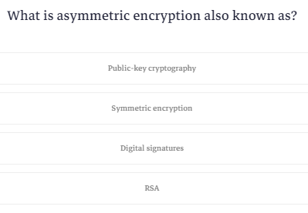

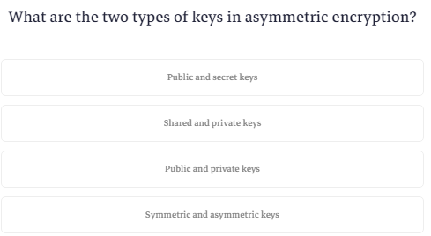

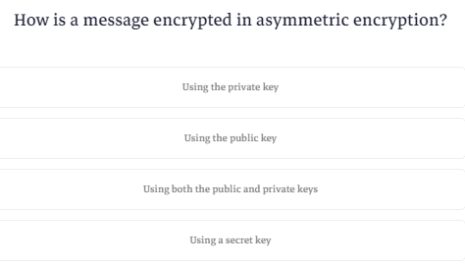

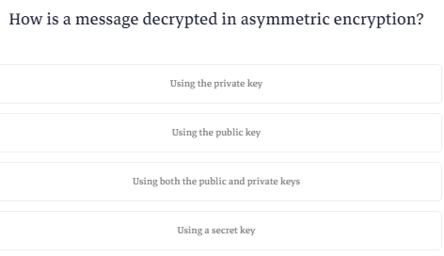

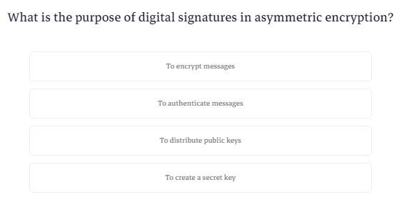

**Encrypt and Decrypt Image Example**

ده مثال عالتشفير

فبيقولك قبل ماتبدأ اعمل ملف في ال c وخد الصورة وحطها فيه

|  |
| --- |
| c:\Image |

وبعدين حط الكود ده

هوا بيستخدم الكود بتاع ال aes

وفي التشفير بدل ماكان بيكتب عال ram لا بيستخدم الملف اللي عمله

في عمليه التشفير هوا بيحول الصوره ل bits وبعدين بيشفر ال bytes وبيرجعهم تاني

بس دي الفكره

|  |
| --- |
| using System;  using System.IO;  using System.Security.Cryptography;  using System.Text;  class NullableExample  {  static void Main()  {  string inputFile = "c:\\Image\\MyImage.jpg";  string encryptedFile = "c:\\Image\\encrypted.jpg";  string decryptedFile = "c:\\Image\\decrypted.jpg";  // Generate a random IV for each encryption operation  byte[] iv;  using (Aes aesAlg = Aes.Create())  {  iv = aesAlg.IV;  }  string key = "1234567890123456";  EncryptFile(inputFile, encryptedFile, key, iv);  DecryptFile(encryptedFile, decryptedFile, key, iv);  Console.WriteLine("Encryption and decryption completed successfully.");  Console.WriteLine("go to c:\\Image folder to see the results");  Console.ReadKey();  }  static void EncryptFile(string inputFile, string outputFile, string key, byte[] iv)  {  using (Aes aesAlg = Aes.Create())  {  aesAlg.Key = System.Text.Encoding.UTF8.GetBytes(key);  aesAlg.IV = iv;  using (FileStream fsInput = new FileStream(inputFile, FileMode.Open))  using (FileStream fsOutput = new FileStream(outputFile, FileMode.Create))  using (ICryptoTransform encryptor = aesAlg.CreateEncryptor())  using (CryptoStream cryptoStream = new CryptoStream(fsOutput, encryptor, CryptoStreamMode.Write))  {  // Write the IV to the beginning of the file  fsOutput.Write(iv, 0, iv.Length);  fsInput.CopyTo(cryptoStream);  }  }  }  static void DecryptFile(string inputFile, string outputFile, string key, byte[] iv)  {  using (Aes aesAlg = Aes.Create())  {  aesAlg.Key = System.Text.Encoding.UTF8.GetBytes(key);  aesAlg.IV = iv;  using (FileStream fsInput = new FileStream(inputFile, FileMode.Open))  using (FileStream fsOutput = new FileStream(outputFile, FileMode.Create))  using (ICryptoTransform decryptor = aesAlg.CreateDecryptor())  using (CryptoStream cryptoStream = new CryptoStream(fsOutput, decryptor, CryptoStreamMode.Write))  {  // Skip the IV at the beginning of the file  fsInput.Seek(iv.Length, SeekOrigin.Begin);  fsInput.CopyTo(cryptoStream);  }  }  }  } |

static void Main()

{

    string inputFile = "c:\\Image\\MyImage.jpg";

    string encryptedFile = "c:\\Image\\encrypted.jpg";

    string decryptedFile = "c:\\Image\\decrypted.jpg";

    // Generate a random IV for each encryption operation

    byte[] iv;

    using (Aes aesAlg = Aes.Create())

    {

        iv = aesAlg.IV;

    }

    string key = "1234567890123456";

    EncryptFile(inputFile, encryptedFile, key, iv);

    DecryptFile(encryptedFile, decryptedFile, key, iv);

    Console.WriteLine("Encryption and decryption completed successfully.");

    Console.WriteLine("go to c:\\Image folder to see the results");

    Console.ReadKey();

}

This is the entry point of the program. Here's what each part does:

1. File Paths and Key: Defines file paths for the input image (MyImage.jpg), the encrypted image (encrypted.jpg), and the decrypted image (decrypted.jpg). It also defines a key ("1234567890123456"). Note that in real-world scenarios, using a hardcoded key is not secure, and key management should be handled more securely.
2. Initialization Vector (IV) Generation: Creates an instance of Aes to generate a random IV for each encryption operation. The IV is stored in the iv variable.
3. Encryption and Decryption Calls: Calls the EncryptFile method to encrypt the input image and the DecryptFile method to decrypt the encrypted image. Both methods receive the input file, output file, key, and IV as parameters.
4. Console Output and User Interaction: Prints messages indicating the success of encryption and decryption. It prompts the user to press any key before exiting, allowing them to view the results.

### **EncryptFile Method**

static void EncryptFile(string inputFile, string outputFile, string key, byte[] iv)

{

    using (Aes aesAlg = Aes.Create())

    {

        aesAlg.Key = System.Text.Encoding.UTF8.GetBytes(key);

        aesAlg.IV = iv;

        using (FileStream fsInput = new FileStream(inputFile, FileMode.Open))

        using (FileStream fsOutput = new FileStream(outputFile, FileMode.Create))

        using (ICryptoTransform encryptor = aesAlg.CreateEncryptor())

        using (CryptoStream cryptoStream = new CryptoStream(fsOutput, encryptor, CryptoStreamMode.Write))

        {

            // Write the IV to the beginning of the file

            fsOutput.Write(iv, 0, iv.Length);

            fsInput.CopyTo(cryptoStream);

        }

    }

}

This method performs file encryption using the AES algorithm:

1. AES Initialization: Creates an instance of Aes and sets its key and IV based on the provided parameters.
2. File Streams and CryptoStream: Creates file streams for input and output files. Also, creates a CryptoStream to perform the encryption. The encrypted data is written to fsOutput through the CryptoStream.
3. Write IV to Output File: Writes the IV to the beginning of the output file before writing the actual encrypted content.

### **DecryptFile Method**

static void DecryptFile(string inputFile, string outputFile, string key, byte[] iv)

{

    using (Aes aesAlg = Aes.Create())

    {

        aesAlg.Key = System.Text.Encoding.UTF8.GetBytes(key);

        aesAlg.IV = iv;

        using (FileStream fsInput = new FileStream(inputFile, FileMode.Open))

        using (FileStream fsOutput = new FileStream(outputFile, FileMode.Create))

        using (ICryptoTransform decryptor = aesAlg.CreateDecryptor())

        using (CryptoStream cryptoStream = new CryptoStream(fsOutput, decryptor, CryptoStreamMode.Write))

        {

            // Skip the IV at the beginning of the file

            fsInput.Seek(iv.Length, SeekOrigin.Begin);

            fsInput.CopyTo(cryptoStream);

        }

    }

}

This method performs file decryption using the AES algorithm:

1. AES Initialization: Creates an instance of Aes and sets its key and IV based on the provided parameters.
2. File Streams and CryptoStream: Creates file streams for input and output files. Also, creates a CryptoStream to perform the decryption. The decrypted data is written to fsOutput through the CryptoStream.
3. Skip IV during Decryption: Skips the IV bytes at the beginning of the input file before starting the decryption process.

Overall, this code demonstrates a simple file encryption and decryption process using the AES algorithm in C#. It includes the generation of a random IV for each encryption operation and writes the IV to the output file for later use during decryption.

**What is Operator Overloading**

ال operator overloading زي علامة اجمع يمكن استخدامها اكثر من استخدام فلو حطيتها بين رقمين هتجمعهم ولوحطيتها بين نصين هترصم جنب بعض

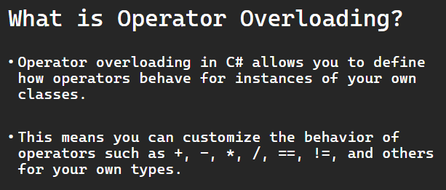

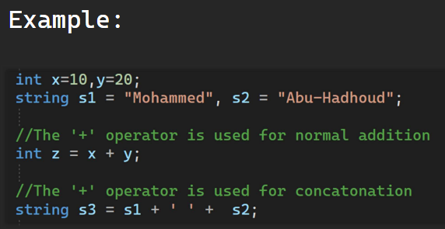

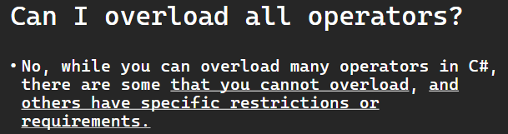

Operator overloading in C# allows you to define how operators behave for instances of your own classes. This means you can customize the behavior of operators such as +, -, *, /, ==, !=, and others for your own types.

﻿

### **Normal Addition vs. Concatenation:**

The behavior of the + operator depends on the context and the types involved. For numeric types, it performs addition, while for string types, it performs concatenation. However, with operator overloading, you can define custom behaviors for the + operator based on the types you are working with.

In this example , we are demonstrating the use of the + operator for both normal addition and string concatenation.

using System;

    public class Program

    {

        static void Main(string[] args)

        {

        int x=10,y=20;

        string s1 = "Mohammed", s2 = "Abu-Hadhoud";

        //The '+' operator is used for normal addition

        int z = x + y;

        //The '+' operator is used for concatonation

        string s3 = s1 + ' ' +  s2;

        Console.WriteLine($"The '+' operator is used for normal addition resulting z = {z}");

        Console.WriteLine($"The '+' operator is used for concatonation rsulting s3 = {s3}");

        Console.ReadKey();

    }

    }

Explanation:

1. You have two integers x and y representing numeric values, and you use the + operator for normal addition, calculating the sum and storing it in the variable z.
2. You have two strings s1 and s2 representing names. You use the + operator for string concatenation, combining the two strings along with a space in the middle, and storing the result in the variable s3.
3. You use Console.WriteLine to print the results to the console, indicating whether the + operator is used for normal addition or concatenation.
4. Finally, Console.ReadKey() is used to wait for a key press before the console window is closed.

When you run this program, it will output:

The '+' operator is used for normal addition resulting z = 30

The '+' operator is used for concatenation resulting s3 = Mohammed Abu-Hadhoud

This demonstrates the dual nature of the + operator in C#, where its behavior depends on the types of the operands. For numeric types, it performs addition, and for string types, it performs concatenation.

**Operator Overloading Example**

عشان تعمل operator overloading بتيجي بعد اسم ال method وبتكتب كلمة operator وبعدها العلامة اللي عايز تعملها overload

يعني بص المثال ده

هنعمل كلاس بيخزن نقطة مكونه من محورين x و y

|  |
| --- |
| class Point  {  public int X { get; set; }  public int Y { get; set; }  public Point(int x, int y)  {  X = x;  Y = y;  } |

دلوقتي انا عايز لما اجي اجمع اتنين objects من نفس الكلاس ده ياخد اول متغير من اول object ويجمعه مع اول متغير من تاني object

وياخد تاني متغير من اول object ويجمعه مع تاني متغير من تاني object

ك ده بمجرد مااحط object1+object2

|  |
| --- |
| public static Point operator +(Point p1, Point p2)  {  return new Point(p1.X + p2.X, p1.Y + p2.Y);  } |

بص بقي هستخدمها ازاي

|  |
| --- |
| Point point3 = point1 + point2; |

ونفس الكلام بالنسبه لعلامة الطرح وال = وال != بتعمل method بالكود اللي عايز تنفذه لو تم استدعاء علامه من العلامات دي

وفيه ملوحظه انك لو جيت تعمل ال == لازم معاها تعمل ال !=

|  |
| --- |
| using System;  using System.IO;  using System.Security.Cryptography;  using System.Text;  class NullableExample  {  class Point  {  public int X { get; set; }  public int Y { get; set; }  public Point(int x, int y)  {  X = x;  Y = y;  }  public static Point operator +(Point p1, Point p2)  {  return new Point(p1.X + p2.X, p1.Y + p2.Y);  }  public static Point operator -(Point p1, Point p2)  {  return new Point(p1.X - p2.X, p1.Y - p2.Y);  }  // Overloading the == operator for fraction equality  public static bool operator ==(Point p1, Point p2)  {  return (p1.X == p2.X) && (p1.Y == p2.Y);  }  // Overloading the != operator for fraction equality  public static bool operator !=(Point p1, Point p2)  {  return (p1.X != p2.X) || (p1.Y != p2.Y);  }  // Overriding ToString for better readability  public override string ToString()  {  return $"({X}, {Y})";  }  }  static void Main()  {  Point point1 = new Point(1, 2);  Point point2 = new Point(3, 4);  // Using the overloaded + operator for point addition  Point point3 = point1 + point2;  // Using the overloaded + operator for point addition  Point point4 = point1 - point2;  Console.WriteLine($"Point1 : {point1.ToString()}");  Console.WriteLine($"Point2 : {point2.ToString()}");  Console.WriteLine($"Point3 is the result of point1 + point2: {point3.ToString()}");  Console.WriteLine($"Point4 is the result of point1 - point2: {point4.ToString()}");  // Using the overloaded == operator for point equality  if (point1 == point2)  Console.WriteLine("Using == : Yes, Point1 = Point2");  else  Console.WriteLine("Using == : No, Piont1 does not equal Point2");  // Using the overloaded != operator for point inequality  if (point1 != point2)  Console.WriteLine("Using != : Yes, Piont1 does not equal Point2");  else  Console.WriteLine("Using != : No, Piont1 = Point2");  Console.ReadKey();  }  } |

This code defines a Point class to represent 2D points and demonstrates operator overloading in C# by overloading the +, -, ==, and != operators.

using System;

class Point

{

    public int X { get; set; }

    public int Y { get; set; }

    public Point(int x, int y)

    {

        X = x;

        Y = y;

    }

    // Overloading the + operator for point addition

    public static Point operator +(Point p1, Point p2)

    {

        return new Point(p1.X + p2.X, p1.Y + p2.Y);

    }

    public static Point operator -(Point p1, Point p2)

    {

        return new Point(p1.X - p2.X, p1.Y - p2.Y);

    }

    // Overloading the == operator for fraction equality

    public static bool operator == (Point p1, Point p2)

    {

        return (p1.X == p2.X) && (p1.Y == p2.Y);

    }

    // Overloading the != operator for fraction equality

    public static bool operator !=(Point p1, Point p2)

    {

        return (p1.X != p2.X) || (p1.Y != p2.Y);

    }

    // Overriding ToString for better readability

    public override string ToString()

    {

        return $"({X}, {Y})";

    }

}

class Program

{

    static void Main()

    {

        Point point1 = new Point(1, 2);

        Point point2 = new Point(3, 4);

        // Using the overloaded + operator for point addition

        Point point3 = point1 + point2;

        // Using the overloaded + operator for point addition

        Point point4 = point1 - point2;

        Console.WriteLine($"Point1 : {point1.ToString()}");

        Console.WriteLine($"Point2 : {point2.ToString()}");

        Console.WriteLine($"Point3 is the result of point1 + point2: {point3.ToString()}");

        Console.WriteLine($"Point4 is the result of point1 - point2: {point4.ToString()}");

        // Using the overloaded == operator for point equality

        if (point1 == point2)

            Console.WriteLine("Using == : Yes, Point1 = Point2");

        else

            Console.WriteLine("Using == : No, Piont1 does not equal Point2");

        // Using the overloaded != operator for point inequality

        if (point1 != point2)

            Console.WriteLine("Using != : Yes, Piont1 does not equal Point2");

        else

            Console.WriteLine("Using != : No, Piont1 = Point2");

        Console.ReadKey();

    }

}

Here's an explanation of the code:

**Point Class:**

* The Point class has two properties, X and Y, representing the coordinates of a 2D point.
* The + operator is overloaded for point addition.
* The - operator is overloaded for point subtraction.
* The == operator is overloaded for point equality.
* The != operator is overloaded for point inequality.
* The ToString method is overridden to provide a custom string representation of the point.

**Program Class:**

* + In the Main method, two Point objects (point1 and point2) are created with different coordinates.
  + The overloaded + operator is used to add point1 and point2, and the result is stored in point3.
  + The overloaded - operator is used to subtract point2 from point1, and the result is stored in point4.
  + The program then prints the original points and the results of the addition and subtraction.
  + Finally, the overloaded == and != operators are used to check for equality and inequality between point1 and point2, and the results are printed accordingly.

When you run this program, it will output the coordinates of points, the results of point addition and subtraction, and whether the points are equal or not.

**Note:** you can apply the same concept for most of other operators.

Also note that not all operators can be overloaded in C#, we will discuss this in the next lesson.

**Quiz 1**

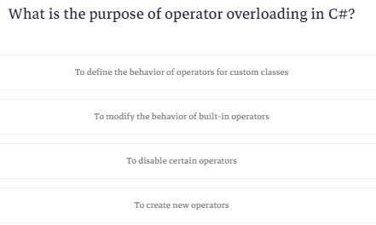

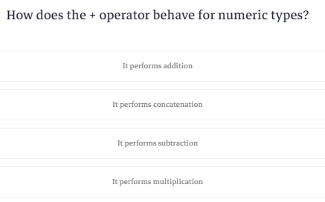

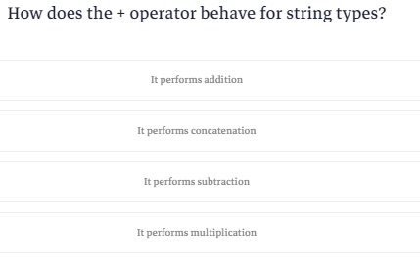

**Can I overload all operators in C#?**

هنا بيقولك انك ماتقدرش تعمل overloading لكل ال operators وبيعرفك ايه اللي ينفع وايه اللي ماينفعش وايه اللي عليه قيود

دول ماينفعش تعملهم overloading

* Operators You Cannot Overload:
  + && (conditional AND)
  + || (conditional OR)
  + ?: (conditional)
  + sizeof (size of)
  + typeof (type of)
  + -> (member access)
  + . (member access)
  + checked and unchecked

ودول ينفع بس بشروط

* 1. علامة يساوي تنفع تعملها overloading بس بشرط ان تكون نتيجة ال method انك تعمل object من الكلاس اللي انت فيه بحيث انك مثلا بدل ماتقول

clsMyclass myObject=new clsMyClass(42);

لاتقدر تعمل كده

clsMyclass myObject=42;

* 1. العلامه بتاعت ال short hand if تقدر تعملها overloading بشرط ان ال data type بتاع النتايج تكون واحده
  2. علامة الجمع او الطرح المفردة اللي هما (+ و -) ماتقدرش تستخدمهم مع ال bool وال byte وال sbyte وال ushort وال short وال uint وال int وال ulong وال long
  3. العلامات اللي هيا =+ و =- وال =* والكلام ده بيتعملهم overloading تلقائيا لما بتيجي تعمل overloading للنظائر بتاعتهم يعني لما تيجي تعمل مثلا overloading لعلامة الجمع هتلاقي انه ال =+ اتعملها هيا كمان overloading وهتستخدم نفس الmethod بتاعت علامة الجمع
  4. العلامات اللي بترجعلك قيمه true او false لو عملت overloading لعلامه لازم تعمل overloading للعلامه المقابله ليها يعني لو جيت تعمل overload لعلامة اكبر من لازم تعمل لعلامة اصغر من ولو عملت لعلامة == لازم تعمل لعلامة لايساوي =!
  5. علامة ال array لازم نتيجتها تكون عنصر من عناصر ال array
* Operators with Restrictions:
  + = (assignment) can be overloaded only by defining a user-defined conversion to the type of the left-hand operand.
  + ?: (conditional) can be overloaded only if the types of the second and third operands are the same.
* Unary Operators Restrictions:
  + + (unary plus) and - (unary minus) cannot be overloaded for bool, byte, sbyte, ushort, short, uint, int, ulong, or long.
* Binary Operators Restrictions:
  + The assignment operators (+=, -=, *=, /=, and so on) can be overloaded, but their behavior is determined by the behavior of the corresponding binary operator.
* Equality and Comparison Operators Restrictions:
  + The == and != operators must be overloaded together. The same applies to <, >, <=, and >= when overloading.
* Indexing Operator Restrictions:
  + The [] operator can only be overloaded if the containing type is an array or an indexer property.
* Conversion Operators Restrictions:
  + implicit and explicit conversion operators can be overloaded with certain restrictions. They must involve user-defined types and follow specific rules.

In summary, while you can overload many operators in C#, there are some that you cannot overload, and others have specific restrictions or requirements. Always refer to the C# language specification for the most accurate and up-to-date information regarding operator overloading.

**Quiz 2**

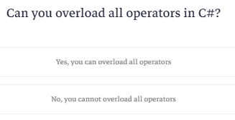

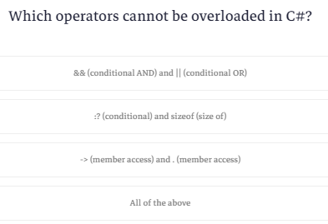

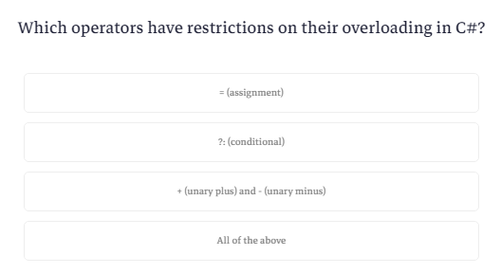

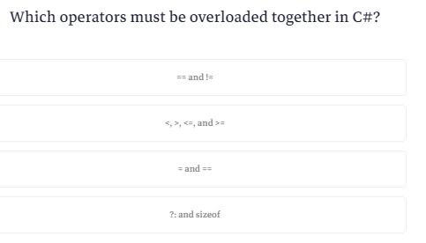

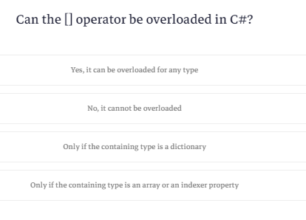

**Process vs Thread**

ال process هيا مكان في ال memory بيتم استخدامه عشان تشغل فيه البرنامج بتاعك زي ال process اللي في الtask manager

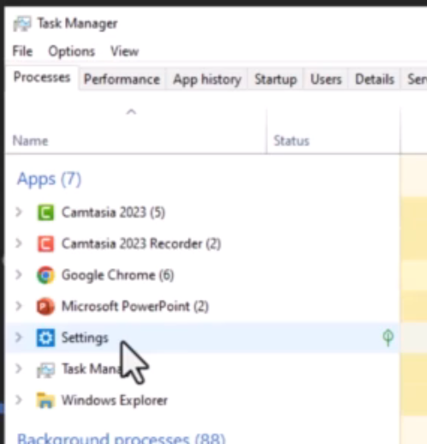

ال process بتكون مستقله بذاتها ومسؤوله عن البرنامج بتاعك لو واحدة باظت التانيه اللي بتشغل برنامج تاني بتفضل شغاله

ال process دي بتتكون من threads وبيكون ليها main thread

كل البرامج اللي عملناها بتستخدم thread واحد اللي هوا ال main

بتقدر تعمل اكتر من thread وبتشغلهم مع بعض وده ال multi threading او ال parallel programming

ال threads بتاعت البرنامج الواحد بتتشارك مع نفس المساحه المخصصه لل process

ال threads بتاعت البرنامج الواحد بتقدر تتواصل مع بعضها اعتبرها زي ال functions

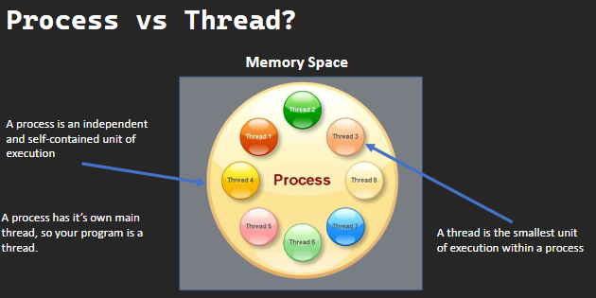

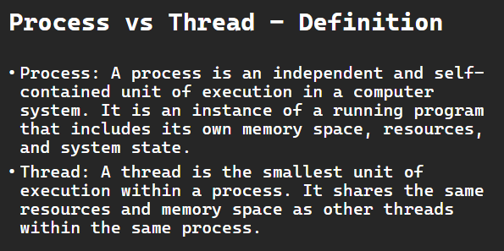

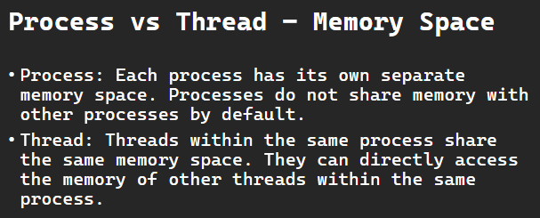

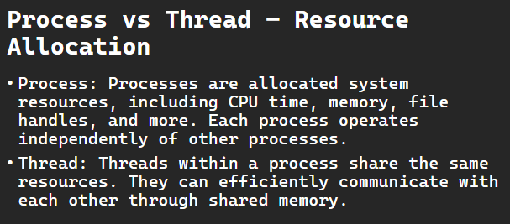

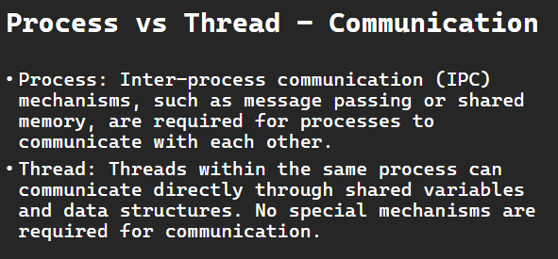

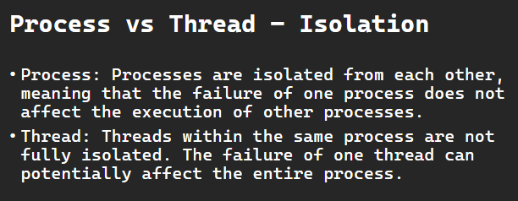

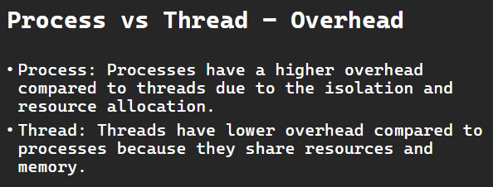

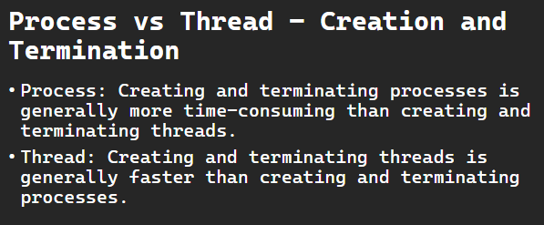

# **Process vs Thread**

**Process:**

* Definition:
  + A process is an independent and self-contained unit of execution in a computer system. It is an instance of a running program that includes its own memory space, resources, and system state.
* Memory Space:
  + Each process has its own separate memory space. Processes do not share memory with other processes by default.
* Resource Allocation:
  + Processes are allocated system resources, including CPU time, memory, file handles, and more. Each process operates independently of other processes.
* Communication:
  + Inter-process communication (IPC) mechanisms, such as message passing or shared memory, are required for processes to communicate with each other.
* Isolation:
  + Processes are isolated from each other, meaning that the failure of one process does not affect the execution of other processes.
* Overhead:
  + Processes have a higher overhead compared to threads due to the isolation and resource allocation.
* Creation and Termination:
  + Creating and terminating processes is generally more time-consuming than creating and terminating threads.
* Process typically has a main thread. The main thread is the initial thread that is created when a program starts. It is the thread responsible for executing the main entry point of the program, such as the main function in C or C++.

**Thread:**

* Definition:
  + A thread is the smallest unit of execution within a process. It shares the same resources and memory space as other threads within the same process.
* Memory Space:
  + Threads within the same process share the same memory space. They can directly access the memory of other threads within the same process.
* Resource Allocation:
  + Threads within a process share the same resources. They can efficiently communicate with each other through shared memory.
* Communication:
  + Threads within the same process can communicate directly through shared variables and data structures. No special mechanisms are required for communication.
* Isolation:
  + Threads within the same process are not fully isolated. The failure of one thread can potentially affect the entire process.
* Overhead:
  + Threads have lower overhead compared to processes because they share resources and memory.
* Creation and Termination:
  + Creating and terminating threads is generally faster than creating and terminating processes.

**Summary:**

* A process is an independent program with its own memory space, resources, and system state.
* A thread is the smallest unit of execution within a process, sharing the same resources and memory space with other threads in the same process.
* Processes are isolated, and communication between them requires special mechanisms.
* Threads within the same process can communicate directly through shared memory.
* Processes have higher overhead due to their isolation and separate resource allocation.
* Threads have lower overhead as they share resources within the same process.
* Processes are more robust in the face of failures since one process's failure does not affect others.
* Threads within a process are less isolated, and the failure of one thread can potentially affect the entire process.

**Quiz 1**

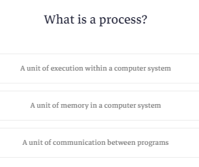

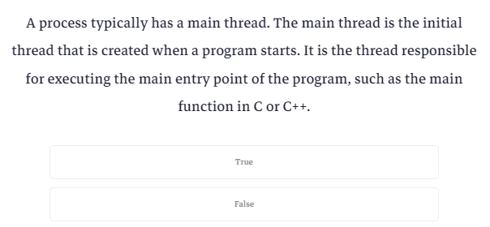

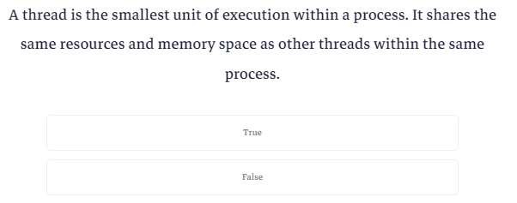

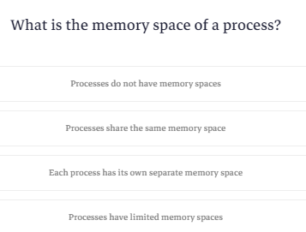

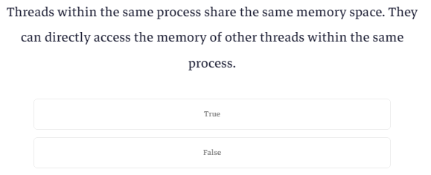

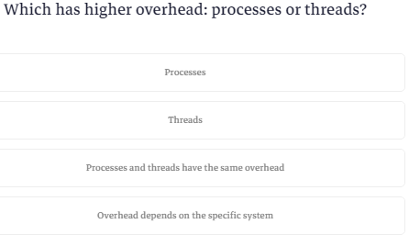

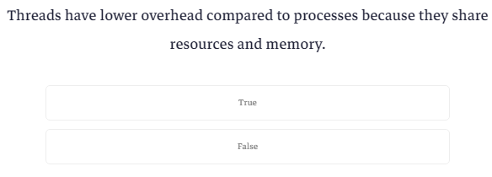

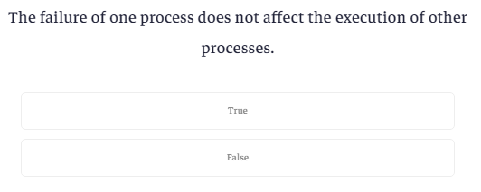

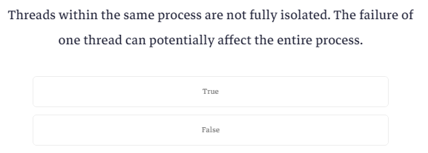

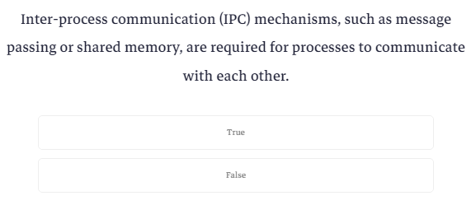

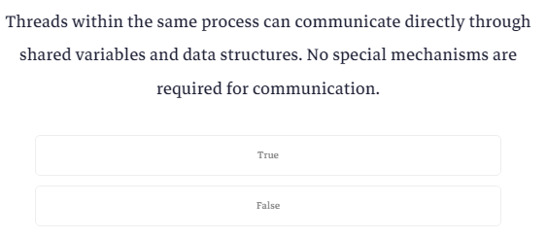

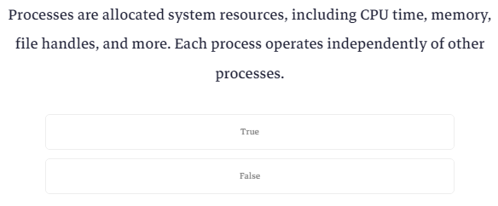

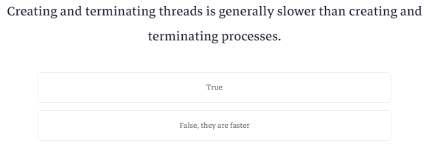

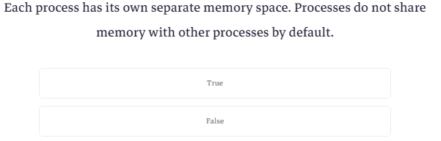

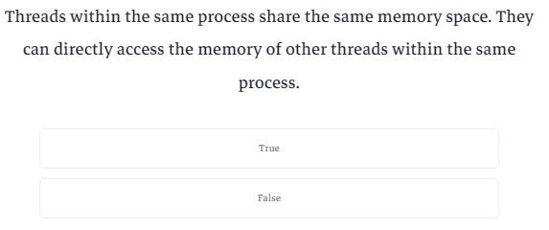

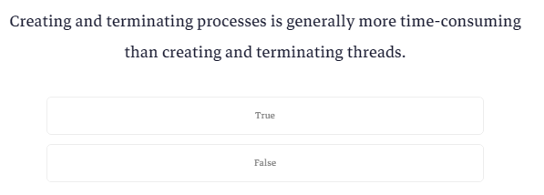

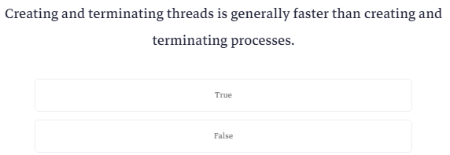

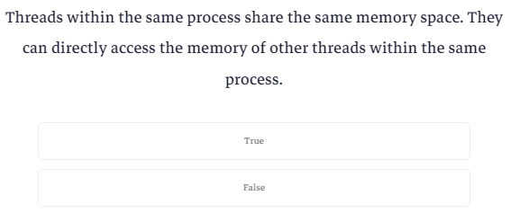

**What is Multithreading?**

ال multithreading هوا انك تشغل اكتر من thread مع بعض وده بيكون اسرع بس لازم تكون فاهم انت بتعمل ايه

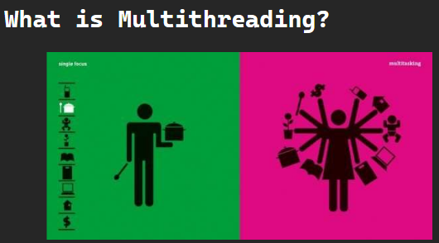

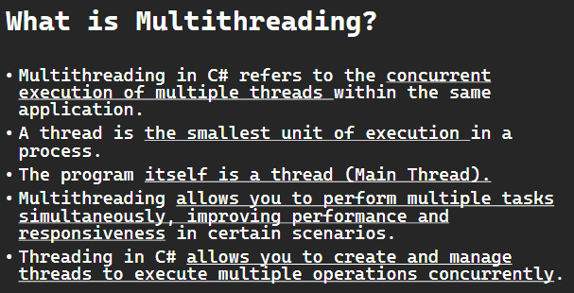

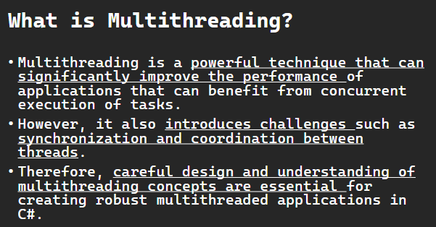

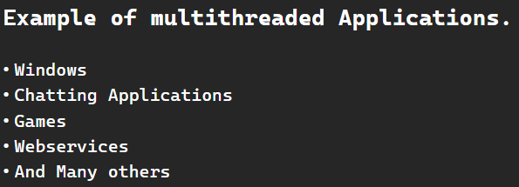

**Multithreading in C#** refers to the concurrent execution of multiple threads within the same application. A thread is the smallest unit of execution in a process, and multithreading allows you to perform multiple tasks simultaneously, improving performance and responsiveness in certain scenarios.

Threading in C# allows you to create and manage threads to execute multiple operations concurrently.

Multithreading is a powerful technique that can significantly improve the performance of applications that can benefit from concurrent execution of tasks. However, it also introduces challenges such as synchronization and coordination between threads. Therefore, careful design and understanding of multithreading concepts are essential for creating robust multithreaded applications in C#.

**Quiz 2**

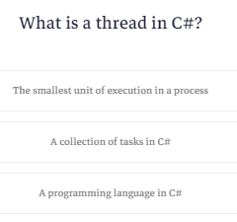

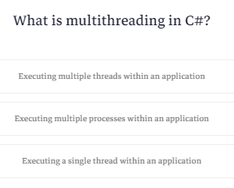

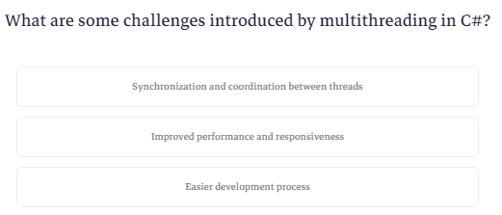

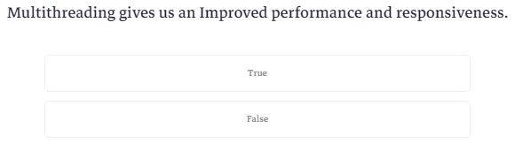

**What is Thread Class?**

لو عمل عمليات علي ال mainthread يكفي انك تكتب اسم الكلاس وتستدعي ال method اللي انت عايزها

زي كده

ال sleep بتخلي الthread ينام لفتره وبعدين يقوم يكمل شغل

|  |
| --- |
| static void Main()  {  for (int i = 0; i <= 5; i++)  {  Console.WriteLine("Main Thread:" + i);  Thread.Sleep(500);  }  Console.ReadKey();  } |

طيب لو انا هعمل thread خاصه بيا ؟

هعمل object من الكلاس thread وال constructor بتاعه بيطلب delegate فبديله ال method اللي عايز اشغلها اثناء مال main thread شغال

وبقوله start عشان يشتغل

ملحوظه هنا ال threads كلها بتشتغل مع بعضها وانت ماتضمنش مين يشتغل قبل مين لانه ممكن الthread اللي انت عاملها تسبق ال main thread وده اسمه thread racing

فيه حاجه كمان وهيا ال method اللي اسمها join ودي بتخلي ال main thread يوقف لحد ماال thread يخلص شغله

|  |
| --- |
| using System;  using System.IO;  using System.Security.Cryptography;  using System.Text;  using System.Threading;  class NullableExample  {  static void Method1() {  for (int i=0;i<=5;i++) {  Console.WriteLine("Thread Method1:" + i);  Thread.Sleep(500);  }  }  static void Main()  {  Thread t= new Thread(Method1);  t.Start();  for (int i = 0; i <= 5; i++)  {  Console.WriteLine("Main Thread:" + i);  Thread.Sleep(500);  }  Console.ReadKey();  }  } |

### **Thread Class:**

The Thread class in the System.Threading namespace is a fundamental building block for creating and managing threads in C#.

class Program

{

    static void Main()

    {

        // Note that your program is the main thread.

        // Create a new thread and start it

        Thread t = new Thread(ThreadMethod1);

        t.Start();

        // Main thread continues its execution

        for (int i = 1; i <= 10; i++)

        {

            Console.WriteLine("Main Thread: " + i);

            Thread.Sleep(1000); // Sleep for 1 second

        }

        Console.ReadKey();

    }

    static void ThreadMethod1()

    {

        for (int i = 1; i <= 5; i++)

        {

            Console.WriteLine("Thread Method1: " + i);

            Thread.Sleep(1000);

        }

    }

}

### **Explanation:**

* Main Method:
  + The Main method is the entry point of the program and represents the main thread.
  + A new thread (t) is created by instantiating the Thread class, and the method ThreadMethod1 is specified as the method to be executed by this thread.
  + The new thread (t) is started with the Start method.
* Main Thread Execution:
  + The main thread then enters a loop that runs for 10 iterations.
  + In each iteration, it prints a message to the console indicating the current iteration number along with the text "Main Thread."
  + After printing the message, the main thread sleeps for 1000 milliseconds (1 second) using Thread.Sleep(1000).
* Thread t Execution (ThreadMethod1):
  + Meanwhile, the new thread (t) executes the ThreadMethod1.
  + ThreadMethod1 runs in its own thread and enters a loop that runs for 5 iterations.
  + In each iteration, it prints a message to the console indicating the current iteration number along with the text "Thread Method1."
  + After printing the message, the thread (t) sleeps for 1000 milliseconds (1 second) using Thread.Sleep(1000).
* Console Output:
  + The output in the console will be a mix of messages from the main thread and the ThreadMethod1 thread, indicating concurrent execution.
  + The main thread prints messages while the ThreadMethod1 thread is also printing its messages.
* Console.ReadKey():
  + The Console.ReadKey() at the end is used to prevent the console window from closing immediately, allowing you to observe the output.

In summary, this code demonstrates the concurrent execution of the main thread and an additional thread (ThreadMethod1). Both threads print messages to the console in a loop, and the Thread.Sleep calls introduce delays to observe the interleaved execution of the two threads. The program will wait for a key press before exiting the console window.

**Quiz 3**

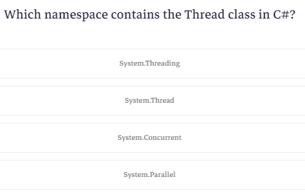

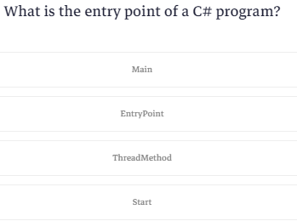

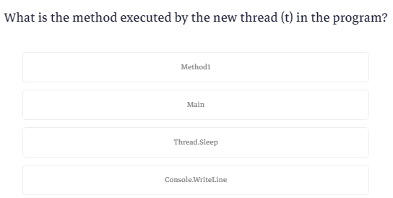

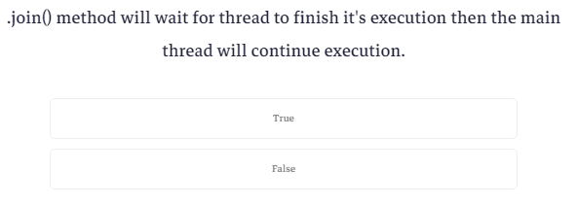

**Parameterized Thread**

احنا دلوقتي عايزين نبعت parameters لل thread

هنا بيقولك انه فيه طريقة تخلي ال start تاخد parameters بس الاسهل انك تستعمل ال lambda في انك تبعت parameters

الطريقه هيا انك تعمل method تشغل ال method الخاصه بال thread

|  |
| --- |
| using System;  using System.IO;  using System.Security.Cryptography;  using System.Text;  using System.Threading;  class NullableExample  {  static void Method1(string Text) {  for (int i=0;i<=5;i++) {  Console.WriteLine("Thread Method1:" +Text + i);  Thread.Sleep(500);  }  }  static void Main()  {  Thread t= new Thread(()=>Method1("Thread1"));  t.Start();  for (int i = 0; i <= 5; i++)  {  Console.WriteLine("Main Thread:" + i);  Thread.Sleep(500);  }  Console.ReadKey();  }  } |

**Download 3 Web Pages using Multi Threading**

هنعمل 3 tasks كل واحد فيهم بينزل صحفه من الانترنت وكلهم بيشتغلوا مع بعض

الكود مش محتاج شرح

|  |
| --- |
| using System;  using System.IO;  using System.Net;  using System.Security.Cryptography;  using System.Text;  using System.Threading;  class NullableExample  {  static void DownloadAndPrint(string url) {  string Content;  using (WebClient client=new WebClient()) {  Thread.Sleep(100);  Content = client.DownloadString(url);  }  Console.WriteLine($"{url}: {Content.Length} Characters Downloaded");  }  static void Main()  {  Console.WriteLine("Starting threads...");  Thread t1= new Thread(()=>DownloadAndPrint("https://www.cnn.com"));  t1.Start();  Console.WriteLine("Thread 1 started...");  Thread t2 = new Thread(() => DownloadAndPrint("https://www.amazon.com"));  t2.Start();  Console.WriteLine("Thread 2 started...");  Thread t3 = new Thread(() => DownloadAndPrint("https://www.ProgrammingAdvices.com"));  t3.Start();  Console.WriteLine("Thread 3 started...");  t1.Join();  t2.Join();  t3.Join();  Console.WriteLine("Done");  Console.ReadKey();  }  } |

**What is Race Condition?**

زي ماقولنا ان انت مابتقدرش تحدد مين اللي بيشتغل الاول في ال threads وده اسمه ال racing عشان كده بتحاول تتجنب ال shared resouces وانك تستعمل immutable objects عشان تتجنب الأخطاء

هنا بيقولك انه فيه حل للمشكله دي وهوا ال thread synchronization

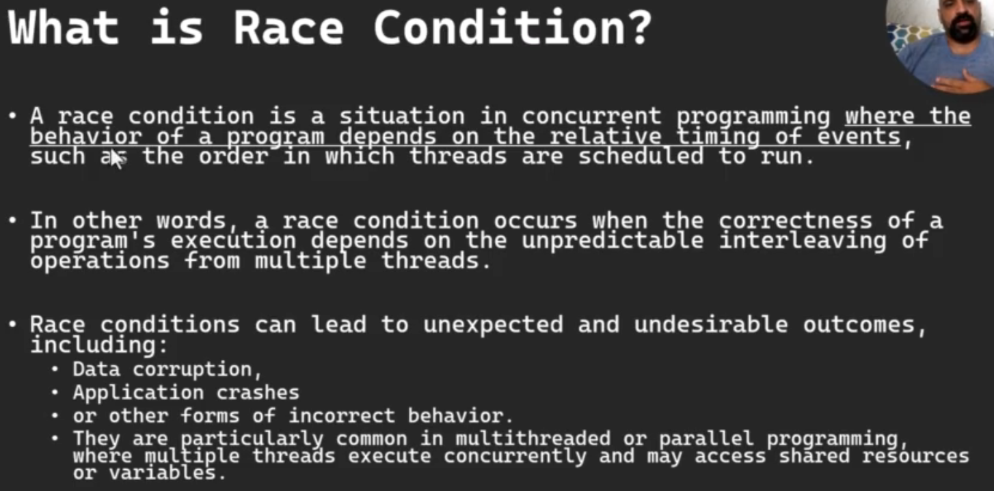

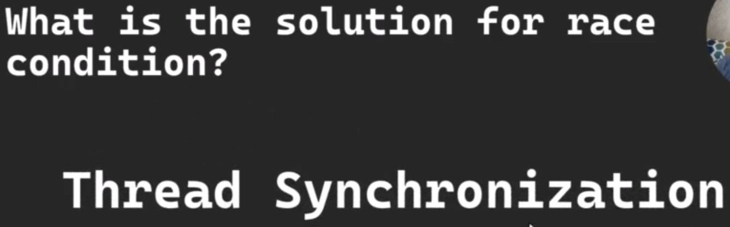

**What is Race Condition?**

A race condition is a situation in concurrent programming where the behavior of a program depends on the relative timing of events, such as the order in which threads are scheduled to run.

In other words, a race condition occurs when the correctness of a program's execution depends on the unpredictable interleaving of operations from multiple threads.

Race conditions can lead to unexpected and undesirable outcomes, including:

* Data corruption,
* Application crashes
* or other forms of incorrect behavior.

They are particularly common in multithreaded or parallel programming, where multiple threads execute concurrently and may access shared resources or variables.

**Quiz 4**

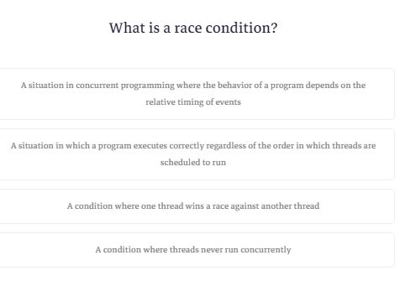

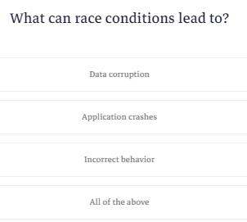

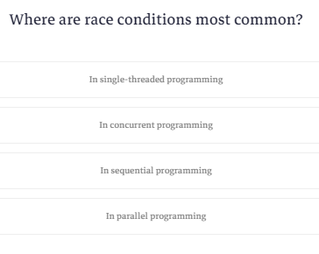

**Introduction to Thread Synchronization**

ال race synchronization هيا الحل لل race condition وهوا عباره عن انك تعمل تنسيق لل threads اشهر واحدة فيهم lock statement ودي بتتاكد انه مفيش اكتر من thread شغالين علي نفس ال object في نفس الوقت بيوقف الthreads طابور زي طابور العيش اول thread تستعمل ال object بيخليها تستعمله وبيعمل lock عليها ولو جه thread تاني يشتغل عليه بيوقفه في الطابور لحد مايخلص

فيه اكتر من synchronization mechanisms تانيه غير ال lock statement

فيه mechanism بتنسق العمل بين اتنين processes وفيه اللي بتخلي الobject متاح لthread واحد فقط وفيه اللي بتخليك انت تحدد عدد الthreads زي الداتابيز كده

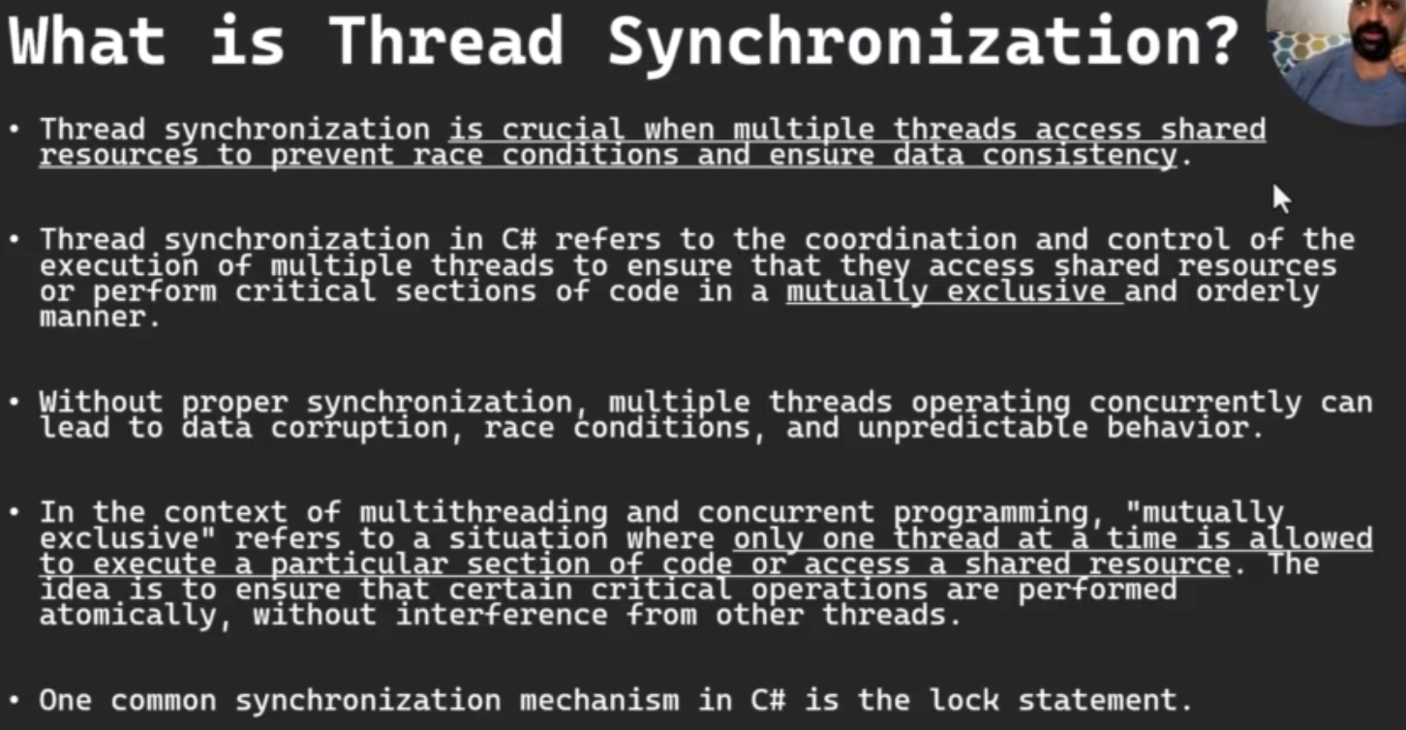

### **Thread Synchronization:**

Thread synchronization in C# refers to the coordination and control of the execution of multiple threads to ensure that they access shared resources or perform critical sections of code in a mutually exclusive and orderly manner. Without proper synchronization, multiple threads operating concurrently can lead to data corruption, race conditions, and unpredictable behavior.

In the context of multithreading and concurrent programming, "mutually exclusive" refers to a situation where only one thread at a time is allowed to execute a particular section of code or access a shared resource. The idea is to ensure that certain critical operations are performed atomically, without interference from other threads.

Thread synchronization is crucial when multiple threads access shared resources to prevent race conditions and ensure data consistency. One common synchronization mechanism in C# is the lock statement.

Multithreading is a powerful technique that can significantly improve the performance of applications that can benefit from concurrent execution of tasks. However, it also introduces challenges such as synchronization and coordination between threads. Therefore, careful design and understanding of multithreading concepts are essential for creating robust multithreaded applications in C#.

**Synchronization Example**

هنشرح مثال علي ال lock mechanism واللي بتتحقق من ال mutually exclusive واللي معناها انه ال object اللي يوصله thread واحد كل مره

هنا هنعمل متغيرمن النوع int وهيكون static وهنعمل object هيكون static برضه

|  |
| --- |
| static int sharedCounter = 0;  static object lockObject = new object(); |

الكود بتاعنا في ال main ماشي عادي جدا

|  |
| --- |
| static void Main()  {  Thread t1 = new Thread(IncrementCounter);  Thread t2 = new Thread(IncrementCounter);  t1.Start();  t2.Start();  t1.Join();  t2.Join();  Console.WriteLine("Final Counter Value: " + sharedCounter);  Console.ReadKey();  } |

امال هنعمل ال lock ازاي؟

قالك بتكتب lock وتفتح قوسين تحط فيهم ال object وقوسين تانيين تكتب فيهم الكود اللي انت عايزه او العمليه اللي مش عايز اكتر من thread يدخل عيها

هنا ال lock ده يعتبر البوابه وال object ده البواب اللي بيحرس الكود من ان اكتر من حد يشتغل عليه

|  |
| --- |
| for (int i = 0; i < 100000; i++)  {  lock (lockObject)  {  sharedCounter++;  }  } |

بس كده

وده الكود كله

|  |
| --- |
| using System;  using System.IO;  using System.Net;  using System.Security.Cryptography;  using System.Text;  using System.Threading;  class NullableExample  {  static int sharedCounter = 0;  static object lockObject = new object();  static void Main()  {  Thread t1 = new Thread(IncrementCounter);  Thread t2 = new Thread(IncrementCounter);  t1.Start();  t2.Start();  t1.Join();  t2.Join();  Console.WriteLine("Final Counter Value: " + sharedCounter);  Console.ReadKey();  }  static void IncrementCounter()  {  for (int i = 0; i < 100000; i++)  {  lock (lockObject)  {  sharedCounter++;  }  }  }  } |

Here's an example demonstrating thread synchronization using lock:

using System;

using System.Threading;

class Program

{

    static int sharedCounter = 0;

    static object lockObject = new object();

    static void Main()

    {

        // Create two threads that increment a shared counter

        Thread t1 = new Thread(IncrementCounter);

        Thread t2 = new Thread(IncrementCounter);

        t1.Start();

        t2.Start();

        // Wait for both threads to complete

        t1.Join();

        t2.Join();

        Console.WriteLine("Final Counter Value: " + sharedCounter);

        Console.ReadKey();

    }

    static void IncrementCounter()

    {

        for (int i = 0; i < 100000; i++)

        {

            // Use lock to synchronize access to the shared counter

            lock (lockObject)

            {

                sharedCounter++;

            }

        }

    }

}

Explanation:

1. sharedCounter and lockObject:
   * sharedCounter is a shared variable that both threads will increment.
   * lockObject is an object used as a lock to synchronize access to the shared resource.
2. IncrementCounter Method:
   * The IncrementCounter method is the code that each thread will execute.
   * It contains a loop where the shared counter is incremented multiple times.
   * The lock statement is used to ensure that only one thread can execute the critical section (the code inside the lock) at a time.
3. Main Method:
   * Two threads (t1 and t2) are created, both calling the IncrementCounter method.
   * The threads are started using the Start method.
   * The Join method is used to wait for both threads to complete before proceeding.
4. Console Output:
   * The final value of the shared counter is printed to the console.

In this example, without the lock statement, there could be a race condition where both threads try to increment sharedCounter simultaneously, leading to incorrect results. The lock statement ensures that only one thread can access the critical section at a time, preventing such race conditions and ensuring data consistency.

In the example provided earlier:

static int sharedCounter = 0;

static object lockObject = new object();

static void IncrementCounter()

{

    for (int i = 0; i < 100000; i++)

    {

        // Use lock to synchronize access to the shared counter

        lock (lockObject)

        {

            sharedCounter++;

        }

    }

}

Here, lockObject is the lock object. Let's break down its use:

* Creating the Lock Object:
  + lockObject is created as a simple object instance using new object();.
  + It is a dedicated object whose sole purpose is to be used as a synchronization object.
* Synchronization with lock:
  + The lock statement ensures that only one thread at a time can enter the critical section of code (the block of code inside the lock statement).
  + When a thread encounters the lock statement, it attempts to acquire the lock on the specified lock object (lockObject in this case).
  + If the lock is already held by another thread, the current thread will be blocked until the lock becomes available.
* Preventing Race Conditions:
  + A race condition is a situation in concurrent programming where the behavior of a program depends on the relative timing of events, such as the order in which threads are scheduled to run. In other words, a race condition occurs when the correctness of a program's execution depends on the unpredictable interleaving of operations from multiple threads.
  + Race conditions can lead to unexpected and undesirable outcomes, including data corruption, application crashes, or other forms of incorrect behavior. They are particularly common in multithreaded or parallel programming, where multiple threads execute concurrently and may access shared resources or variables.
  + In this example, the critical section is the increment operation on the sharedCounter.
  + Without the lock statement and proper synchronization, multiple threads could attempt to increment sharedCounter simultaneously, leading to race conditions and incorrect results.
* Ensuring Data Consistency:
  + By using lock and the designated lock object, data consistency is ensured. Only one thread can be inside the critical section at any given time, preventing conflicting updates to the shared resource.
* Avoiding Deadlocks:
  + Using a dedicated lock object (such as lockObject) is a good practice because it helps avoid deadlocks. Deadlocks can occur when multiple threads contend for multiple locks simultaneously, leading to a situation where no thread can make progress.

In summary, the lockObject is a synchronization object used with the lock statement to ensure mutually exclusive access to a critical section of code. It plays a crucial role in preventing race conditions, ensuring data consistency, and avoiding deadlocks in multithreaded applications.

**Quiz 5**

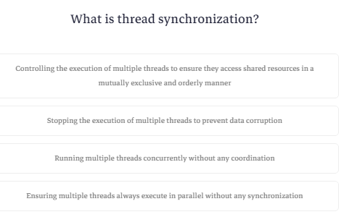

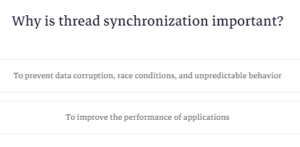

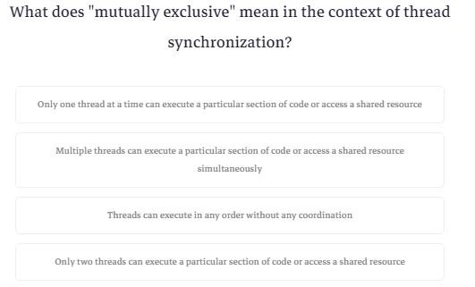

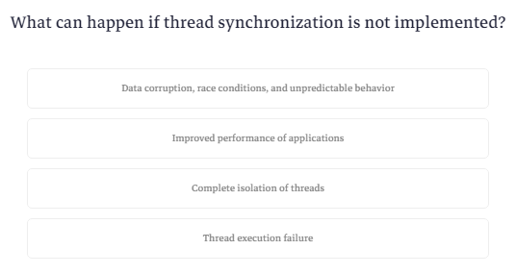

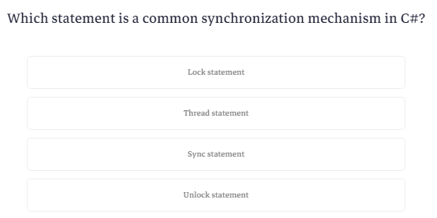

**What is Async Programming? how it's Different from multi threading?**

هنشرح الفرق بين ال synchronous programming وال multi threading وال

Asynchronous programming

هنا تخيل لو عندنا 3 tasks

اول واحده بتاخد 8 خطوات ومدة تشغيلها 8 ثواني

الثانيه بتاخد 4 خطوات ومدة تشغيلها 4 ثواني

الثالثه بتاخد خطوتين ومدة تشغيلها ثانيتين

هنا بيقولك لو المبرمج مش فاهم هيستخدم ال synchromous

ومعناها باختصار هوا انك هتشغل البرنامج علي thread واحد فيبدأ بال task الاولي يخلصها ينقل لل task التانيه يخلصها ينقل للثالثه

وبكده مدة تشغيل البرنامج 14 ثانيه

طيب لو حد فاهم شوية ؟

هنا هيستخدم ال multi threading وهيا انه يشغل البرنامج علي 3threads وبكده هيشغل ال 3tasks مع بعضهم

وبكدة مدة تشغيل البرنامج بتكون هيا مدة أطول task فيهم يعني 8 ثواني

طيب أي هيا ال asynchronous programming ؟

بيقولك انها بتكون عامل واحد يعني thread واحد بس لما يكون فيه حاجه بتعطله مابينامش او بيستني لما تخلص لا ده بيروح يشوف task تانيه يخلصها

يعني مثلا افرض انه ال task الاولانيه كان من ضمن الخطوات اللي فيها كان فيه 3 ثواني انتظار الرد من الداتا بيز

هل هينام جنبها لحد ما الرد يجيله ؟

قالك لا هيروح يشتغل في task تانيه مدة ال 3 ثواني دي لحد مالداتابيز ترد عليه وأول ماترد عليه بيسيب اللي في ايده ويروح يكمل اول task ولما يخلص ال task بيرجع علي task 2 يكمل الشغل اللي فيها وبعدين يروح علي task 3

وبالتالي الوقت المطلوب هوا عدد الثواني اللي اشتغلها فعلا من غير ال idle time يعني 11 ثانيه

ال synchronous هيا sequential programming

ال multi threading هيا parallel programming

ال asynchronous هيا concurrent programming

ال asynchronous بيبقي فيه حالات هوا بيكون فيها اسرع من ال multi threading

ال cost بتاعت تشغيل ال multithreading اعلي من ال asynchronous

طيب امتي استخدم ال asynchronous وامتي استخدم ال multi threading ؟

قالك بتستخدم ال asynchronous بتستخدمها في عمليات ال I/O Bound يعني عمليات ال input وال output زي التعامل مع الملفات لانه بيكون فيها اسرع من ال multi threading لانك لو استخدمت ال multi threading مع العمليات دي هتستهلك موارد اكتر

ال multithreading اسرع في حالة ال cpu bound tasks زي العمليات الحسابيه

ال asynchronous بتعرف ان الداتا بيز خلصت ؟

قالك عن طريق ال callback functions

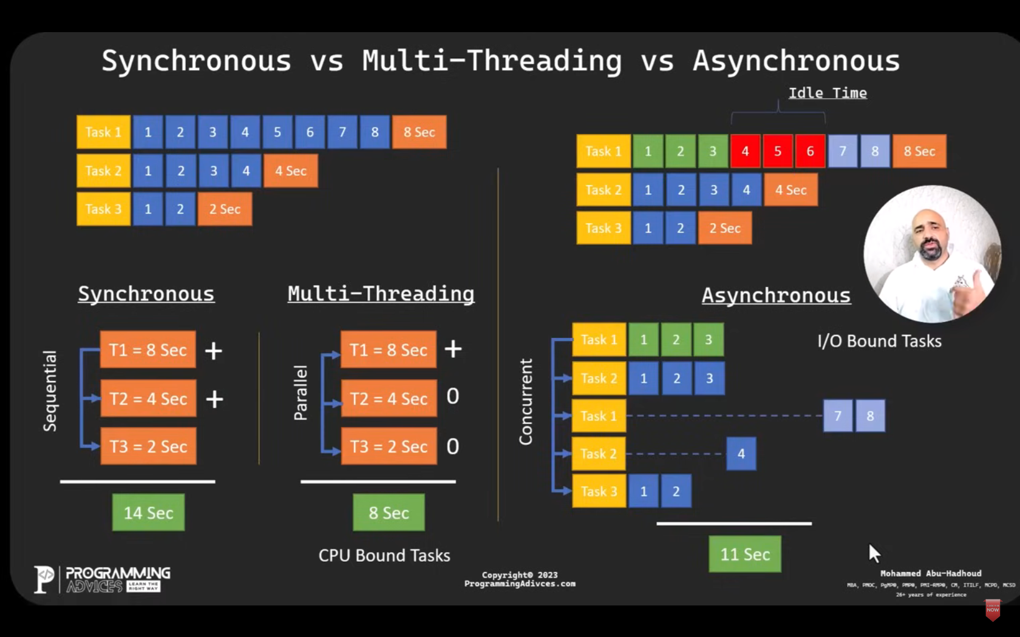

**Synchronous Vs. multithreading Vs. Synchronous programming in various aspects:**

* **Concurrency Model:**
  + Synchronous Programming: Concurrency is achieved through sequential execution. Each task is completed before moving on to the next, and the program waits for each operation to finish.
  + Multithreading: Concurrency is achieved by creating multiple threads of execution within a process. Threads can run independently, and the operating system scheduler decides when to switch between them.
  + Asynchronous Programming: Concurrency is achieved through non-blocking operations. The program can continue executing other tasks while waiting for certain operations (e.g., I/O or network requests) to complete.
* **Parallelism:**
  + Synchronous Programming: Does not inherently support parallelism. Tasks are executed sequentially.
  + Multithreading: Supports parallelism as multiple threads can execute tasks simultaneously on multiple CPU cores.
  + Asynchronous Programming: Does not necessarily imply parallelism but enables efficient use of resources by allowing tasks to run concurrently without blocking the main thread.
* **Programming Model:**
  + Synchronous Programming: Uses a straightforward, blocking model. Tasks are executed one after another in a linear fashion.
  + Multithreading: Requires explicit creation and management of threads, often involving synchronization mechanisms like locks.
  + Asynchronous Programming: Utilizes non-blocking constructs like callbacks, promises, or async/await. Facilitates the creation of non-blocking code, making it easier to handle multiple tasks concurrently.
* **Complexity and Safety:**
  + Synchronous Programming: Typically less complex and easier to understand, but can lead to blocking and potential inefficiencies.
  + Multithreading: Introduces complexities related to thread synchronization, shared data safety, and potential race conditions. Requires careful management to avoid issues like deadlocks.
  + Asynchronous Programming: Can be more readable for certain tasks, especially I/O-bound operations. However, managing callbacks and ensuring proper error handling can introduce complexity.
* **Resource Overhead:**
  + Synchronous Programming: Generally has lower resource overhead compared to multithreading.
  + Multithreading: Can have higher resource overhead due to the creation and management of multiple threads. Synchronization mechanisms add to complexity.
  + Asynchronous Programming: Tends to have lower resource overhead as it doesn't require creating and managing multiple threads.
* **Use Cases:**
  + Synchronous Programming: Well-suited for simpler applications or scenarios where blocking operations do not significantly impact performance.
  + Multithreading: Suitable for CPU-intensive tasks (CPU-Bound tasks) that can be parallelized, such as complex calculations or image processing.
  + Asynchronous Programming: Well-suited for scenarios where I/O operations are prevalent, such as networking, file I/O, or database queries.

In summary, the choice between synchronous programming, multithreading, and asynchronous programming depends on the nature of the tasks, the specific requirements of the application, and the desired balance between simplicity, concurrency, and parallelism. In many cases, a combination of these techniques may be used to achieve optimal performance.

**Quiz**

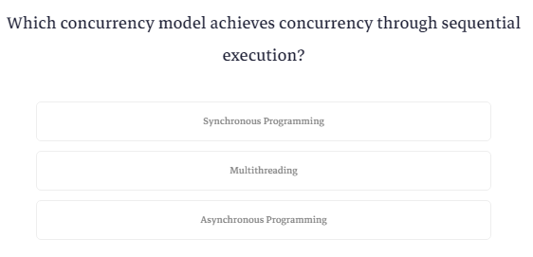

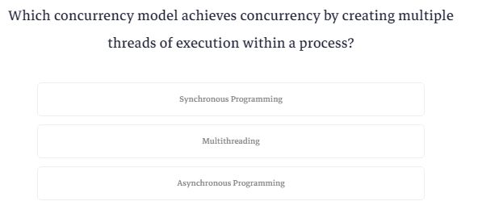

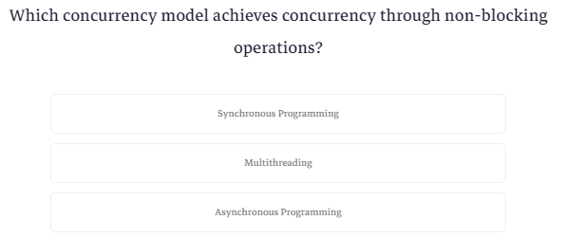

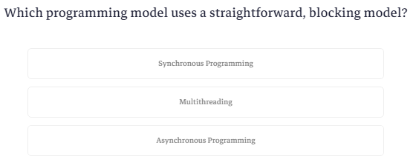

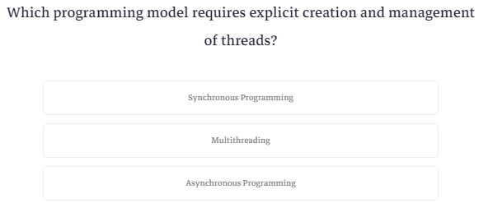

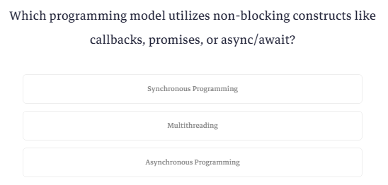

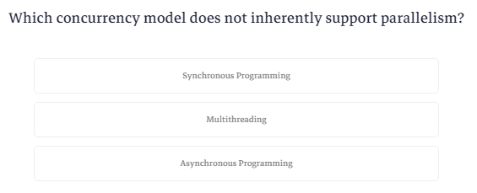

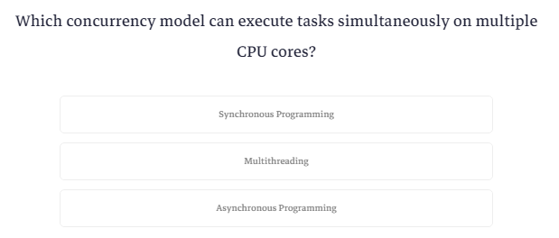

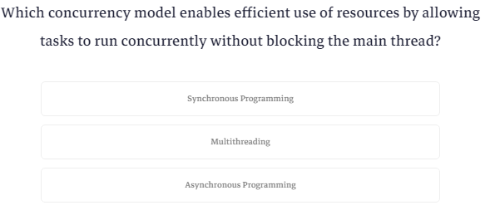

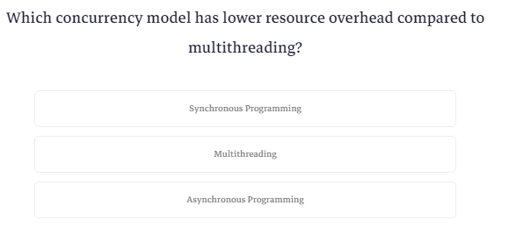

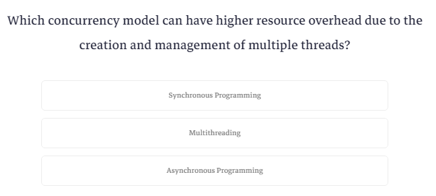

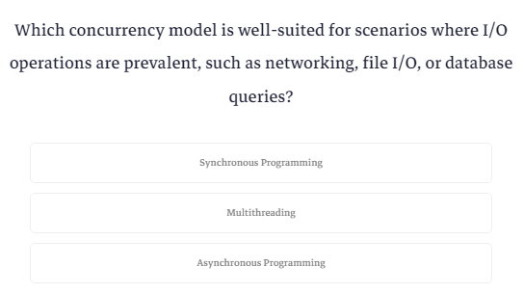

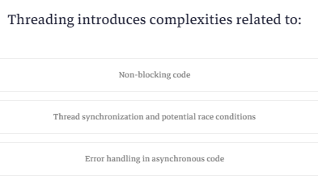

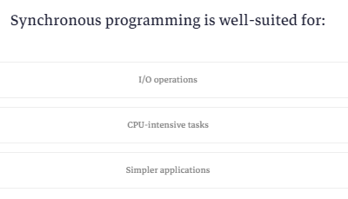

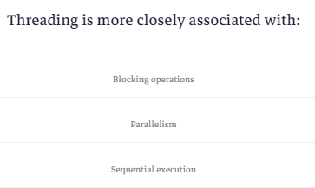

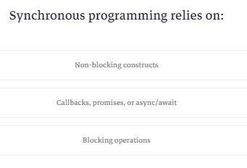

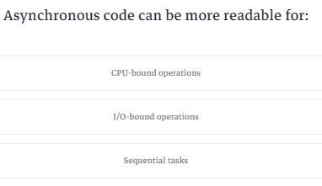

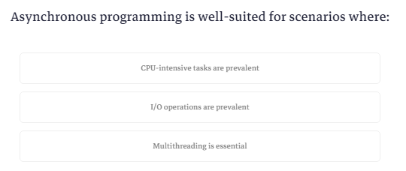

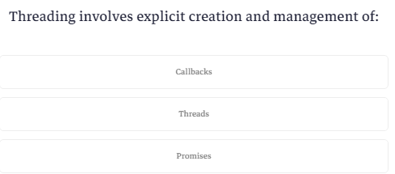

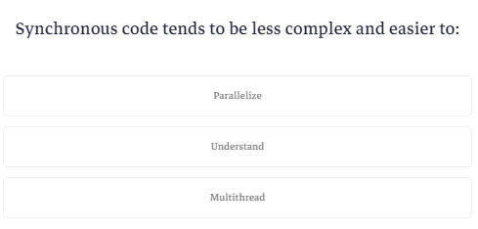

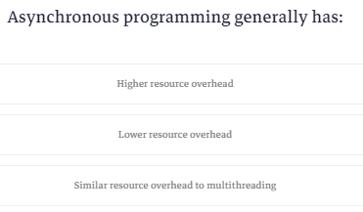

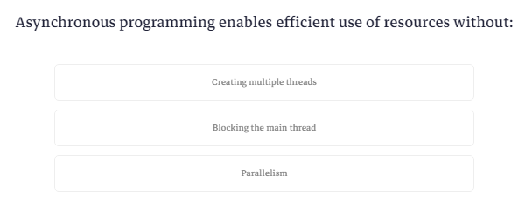

**Task Class**

عشان تستخدم ال async programming بتستخدم كلاس اسمه tasks وده بيكون في مكتبه اسمها TPL وهيا اختصار ل task parallel library وهنستخدم اتنين key words اسمهم async و await

كلمة async بتحطها جنب ال method عشان تضيفها للعمليات اللي عايز تضيفها لل async

كلمة await بتمنع ال thread من انه ينتقل للسطر الجاي من غير مايخلص method معينه

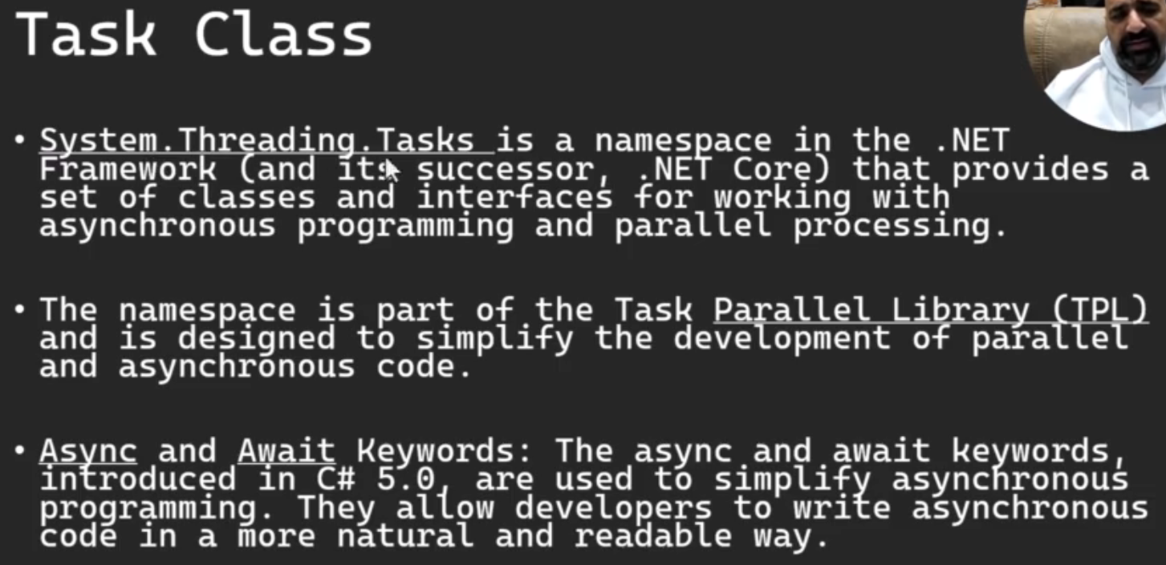

طيب اول خطوة عشان تستخدم ال async بتستدعي المكتبه دي

|  |
| --- |
| using System.Threading.Tasks; |

بعدين بنروح لل main ونكتب جنبها كلمة task async عشان تضمها للعمليات اللي عايز تعملها async

|  |
| --- |
| static async Task Main() |

بعدين هنعمل method بسيطه بتنيم ال thread لمدة 4 ثواني وبعدها بترجع رقم

عشان نعمل ده محتاجين حاجتين

اول حاجه نكتب كلمة async عشان نضيف ال method للعمليات بتاعت ال async

وفي ال return type هنقوه يرجعلنا task ال data type بتاعه int

ال task هنا هوا operation بترجع قيمه ولو كانت ال method بترجع void بتكتب task بس

|  |
| --- |
| static async Task<int> PerformAsyncOperation() {  await Task.Delay(4000);  return 42;  } |

بعدين نيجي لل main

هناخد object من task ونخلي ال generic type بتاعه يكون int او من نفس النوع اللي راجع من ال method ونديله ال method اللي هيشغلها

|  |
| --- |
| Task<int> resultTask = PerformAsyncOperation(); |

وبعدين هنعرف متغير نخزن فيه القيمه اللي راجعه من ال task وبنقوله يستني لحد مايخلصها عشان يرجع بالرقم

|  |
| --- |
| int result =await resultTask;  Console.WriteLine($"Result: {result}"); |

ده الكود كله

|  |
| --- |
| using System;  using System.Threading.Tasks;  class NullableExample  {  static async Task<int> PerformAsyncOperation() {  await Task.Delay(4000);  return 42;  }  static async Task Main()  {  Task<int> resultTask = PerformAsyncOperation();  Console.WriteLine("Do Some Other Work..." );  int result =await resultTask;  Console.WriteLine($"Result: {result}");  Console.ReadKey();  }  } |

طب ايه اللي بيحصل فيه؟

اول حاجه بيروح لأول سطر وهوا ان يعمل object من task ويبدأ يشغل ال method وبعدين بيلاقي امر بيعطله اللي هوا ال delay

كده المفروض انه

ينقل للسطر اللي بعده ويعمل return

بس عشان فيه delay فبيروح للسطر بتاع do some work عبال مالاربع ثواني تخلص

بعدين بينقل للسطر اللي بعده وهوا انه يعرف متغير من النوع int

المفروض هنا انه ياخد القيمه بتاعت ال result task بس بيلاقي كلمة await يعني استني لحد مال result Task تخلص

فبينقل لل perform operations عشان يكمل شغل

هنا المفروض انه هينفذ ال return بس بيلاقي كلمة await

فبيستني لحد مال delay يخلص

بعدين بينفذ السطر اللي بعده ويرجع القيمه

بعدين بيروح يكمل تعريف المتغير ويديله القيمه اللي راجعه

بعدين بيكمل شغله في ال main عادي

System.Threading.Tasks is a namespace in the .NET Framework (and its successor, .NET Core) that provides a set of classes and interfaces for working with asynchronous programming and parallel processing. The namespace is part of the Task Parallel Library (TPL) and is designed to simplify the development of parallel and asynchronous code.

Here are some key components and concepts within the System.Threading.Tasks namespace:

* Task Class:
  + The Task class is a fundamental building block in the Task Parallel Library. It represents an asynchronous operation and provides methods to monitor and interact with the operation's status.
* Async and Await Keywords:
  + The async and await keywords, introduced in C# 5.0, are used to simplify asynchronous programming. They allow developers to write asynchronous code in a more natural and readable way.

Here's a simple example of using Task and async/await:

using System;

using System.Threading.Tasks;

class Program

{

    static async Task Main()

    {

        // Create and run an asynchronous task

        Task<int> resultTask = PerformAsyncOperation();

        // Do some other work while waiting for the task to complete

        Console.WriteLine("Doing some other work...");

        // Wait for the task to complete and retrieve the result

        int result = await resultTask;

        // Process the result

        Console.WriteLine($"Result: {result}");

    }

    static async Task<int> PerformAsyncOperation()

    {

        // Simulate an asynchronous operation

        await Task.Delay(2000);

        // Return a result

        return 42;

    }

}

In this example, the PerformAsyncOperation method simulates an asynchronous operation using Task.Delay, and the async/await keywords are used to compose asynchronous operations in a readable manner. The Main method can perform other work while waiting for the asynchronous operation to complete. The Task<int> represents the asynchronous operation's result.

Overall, System.Threading.Tasks plays a crucial role in modern .NET development, making it easier for developers to write efficient, scalable, and readable asynchronous and parallel code.

**Task Class Example 2**

بص كده الكود ده

|  |
| --- |
| using System;  using System.Net;  using System.Net.Mime;  using System.Threading.Tasks;  class NullableExample  {  static async Task DownloadAndPrintAsync(string url) {  string Content;  using (WebClient Client=new WebClient()) {  await Task.Delay(100);  Content = await Client.DownloadStringTaskAsync(url);  }  Console.WriteLine($"{url}: {Content.Length} Charachters dowloaded");  }  static async Task Main()  {  Console.WriteLine("Starts Tasks...");  Task task1 = DownloadAndPrintAsync("https://www.cnn.com");  Console.WriteLine("Task 1 started...");  Task task2 = DownloadAndPrintAsync("https://www.amazon.com");  Console.WriteLine("Task 2 started...");  Task task3 = DownloadAndPrintAsync("https://www.ProgrammingAdvices.com");  Console.WriteLine("Task 3 started...");  await Task.WhenAll(task1, task2, task3);    Console.WriteLine($"AllDone");  Console.ReadKey();  }  } |

البرنامج هنا هيمشي ازاي؟

اول حاجه هينفذ السطر ده

|  |
| --- |
| Console.WriteLine("Starts Tasks..."); |

بعدين هيدخل عالسطر ده يعمل ال object

|  |
| --- |
| Task task1 = DownloadAndPrintAsync("https://www.cnn.com"); |

وبعدين هيدخل عال method وينفذ لحد هنا

|  |
| --- |
| static async Task DownloadAndPrintAsync(string url) {  string Content;  using (WebClient Client=new WebClient()) {  await Task.Delay(100); |

هيلاقي نفسه قاعد فاضي فيرجع لل main وينفذ السطر ده

|  |
| --- |
| Console.WriteLine("Task 1 started..."); |

وبعدين ينفذ السطر ده ويدخل عال method

|  |
| --- |
| static async Task DownloadAndPrintAsync(string url) {  string Content;  using (WebClient Client=new WebClient()) {  await Task.Delay(100); |

كده انت بقي عندك مسارين عطلان فيهم

فيدخل عال main لتالت مره وينفذ السطر ده

|  |
| --- |
| Console.WriteLine("Task 2 started..."); |

وبعدين يكمل في السطر ده

|  |
| --- |
| Task task3 = DownloadAndPrintAsync("https://www.ProgrammingAdvices.com"); |

ويدخل في ال method وينفذ في السطر ده

|  |
| --- |
| static async Task DownloadAndPrintAsync(string url) {  string Content;  using (WebClient Client=new WebClient()) {  await Task.Delay(100); |

هيلاقي نفسه عطلان لتالت مره فيدخل عال main وينفذ السطر ده

|  |
| --- |
| Console.WriteLine("Task 3 started..."); |

وبعدها ينقل عالسطر اللي بعده

|  |
| --- |
| await Task.WhenAll(task1, task2, task3); |

هنا بيقوله استني لحد مال tasks كلها تخلص

فيرجع لأول task ويستني المده تخلص وييجي ينفذ السطر ده

|  |
| --- |
| Content = await Client.DownloadStringTaskAsync(url); |

يقوله استني لحد مالتحميل يخلص

يقعد فاضي؟

لا يدخل عال task 2 ويستني المده تخلص وييجي ينفذ السطر ده

|  |
| --- |
| Content = await Client.DownloadStringTaskAsync(url); |

يقوله استني لحد مالتحميل يخلص

يقعد فاضي؟

لا يدخل عال task3 ويستني المده تخلص وينفذ السطر ده

|  |
| --- |
| Content = await Client.DownloadStringTaskAsync(url); |

يقوله استني لما التحميل يخلص

يقعد فاضي؟

هنا هيقعد فاضي لانه لو دخل عال main هيلاقيه بيقوله استني برضه

فيقعد مستني لحد ما صفحه من الصفحات تحمل وينزل ينفذ جمله الطباعه دي

|  |
| --- |
| Console.WriteLine($"{url}: {Content.Length} Charachters dowloaded"); |

ويستني لما task تانيه تحمل ويطبع ويستني حد ما task تالته تحمل وتطبع

وبعدين يدخل عال main يقوله خلاويص ؟ يقوله خلاص يقوم مكمل في الكود عادي

**Task Class With Call back Event Example**

هنا احنا عاوزين نشغل task معينه ولما تخلص تشغل event تبلغك انه خلص

اول حاجه هيا اننا نجهز ال event وناخد object منه

|  |
| --- |
| public class CustomEventArgs : EventArgs {    public int Parameter1 { get; }  public string Parameter2 { get; }  public CustomEventArgs(int Parameter1, string Parameter2) {  this.Parameter1 = Parameter1;  this.Parameter2 = Parameter2;  }  }  public delegate void CallbackEventHandler(object sender, CustomEventArgs e);  public static event CallbackEventHandler CallbackEvent; |

وبعدين هنعمل method ونضيفها لل event

|  |
| --- |
| static void OnCallBackRecieved(object sender, CustomEventArgs e) {  Console.WriteLine($"Event Recieved: Parameter 1 = {e.Parameter1} Parameter 2= {e.Parameter2}");  }  static async Task Main()  {  CallbackEvent += OnCallBackRecieved; |

وبعدين نعمل ال method بتاعت ال task ونخليها تاخد parameter من نوع ال event

عن طريق ال object ده نقدر نستدعي منه ال invoke بعد مانخلص كل الكود بتاع ال method بحيث انه لما يخلص شغل يسدعي ال method بتاعت on call back received

|  |
| --- |
| static async Task PerformAsyncOperation(CallbackEventHandler callBack) {  await Task.Delay(2000);  CustomEventArgs eventArgs = new CustomEventArgs(42, "Hello from event");  callBack?.Invoke(null,eventArgs);  } |

بس كده وبقيت الكود مافيهوش مشكله

هوا الجديد بس انه بيقولك لو عايز تعمل event مع ال async task خلي ال method بتاعت ال task تاخد parameter من ال event بحيث انها تعمل invoke لما تخلص شغل

|  |
| --- |
| using System;  using System.Net;  using System.Threading.Tasks;  class NullableExample  {  public class CustomEventArgs : EventArgs {    public int Parameter1 { get; }  public string Parameter2 { get; }  public CustomEventArgs(int Parameter1, string Parameter2) {  this.Parameter1 = Parameter1;  this.Parameter2 = Parameter2;  }  }  public delegate void CallbackEventHandler(object sender, CustomEventArgs e);  public static event CallbackEventHandler CallbackEvent;  static async Task PerformAsyncOperation(CallbackEventHandler callBack) {  await Task.Delay(2000);  CustomEventArgs eventArgs = new CustomEventArgs(42, "Hello from event");  callBack?.Invoke(null,eventArgs);  }  static void OnCallBackRecieved(object sender, CustomEventArgs e) {  Console.WriteLine($"Event Recieved: Parameter 1 = {e.Parameter1} Parameter 2= {e.Parameter2}");  }  static async Task Main()  {  CallbackEvent += OnCallBackRecieved;  Task PerformTask = PerformAsyncOperation(CallbackEvent) ;  Console.WriteLine("Doing some Other work");  await PerformTask;  Console.WriteLine("Done");  Console.ReadKey();  }  } |

**Task.Run**

هنا بيقولك انه ال task.run بتستخدمها عشان تنفذ كود بتاع thread معين في الخلفيه بحيث ان الفورم مايتعطلش ويسمح لليوزر بتحريكه

هنا انت كأنك بتعمل thread وبتشغلها

وهوا بيستخدم threads مش async

وكمان بيقولك انك ممكن تدمج مابين ال threading وال async بحيث تخلي البرنامج اسرع

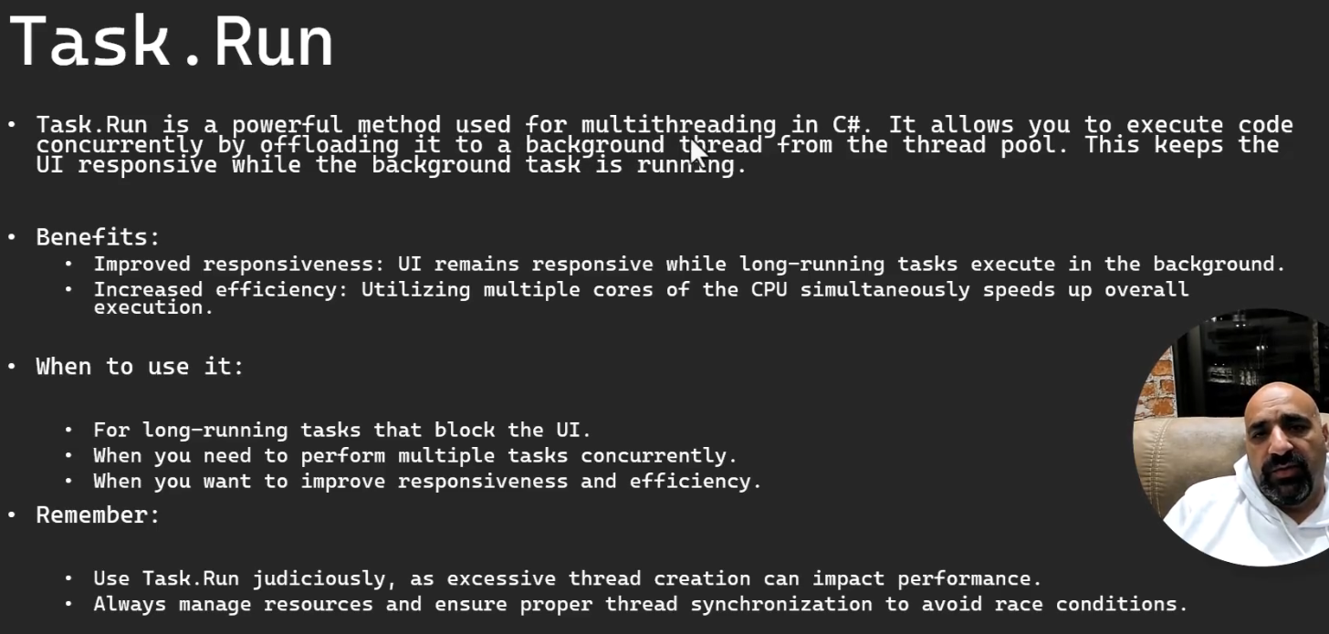

وده مثال

|  |
| --- |
| using System;  using System.Threading;  using System.Threading.Tasks;  class NullableExample  {  static void DownloadFile(string TaskName) {  Console.WriteLine($"{TaskName} : Started!");  Thread.Sleep(5000);  Console.WriteLine($"{TaskName} : Completed!");  }    static async Task Main()  {  Task task1 = Task.Run(() => DownloadFile("Download File 1"));  Task task2 = Task.Run(() => DownloadFile("Download File 2"));  await Task.WhenAll(task1, task2);  Console.WriteLine($"Task 1 and 2 completed");  Console.ReadKey();  }  } |

**What is Task.Run?**

Task.Run is a powerful method in C# that facilitates multithreading. It is part of the Task Parallel Library (TPL) and serves as a convenient way to execute code concurrently by offloading it to a background thread from the thread pool. This is particularly useful for scenarios where you want to keep the user interface (UI) responsive while computationally intensive or time-consuming tasks run in the background.

**Benefits:**

**1. Improved Responsiveness:**

By utilizing Task.Run, you ensure that long-running tasks are executed in the background, preventing them from blocking the UI. This enhances the overall responsiveness of your application, providing a smoother user experience.

**2. Increased Efficiency:**

 Task.Run enables the simultaneous utilization of multiple CPU cores, optimizing the execution of tasks. This can lead to improved efficiency and performance in scenarios where parallel processing is beneficial.

**When to use it:**

**1. For Long-Running Tasks that Block the UI:**

 Task.Run is particularly well-suited for tasks that have the potential to block the UI due to their duration. Offloading such tasks to a background thread ensures that the UI remains responsive to user interactions.

**2. When You Need to Perform Multiple Tasks Concurrently:**

 If your application involves multiple independent tasks that can run concurrently, Task.Run provides a straightforward way to parallelize the execution of these tasks.

**3. When You Want to Improve Responsiveness and Efficiency:**

 Task.Run is a valuable tool when the goals include both improving UI responsiveness and optimizing the overall efficiency of task execution through parallelism.

**Remember:**

**1. Use Task.Run Judiciously:**

While Task.Run is a powerful tool, excessive use can lead to the creation of too many threads, impacting performance negatively. Exercise caution and use it judiciously based on the specific needs of your application.

**2. Manage Resources and Ensure Thread Synchronization:**

To prevent potential issues such as race conditions, it is crucial to manage resources carefully and ensure proper thread synchronization. This involves using synchronization mechanisms when accessing shared resources to avoid conflicts.

By understanding Task.Run, you can leverage multithreading effectively in your C# applications, leading to more responsive and efficient code.

**Quiz 2**

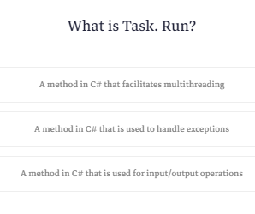

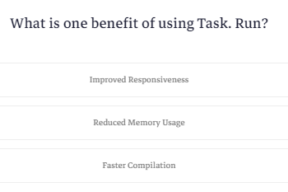

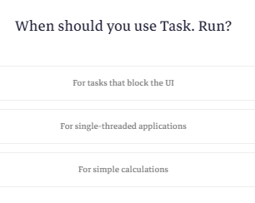

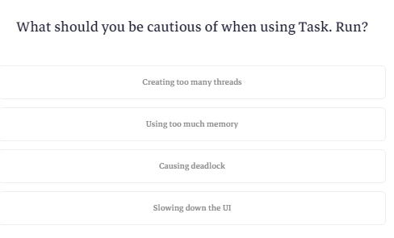

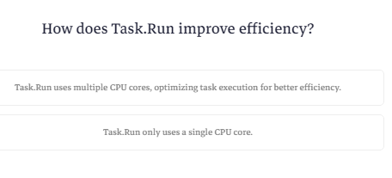

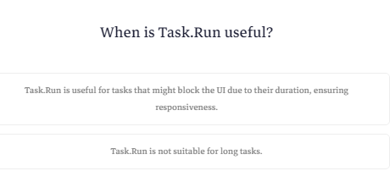

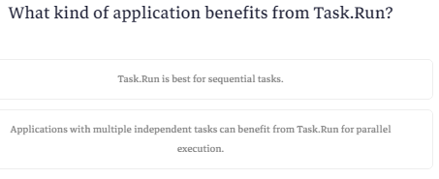

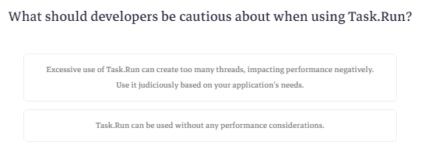

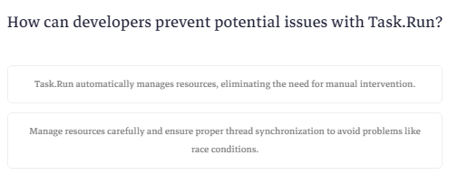

**Introduction to Task Factory Class**

ال task factory class هيا مكتبه بتسهل عليك التعامل مع ال tasks وبتتيحلك انك تعمل configurations معينه قبل ماتشغل ال task او انك تضم اكتر من task تحت task factory وتتعامل معاهم كهم مرة واحده منها مثلا انك لما تيجي تشغل task معينه تقدر في أي وقت تلغيها او انك تدي task معينه اولويه عن التانيه

الفكرة هنا انك بتعمل object من task factory وبتحدد فيه ازاي ال tasks اللي هتضيفها ليه هتشتغل

وبعدين لما تحب تضيفله task جديدة بتستدعي method اسمها start new وتخزنها في object من النوع task

يعني اعتبر نفسك بتعمل tasks عاديه جدا بس بتحددلها الاطار العام اللي هتشتغل فيه من خلال ال task factory

|  |
| --- |
| using System;  using System.Threading;  using System.Threading.Tasks;  class NullableExample  {    static async Task Main()  {  CancellationTokenSource cts=new CancellationTokenSource();  CancellationToken token=cts.Token;  TaskFactory taskFactory = new TaskFactory(token,  TaskCreationOptions.AttachedToParent,  TaskContinuationOptions.ExecuteSynchronously,  TaskScheduler.Default);  Task task1 = taskFactory.StartNew(() =>  {  Console.WriteLine("Task 1 is running");  Thread.Sleep(2000);  Console.WriteLine("Task 1 Completed");  });  // cts.Cancel();  Task task2 = taskFactory.StartNew(() =>  {  Console.WriteLine("Task 2 is running");  Thread.Sleep(2000);  Console.WriteLine("Task 2 Completed");  });  try {  Task.WaitAll(task1, task2);  Console.WriteLine("All tasks Completed");  } catch (AggregateException ae) {  foreach (var e in ae.InnerExceptions)  {  Console.WriteLine(e.Message);  }  }  cts.Dispose();  Console.ReadKey();  }  } |

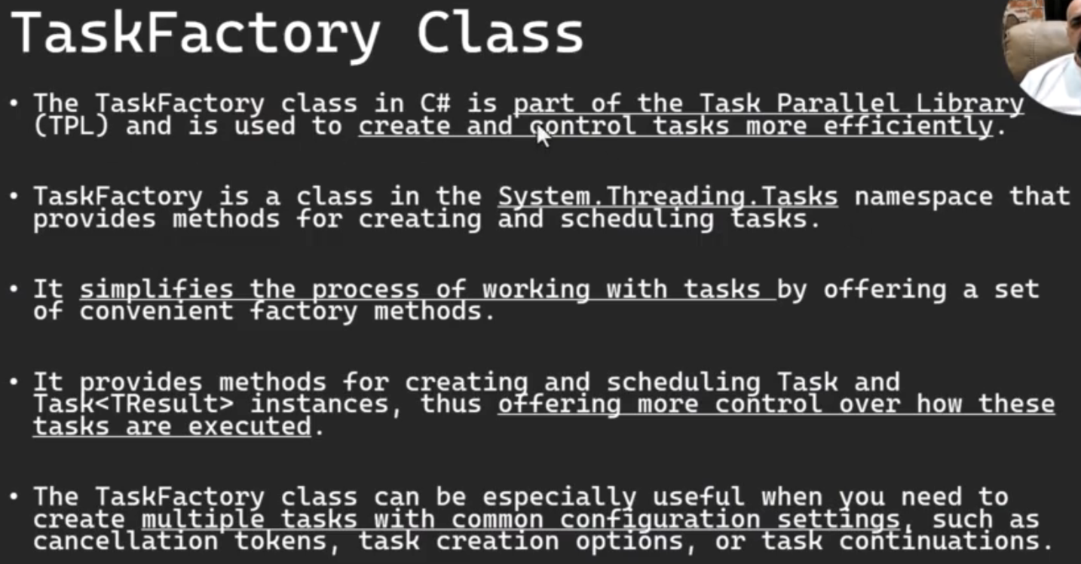

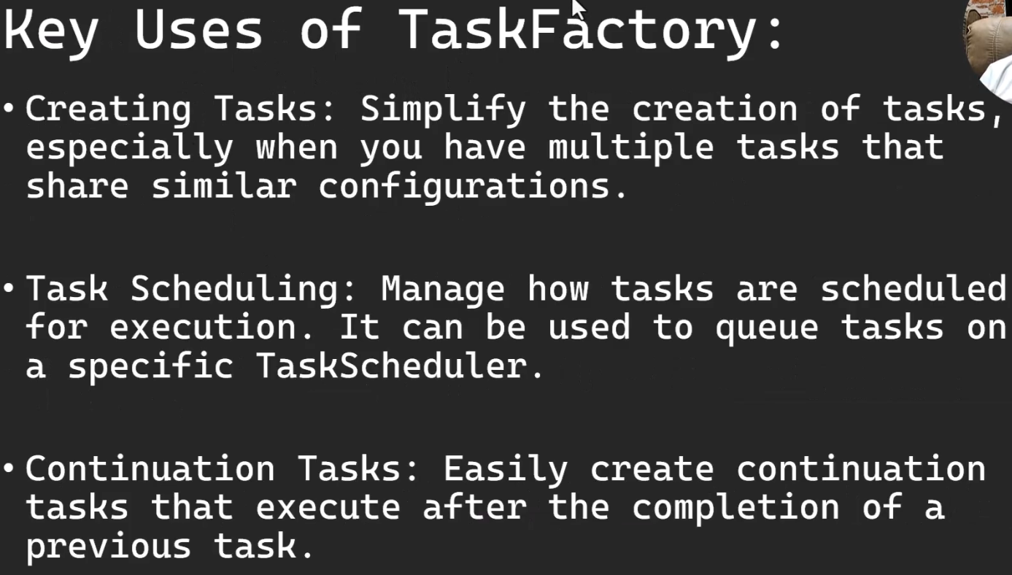

**TaskFactory Class:**

﻿The TaskFactory class in C# is part of the Task Parallel Library (TPL) and is used to create and control tasks more efficiently.

TaskFactory is a class in the System.Threading.Tasks namespace that provides methods for creating and scheduling tasks.

It simplifies the process of working with tasks by offering a set of convenient factory methods.

It provides methods for creating and scheduling Task and Task<TResult> instances, thus offering more control over how these tasks are executed. The TaskFactory class can be especially useful when you need to create multiple tasks with common configuration settings, such as cancellation tokens, task creation options, or task continuations.

### **Key Uses of TaskFactory:**

1. Creating Tasks: Simplify the creation of tasks, especially when you have multiple tasks that share similar configurations.
2. Task Scheduling: Manage how tasks are scheduled for execution. It can be used to queue tasks on a specific TaskScheduler.
3. Continuation Tasks: Easily create continuation tasks that execute after the completion of a previous task.

**Example Usage of TaskFactory:**

Here's a simple example demonstrating the use of TaskFactory:

using System;

using System.Threading;

using System.Threading.Tasks;

class Program

{

    static void Main(string[] args)

    {

        // Define a cancellation token so we can stop the task if needed

        CancellationTokenSource cts = new CancellationTokenSource();

        CancellationToken token = cts.Token;

        // Create a TaskFactory with some common configuration

        TaskFactory taskFactory = new TaskFactory(

            token,

            TaskCreationOptions.AttachedToParent,

            TaskContinuationOptions.ExecuteSynchronously,

            TaskScheduler.Default);

        // Use the TaskFactory to create and start a new task

        Task task1 = taskFactory.StartNew(() =>

        {

            Console.WriteLine("Task 1 is running");

            // Simulate some work

            Thread.Sleep(2000);

            Console.WriteLine("Task 1 completed");

        });

        // Create another task using the same TaskFactory

        Task task2 = taskFactory.StartNew(() =>

        {

            Console.WriteLine("Task 2 is running");

            // Simulate some work

            Thread.Sleep(1000);

            Console.WriteLine("Task 2 completed");

        });

        try

        {

            // Wait for both tasks to complete

            Task.WaitAll(task1, task2);

            Console.WriteLine("All tasks completed.");

        }

        catch (AggregateException ae)

        {

            // Handle exceptions if any task throws

            foreach (var e in ae.InnerExceptions)

                Console.WriteLine($"Exception: {e.Message}");

        }

        // Dispose of the CancellationTokenSource

        cts.Dispose();

    }

}

In this example, a TaskFactory is created with specific configuration options, and it's used to start two tasks. Both tasks are managed by the same TaskFactory, thus inheriting its configuration settings. The CancellationTokenSource and CancellationToken are used to demonstrate how you could cancel the tasks if necessary.

### **When to Use TaskFactory:**

* When you need multiple tasks with similar configurations.
* When you need more control over task scheduling.
* When working with task continuations or parent-child task relationships.

Remember, while TaskFactory is a powerful tool, it's not always necessary for simple task parallelism scenarios. The Task.Run method is often sufficient for running tasks without requiring specific configurations that TaskFactory provides.

TaskCreationOptions is an enumeration in the .NET Framework that provides several options to control the behavior of tasks created using the Task Parallel Library (TPL). These options give you more fine-grained control over how tasks are scheduled, executed, and how they behave in relation to other tasks. Here are some of the key options available in the TaskCreationOptions enumeration:

1. None: Specifies that the default configuration should be used. This is the most common setting when none of the other options are needed.
2. PreferFairness: Hints to the Task Scheduler that fairness should be prioritized. This means that tasks will be scheduled in the order they were queued, attempting to avoid situations where a later-created task runs before an earlier-created one.
3. LongRunning: Indicates that a task will be a long-running, coarse-grained operation involving fewer, larger components. This hint allows the Task Scheduler to optimize the execution of these tasks, possibly avoiding the overhead of context switching.
4. AttachedToParent: Specifies that a task is attached to a parent in the task hierarchy. When a parent task waits on its children, it will implicitly wait for all tasks attached to it as well.
5. DenyChildAttach: Prevents any child tasks from attaching to the current task. This option is useful when you want to create a task within another task but prevent it from being attached to the parent task.
6. HideScheduler: Prevents the ambient task scheduler from being seen as the current scheduler in the created task. This means that tasks created within this task will not see the current task's scheduler as the default scheduler.
7. RunContinuationsAsynchronously: Ensures that continuations added to the current task run asynchronously. This option can be used to avoid potential deadlocks and improve responsiveness.

TaskContinuationOptions is an enumeration in C# that provides a set of options that control the behavior of task continuations. Task continuations are created using methods like Task.ContinueWith, which allow you to specify actions that should be executed after a task completes. These options give you fine-grained control over when and how continuations are executed in relation to the task they are continuing from. Here are some of the key options available in the TaskContinuationOptions enumeration:

1. None: Specifies that the default behavior should be used, with no special conditions applied to the continuation task.
2. PreferFairness: Indicates that the continuation task should be scheduled in a fair manner in relation to other tasks. This can be useful in scenarios where you want to maintain a first-in, first-out (FIFO) order of task execution.
3. LongRunning: Suggests that the continuation will be a long-running operation. This option hints to the Task Scheduler that an additional thread might be advantageous for running the continuation, thus reducing the chance of it blocking other tasks.
4. AttachedToParent: Indicates that the continuation task is attached to the parent task in a nested task structure. The parent task will wait for the attached child continuation tasks to complete before it completes.
5. ExecuteSynchronously: Advises the Task Scheduler to try to execute the continuation synchronously on the same thread that ran the antecedent task, rather than queuing it to the ThreadPool. This can be more efficient for short continuations, but care should be taken as it can potentially lead to deadlocks or stack overflows.
6. LazyCancellation: Specifies that the continuation task should not be canceled immediately if its antecedent task is canceled. Instead, the continuation will start and then check the cancellation token, if any, to determine whether to continue executing.
7. NotOnRanToCompletion: Specifies that the continuation should not be executed if the antecedent task completes successfully.
8. NotOnFaulted: Specifies that the continuation should not be executed if the antecedent task throws an unhandled exception (faults).
9. NotOnCanceled: Specifies that the continuation should not be executed if the antecedent task is canceled.
10. OnlyOnRanToCompletion: Specifies that the continuation should only be executed if the antecedent task completes successfully.
11. OnlyOnFaulted: Specifies that the continuation should only be executed if the antecedent task throws an unhandled exception.
12. OnlyOnCanceled: Specifies that the continuation should only be executed if the antecedent task is canceled.

TaskScheduler is a fundamental class in the Task Parallel Library (TPL) in C#. It serves as the engine behind task scheduling, execution, and management. The TaskScheduler abstract class provides a means to queue tasks to the ThreadPool or to a custom scheduler.

### **Key Concepts of TaskScheduler:**

1. Default Task Scheduler: By default, the TPL uses the ThreadPoolTaskScheduler. This default scheduler is efficient for most scenarios, balancing responsiveness and throughput. It queues tasks to the system's thread pool.
2. Custom Task Schedulers: You can implement custom task schedulers by deriving from the TaskScheduler class. This is useful for specialized scenarios, like scheduling tasks to run on a UI thread, handling tasks with specific priorities, or managing tasks in an environment with unique threading requirements.
3. Queuing Tasks: The TaskScheduler determines how tasks are queued and when they are executed. It abstracts the details of how tasks are managed, whether that's on a thread pool, a single thread, or some other mechanism.
4. Task Execution: The scheduler determines when and how a task is executed. This includes considerations like concurrency limits, prioritization, and dealing with unhandled exceptions in tasks.
5. Synchronization Context Integration: For applications with a synchronization context (like Windows Forms or WPF applications), the default scheduler can ensure that task continuations that update the UI are executed on the correct thread.

**Quiz 3**

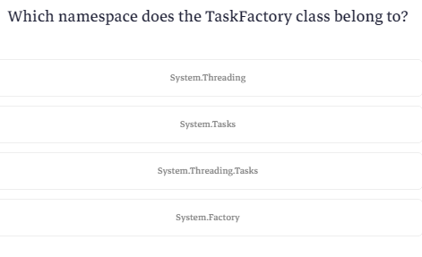

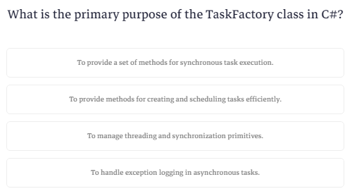

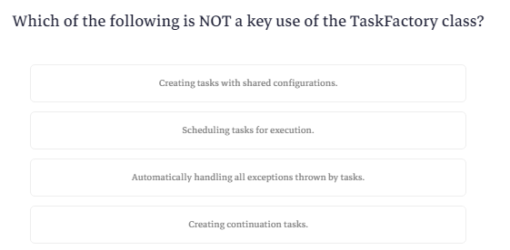

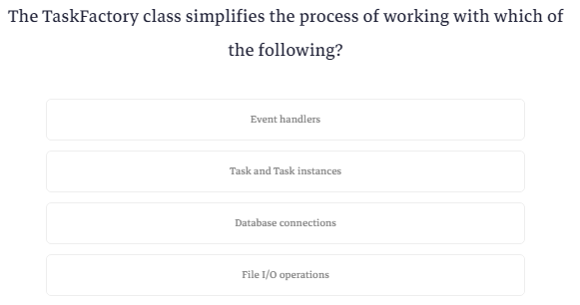

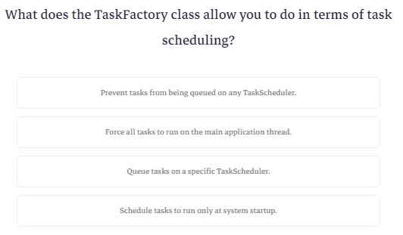

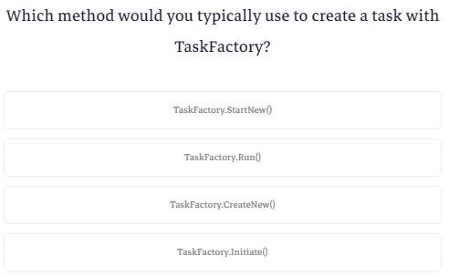

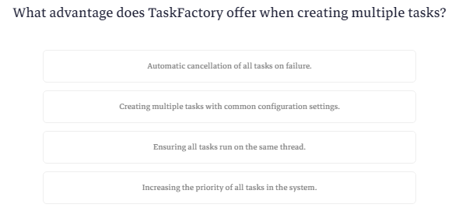

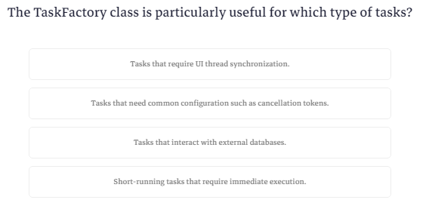

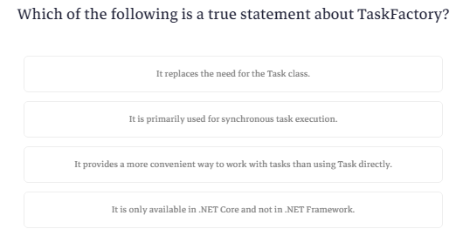

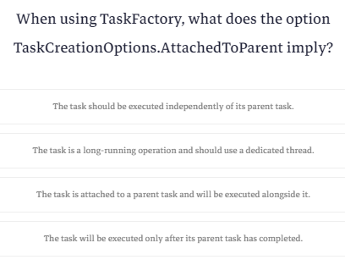

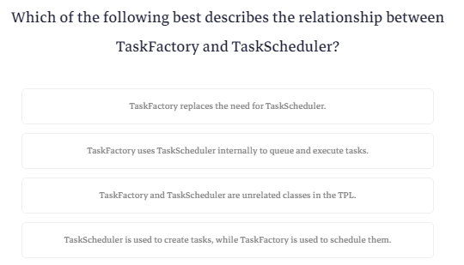

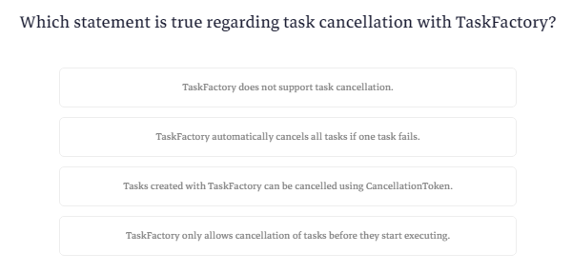

**Parallel Class in C#**

ال parallel class بيوفرلك loops وmethods تقدر تستخدمها عشان تحقق ال parallelism في البرمجه

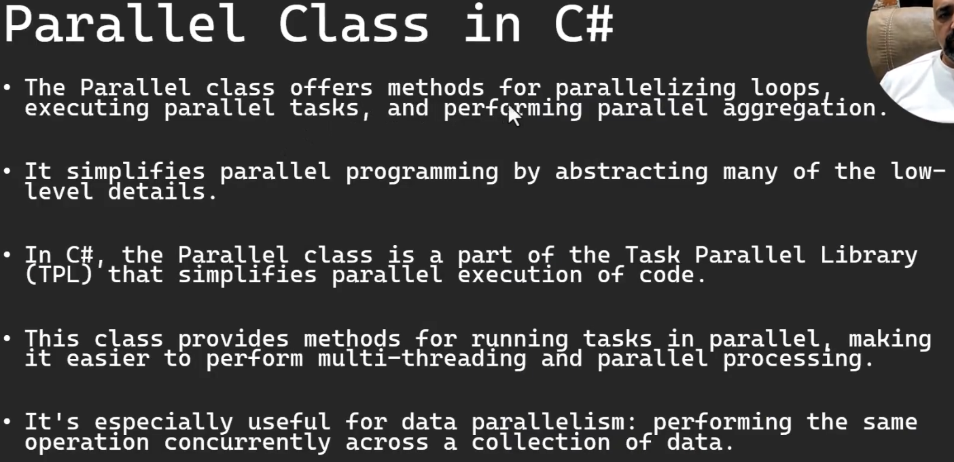

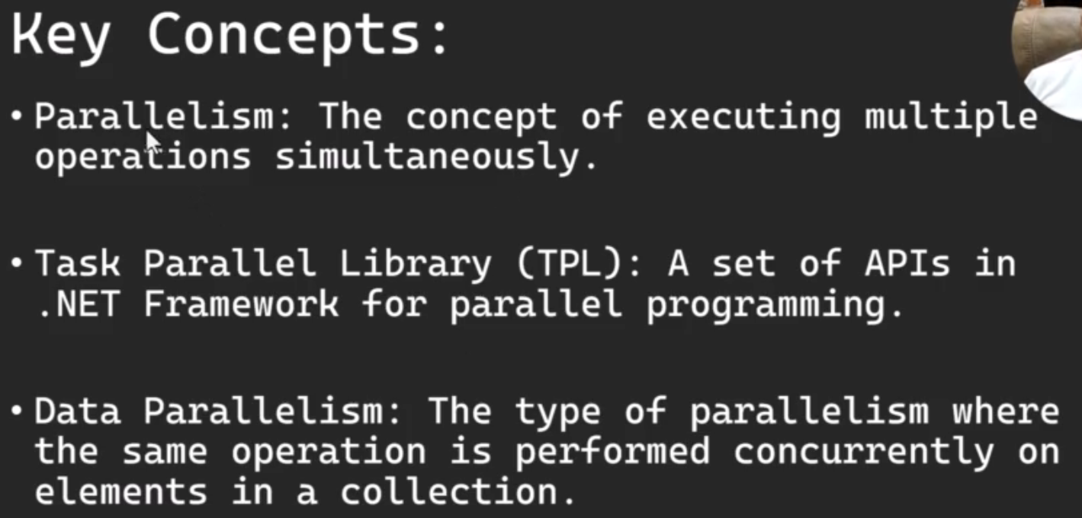

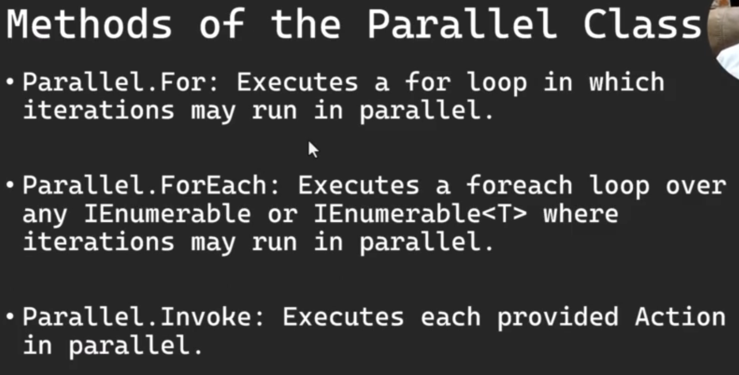

# **Parallel Class in C#**

## Introduction

The Parallel class offers methods for parallelizing loops, executing parallel tasks, and performing parallel aggregation. It simplifies parallel programming by abstracting many of the low-level details.

In C#, the Parallel class is a part of the Task Parallel Library (TPL) that simplifies parallel execution of code. This class provides methods for running tasks in parallel, making it easier to perform multi-threading and parallel processing. It's especially useful for data parallelism: performing the same operation concurrently across a collection of data.

## Key Concepts

1. Parallelism: The concept of executing multiple operations simultaneously.
2. Task Parallel Library (TPL): A set of APIs in .NET Framework for parallel programming.
3. Data Parallelism: The type of parallelism where the same operation is performed concurrently on elements in a collection.

## Using the Parallel Class

### **Methods of the Parallel Class**

* Parallel.For: Executes a for loop in which iterations may run in parallel.
* Parallel.ForEach: Executes a foreach loop over any IEnumerable or IEnumerable<T> where iterations may run in parallel.
* Parallel.Invoke: Executes each provided Action in parallel.

## Best Practices and Considerations

* Thread Safety: Ensure your code is thread-safe when using parallel constructs.
* Overhead: Parallel operations introduce some overhead. Use them when the benefits of parallelism outweigh this overhead.
* I/O Bound vs CPU Bound: The Parallel class is best suited for CPU-bound operations. For I/O-bound operations, consider using asynchronous programming with async and await.

## Conclusion

The Parallel class in C# provides a simple and efficient way to implement parallelism in your applications. It's particularly useful for scenarios where you need to perform operations concurrently across collections or execute multiple independent actions simultaneously. However, always consider thread safety and the nature of the tasks when using this class.

**Parallel.For**

ال parallel.for هيا for loop عاديه بس مخصصه لل threads يعني بدل ماتعمل اكتر من thread او بدل ماتعمل for loop وجواها تقوله اعمل task جديده وخليها تشغل ال method الفلانيه لا هوا وفر عليك القصه دي

|  |
| --- |
| using System;  using System.Threading.Tasks;  class NullableExample  {    static async Task Main()  {  int NumberOfIterations = 10;  Parallel.For(0, NumberOfIterations, i => {  Console.WriteLine(i+" "+Task.CurrentId);  Task.Delay(1000).Wait();    });  Console.WriteLine("Finished");  Console.ReadKey();  }  } |

وفي الكود ده هوا بدل ال lambda expression ب method

|  |
| --- |
| using System;  using System.Threading.Tasks;  class NullableExample  {    static async Task Main()  {  int NumberOfIterations = 10;  Parallel.For(0, NumberOfIterations, ProcessIteration);  Console.WriteLine("Finished");  Console.ReadKey();  }  static void ProcessIteration(int i) {  Console.WriteLine(i + " " + Task.CurrentId);  Task.Delay(1000).Wait();  }  } |

**Parallel.For**

Parallel.For is a method in C# that allows you to execute a for loop in parallel, making it easier to perform parallel operations on a collection or for a specific number of iterations.

**Example:**

Here's an example demonstrating how to use Parallel.For:

using System;

using System.Threading.Tasks;

class Program

{

    static void Main()

    {

        // Define the number of iterations

        int numberOfIterations = 10;

        // Use Parallel.For to execute the loop in parallel

        Parallel.For(0, numberOfIterations, i =>

        {

            Console.WriteLine($"Executing iteration {i} on thread {Task.CurrentId}");

            // Simulate some work

            Task.Delay(1000).Wait();

        });

        Console.WriteLine("All iterations completed.");

    }

}

In this example:

1. Parallel.For is used to execute iterations in parallel from 0 to numberOfIterations - 1.
2. Inside the Parallel.For, a lambda expression is defined to perform the work for each iteration. In this case, it's printing the iteration number and the current task ID to the console, followed by a simulated work delay.
3. Parallel.For will handle the distribution of these iterations across multiple threads.
4. After Parallel.For completes, a message is printed to indicate that all iterations are done.

Note: The actual order of execution of the iterations may vary each time you run the program, as Parallel.For will execute them concurrently on different threads.

**Same Example using separate function:**

o use Parallel.For with separate functions instead of a lambda expression, you can define a method that encapsulates the work you want to perform in each iteration. Here's how you can modify the example:

using System;

using System.Threading.Tasks;

class Program

{

    static void Main()

    {

        // Define the number of iterations

        int numberOfIterations = 10;

        // Use Parallel.For to execute the loop in parallel

        Parallel.For(0, numberOfIterations, ProcessIteration);

        Console.WriteLine("All iterations completed.");

    }

    static void ProcessIteration(int i)

    {

        Console.WriteLine($"Executing iteration {i} on thread {Task.CurrentId}");

        // Simulate some work

        Task.Delay(1000).Wait();

    }

}

In this revised example:

1. The ProcessIteration method is defined to handle the work for each iteration. It takes an integer i as a parameter, which represents the current iteration number.
2. Parallel.For is used to execute iterations in parallel, calling the ProcessIteration method for each iteration.
3. Within ProcessIteration, the iteration number and the current task ID are printed, followed by a simulated delay to represent some work.

By using this approach, the loop's work is encapsulated in a method, making the code more modular and potentially easier to understand and maintain.

**Parallel.ForEach**

ده ال for each نفس فكرة ال for loop

|  |
| --- |
| using System;  using System.Collections.Generic;  using System.Net;  using System.Threading;  using System.Threading.Tasks;  class NullableExample  {  static List<string> urls = new List<string> {  "https://www.cnn.com",  "https://www.amazon.com",  "https://www.ProgrammingAdvices.com"  };  static void Main()  {  Parallel.ForEach(urls, url =>  {  DownloadContent(url);  });  Console.WriteLine("Done");  Console.ReadKey();  }  static void DownloadContent(string url) {  string content;  using (WebClient client=new WebClient()) {  Thread.Sleep(100);  content = client.DownloadString(url);  }  Console.WriteLine(url+" "+content.Length);  }  } |

**Parallel.ForEach:**

Parallel.ForEach is used in C# to execute a parallel loop over a collection or an enumerable. It can efficiently process items in parallel, improving performance for suitable tasks.

Here's an example demonstrating Parallel.ForEach:

using System;

using System.Collections.Generic;

using System.Net;

using System.Threading;

using System.Threading.Tasks;

class Program

{

    static List<string> urls = new List<string>

    {

        "https://www.cnn.com",

        "https://www.amazon.com",

        "https://www.programmingadvices.com"

    };

    static void Main()

    {

        // Use Parallel.ForEach to download the web pages concurrently

        Parallel.ForEach(urls, url =>

        {

             DownloadContent(url);

        });

        Console.WriteLine("Done!");

        Console.ReadKey();

    }

    static void DownloadContent(string url)

    {

        string content;

        using (WebClient client = new WebClient())

        {

            // Simulate some work by adding a delay

            Thread.Sleep(100);

            // Download the content of the web page

            content = client.DownloadString(url);

        }

     Console.WriteLine( $"{url}: {content.Length} characters downloaded");

    }

}

downloading content from a list of URLs using Parallel.ForEach. This approach will download the contents of each URL in parallel, and after downloading, it prints the length of the content directly within the DownloadContent method. This is a thread-safe way to handle the console output since Console.WriteLine is inherently thread-safe.

Here's a brief overview of your code:

1. List of URLs: You have a list of URLs (urls) from which the content will be downloaded.
2. Parallel Download: Parallel.ForEach is used to iterate over the URLs. For each URL, DownloadContent is called in parallel.
3. Download and Print: Inside DownloadContent, each URL's content is downloaded, and the length of the content is printed to the console.
4. Completion Message: After all parallel operations are complete, a "Done!" message is displayed.
5. Thread Delay: There's a Thread.Sleep(100) call in DownloadContent, simulating some work or delay. This may represent the network latency in a real-world scenario.

This code will efficiently utilize multiple threads to download data from different URLs simultaneously, which can significantly speed up the process compared to downloading each URL sequentially.

Just a few points to consider:

* Error Handling: Consider adding error handling within DownloadContent to manage situations where a download might fail (e.g., due to a bad URL or network issues).
* Resource Utilization: Be aware that making too many simultaneous web requests can strain the network and the server you are querying. It's generally good practice to limit the number of concurrent network requests.
* Async Approach: For network-bound operations like web requests, an asynchronous approach using async and await with HttpClient might be more efficient and can help avoid blocking threads. This is especially relevant for I/O-bound operations.

**Parallel.Invoke**

الطريقتين اللي فاتوا كنت بتستعملهم لو عندك اكتر من task بيستخدموا نفس الmethod

هنا بقي انت عندك اكتر من method بتشغل كل واحده في task لوحدها

|  |
| --- |
| using System;  using System.Collections.Generic;  using System.Net;  using System.Threading;  using System.Threading.Tasks;  class NullableExample  {  static void Main()  {  Console.WriteLine("Starting parallel functions");  Parallel.Invoke(Function1,Function2,Function3);  Console.WriteLine("all functions are completed");  Console.ReadKey();  }  static void Function1() {  Console.WriteLine("Funcion 1 is starting");  Task.Delay(1000).Wait();  Console.WriteLine("Function1 is completed");  }  static void Function2()  {  Console.WriteLine("Funcion 2 is starting");  Task.Delay(1000).Wait();  Console.WriteLine("Function2 is completed");  }  static void Function3()  {  Console.WriteLine("Funcion 3 is starting");  Task.Delay(1000).Wait();  Console.WriteLine("Function3 is completed");  }  } |
|  |

### **Parallel.Invoke**

Parallel.Invoke allows you to execute multiple actions in parallel.

### **Parallel.Invoke - Example**

using System;

using System.Threading.Tasks;

class Program

{

    static void Main()

    {

        Parallel.Invoke(

            () => Console.WriteLine($"Action 1 on thread {Task.CurrentId}"),

            () => Console.WriteLine($"Action 2 on thread {Task.CurrentId}"),

            () => Console.WriteLine($"Action 3 on thread {Task.CurrentId}")

        );

    }

}

#### Explanation:

This code executes three actions in parallel. Each action is a lambda expression that prints a message including the ID of the thread it's running on.

**Simpler way:**

### **Parallel.Invoke - Example2**

Parallel.Invoke, you can define separate methods for each function and then call these methods within Parallel.Invoke. Here's the modified example:

using System;

using System.Threading.Tasks;

class Program

{

    static void Main()

    {

        // Run the functions in parallel

        Console.WriteLine("Starting parallel functions.");

        Parallel.Invoke(Function1, Function2, Function3);

        Console.WriteLine("All parallel functions are completed.");

    }

    static void Function1()

    {

        Console.WriteLine("Function 1 is starting.");

        Task.Delay(1000).Wait(); // Simulating work

        Console.WriteLine("Function 1 is completed.");

    }

    static void Function2()

    {

        Console.WriteLine("Function 2 is starting.");

        Task.Delay(1000).Wait(); // Simulating work

        Console.WriteLine("Function 2 is completed.");

    }

    static void Function3()

    {

        Console.WriteLine("Function 3 is starting.");

        Task.Delay(1000).Wait(); // Simulating work

        Console.WriteLine("Function 3 is completed.");

    }

}

In this example:

1. Function1, Function2, and Function3 are defined as separate static methods in the Program class.
2. Each function simulates some work by calling Task.Delay.
3. Parallel.Invoke is used to execute these methods in parallel. The methods are passed as arguments to Parallel.Invoke without using lambda expressions.
4. The program prints messages to the console indicating the start and completion of each function, as well as the overall completion of all functions.

**Quiz4**

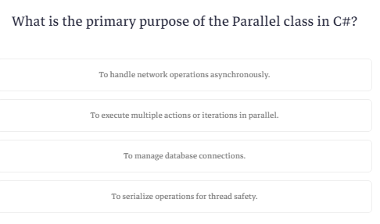

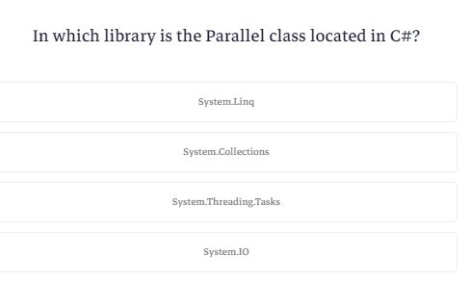

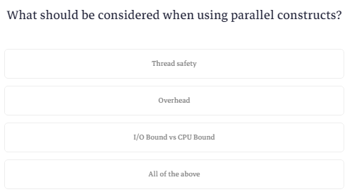

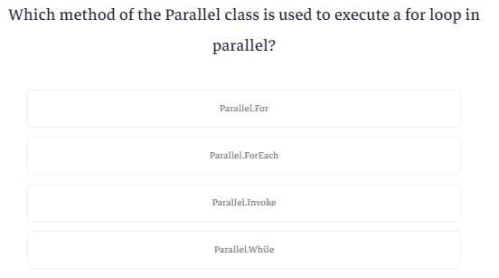

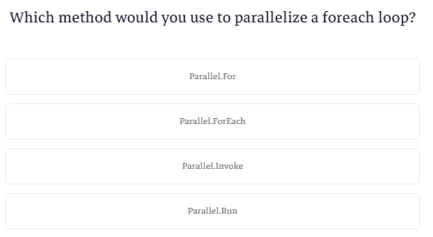

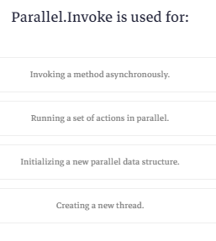

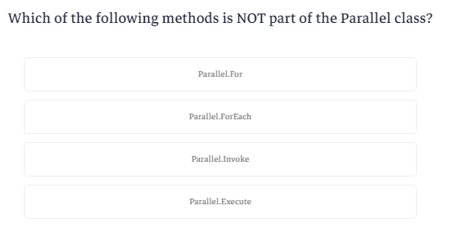

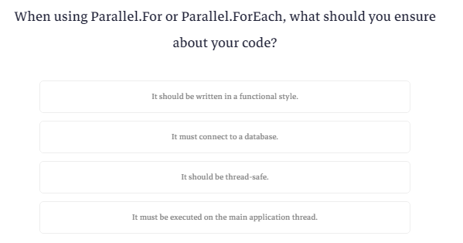

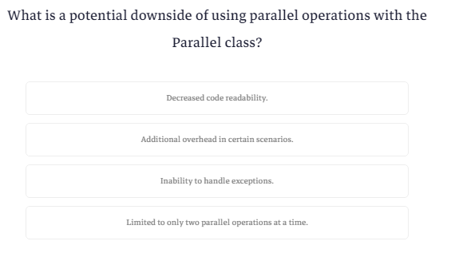

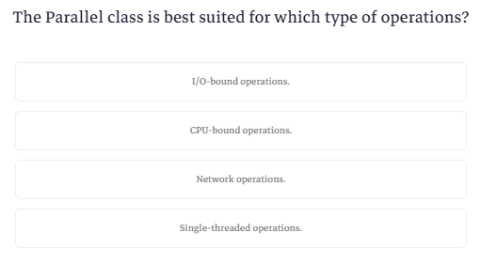

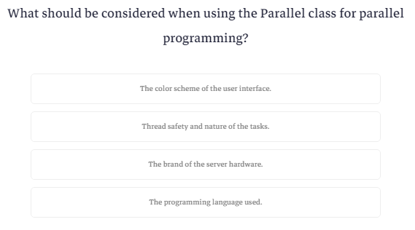

**Traffic Light Project Idea (Traffic Light User Control)**

بتعمل ال control ده



ولما تروح عال properties بتكون عامل ال properties دي

من هنا تقدر تغير اللون ال default وبالتالي يتغير النور بتاع ال control

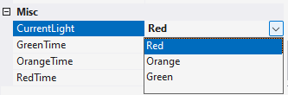

ومن هنا تقدر تتحكم في الوقت اللي كل لون بيظهر فيه

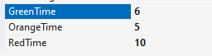

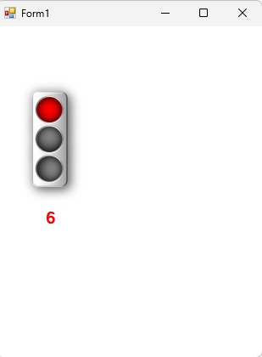

وبعد مابيخلص كل لون مده بتطلعلك رساله

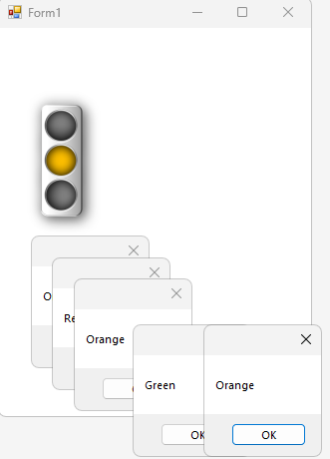

تعالي نعملها واحده واحده

اول حاجه هنعملها الديزاين

هنعمل control جديد ونحط فيه picture box و label وtimer

وهنخلي ال interval بتاعت ال timer تكون قيمتها ب 1000 اللي هيا تعادل ثانيه واحده

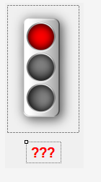

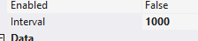

تعالي بقي نخش للكود

اول حاجه محتاجين نعمل enum عشان نقدر نحدد نوع اللون بتاع الاشاره بسهوله

ومحتاجين نعمل متغير نخزن فيه اللون الحالي اللي ظاهر علي الشاشه وكمان متغيرات بنخزن فيها القيم الافتراضيه للوقت بتاع كل لون ومتغير تاني هنستخدمه كعداد

|  |
| --- |
| public enum enTrafficLight {Red=0,Orange=1,Green=2}  private enTrafficLight _CurrentLight = enTrafficLight.Red;  private int _RedLightDuration=3;  private int _OrangeLightDuration = 5;  private int _GreenLightDuration = 10;  private int _CurrentCountDownValue; |

هنعمل متغيرات تانيه تتحكم في المتغيرات دي بحيث اننا نخلي اليوزر يقدر يعملها initialization من بره

|  |
| --- |
| public int RedLightDuration {  get { return this._RedLightDuration; }  set { this._RedLightDuration = value; }  }  public int OrangeLightDuration  {  get { return this._OrangeLightDuration; }  set { this._OrangeLightDuration = value; }  }  public int GreenLightDuration  {  get { return this._GreenLightDuration; }  set { this._GreenLightDuration = value; }  } |

دي method من خلالها اقدر اجيب ال current time اللي هوا الوقت بتاع اللون الحالي

|  |
| --- |
| public int GetCurrentTime() {  switch (this._CurrentLight) {  case enTrafficLight.Red:  return this.RedLightDuration;  break;  case enTrafficLight.Orange:  return this.OrangeLightDuration;  break;  case enTrafficLight.Green:  return this.GreenLightDuration;  break;  default: return this.RedLightDuration;  }  } |

ودول 2 methods من خلالهم اقدر اشغل ال timer واوقفه

|  |
| --- |
| public void Start() {  this._CurrentCountDownValue = GetCurrentTime();  timer1.Start();  }  public void Stop() {  timer1.Stop();  } |

وهنا method بغير منها اللون

بتغيرالصوره المعروضه وبتغير الوقت الحالي والرقم اللي في ال label وبتشغل event

|  |
| --- |
| private void ChangeLight() {  switch (this._CurrentLight) {  case enTrafficLight.Red:  this.CurrentLight = enTrafficLight.Orange;  this._CurrentCountDownValue = this.OrangeLightDuration;  lblTimer.Text = this._CurrentCountDownValue.ToString();  OrangeLightRaisedOn();  break;  case enTrafficLight.Orange:  this.CurrentLight = enTrafficLight.Green;  this._CurrentCountDownValue = this.GreenLightDuration;  lblTimer.Text = this._CurrentCountDownValue.ToString();  GreenLightRaisedOn();  break;  case enTrafficLight.Green:  this.CurrentLight = enTrafficLight.Red;  this._CurrentCountDownValue = this.RedLightDuration;  lblTimer.Text = this._CurrentCountDownValue.ToString();  RedLightRaisedOn();  break;  }  } |

هنا بشغل event علي الtimer بقوله يحدث قيمة ال label ويشوف لو الوقت الحالي لايساوي صفر يقلل العداد بواحد ولو كده يغير اللون

فلما هييجي يغير اللون هيرجع يعمل اختبار للرقم وكده كده مش هيقف لاني ماقولتلهوش يقف

|  |
| --- |
| private void timer1_Tick(object sender, EventArgs e)  {  lblTimer.Text=this._CurrentCountDownValue.ToString();  if (this._CurrentCountDownValue==0) {  ChangeLight();  }  else {  -- this._CurrentCountDownValue;  }  } |

وبعدين نييجي لل events ودي امرها سهل

هنعمل كلاس بالحاجات اللي عايزين نبعتها

|  |
| --- |
| public class TrafficLightEventArgs : EventArgs {  public enTrafficLight CurrentLight;  public int LightDuration;  public TrafficLightEventArgs(enTrafficLight CurrentLight, int LightDuration) {  this.CurrentLight = CurrentLight;  this.LightDuration = LightDuration;  }  } |

وبعدين هنعمل object من eventhandler

|  |
| --- |
| public event EventHandler<TrafficLightEventArgs> RedLightOn; |

وبعدين ال methods اللي هتشغله

|  |
| --- |
| private void RaiseRedLightOn(TrafficLightEventArgs e) {  RedLightOn?.Invoke(this, e);  }  private void RedLightRaisedOn() {  RaiseRedLightOn(new TrafficLightEventArgs(enTrafficLight.Red, _RedLightDuration));  } |

ونكرر نفس الكلام مع كل الألوان

وفي الفورم نفسه هنطلع رساله تظهر بعد ما كل لون يشتغل

وده كود ال control

|  |
| --- |
| using MyTrafficLights.Properties;  using System;  using System.Drawing;  using System.Windows.Forms;  namespace MyTrafficLights  {  public partial class ctrlTrafficLights : UserControl  {  public ctrlTrafficLights()  {  InitializeComponent();  }  public enum enTrafficLight {Red=0,Orange=1,Green=2}  private enTrafficLight _CurrentLight = enTrafficLight.Red;  private int _RedLightDuration=3;  private int _OrangeLightDuration = 5;  private int _GreenLightDuration = 10;  private int _CurrentCountDownValue;    public int RedLightDuration {  get { return this._RedLightDuration; }  set { this._RedLightDuration = value; }  }  public int OrangeLightDuration  {  get { return this._OrangeLightDuration; }  set { this._OrangeLightDuration = value; }  }  public int GreenLightDuration  {  get { return this._GreenLightDuration; }  set { this._GreenLightDuration = value; }  }  public int GetCurrentTime() {  switch (this._CurrentLight) {  case enTrafficLight.Red:  return this.RedLightDuration;  break;  case enTrafficLight.Orange:  return this.OrangeLightDuration;  break;  case enTrafficLight.Green:  return this.GreenLightDuration;  break;  default: return this.RedLightDuration;  }  }  public void Start() {  this._CurrentCountDownValue = GetCurrentTime();  timer1.Start();  }  public void Stop() {  timer1.Stop();  }  private void ChangeLight() {  switch (this._CurrentLight) {  case enTrafficLight.Red:  this.CurrentLight = enTrafficLight.Orange;  this._CurrentCountDownValue = this.OrangeLightDuration;  lblTimer.Text = this._CurrentCountDownValue.ToString();  OrangeLightRaisedOn();  break;  case enTrafficLight.Orange:  this.CurrentLight = enTrafficLight.Green;  this._CurrentCountDownValue = this.GreenLightDuration;  lblTimer.Text = this._CurrentCountDownValue.ToString();  GreenLightRaisedOn();  break;  case enTrafficLight.Green:  this.CurrentLight = enTrafficLight.Red;  this._CurrentCountDownValue = this.RedLightDuration;  lblTimer.Text = this._CurrentCountDownValue.ToString();  RedLightRaisedOn();  break;  }  }  private void timer1_Tick(object sender, EventArgs e)  {  lblTimer.Text=this._CurrentCountDownValue.ToString();  if (this._CurrentCountDownValue==0) {  ChangeLight();  }  else {  -- this._CurrentCountDownValue;  }  }  public class TrafficLightEventArgs : EventArgs {  public enTrafficLight CurrentLight;  public int LightDuration;  public TrafficLightEventArgs(enTrafficLight CurrentLight, int LightDuration) {  this.CurrentLight = CurrentLight;  this.LightDuration = LightDuration;  }  }  public event EventHandler<TrafficLightEventArgs> RedLightOn;  private void RaiseRedLightOn(TrafficLightEventArgs e) {  RedLightOn?.Invoke(this, e);  }  private void RedLightRaisedOn() {  RaiseRedLightOn(new TrafficLightEventArgs(enTrafficLight.Red, _RedLightDuration));  }  public event EventHandler<TrafficLightEventArgs> OrangeLightOn;  private void RaiseOrangeLightOn(TrafficLightEventArgs e) {  OrangeLightOn?.Invoke(this, e);  }  private void OrangeLightRaisedOn() {  RaiseOrangeLightOn(new TrafficLightEventArgs(enTrafficLight.Orange, _OrangeLightDuration));  }  public event EventHandler<TrafficLightEventArgs> GreenLightOn;  private void RaiseGreenLightOn(TrafficLightEventArgs e) {  GreenLightOn?.Invoke(this, e);  }  private void GreenLightRaisedOn() {  RaiseGreenLightOn(new TrafficLightEventArgs(enTrafficLight.Green, _GreenLightDuration));  }  public enTrafficLight CurrentLight  {  get { return this._CurrentLight; }  set  {  this._CurrentLight = value;  switch (this._CurrentLight)  {  case enTrafficLight.Red:  pbTrafficLight.Image = Resources.Red;  lblTimer.ForeColor = Color.Red;  break;  case enTrafficLight.Orange:  pbTrafficLight.Image = Resources.Orange;  lblTimer.ForeColor = Color.Orange;  break;  case enTrafficLight.Green:  pbTrafficLight.Image = Resources.Green;  lblTimer.ForeColor = Color.Green;  break;  default:  lblTimer.ForeColor = Color.Red;  break;  }  }  }  }  } |

وده كود الفورم

|  |
| --- |
| using System;  using System.Collections.Generic;  using System.ComponentModel;  using System.Data;  using System.Drawing;  using System.Linq;  using System.Text;  using System.Threading.Tasks;  using System.Windows.Forms;  namespace MyTrafficLights  {  public partial class Form1 : Form  {  public Form1()  {  InitializeComponent();    }  private void Form1_Load(object sender, EventArgs e)  {  ctrlTrafficLights1.Start();  }  private void ctrlTrafficLights1_GreenLightOn(object sender, ctrlTrafficLights.TrafficLightEventArgs e)  {  MessageBox.Show(e.CurrentLight.ToString());  }  private void ctrlTrafficLights1_OrangeLightOn(object sender, ctrlTrafficLights.TrafficLightEventArgs e)  {  MessageBox.Show(e.CurrentLight.ToString());  }  private void ctrlTrafficLights1_RedLightOn(object sender, ctrlTrafficLights.TrafficLightEventArgs e)  {  MessageBox.Show(e.CurrentLight.ToString());  }  }  } |

**Pool Club Project Idea (Pool User Control)**

هنعمل مشروع ترابيزات بلياردو

هنعمل control واحد وبيتكرر معانا 9 مرات في الفورم

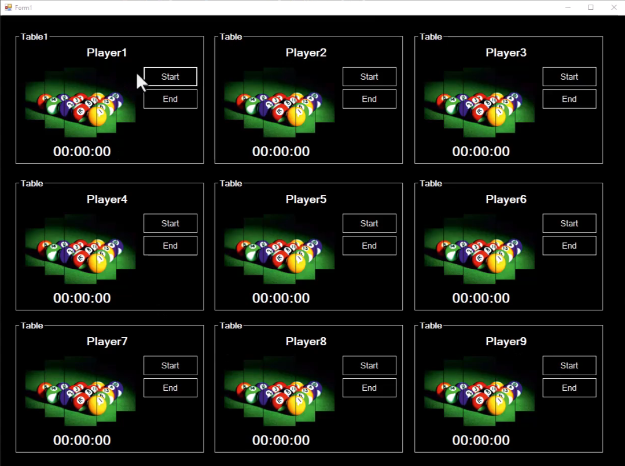

لما تدوس علي start يشغل العداد

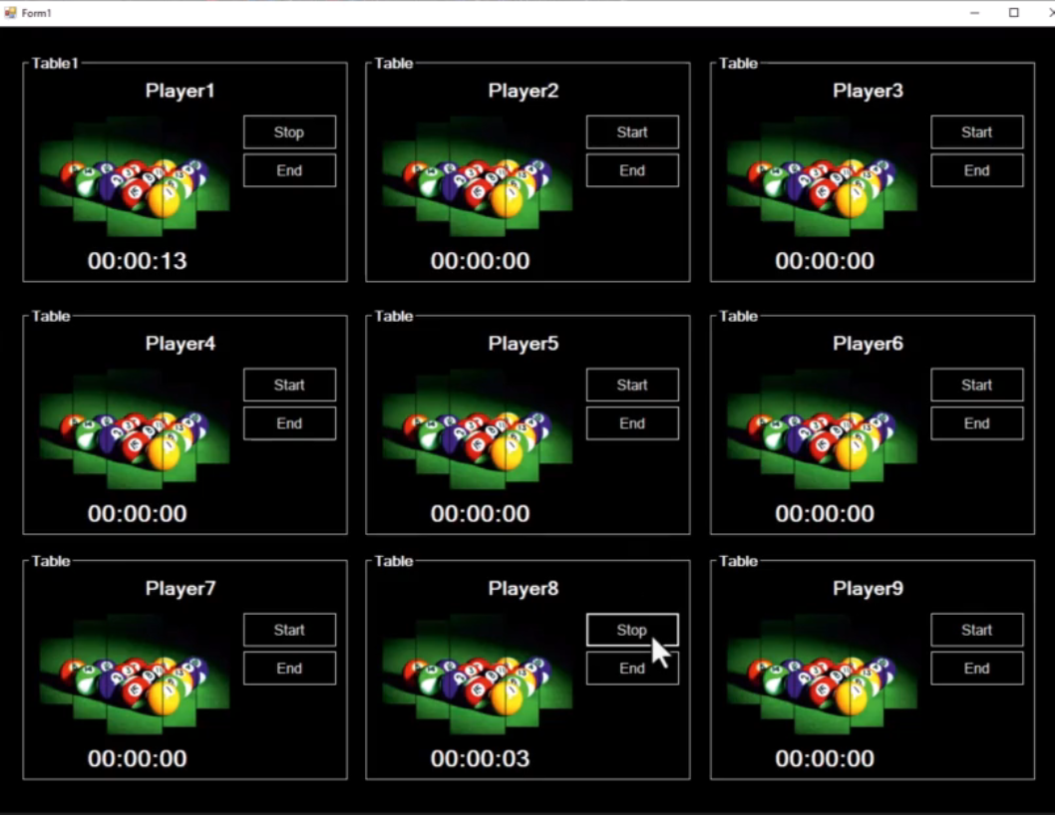

ولما تدوس علي stop العداد يوقف بحيث يعمل pause

ولما تدوس علي end يظهرلك الوقت وسعر الساعه والاجمالي وتدوس ok يصفر العداد وتقدر بعد كده تعمل api ينور النور بتاع الترابيزه ويقفلها وتخلي كل ترابيزه بسعر معين وهكذا



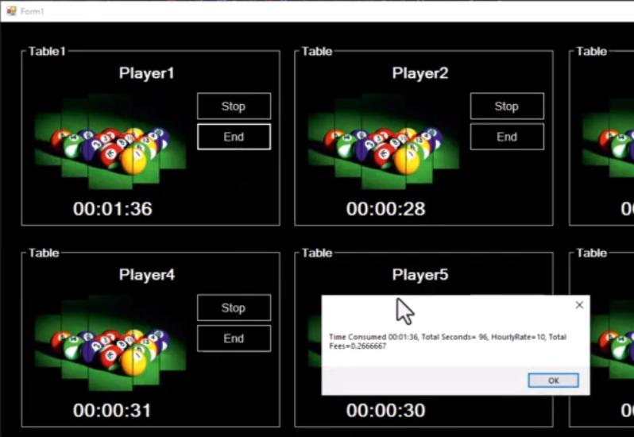

فيه هنا عندك ال properties مش بتطلع في ال misc بتطلع هنا في category لوحدها

ودي طريقتها بتحط اسم ال category وال description فوق كل property انت عايزها

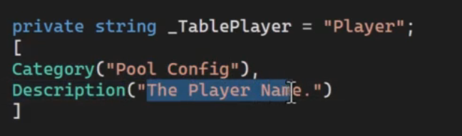

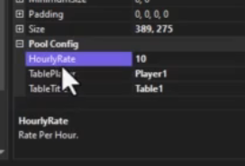

وده الكود   
نفس الفكرة بتاعت المثال اللي فات

|  |
| --- |
| using System;  using System.ComponentModel;  using System.Windows.Forms;  namespace _8Pool  {  public partial class PoolTable : UserControl  {  public PoolTable()  {  InitializeComponent();  }  public class TableCompletedEventArgs : EventArgs  {  public string TimeText { get; }  public int TimeInSeconds { get; }  public float RatePerHour { get; }  public float TotalFees { get; }  public TableCompletedEventArgs(string TimeText, int TimeInSeconds, float RatePerHour, float TotalFees)  {  this.TimeText = TimeText;  this.TimeInSeconds = TimeInSeconds;  this.RatePerHour = RatePerHour;  this.TotalFees = TotalFees;  }  }  public event EventHandler<TableCompletedEventArgs> OnTableComplete;  public void RaiseOnTableComplete(string TimeText, int TimeInSeconds, float RatePerHour, float TotalFees)  {  RaiseOnTableComplete(new TableCompletedEventArgs(TimeText, TimeInSeconds, RatePerHour, TotalFees));  }  protected virtual void RaiseOnTableComplete(TableCompletedEventArgs e)  {  OnTableComplete?.Invoke(this, e);  }  int _Seconds;    // Private data member that backs the EndColor property.  private string _TableTitle = "Table";    // The Category attribute tells the designer to display  // it in the Flash grouping.  // The Description attribute provides a description of  // the property.  [  Category("Pool Config"),  Description("The table Name.")  ]  // The public property EndColor accesses endColor.  public string TableTitle  {  get  {  return _TableTitle;  }  set  {  _TableTitle = value;    grpTable.Text = value;  // The Invalidate method calls the OnPaint method, which redraws  // the control.  Invalidate();  }  }  private string _TablePlayer = "Player";  [  Category("Pool Config"),  Description("The Player Name.")  ]    public string TablePlayer  {  get  {  return _TablePlayer;  }  set  {  _TablePlayer = value;  lblName.Text = value;  // The Invalidate method calls the OnPaint method, which redraws  // the control.  Invalidate();  }  }  private float _HourlyRate= 10.00F;  [  Category("Pool Config"),  Description("Rate Per Hour.")  ]  public float HourlyRate  {  get  {  return _HourlyRate;  }  set  {  _HourlyRate = value;  }  }  private void btnStartStop_Click(object sender, EventArgs e)  {  if (btnStartStop.Text == "Start")  {  btnStartStop.Text = "Stop";  timer1.Start();  }  else  {  btnStartStop.Text = "Start";  timer1.Stop();  }  }  private void timer1_Tick(object sender, EventArgs e)  {  _Seconds++;  TimeSpan time = TimeSpan.FromSeconds(_Seconds);  string str = time.ToString(@"hh\:mm\:ss");  lblTime.Text = str;  lblTime.Refresh();  }  private void PoolTable_Load(object sender, EventArgs e)  {  grpTable.Text = _TableTitle;  lblName.Text=_TablePlayer;  }  private void lblTime_Click(object sender, EventArgs e)  {  }  private void btnEnd_Click(object sender, EventArgs e)  {    timer1.Stop();  float TotalFees = ((float)_Seconds / 60 / 60) * _HourlyRate;  RaiseOnTableComplete(lblTime.Text , _Seconds, _HourlyRate, TotalFees) ;  grpTable.Text = "Table";  lblName.Text = "Player";  lblTime.Text = "00:00:00";  btnStartStop.Text = "Start";  _Seconds = 0;  }    private void toolStripTextBox1_TextChanged(object sender, EventArgs e)  {  lblName.Text = toolStripTextBox1.Text;  }  }  } |

|  |
| --- |
| using System;  using System.Windows.Forms;  namespace _8Pool  {  public partial class Form1 : Form  {  public Form1()  {  InitializeComponent();  }  private void button1_Click(object sender, EventArgs e)  {    }  private void poolTable4_Load(object sender, EventArgs e)  {  }  private void poolTable_OnTableComplete(object sender, PoolTable.TableCompletedEventArgs e)  {  string TableResults = "";  TableResults = "Time Consumed " + e.TimeText;  TableResults = TableResults + ", Total Seconds= " + e.TimeInSeconds;  TableResults = TableResults + ", HourlyRate=" + e.RatePerHour.ToString();  TableResults = TableResults + ", Total Fees=" + e.TotalFees.ToString();  MessageBox.Show(TableResults);  }  }  } |

**Control Library**

**Introduction**

الفكره هنا اننا هنعمل control ونحطه في مكتبه بحيث نقدر نشتغل بيه في أي مشروع

والمكتبه هتكون بصيغة dll

هنعمل مشروع عادي

وبعدين كليك يمين علي ال solution ونختار add>>new project

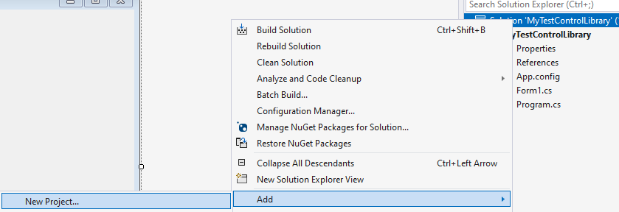

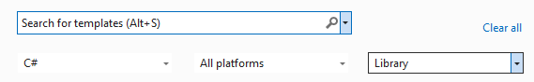

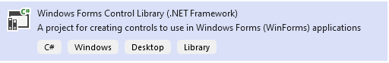

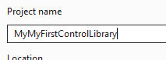

حطينا text box و label وعملنا event عال text box

|  |
| --- |
| using System;  using System.Windows.Forms;  namespace MyMyFirstControlLibrary  {  public partial class UserControl1: UserControl  {  public UserControl1()  {  InitializeComponent();  }  private void textBox1_TextChanged(object sender, EventArgs e)  {  label1.Text = textBox1.Text;  }  }  } |

دلوقتي اصبح عندك control library

ازاي هتستخدمه في ال windows forms ؟

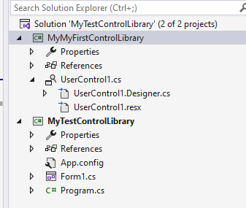

وبتضيفه ك reference

لو هوا موجود ضمن ال project هتلاقيه عندك

ولو مش من ضمن المشروع هتضيف ال dll بتاعه

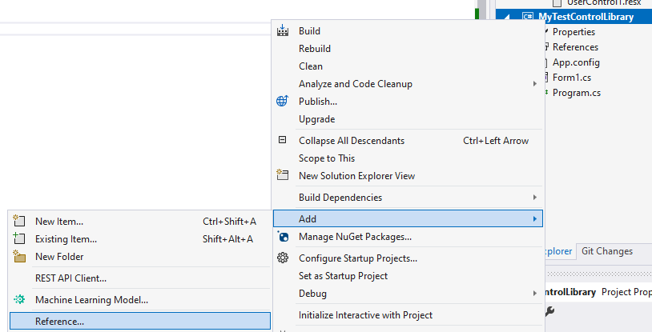

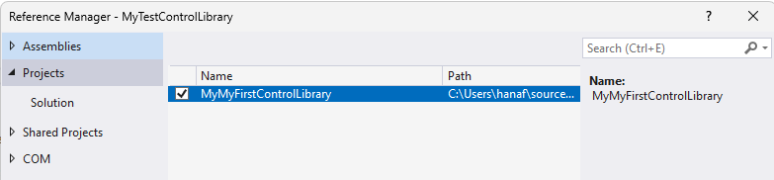

هتروح للفورم هتلاقيه في ال tool box اعمل بيه اللي انت عاوزه

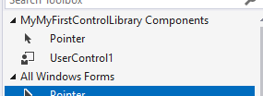

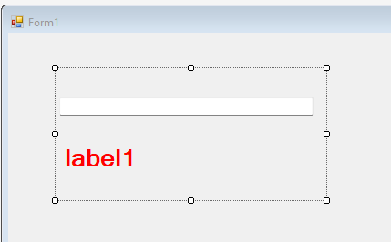

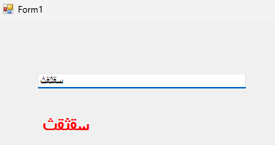

**Introduction to Custom Controls**

هنا الفكره انك عايز تاخد ال controls الموجوده واللي معموله جاهزة زي ال textbox وتورث منها بحيث تقدر تعدل عليها

هنعمل مشروع عادي وبعدين add>>new item

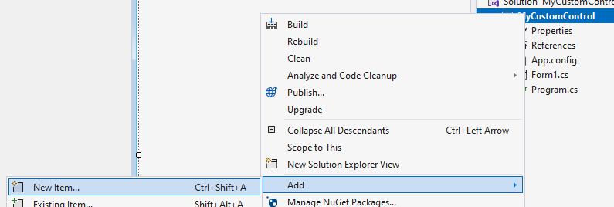

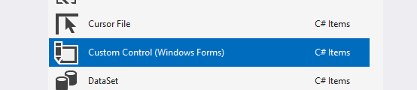

هتطلعلك الشاشه دي لانك ماتقدرش ترسم عليه

انت بتبنيه من الصفر او تورث من واحد موجود

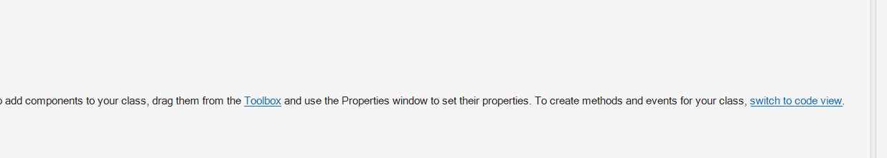

احنا هنورث من ال textbox عشان نعمل عليه validation

هتدوس علي دي



هيطلعلك الكلاس بيورث من control

احنا هنخليه يورث من textbox

|  |
| --- |
| using System.Windows.Forms;  namespace MyCustomControl  {  public partial class MyCustomTextBox : TextBox  {  public MyCustomTextBox()  {  InitializeComponent();  }  protected override void OnPaint(PaintEventArgs pe)  {  base.OnPaint(pe);  }  }  } |

اعمل build هتلاقيه هنا

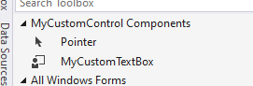

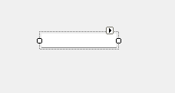

بعدين هنضيف 2 properties

|  |
| --- |
| public bool IsRequired { get; set; }  public enum InputTypeEnum {TesxtInput,NumberInput }  public InputTypeEnum InputType { get; set;}= InputTypeEnum.TesxtInput; |

وده كود بسيط عشان يعمل validation

|  |
| --- |
| public bool IsRequired  { get; set; }  public enum InputTypeEnum { TextInput, NumberInput }  public InputTypeEnum InputType  { get; set; } = InputTypeEnum.TextInput;  private bool IsNumeric()  {  string s = this.Text.Trim();  foreach (char c in s)  {  if (!char.IsDigit(c) && c != '.')  {  return false;  }  }  return true;  }  public Boolean IsValid()  {  if (IsRequired)  {  if (this.Text.Trim().Length == 0)  return false;  }  if (InputType == InputTypeEnum.NumberInput)  {  return IsNumeric();  }  return true;  } |

وهنا بيستخدمه في الفورم

|  |
| --- |
| private void button1_Click(object sender, EventArgs e)  {  MessageBox.Show(myCustomTextBox1.IsValid().ToString());  } |

**Calling a SP_AddNewPerson from C# Using ADO.NET**

هنا عشان تقدر تتعامل مع ال stored procedures مع ال ado.net

نفس اللي كنا بنعمله مع أي query بس باختلاف بسيط وهوا سطر ال command



بس وباقي المثال عادي

### **Calling a SP_AddNewPerson from C# Using ADO.NET**

#### ****Introduction****

In this lesson, we'll learn how to interact with a SQL Server database from a C# application using ADO.NET. We'll focus on calling a stored procedure to insert data into a database and retrieve a generated ID.

#### ****SQL Stored Procedure****

First, we have a stored procedure SP_AddNewPerson in SQL Server:

CREATE PROCEDURE SP_AddNewPerson

    @FirstName NVARCHAR(100),

    @LastName NVARCHAR(100),

    @Email NVARCHAR(255),

    @NewPersonID INT OUTPUT

AS

BEGIN

    INSERT INTO People (FirstName, LastName, Email)

    VALUES (@FirstName, @LastName, @Email);

    SET @NewPersonID = SCOPE_IDENTITY();

END

This procedure inserts a new person into the People table and returns the new person's ID.

#### ****Calling the Stored Procedure from C#****

To call this stored procedure from a C# application using ADO.NET, follow these steps:

Setting Up the Connection: First, establish a connection to your SQL Server database.

using System.Data.SqlClient;

string connectionString = "YourConnectionStringHere";

using SqlConnection connection = new SqlConnection(connectionString);

Creating the Command: Create a command object to represent the stored procedure.

using SqlCommand command = new SqlCommand("SP_AddNewPerson", connection);

command.CommandType = CommandType.StoredProcedure;

Adding Parameters: Add parameters to the command.

command.Parameters.AddWithValue("@FirstName", "John");

command.Parameters.AddWithValue("@LastName", "Doe");

command.Parameters.AddWithValue("@Email", "john.doe@example.com");

SqlParameter outputIdParam = new SqlParameter("@NewPersonID", SqlDbType.Int)

{

    Direction = ParameterDirection.Output

};

command.Parameters.Add(outputIdParam);

Executing the Command: Open the connection and execute the command.

connection.Open();

command.ExecuteNonQuery();

Retrieving the Output Parameter: After execution, retrieve the value of the output parameter.

int newPersonID = (int)command.Parameters["@NewPersonID"].Value;

Console.WriteLine($"New Person ID: {newPersonID}");

Closing the Connection: Finally, close the connection.

connection.Close();

#### Example

Here's a simple C# console application example that demonstrates the entire process:

using System;

using System.Data;

using System.Data.SqlClient;

class Program

{

    static void Main()

    {

        string connectionString = "YourConnectionStringHere";

        using SqlConnection connection = new SqlConnection(connectionString);

        using SqlCommand command = new SqlCommand("SP_AddNewPerson", connection);

        command.CommandType = CommandType.StoredProcedure;

        // Add parameters

        command.Parameters.AddWithValue("@FirstName", "John");

        command.Parameters.AddWithValue("@LastName", "Doe");

        command.Parameters.AddWithValue("@Email", "john.doe@example.com");

        SqlParameter outputIdParam = new SqlParameter("@NewPersonID", SqlDbType.Int)

        {

            Direction = ParameterDirection.Output

        };

        command.Parameters.Add(outputIdParam);

        // Execute

        connection.Open();

        command.ExecuteNonQuery();

        // Retrieve the ID of the new person

        int newPersonID = (int)command.Parameters["@NewPersonID"].Value;

        Console.WriteLine($"New Person ID: {newPersonID}");

        connection.Close();

    }

}

In this example, replace "YourConnectionStringHere" with your actual database connection string. This application will add a new person to the People table and print the new person's ID to the console.

**Calling SP_CheckPersonExists from C# Using ADO.NET**

وهنا مثال تاني

### **Calling SP_CheckPersonExists from C# Using ADO.NET**

#### ****Introduction****

In this lesson, you'll learn how to call a SQL Server stored procedure from a C# application using ADO.NET. The focus will be on executing a procedure that checks whether a record exists in a database based on a given ID.

#### ****SQL Stored Procedure****

Firstly, we have a stored procedure named SP_CheckPersonExists in SQL Server:

CREATE PROCEDURE SP_CheckPersonExists

    @PersonID INT

AS

BEGIN

    IF EXISTS(SELECT * FROM People WHERE PersonID = @PersonID)

        RETURN 1;  -- Person exists

    ELSE

        RETURN 0;  -- Person does not exist

END

This procedure checks if a person exists in the People table using PersonID.

#### ****Calling the Stored Procedure from C#****

To call this stored procedure from a C# application, follow these steps:

1. Setting Up the Connection:
2. Establish a connection to the SQL Server database.

using System.Data.SqlClient;

string connectionString = "YourConnectionStringHere";

using SqlConnection connection = new SqlConnection(connectionString);

1. Creating the Command:
2. Create a command object for the stored procedure.

using SqlCommand command = new SqlCommand("SP_CheckPersonExists", connection);

command.CommandType = CommandType.StoredProcedure;

1. Adding Parameters:
2. Add the necessary parameter to the command.

command.Parameters.AddWithValue("@PersonID", 123); // Example ID

1. Executing the Command:
2. Open the connection and execute the command. In this case, we'll use ExecuteScalar() since we're expecting a single value in return.

connection.Open();

int result = (int)command.ExecuteScalar();

1. Interpreting the Result:
2. The returned value indicates the existence of the person.

bool personExists = result == 1;

Console.WriteLine($"Person exists: {personExists}");

1. Closing the Connection:
2. Close the connection to the database.

connection.Close();

#### Example

Here's a complete C# console application example demonstrating the entire process:

using System;

using System.Data;

using System.Data.SqlClient;

class Program

{

    static void Main()

    {

        string connectionString = "YourConnectionStringHere";

        using SqlConnection connection = new SqlConnection(connectionString);

        using SqlCommand command = new SqlCommand("SP_CheckPersonExists", connection);

        command.CommandType = CommandType.StoredProcedure;

        // Add parameter

        command.Parameters.AddWithValue("@PersonID", 123); // Example ID

        // Execute

        connection.Open();

        int result = (int)command.ExecuteScalar();

        // Check if person exists

        bool personExists = result == 1;

        Console.WriteLine($"Person exists: {personExists}");

        connection.Close();

    }

}

In this example, replace "YourConnectionStringHere" with your actual database connection string, and adjust the PersonID value accordingly. This application will check if a person with the specified ID exists in the People table and print the result to the console.

**Message**

الكورس اللي جاي بتاع ال data structure هيعلمهولنا بال c# عشان نستخدم ال tools اللي في ال c# ويقع العاتق عليك في التطبيق

